Effect of Hand-movement on the Presence of another Person in a Virtual Environment

Team:

2973140 - Felix Bühler, 3141241 - Jamie Ullerich, 2893121 - Jan Leusmann

Report:

1. Build a meeting room in Unity

For this study we first build a unity scene, which represents a meeting room. The scene consists of a room with a window and a door, a table, and two office chairs. We want this room to look like a meeting room, but we don't want to add a lot of disturbing objects so participants aren't distracted. We decided to not add a ceiling, so the lighting and more explicitly the shadows are good, as shadows of hands are very important for being able to track moving objects (in our case the avatars hands) in a 3-dimensional space. In this step we did not encounter any big challengers.

We want to set up the real life study setting, which is represented by the study scene, so participants should sit at a table facing each other.

1. Setting up a network connection, so two VR Avatars are being controlled by two persons

To control two VR players in the unity scene, we had to set up a network connection. For

this we used the photon pun 2 asset from the unity asset store[1]. We decided not to build a complicated lobby system, but instead we chose, that the first connecting player (master) creates a room, and the second player just joins this room. We then later can let the master switch between scenes, whereby each scene is for one specific condition (real hand movement, no hand movement, fake hand movement). Explanations about our independent variable with the three conditions can be seen in our previous milestone submissions. In this step we encountered some challenges, but we were able to solve them. The photon asset first needs to connect to an external server, which was not possible using UDP (which was the standard for photon), so now we use TCP. Also we needed to write some scripts to transfer the positional information from the avatars, which are each controlled by one HTC Vive.

1. Controll the avatars with the HTC Vive and the hands with Leap Motion and transfer the positional information to the other study member

We are now at the point, where we need to think about how we want to control and represent each avatar. For this we thought about several options:

1. **Having a complete avatar, and control them via the HTC Vive and the Leap Motion and using inverse kinematics to move the avatar in a natural way**

This would probably be the most realistic way to control the avatars, but leads to some challenges. The first being if we have to build an inverse kinematics avatar controller would be very time consuming and probably out of scope for this project. If we could use an asset, which does exactly that, this challenge could be solved. As we want to focus on hand movement, and not use any additional hardware like cameras, we are not able to track facial expressions and most importantly mouth movement, when the participants talk. Olov Ståhl[2] found, that this can lead to problems, where participants did not know if the other person understood them and repeated their statement. We hope, that hand movement, through good hand tracking can minimize this problem.

1. **Having an abstract avatar, where only the hands are rendered in a realistic way**

This would automatically shift the focus of participants to the hands, which could be perfect for this study, as there are no other distracting factors. The only problem with this could be the embodiment of the other person. But it is known, that humans are able to embody themself, even if they have a very abstract avatar, as long as self-location is given.

1. **Having a complete avatar, but only control hand movement with Leap Motion and the general position with the HTC Vive.**

This is pretty similar to the previous idea, but as the full body is rendered could lead to more embodiment. A negative aspect could be related to the uncanny valley, that it would be creepy, if participants see a full avatar, with only the hands moving.

We are currently working on transferring the hand movement, we get from the Leap Motions, to the second player. We think idea b) serves the purpose of this study best, as we do not have the problem of uncanny valley, the focus of the participants automatically gets shifted to the hands, and we can explicitly study how much the hand movement influences the presence of other people in VR. If the findings of this study show that hand movement influences this presence, a follow up study with a fully moving avatar (by body tracking or inverse kinematics) could be done. To take idea b) was also confirmed by the feedback of another group.

1. Plan the study execution

Mostly we already we did this in the previous milestone submissions, but the planned procedure can be seen in Figure 1. We want to have both participants having the same independent variables at the same time. They should have a 10 minute conversation for each of them, where we want to have a 2 minute warm-up phase and a 8 minute study phase. In the study phase we want to log the movement from the hands, to have a quantitative dependant variable. With this we can later calculate the correlation between the presence and the amount of hand movement. Also we can see, if participants still move their hands while talking, even if their avatars’ hands do not move. After each independent variable we want to conduct a survey with a Likert-scale. We will take mostly existing questions from the PQ and ITQ[3] and partly rewrite some of them to ask about the felt presence of the other participant. In this we want to ask about:

1. Embodiment
   1. Self-location
   2. Body-Ownership
2. Own presence
3. Immersion
4. Presence of the other participant
5. Eariness

We also want to have a small semi-structured interview after all three independent variables, to gather more subjective feedback.

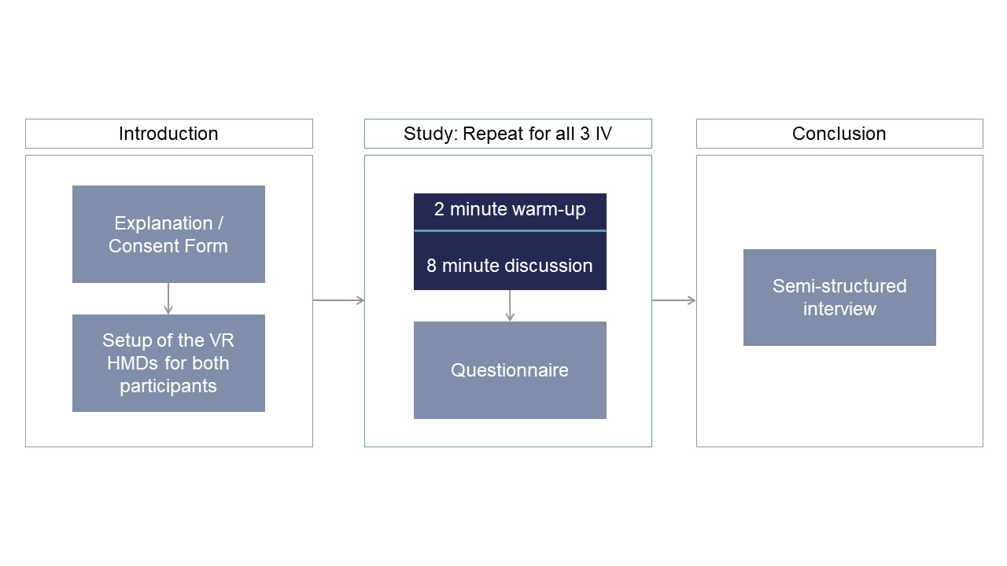

Figure 1: Procedure of the study

1. Feedback

One group mentioned the problem, that if the participants would face each other the Leap Motions might track the other ones hands as well. We will have to test this, and if occurring either have something on the table in between the participants, or let the participants not sit across each other.

More feedback was regarding our missing ceiling, which could negatively influence immersion. We will probably fix that, by adding a ceiling with a window, as we still want to have as much light in the room as possible, which is not nicely achievable with lamps.

1. Current Unity technicals and problems

This application is built for the usage of two players, for this you need two PC’s with our application opened in unity. The network connection is established over PUN. If you need to put in the PUN app id: 65814cf3-4a74-4740-b817-16ac9efe2867.

Each PC also needs to have a HTC Vive and Leap Motion connected. You need to connect to the Photon Server, by clicking on the button “Join”. If the “Offline” button is not replaced by the “Join” button, something went wrong, while trying to establish a connection to the photon servers (make sure you are using TCP). As soon as you are connected to the server, you can see your hands in front of you, when they are tracked with the leapmotion. The Avatars hands positions are getting mapped from the leap motion controller hands. This way, we can transfer the positions to the other computer. If you spawn in the floor, you can move the camera up with the “up arrow” key. If two players are connected you should be able to see the other players hands.

Our largest problem until now was transferring the positional data from the hands over the network. Currently every bones position and rotation is getting transferred to the other PC. This can lead to some kind of lag, where the hands from the other player look very weird. We need to solve this: Either by switching to UDP by connecting to an other network than eduroam, or by optimizing the data transferring / transferring less data.

We also still have to set up spawn points, build a scene switcher, build a data saving class for the positions of the hands and record an animation for the fake hand condition.

This will probably take around two weeks. Afterwards we can start with our study.

GitHub: <https://github.com/J0ekr/VR-Project-MeetingStudy>

1. <https://assetstore.unity.com/packages/tools/network/pun-2-free-119922>
2. <https://dl.acm.org/citation.cfm?id=323691>
3. <https://nil.cs.uno.edu/publications/papers/witmer1998measuring.pdf>