Johanne Vigny, Juin 2025

SystemView

Installation
In the source code of your project, add the source code from System View, Target Sources, don’t get the source code from Github, it’s not up to date.
Install System View logiciel.
Follow the Guide for system view without an Os.
The official Documentation provides more information.
In SEGGER_SYSVIEW_Config_NoOS_CM0.c register the application name, the device name, CPU frequency, and the timestamp frequency.
By default, the timestamp uses the SysTick, you should enable it in your code source.
Use SEGGER_SYSVIEW_Start() after SEGGER_SYSVIEW_Conf() to start recording events directly from the start of the program, otherwise it will start recording when you press the "Start Recording" button in SystemView.
If SystemView doesn’t work, first try Segger RTT to see if it works. It may not work if there is not enough space in the RAM for the RTT buffer. To fix this, reduce the BUFFER_SIZE_UP until it works.

Custom Os
To create a new Os description file, create a file in the /description/ directory of SystemView. The name of the file should have the format SYSVIEW_<OsName>.txt.
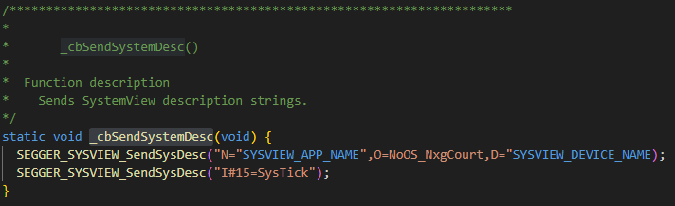
The file SYSVIEW_<OsName>.txt should have the format:
<EventID> <FunctionName> <ParameterDescription> | <ReturnValueDescription>
Example :
60 k_msgq_put msgq=%I, data=%p, Timeout=%TimeOut | Returns %ErrCodeMsg
61 k_msgq_get msgq=%I, data=%p, Timeout=%TimeOut | Returns %ErrCodeMsg
Where separators are spaces and not tabulations. The Parameter description and return description can take some arguments to print in the System View Window. The return value is optional.
EventId before 32 are reserved by systemView. The event can be in the range from 32 to 511.
In the code source, use the function SEGGER_SYSVIEW_RecordXX() to trace the events. XX specifies the number of arguments to send and their types, as well as the end call or isr.
When having an event with return description, you should first call the function SEGGER_SYSVIEW_RecordXX() at the beginning, then call SEGGER_SYSVIEW_RecordEndCallXX() at the end of the function to trace.
All the functions to record are in the file .\SystemView\SYSVIEW\SEGGER_SYSVIEW.h

Terminal
System View has its own terminal using rtt. The messages printed can be a normal print or a warning, or an error message.
You can use the following functions in your code to print in the terminal.
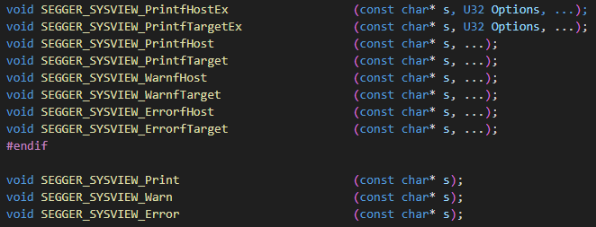

Tasks
It’s possible to create multiple tasks, using the following functions:
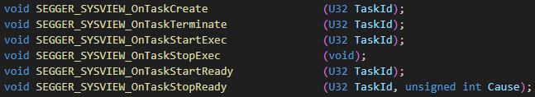
By default, the main task is the idle task in a no Os program. To inform System view that a task starts running, use SEGGER_SYSVIEW_OnTaskStartExec(ID) with the ID of the task, or SEGGER_SYSVIEW_OnIdle() to inform the program that it is in sleep mode.

To create a new task with a name, in the function _cbSendSystemDesc() do the following:
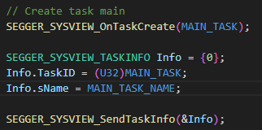
MAIN_TASK in an integer
MAIN_TASK_NAME is a string

This will send the information to System View when pressing the record button.
You can also after that specify the task that is running.
In the file SEGGER_SYSVIEW_Conf.h, you can define the macro MAIN_TASK and MAIN_TASK_NAME.

Timestamp
By default, in no Os systemview, systemView uses the SysTick to get a timestamp. However, in standby (deepsleep) for the samd21, the SysTick stops, and the timestamps are wrong. You can customize the function SEGGER_SYSVIEW_X_GetTimestamp() to use the desired source clock for timestamps.
For the samd21 I used the tc4 with 32bits (using tc4 and tc5), with xosc32k 32kHz as source clock. Every 10 seconds, an interrupt will increment a TickCounter.

Data Plot
To track value in a graph it’s possible to use data plot functionality. In the function _cbSendSystemDesc() register the value you want to watch
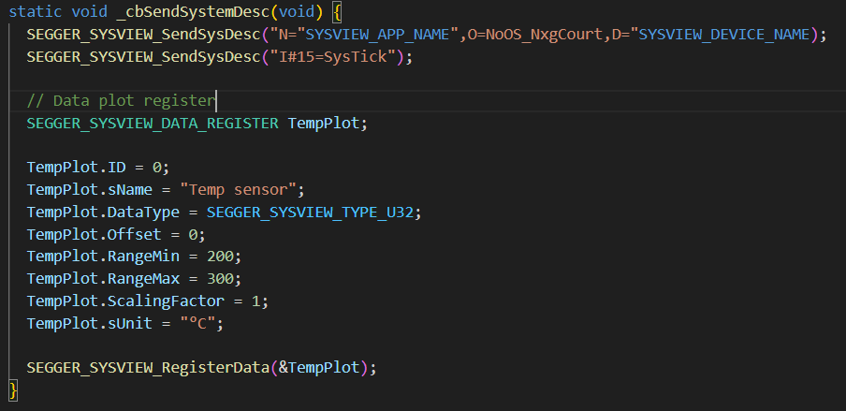
Then you can record the data with the following function:
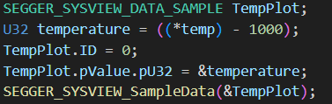
Where 0 is the ID of the event register just before.
You can watch multiple value on the same graph.

