Module Code & Module Title
CS4051NI\CC4059NI Fundamental of Computing

70% Individual Coursework
Submission: Final Submission

Academic Semester: Spring Semester 2026

Credit: 15 credit semester long module

Google Link:

Assignment Due Date: Friday, May 8, 2026
Assignment Submission Date: Friday, May 8, 2026
I confirm that I understand my coursework needs to be submitted online via MST Classroom under the relevant module page before the deadline for my assignment to be accepted and marked. I am fully aware that late submissions will be treated as non-submission and a mark of zero will be awarded
Contents
1. Introduction 5
1.1 Aim and Objectives 6
1.2 Technologies Used 6
1.3 Discussion and analysis 7
2. Algorithm 8
3. Flowchart 11
4. Pseudocode 12
5. Data Structure 21
1.1 Data Types that were used 21
6. Program implementation 23
1. main.py 23
2. sales.py 23
3. restock.py 24
5. invoice.py 26
6. add.py 26
7. Testing 28
7.1 Test 1: Compile and run the program 28
7.2 Choosing between the various options 29
7.2.1 Choosing display medicines 29
7.2.2 Choosing sell medicines 30
7.2.3 Choosing restock medicines 31
7.2.4 Choosing Add New medicine 32
7.2.5 Choosing exit 33
7.3 Testing if Sell Medicines works 34
7.3.1 Testing if entering customer name works 34
7.3.2 Testing if entering customer name works 35
7.3.3 Testing if entering unit works 36
7.3.3.1 Testing if entering tablet works 36
7.3.3.2 Testing if entering strip works 37
37
7.3.4 Testing if entering Quantity works 38
38
7.3.5 Testing if Loop works 39
7.3.5.1 Testing if loops breaks after pressing 0 39
7.3.5.2 Testing if loop works after pressing another medicine number 40
7.4 Testing if Restock Medicines works 41
7.4.1 Testing if entering supplier name works 41
7.4.2 Testing if entering medicine number to restock works 42
7.4.2 Testing if entering unit works 43
7.4.2.1 Testing if entering strip works 43
7.4.2.2 Testing if entering tablet works 44
7.4.3 Testing if entering quantity works 45
7.5 Testing if loop works 46
7.5.1 Testing if loop stops when 0 is pressed 46
7.5.2 Testing if loop works 47
7.6 Testing if Add new medicine works 48
7.6.1 Testing if Enter medicine name works 48
7.6.2 Testing if brand name works 49
7.6.3 Testing if initial quantity works 50
7.6.4 Testing if entering rate per tablet works 51
7.6.5 Testing if entering rate per strip works 52
7.6.6 Testing tablets per strip 53
7.7 Testing if the file handling works 54
7.7.1 Testing if invoice is created when customer purchases 54
7.7.2 Testing if invoice is created when restock happens 55
55
7.7.3 Testing if inventory is updated when customer purchases or medicine is restocked or new medicine is added 56
8. Conclusion 57
6. Appendix 58
6.1 Inventory.txt 58
7. Refernces 74

Figure 1: Flowchart of the entire program 11
Figure 2: example of integer 21
Figure 3: example of string 22
Figure 4: example of list 22
Figure 5: example of dictionary 22
Figure 6: Main Menu from main.py 23
Figure 7: Sales Menu 23
Figure 8: Sales Invoince Generated 24
Figure 9: Restock Menu 24
Figure 10: Restock Invoice 24
Figure 11: Display Menu 25
Figure 12: Inventory.txt 25
Figure 13: Sales Invoice 26
Figure 14: Restock Invoice 26
Figure 15: Inventory.txt before new medicine was added 26
Figure 16: Inventory.txt after new medicine was added 27
Figure 17: Before Running the program 28
Figure 18: After Running the program 28
Figure 19: Selecting the Display option 29
Figure 20: Selecting the Sell option 30
Figure 21: Displaying the Restock menu 31
Figure 22: Displaying the add menu 32
Figure 23: Displaying the exit menu 33
Figure 24: Entering Customer name 34
Figure 25: Entering medicine number 35
Figure 26: Testing if tablets work 36
Figure 27: Testing if strips work 37
Figure 28: Testing if quantity works 38
Figure 29:Testing if loop stops for sales 39
Figure 30: Testing if loop works for sales 40
Figure 31: Testing if entering supplier name works 41
Figure 32: Testing if medicine number works 42
Figure 33: Testing if strips works 43
Figure 34: testing if tablet works 44
Figure 35: Testing if quantity works 45
Figure 36: Testing if loop stops for restock 46
Figure 37: Testing if loop continues for restock 47
Figure 38: Testing if entering new medicine works 48
Figure 39: Testing if brand name works 49
Figure 40: Testing if initial quantity works 50
Figure 41: Testing if entering rate per tablet works 51
Figure 42: Displaying rate per strip 52
Figure 43: Displaying tablets per strips 53
Figure 44: Text file of one of the customer invoice 54
Figure 45: Text file of one of the rerstocks 55
Figure 46: After new medicine was added 56
Figure 47: Before new medicine was added 56

No table of figures entries found.

Introduction
MedStore Management System is a python based application that is developed to help pharmacies to manage their inventory and daily transactions efficiently. A business that is responsible for selling medicines should have a proper management system to make sure that all medicines are accounted for and properly sold to the market. This system automates the management process and reduces the difficulties associated with manual record keeping.
The program reads medicine information from a text file that contains details such as medicine name, brand, available quantity and price. Using the proper data structures in Python, the information is stored, processed and displayed in an organized format. This system allows the seller to view medicine details, sell medicine while creating an invoice, restock medicine and add new medicines to the inventory.
One of the important features of this system is how it handles transaction dynamically. Upon selling a medicine, the program computes the the total cost according to the selected unit type and applies any discount to the sale price. For example the program gives a 5% discount on purchase in strips. Similar logic is applied for restocking of medicines and adding of new medicines an update is done accordingly to keep the inventory up to date
Concepts of programming includes file management, data structure and modular programming have been used in this project. The program consists of different modules with each having their own particular task to improve the efficiency of code and making the code easier to read and maintain.
To summarize the MedStore management system is created to be an effective way to manage medicines inventory, transactions and at the same time demonstrate basic programming knowledge and skills

1.1 Aim and Objectives

The primary aim of this assignment is to develop an efficient and effective system to manage an inventory and transactions within a wholesale setting.
The major objectives of the project
- To create and manage text file using python
- To understand how python interacts with external data
- To display external data in the python shell
- To be able to modify the external data in the python shell
- Generate invoices for both selling and restocking process
- Developing a modular program by implementing different parts of the system into different function and files
- Making sure that the inventory is updated after each transaction and restock
- Displaying the contents of the inventory.txt file in a official manner
- Implement a sales system that will calculate the total cost and discounts when required

1.2 Technologies Used
The technologies used for the development for this course work are
- Python- Python is a high-level language that is in data science, automation, AI, web development and various other sectors. Python is known for its readability which makes it easier to write, understand and maintain the code. Its also backed by strong library support which means we don’t have to build everything from scratch.
- IDLE – Python IDLE is the default integrated development environment (IDE) that comes packaged with every python installation. It is intended IDE for beginners to start out with as it has basic editing, execution and debugging.
- Microsoft Word – Microsoft word is a text editor that is owned by Microsoft which has built in auto correct for spelling and grammatical errors. It also has various features like the ability to inset table of contents, page numbers, images, etc that comes bundle with every laptop with Windows. It also has integrated AI features (which weren’t used for the completion of this report) that can be useful to complete certain sentences.
- Notepad- It is the simplest text editor which was developed by Microsoft that comes with nearly every windows system. It is a low memory consuming, simple design text editor that is useful for saving data in for various projects compared to text editors like Microsoft word or Libre word.

1.3 Discussion and analysis

This program was created following the modular approach, that is, the system is separated into modules like main.py, add.py, inventory.py, sales.py and other modules for a effective and readable program.
Development of the program initially started with the use of the function read_medicine_file which reads the data about medicine from a pre existing file. The data is stored in a list of dictionaries representing each medicine in terms of name, brand, prices and quantity for easier data modification and storage

A display function is created to present the data about the existing medicines to be sold. A counter is included to number the items for better presentation of the information
The selling, restocking and adding new products were implemented in their respective programs. Selling involved getting user input, calculating price for the required unit type and reducing the stock afters sales. In addition, a condition was added to give a 5% discount for purchases that had more than one strip.
The process of invoice generation is done separately by creating a new text file for every transaction that is done. The initial text file has a unique name while inside has details about the transaction that ranges from the date to the medicine purchased. The inventory file gets updated after every transaction to help maintain consistency.
Exception handling was implemented in case when a user may input wrong information or data which could have caused a crash in other scenario. Overall, the software was designed gradually following the initial algorithm and flowchart after which it was made using a modular approach and adopting the right data structures.

Algorithm
Step 1: Start the program
Step 2: Load medicine inventory data from file into memory
Step 3: Display all available medicines
Step 4: Display menu options:
1. Sell Medicine
2. Restock Medicine
3. Display Inventory
4. Exit
Step 5: Ask user to enter choice (1–4)
Step 6: If choice = 1 (Sell Medicine), then:
Step 6.1: Input customer name
Step 6.2: Input number of different medicines to purchase
Step 6.3: Set total_amount = 0
Step 6.4: Repeat for each medicine:
Step 6.4.1: Input medicine name
Step 6.4.2: Input unit type (tablet/strip)
Step 6.4.3: Input quantity
Step 6.4.4: Search medicine in inventory
Step 6.4.5: If medicine not found → show error → repeat Step 6.4
Step 6.4.6: If stock insufficient → show error → repeat Step 6.4
Step 6.4.7: Calculate cost:
• If tablet → cost = quantity × rate_per_tablet
• If strip → cost = quantity × rate_per_strip
Step 6.4.8: If strip quantity ≥ 2:
• discount = 5% of cost
• cost = cost − discount
Step 6.4.9: Convert strips to tablets:
• tablets = quantity × tablets_per_strip
Step 6.4.10: Update stock:
• stock = stock − tablets
Step 6.4.11: Add cost to total_amount
Step 6.4.12: Store item details for invoice
Step 6.5: Generate invoice file including:
• Customer name
• Date
• Medicine details
• Discount
• Total amount
Step 6.6: Save updated inventory to file
Step 6.7: Return to main menu
Step 7: If choice = 2 (Restock Medicine), then:
Step 7.1: Input supplier name
Step 7.2: Input number of medicines to restock
Step 7.3: Set total_restock_cost = 0
Step 7.4: Repeat for each medicine:
Step 7.4.1: Input medicine name
Step 7.4.2: Input quantity (tablet/strip)
Step 7.4.3: Input rate
Step 7.4.4: Search medicine in inventory
Step 7.4.5: If medicine exists:
• Add quantity to stock
Step 7.4.6: Else:
• Create new medicine entry
Step 7.4.7: Calculate cost:
• cost = quantity × rate
Step 7.4.8: Add cost to total_restock_cost
Step 7.5: Generate restock invoice including:
• Supplier name
• Date
• Items
• Total cost
Step 7.6: Save updated inventory to file
Step 7.7: Return to main menu
Step 8: If choice = 3 (Display Inventory), then:
Step 8.1: Open inventory file
Step 8.2: Read all medicine data
Step 8.3: For each medicine:
• Display name
• Display brand
• Display stock
• Display rates
Step 8.4: Return to main menu
Step 9: If choice = 4 (Exit), then:
Step 9.1: Display exit message
Step 9.2: End program
Step 10: If invalid input:
Step 10.1: Display "Invalid choice"
Step 10.2: Return to main menu

Step 11: Repeat Steps 4–10 until user selects Exit
Step 12: Stop program

3. Flowchart
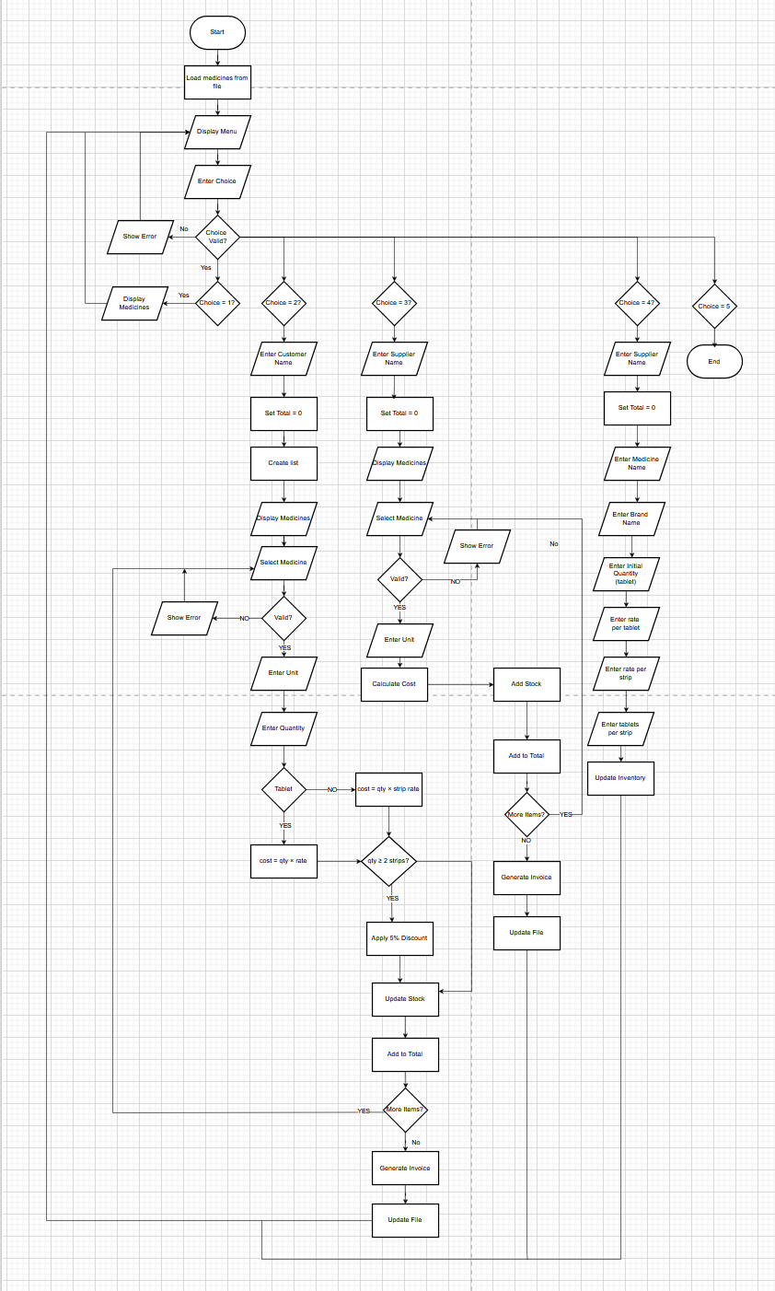
Figure 1: Flowchart of the entire program

4. Pseudocode
main.py
START

LOAD inventory from file

LOOP forever:
DISPLAY menu:
1. Display Medicines
2. Sell Medicines
3. Restock Medicines
4. Add New Medicine
5. Exit

GET user choice

IF choice == 1:
CALL display_inventory

ELSE IF choice == 2:
CALL sell_medicine

ELSE IF choice == 3:
CALL restock_medicine

ELSE IF choice == 4:
CALL add_medicine

ELSE IF choice == 5:
EXIT loop

ELSE:
PRINT "Invalid choice"

END LOOP

END
inventory.py
FUNCTION load_inventory:
CREATE empty inventory list

TRY:
OPEN inventory file
FOR each line in file:
SPLIT line into fields:
name, brand, qty, rate_tab, rate_strip, tabs_per_strip

CREATE dictionary item
ADD item to inventory list

IF file not found:
PRINT "Starting empty"
sales
RETURN inventory
FUNCTION save_inventory(inventory):
OPEN file in write mode

FOR each item in inventory:
WRITE item details in file

END FUNCTION
display
FUNCTION display_inventory(inventory):
PRINT "Available Medicines"

FOR each item with index:
PRINT index + name + brand + stock

END FUNCTION
add.py
FUNCTION add_medicine(inventory):

INPUT name
INPUT brand

FOR each item in inventory:
IF same name AND same brand:
PRINT "Already exists"
RETURN

INPUT qty, rate_tab, rate_strip, tabs_per_strip

IF invalid input:
PRINT error
RETURN

IF any value negative:
PRINT error
RETURN

CREATE new medicine dictionary

ADD to inventory

SAVE inventory

PRINT "Medicine added successfully"

END FUNCTION
sales.py
FUNCTION sell_medicine(inventory):

DISPLAY inventory

INPUT customer name

CREATE empty cart
SET total = 0

LOOP:
INPUT medicine choice

IF choice == 0:
BREAK

IF invalid choice:
PRINT error
CONTINUE

SELECT item

INPUT unit (tablet/strip)
INPUT quantity

IF tablet:
IF not enough stock:
PRINT error
CONTINUE

cost = qty * rate_tab
discount = 0
REDUCE stock

ELSE IF strip:
CALCULATE tablets needed

IF not enough stock:
PRINT error
CONTINUE

cost = qty * rate_strip
discount = 5% IF qty >= 2
REDUCE stock

ELSE:
PRINT error
CONTINUE

ADD to cart
ADD cost to total

GENERATE sales invoice
SAVE inventory

END FUNCTION
restock.py
FUNCTION restock_medicine(inventory):

DISPLAY inventory

INPUT supplier name

CREATE empty cart
SET total = 0

LOOP:
INPUT medicine choice

IF choice == 0:
BREAK

IF invalid:
PRINT error
CONTINUE

SELECT item

INPUT unit
INPUT quantity

IF tablet:
tablets_added = qty
cost = qty * rate_tab

ELSE IF strip:
tablets_added = qty * tabs_per_strip
cost = qty * rate_strip

ELSE:
PRINT error
CONTINUE

INCREASE stock
ADD to cart
ADD cost to total

GENERATE restock invoice
SAVE inventory

END FUNCTION
invoice.py
nvoice Counter
FUNCTION get_next_invoice_number:

TRY read number from file
IF not found:
number = 1

WRITE number + 1 back to file

RETURN number
Generate Filename
FUNCTION generate_filename(prefix):
number = get_next_invoice_number
RETURN prefix + formatted number
Sales Invoice
FUNCTION generate_sales_invoice(customer, cart, total):

CREATE filename

WRITE:
title
customer name
date

FOR each item in cart:
WRITE item details

WRITE total
END FUNCTION
Restock Invoice
FUNCTION generate_restock_invoice(supplier, cart, total):

CREATE filename

WRITE:
title
supplier name
date

FOR each item:
WRITE details

WRITE total

END FUNCTION

5. Data Structure
Data structure is a way of formatting data in a format to access it later in a more efficient manner. They are the fundamentals in all programming languages. But python helps to understand the basics of this structure more easily compared to other languages.
They are divided into two categories:
- Primitive data types: They are the basic building blocks of python. Primitive data types store single values that are immutable. These can be further broken down into:
  - Integer: These store values of whole numbers.
  - Float: These store values of number that end in decimal.
  - Boolean: These store values that are either True or False.
  - String: These store characters as words.
- Non-Primitive Data Types: They store values that are more complex than those of primitive data types and are generally mutable in nature. They too can be further broken down to:
  - List: These store values as an ordered collection of data.
  - Tuple: They are like lists where they too can store multiple values in an orderly fashion but unlike lists, they are immutable.
  - Dictionary: They store values in pairs of keys and values.
  - Set: These store values that are unique and are unordered.

Data Types that were used
- Primitive Data Types
- Integer- It was used to store numbers like quantity and price
For example:
Figure 2: example of integer
- String- It was used to medicine names and brand
For example:
Figure 3: example of string
Non Primitive Data Types
- Lists- It was used to store multiple types of medicines and because it was ordered and changeable
For example:
Figure 4: example of list
- Dictionary- Its used to data in key value pairs( i.e primary keys) and was used to represent a single medicine
Forexample: 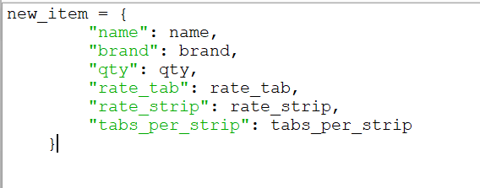
Figure 5: example of dictionary

6. Program implementation

1. main.py
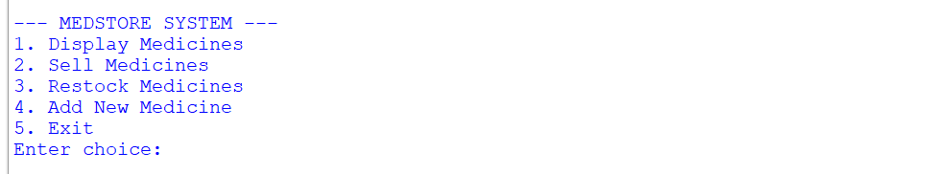
The main.py file is the main control module of the program. It displays the menu options and allows the user to choose different operations such as displaying medicines, medicines, restocking medicines, adding new medicines and exiting the program.
Figure 6: Main Menu from main.py

2. sales.py
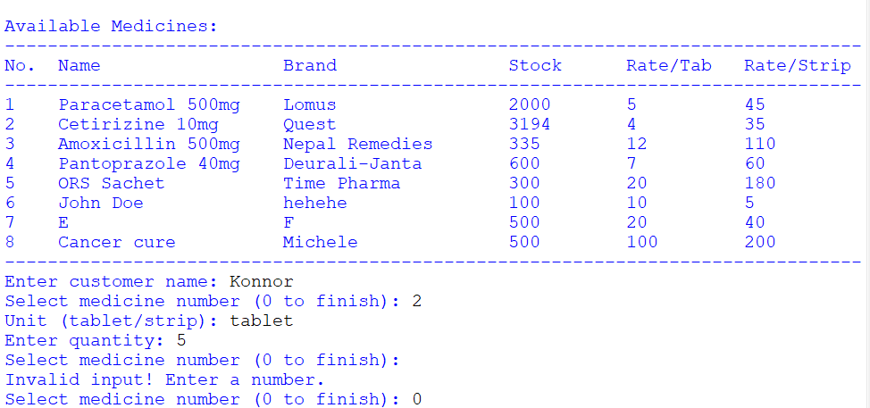
The sell.py script manages the sale of medicines. Customer information, selection of medicines, units and quantities are used as input by this module. The sales.py module computes the total costs, applies discounts, reduces stocks and produces an invoice
Figure 7: Sales Menu
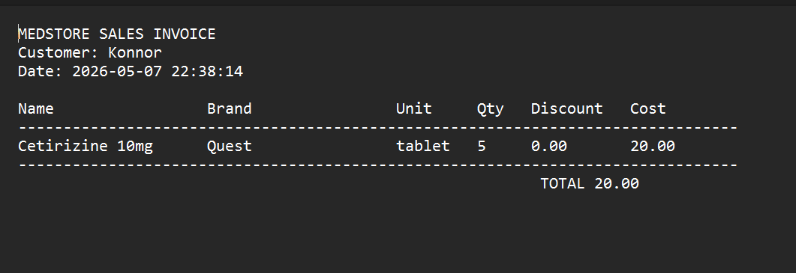
Figure 8: Sales Invoince Generated

3. restock.py
The restock.py file manages the restocking process. It allows the user to add new stock from suppliers by entering medicine details and quantity. The updated stock is then saved back to the inventory file.
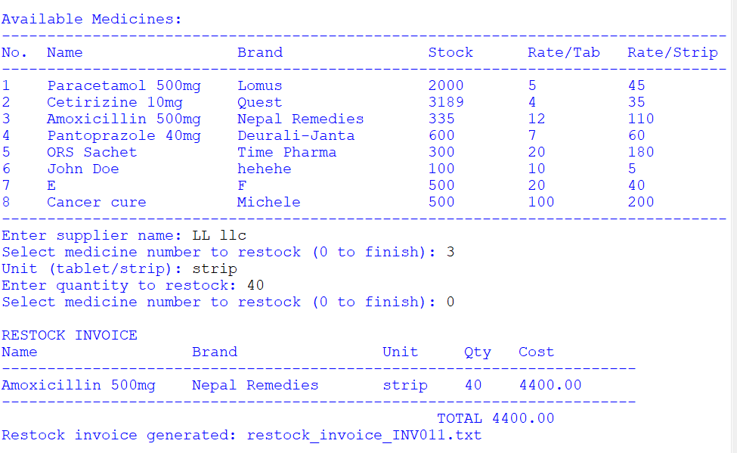
Figure 9: Restock Menu
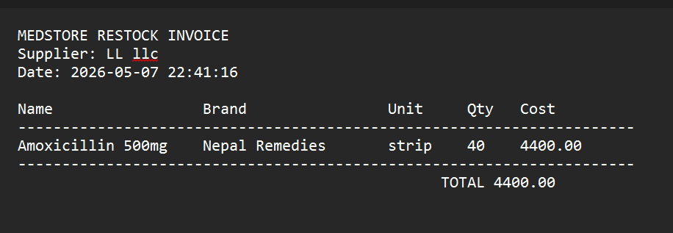
Figure 10: Restock Invoice
4. inventory.py
This module is responsible for both reading of the inventory.txt file along with updating that file. This ensures that the inventory always contains the latest stock information. 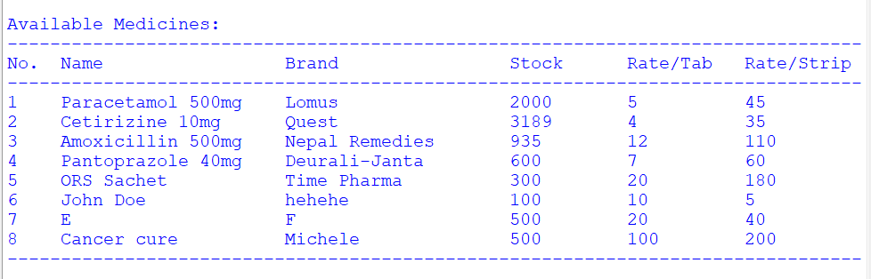
Figure 11: Display Menu
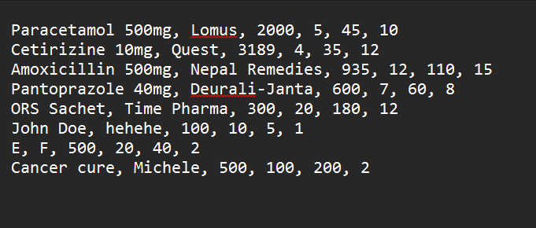
Figure 12: Inventory.txt

5. invoice.py
The invoice.py file is responsible for generating invoice files for both sales and restocking transactions. Each invoice is stored as a separate text file with a unique name 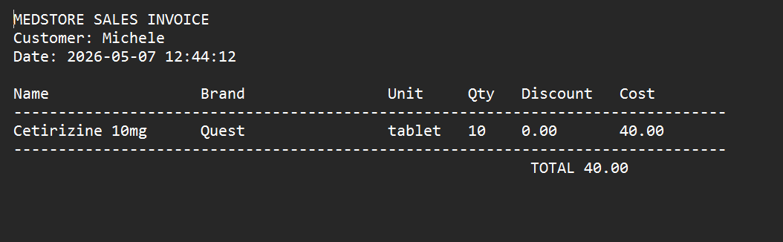
Figure 13: Sales Invoice
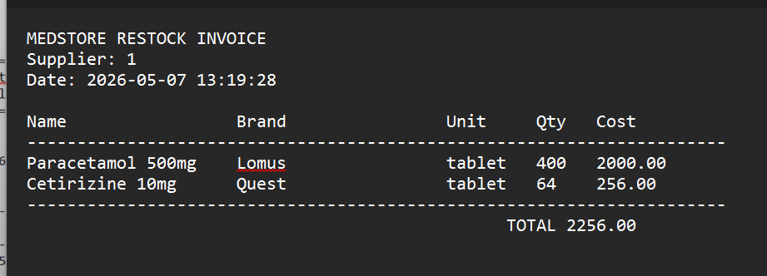
Figure 14: Restock Invoice

6. add.py
The add.py file is responsible for letting the user add a new medicine to the inventory.txt file.
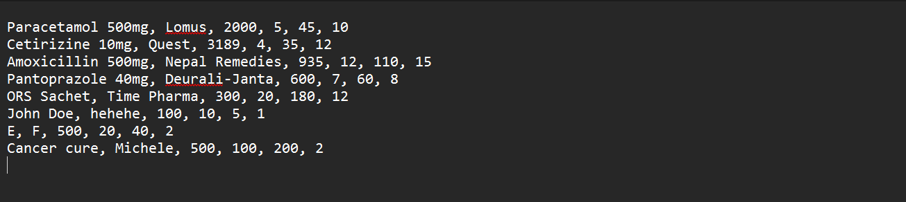
Figure 15: Inventory.txt before new medicine was added
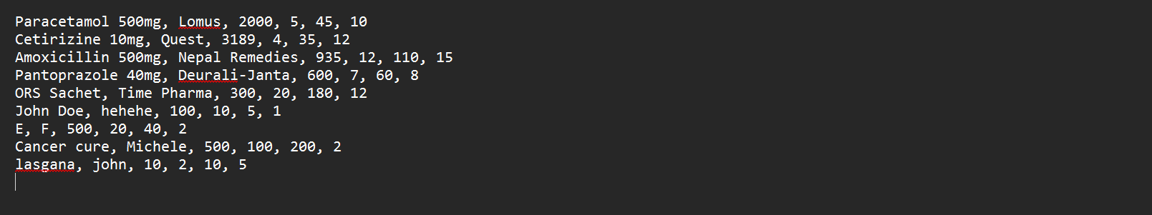
Figure 16: Inventory.txt after new medicine was added

7. Testing

7.1 Test 1: Compile and run the program
Test Case | 1
Objective | To compile and run the project
Action | - Open IDLE  - Compile Main  - Run the project
Expected Outcome | The program runs
Actual Outcome | The program runs
Test Statues | The test was successful

Table 1: compile and test run
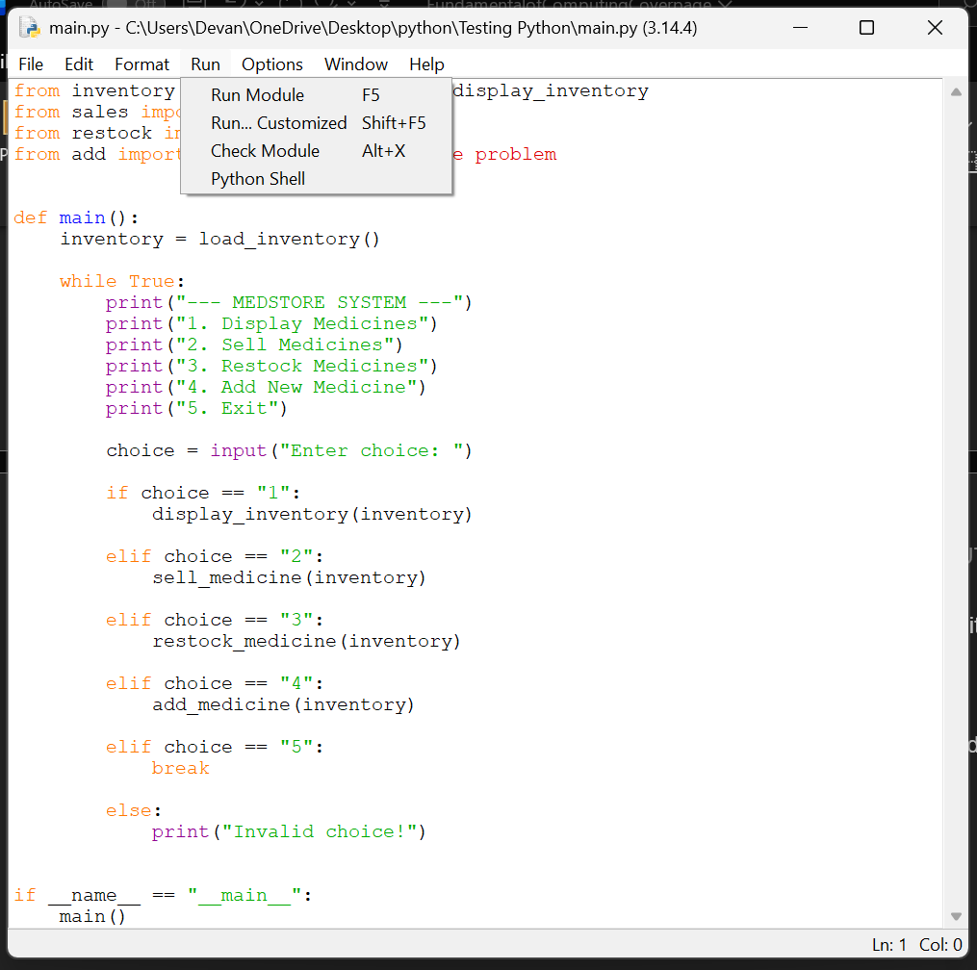
Figure 17: Before Running the program
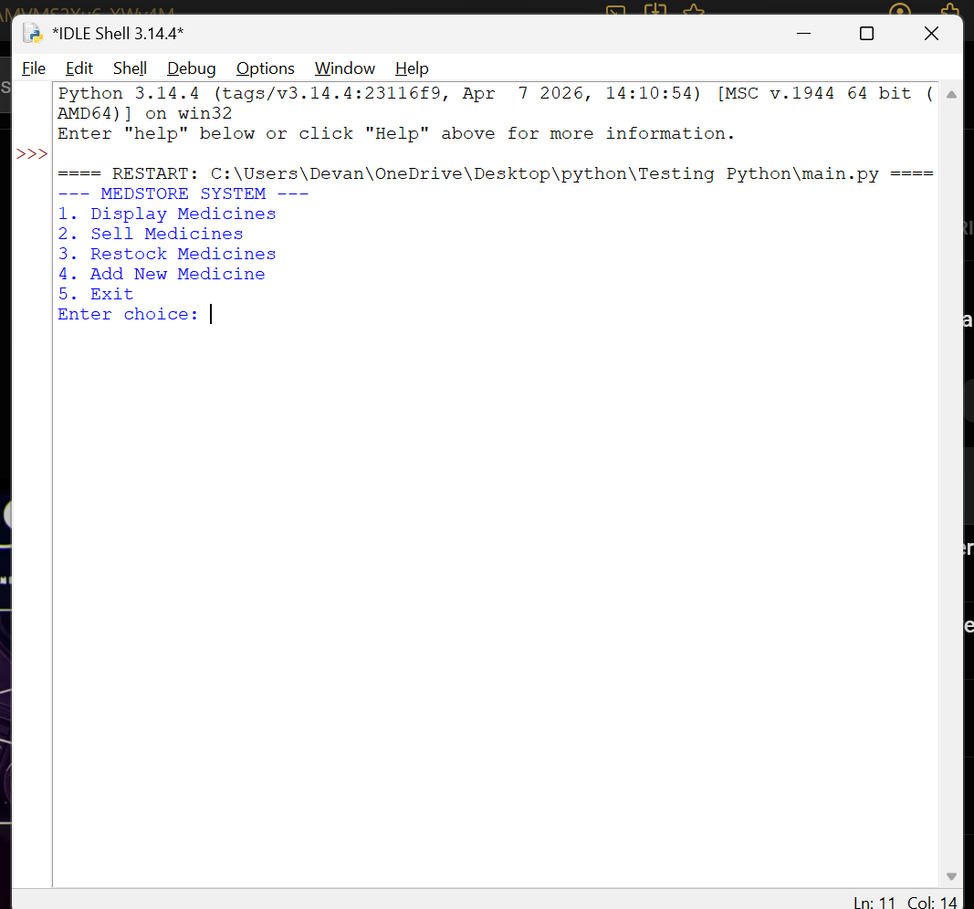
Figure 18: After Running the program

7.2 Choosing between the various options

7.2.1 Choosing display medicines
Test Case | 2
Objective | To choose Display Medicines
Action | - Run Main.py  - Write 1  - Press Enter
Expected outcome | It displays the data
Actual Outcome | It displayed the data
Test Status | The test was succesful
Table 2: choosign display medicine
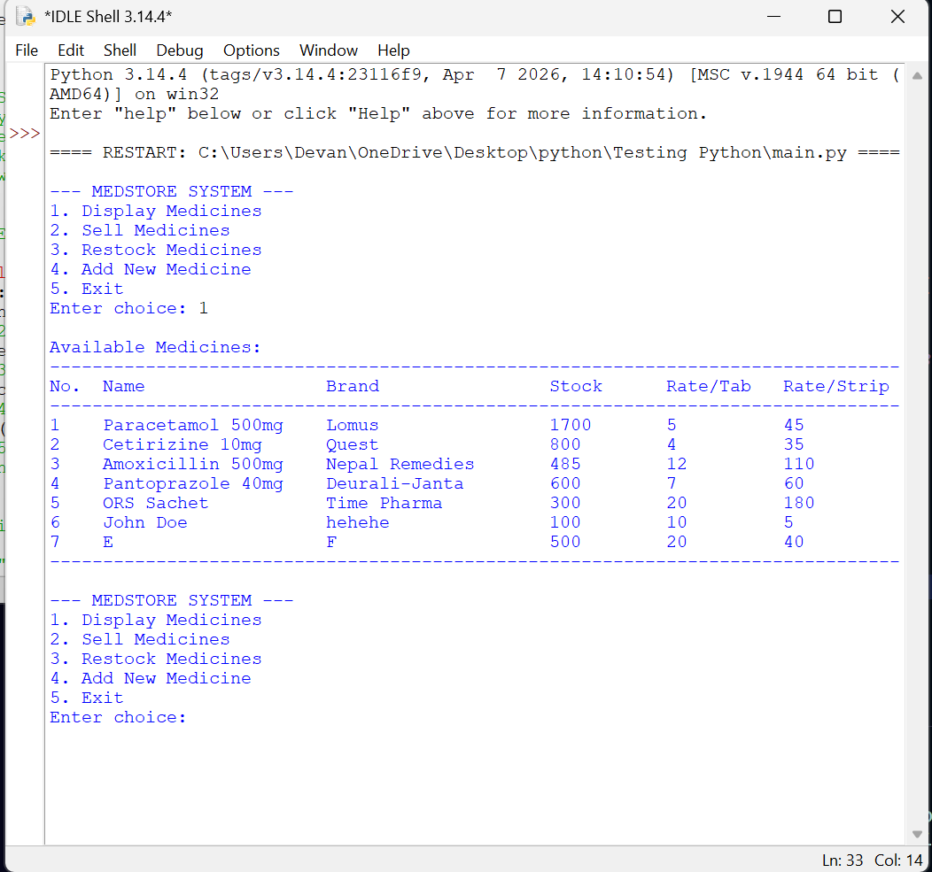
Figure 19: Selecting the Display option

7.2.2 Choosing sell medicines
Test Case | 2
Objective | To choose Sell Medicines
Action | - Run Main.py  - Write 2  - Press Enter
Expected outcome | It displays Enter customer name
Actual Outcome | It displayed Enter customer name
Test Status | The test was successful

Figure 20: Selecting the Sell option

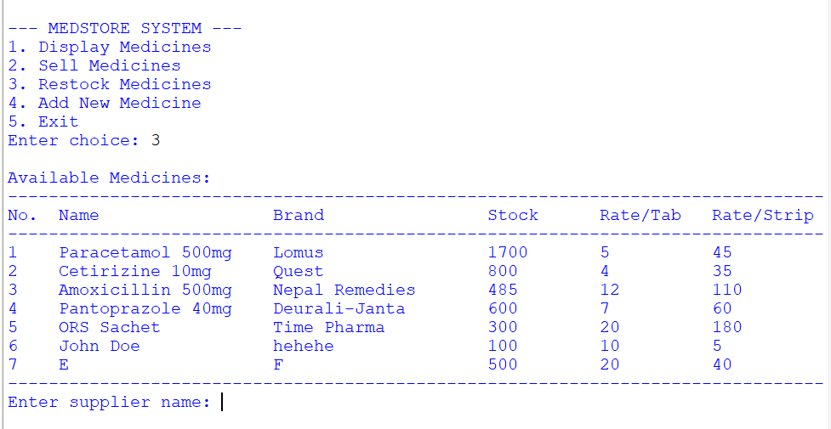
7.2.3 Choosing restock medicines
Figure 21: Displaying the Restock menu
Test Case | 3
Objective | To choose Restock Medicines
Action | - Run Main.py  - Write 3  - Press Enter
Expected outcome | It displays the Enter supplier name
Actual Outcome | It displayed the Enter supplier name
Test Status | The test was successful

7.2.4 Choosing Add New medicine
Table 3: Choosing add new medicine
Test Case | 4
Objective | To choose Add New Medicine
Action | - Run Main.py  - Write 4  - Press Enter
Expected outcome | It displays the Enter medicine name
Actual Outcome | It displayed the Enter medicine name
Test Status | The test was successful

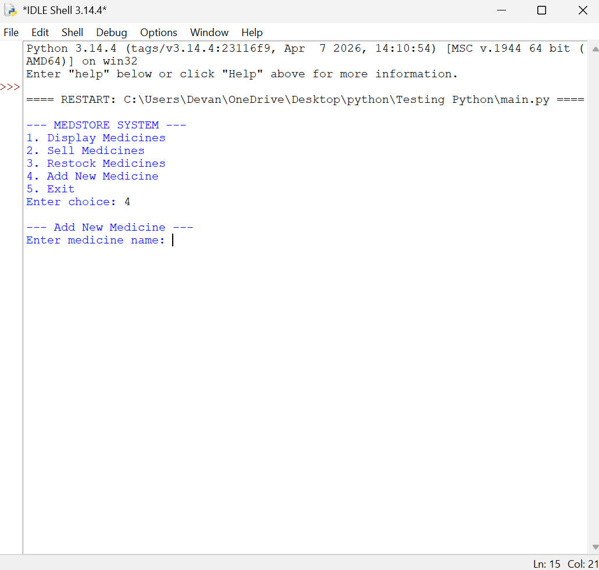
Figure 22: Displaying the add menu

7.2.5 Choosing exit
Table 4: Choosing exit
Test Case | 5
Objective | To choose Add New Medicine
Action | - Run Main.py  - Write 5  - Press Enter
Expected outcome | It displays Exiting
Actual Outcome | It displayed the Exiting
Test Status | The test was successful

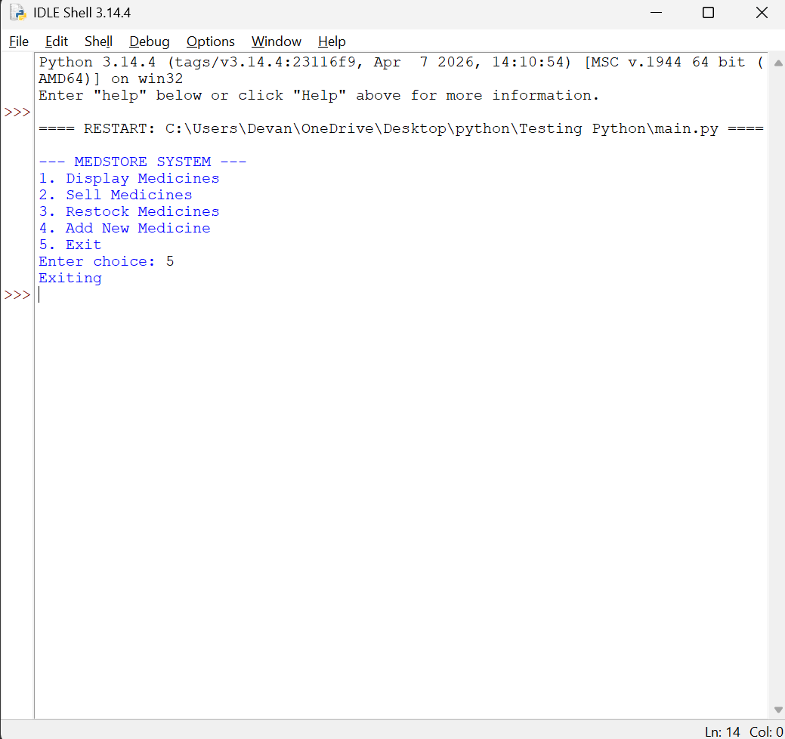
Figure 23: Displaying the exit menu

7.3 Testing if Sell Medicines works

7.3.1 Testing if entering customer name works
Table 5: Entering customer name
Test Case | 6
Objective | To choose enter customer name
Action | - Run Main.py  - Write 2  - Press Enter  - Enter customer name  - Enter
Expected outcome | It displays Select Medicine number
Actual Outcome | It displayed Select Medicine number
Test Status | The test was successful
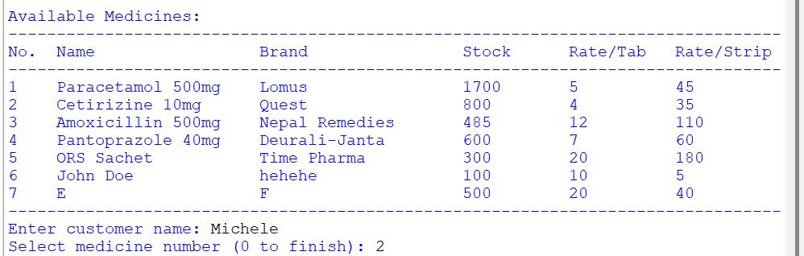
Figure 24: Entering Customer name

Test Case | 7
Objective | To choose enter medicine number
Action | - Run Main.py  - Write 2  - Press Enter  - Enter customer name  - Enter  - Enter medicine number  - Enter
Expected outcome | It displays Unit(tablet/strip)
Actual Outcome | It displayed Unit (tablet/strip)
Test Status | The test was successful

7.3.2 Testing if entering medicine works
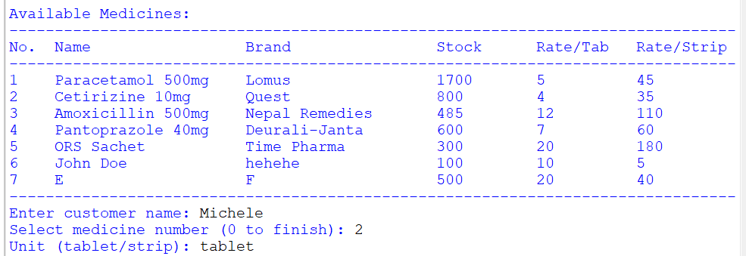
Figure 25: Entering medicine number

7.3.3 Testing if entering unit works

7.3.3.1 Testing if entering tablet works
Test Case | 8
Objective | To choose enter unit
Action | - Run Main.py  - Write 2  - Press Enter  - Enter customer name  - Enter  - Enter medicine number  - Enter  - Enter unit (tablet)
Expected outcome | It displays Quantity
Actual Outcome | It displayed Quantity
Test Status | The test was successful

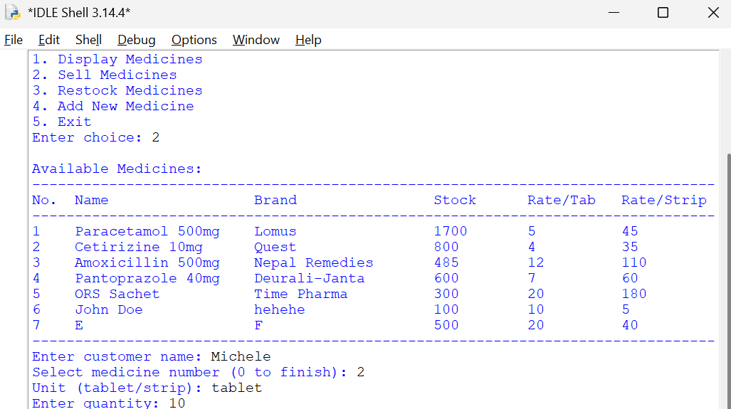
Figure 26: Testing if tablets work

7.3.3.2 Testing if entering strip works
Test Case | 9
Objective | To choose enter unit
Action | - Run Main.py  - Write 2  - Press Enter  - Enter customer name  - Enter  - Enter medicine number  - Enter  - Enter unit (strip)
Expected outcome | It displays Quantity
Actual Outcome | It displayed Quantity
Test Status | The test was successful
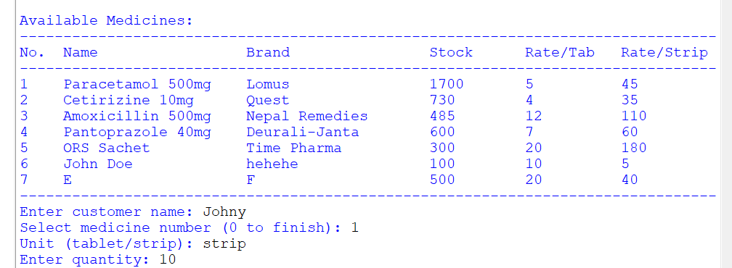
Figure 27: Testing if strips work

7.3.4 Testing if entering Quantity works
Test Case | 10
Objective | To choose enter quantity
Action | - Run Main.py  - Write 2  - Press Enter  - Enter customer name  - Enter  - Enter medicine number  - Enter  - Enter unit  - Enter  - Enter Quantity  - Enter
Expected outcome | It displays Select Medicine Number
Actual Outcome | It displayed Select Medicine Number
Test Status | The test was successful
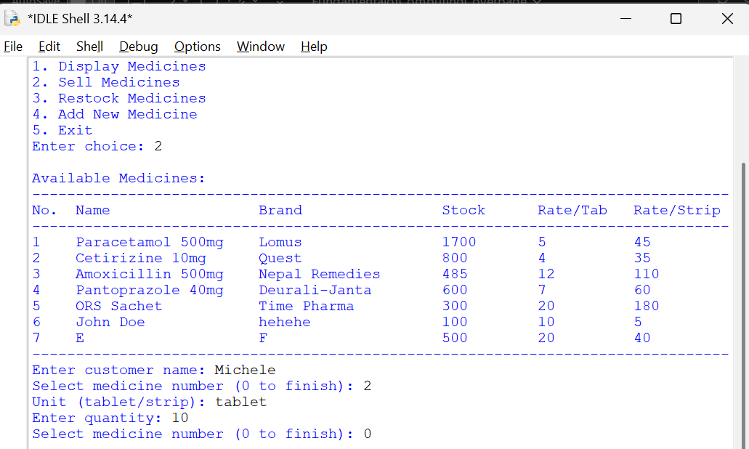
Figure 28: Testing if quantity works

7.3.5 Testing if Loop works

7.3.5.1 Testing if loops breaks after pressing 0
Test Case | 11
Objective | To choose enter quantity
Action | - Run Main.py  - Write 2  - Press Enter  - Enter customer name  - Enter  - Enter medicine number  - Enter  - Enter unit  - Enter  - Enter Quantity  - Enter  - Enter 0  - Enter
Expected outcome | It displays Sales Invoice
Actual Outcome | It displayed Sales Invoice
Test Status | The test was successful
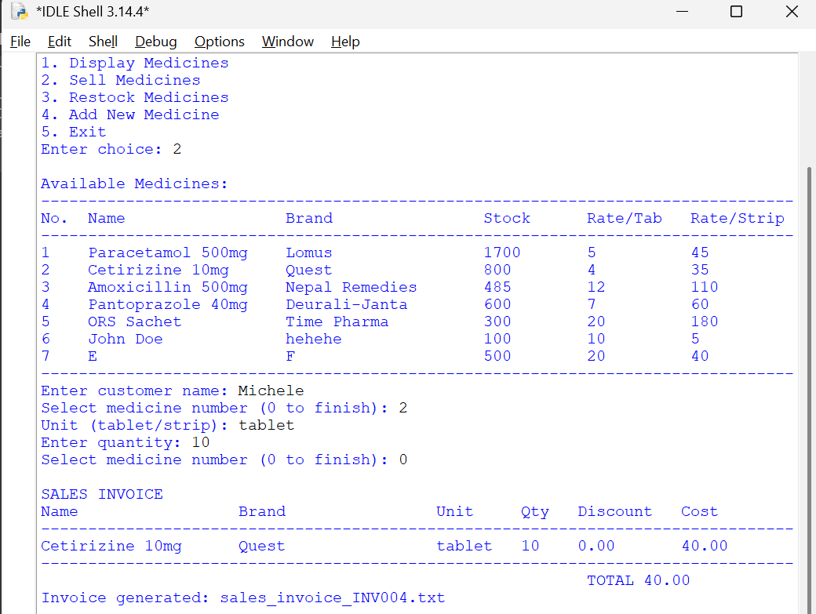
Figure 29:Testing if loop stops for sales

7.3.5.2 Testing if loop works after pressing another medicine number
Test Case | 12
Objective | To choose enter quantity
Action | - Run Main.py  - Write 2  - Press Enter  - Enter customer name  - Enter  - Enter medicine number  - Enter  - Enter unit  - Enter  - Enter Quantity  - Enter  - Enter 0  - Enter
Expected outcome | It displays Sales Invoice
Actual Outcome | It displayed Sales Invoice
Test Status | The test was successful
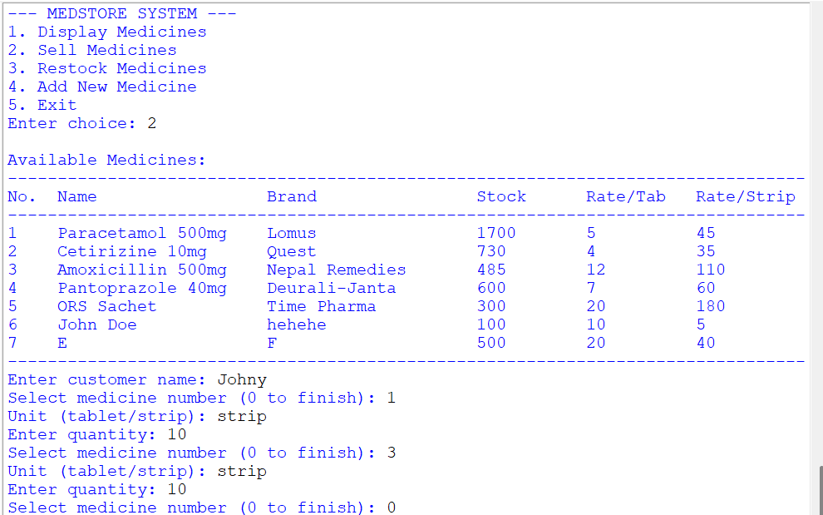
Figure 30: Testing if loop works for sales

7.4 Testing if Restock Medicines works

7.4.1 Testing if entering supplier name works
Test Case | 13
Objective | To choose enter supplier name
Action | - Run Main.py  - Write 3  - Press Enter  - Enter supplier name  - Enter
Expected outcome | It displays Select Medicine number
Actual Outcome | It displayed Select Medicine number
Test Status | The test was successful
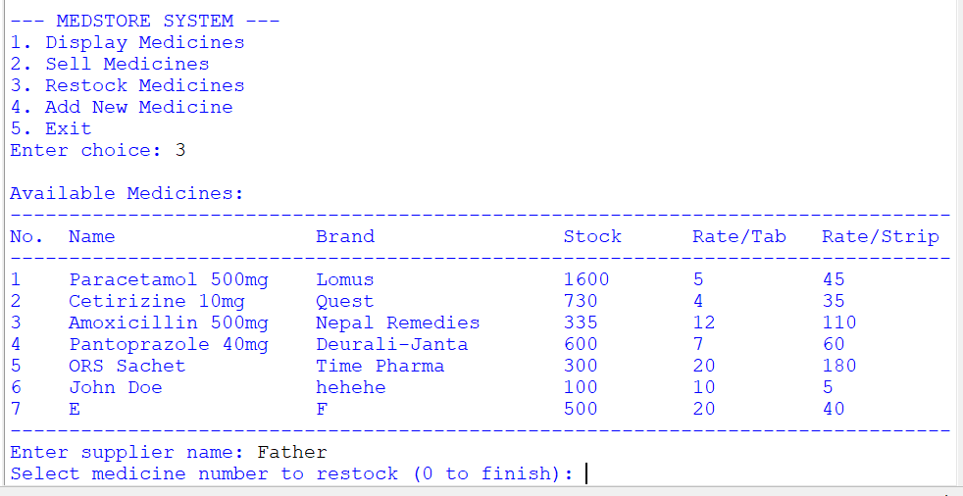
Figure 31: Testing if entering supplier name works

7.4.2 Testing if entering medicine number to restock works
Test Case | 14
Objective | To choose enter medicine number
Action | - Run Main.py  - Write 3  - Press Enter  - Enter supplier name  - Enter  - Enter medicine number  - enter
Expected outcome | It displays Unit
Actual Outcome | It displayed Unit
Test Status | The test was successful
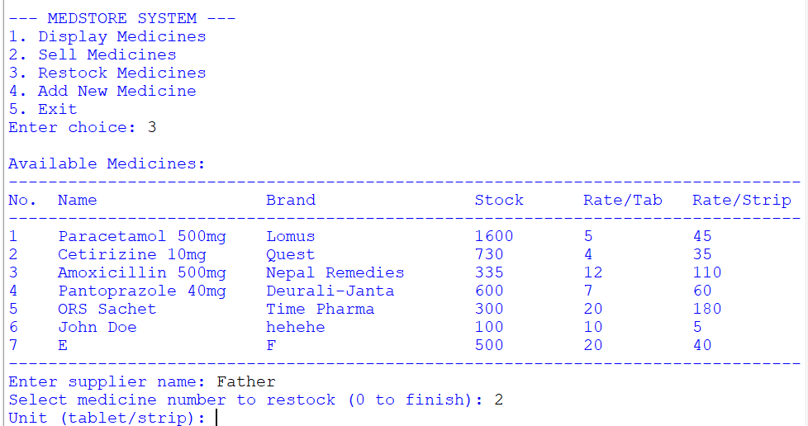
Figure 32: Testing if medicine number works

7.4.2 Testing if entering unit works

7.4.2.1 Testing if entering strip works
Test Case | 15
Objective | To choose enter unit
Action | - Run Main.py  - Write 3  - Press Enter  - Enter supplier name  - Enter  - Enter medicine number  - Enter  - Enter unit (strip)  - Enter
Expected outcome | It displays quantity
Actual Outcome | It displayed quantity
Test Status | The test was successful

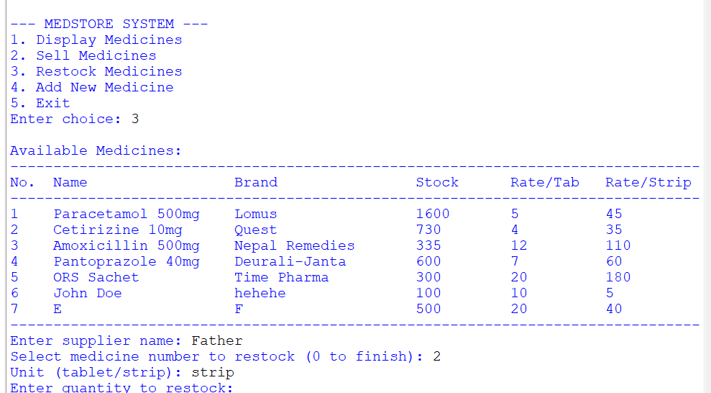
Figure 33: Testing if strips works

7.4.2.2 Testing if entering tablet works
Test Case | 16
Objective | To choose enter unit
Action | - Run Main.py  - Write 3  - Press Enter  - Enter supplier name  - Enter  - Enter medicine number  - Enter  - Enter unit (tablet)  - Enter
Expected outcome | It displays quantity
Actual Outcome | It displayed quantity
Test Status | The test was successful
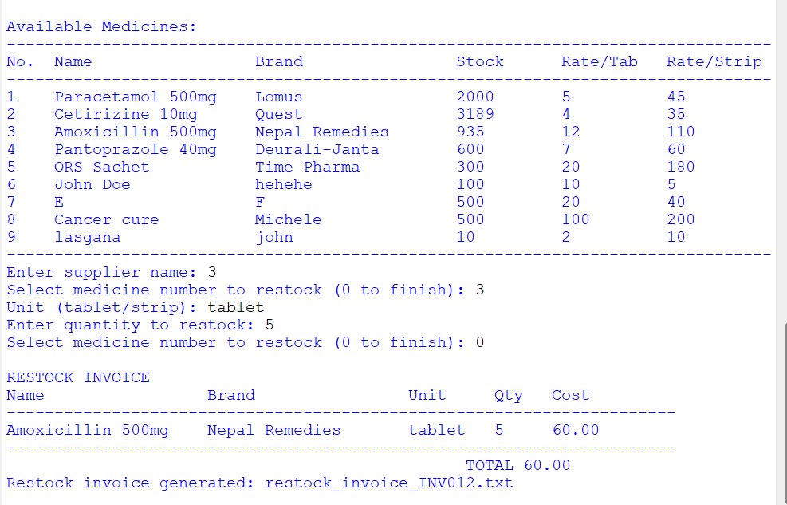
Figure 34: testing if tablet works

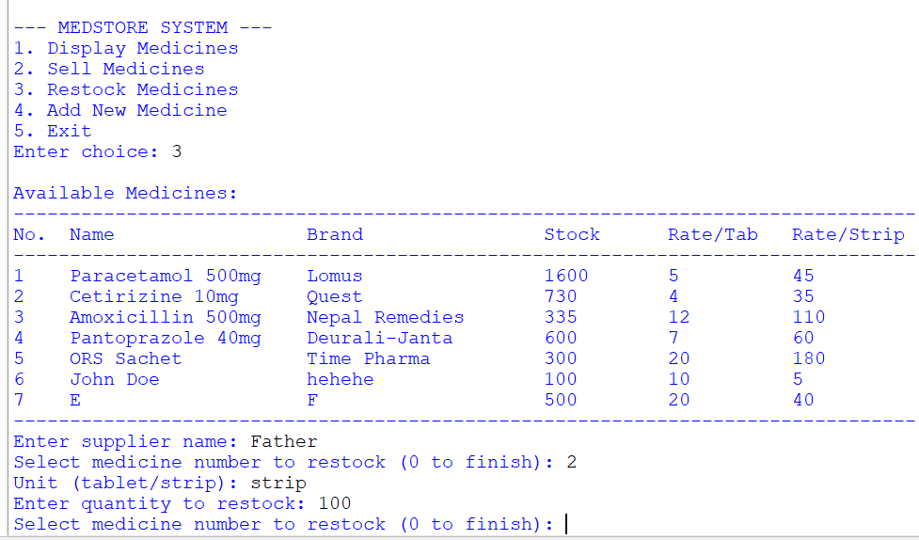
7.4.3 Testing if entering quantity works
Figure 35: Testing if quantity works
Test Case | 17
Objective | To choose enter quantity
Action | - Run Main.py  - Write 3  - Press Enter  - Enter supplier name  - Enter  - Enter medicine number  - Enter  - Enter unit (strip)  - Enter  - Enter Quantity  - Enter
Expected outcome | It displays select medicine to restock
Actual Outcome | It displayed medicine to restock
Test Status | The test was successful

7.5 Testing if loop works

7.5.1 Testing if loop stops when 0 is pressed
Test Case | 18
Objective | To stop loop
Action | - Run Main.py  - Write 3  - Press Enter  - Enter supplier name  - Enter  - Enter medicine number  - Enter  - Enter unit (strip)  - Enter  - Enter Quantity  - Enter  - Enter 0  - Enter
Expected outcome | It displays restock invoice
Actual Outcome | It displayed restock invoice
Test Status | The test was successful

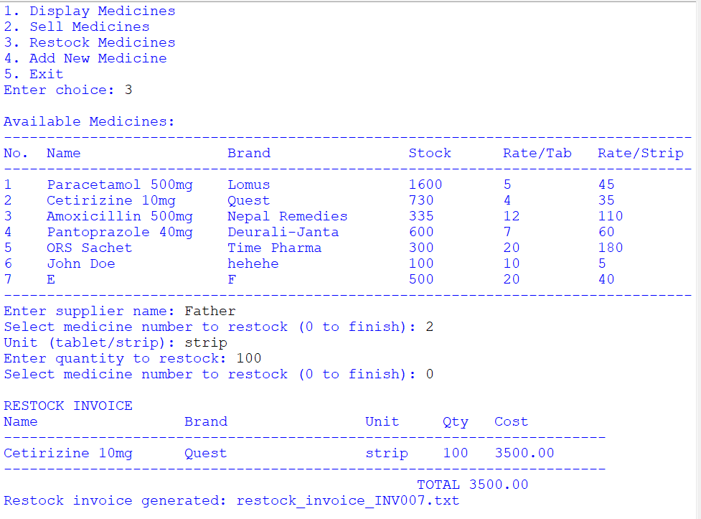
Figure 36: Testing if loop stops for restock

7.5.2 Testing if loop works
Test Case | 19
Objective | To continue loop
Action | - Run Main.py  - Write 3  - Press Enter  - Enter supplier name  - Enter  - Enter medicine number  - Enter  - Enter unit (strip)  - Enter  - Enter Quantity  - Enter  - Enter 2  - Enter
Expected outcome | It displays enter medicine number
Actual Outcome | It displayed medicine number
Test Status | The test was successful
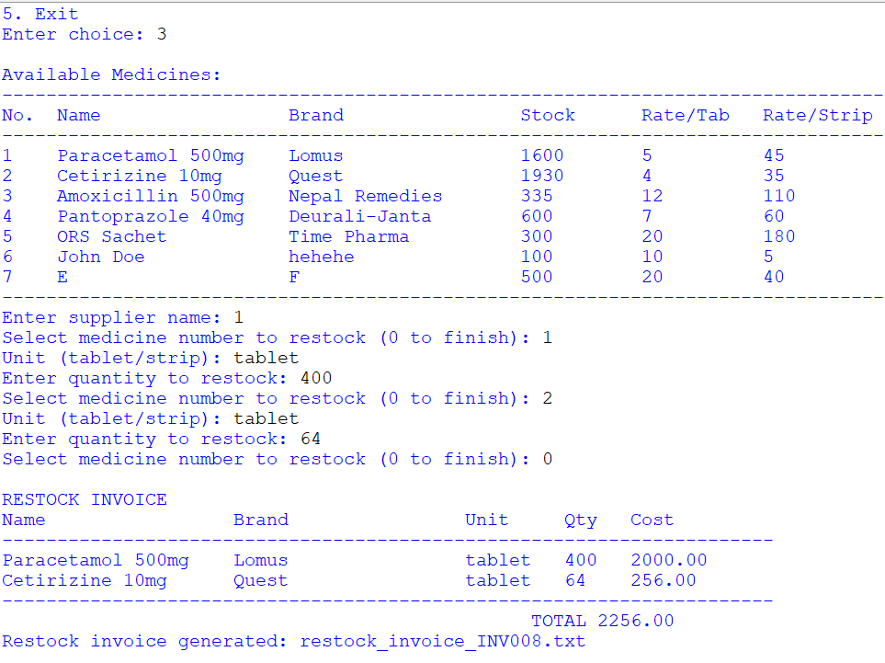
Figure 37: Testing if loop continues for restock

7.6 Testing if Add new medicine works

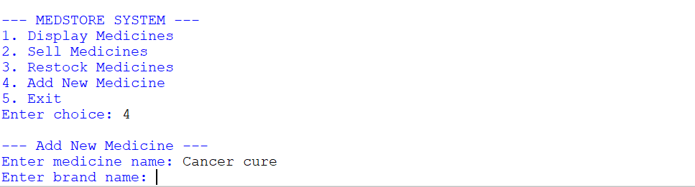
7.6.1 Testing if Enter medicine name works
Figure 38: Testing if entering new medicine works
Test Case | 20
Objective | Testing if medicine name works
Action | - Run Main.py  - Write 4  - Press Enter  - Enter medicine name
Expected outcome | It displays enter brand name
Actual Outcome | It displayed brand name
Test Status | The test was successful

7.6.2 Testing if brand name works
Test Case | 21
Objective | Testing if brand name works
Action | - Run Main.py  - Write 4  - Press Enter  - Enter medicine name  - Enter  - Enter brand name  - Enter
Expected outcome | It displays initial quantity
Actual Outcome | It displayed initial quantity
Test Status | The test was successful
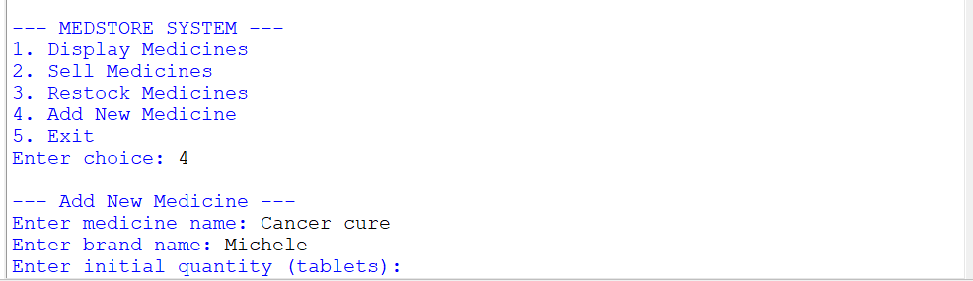
Figure 39: Testing if brand name works

7.6.3 Testing if initial quantity works
Test Case | 22
Objective | Testing if initial quantity
Action | - Run Main.py  - Write 4  - Press Enter  - Enter medicine name  - Enter  - Enter brand name  - Enter  - Enter initial quantity  - Enter
Expected outcome | It displays enter rate per tablet
Actual Outcome | It displayed enter rate per tablet
Test Status | The test was successful
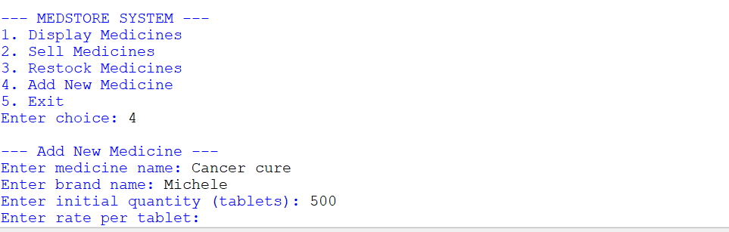
Figure 40: Testing if initial quantity works

7.6.4 Testing if entering rate per tablet works
Test Case | 23
Objective | Testing if entering rate per tablet works
Action | - Run Main.py  - Write 4  - Press Enter  - Enter medicine name  - Enter  - Enter brand name  - Enter  - Enter initial quantity  - Enter  - Enter rate per tablet
Expected outcome | It displays enter rate per strip
Actual Outcome | It displayed enter rate per strip
Test Status | The test was successful
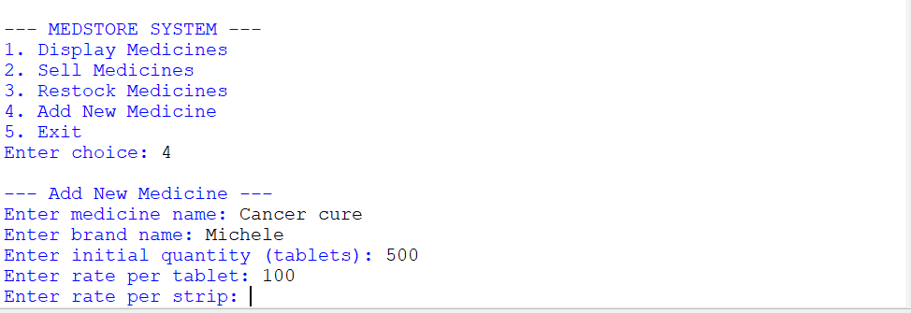
Figure 41: Testing if entering rate per tablet works

7.6.5 Testing if entering rate per strip works
Test Case | 24
Objective | Testing if entering rate per strip works
Action | - Run Main.py  - Write 4  - Press Enter  - Enter medicine name  - Enter  - Enter brand name  - Enter  - Enter initial quantity  - Enter  - Enter rate per tablet  - Enter  - Rate per strip
Expected outcome | It displays enters tablet per strip
Actual Outcome | It displayed enters tablet per strip
Test Status | The test was successful
Figure 42: Displaying rate per strip

7.6.6 Testing tablets per strip
Test Case | 25
Objective | Testing if entering tablets per strip
Action | - Run Main.py  - Write 4  - Press Enter  - Enter medicine name  - Enter  - Enter brand name  - Enter  - Enter initial quantity  - Enter  - Enter rate per tablet  - Enter  - Rate per strip  - Enter  - Enter tablets per strip
Expected outcome | It displays medicine name (brand name)
Actual Outcome | It displayed medicine name (brand name)
Test Status | The test was successful
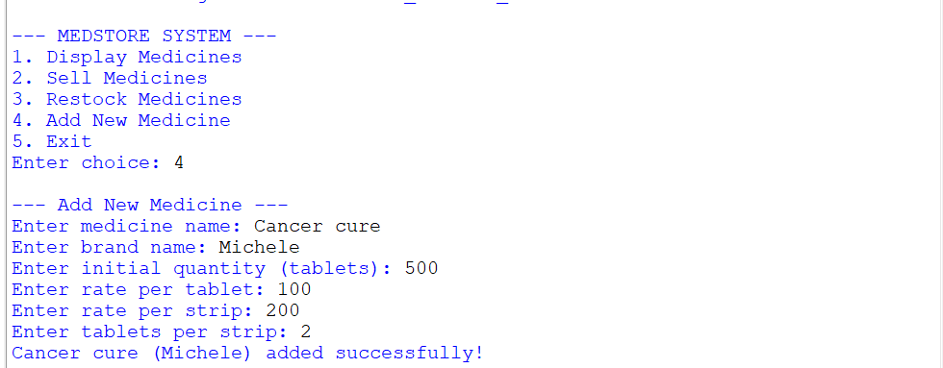
Figure 43: Displaying tablets per strips

7.7 Testing if the file handling works

7.7.1 Testing if invoice is created when customer purchases
Test Case | 26
Objective | Testing if invoice is created if customer purchases
Action | - Run Main.py  - Write 2  - Open File Explorer  - Open txt
Expected outcome | It displays the invoice
Actual Outcome | It displayed the invoice
Test Status | The test was successful

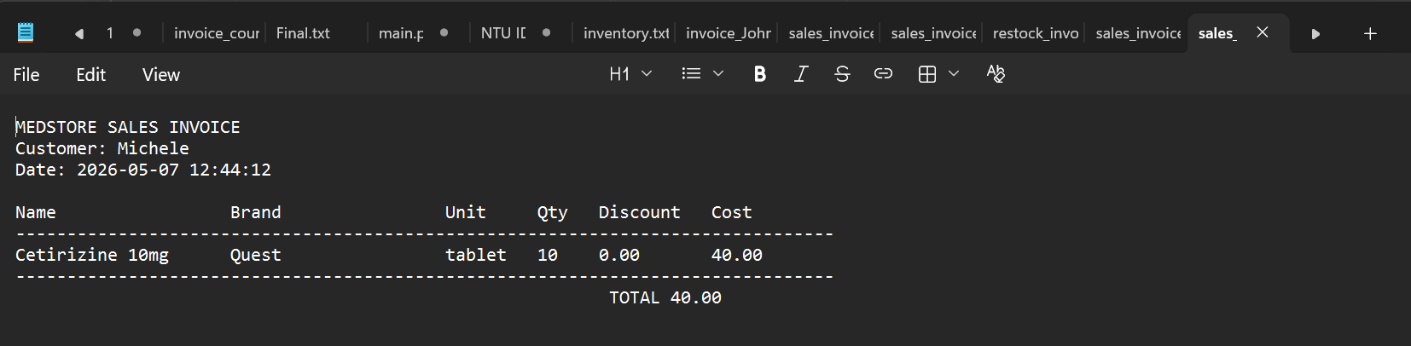
Figure 44: Text file of one of the customer invoice

7.7.2 Testing if invoice is created when restock happens
Test Case | 27
Objective | Testing if invoice is created if restock occurs
Action | - Run Main.py  - Write 2  - Open File Explorer  - Open txt
Expected outcome | It displays the invoice
Actual Outcome | It displayed the invoice
Test Status | The test was successful
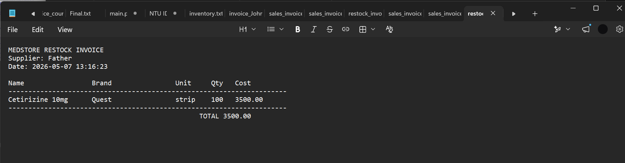
Figure 45: Text file of one of the rerstocks
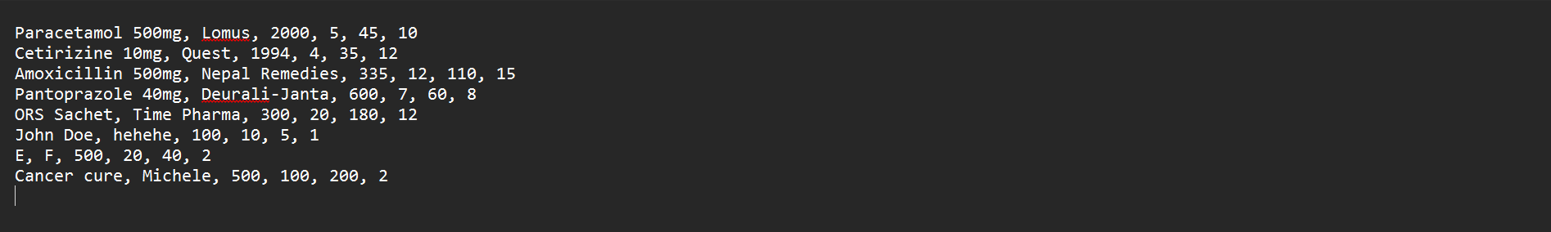
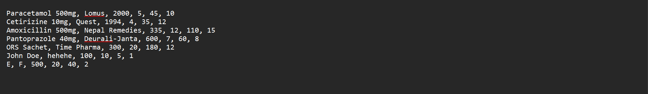
7.7.3 Testing if inventory is updated when customer purchases or medicine is restocked or new medicine is added
Figure 46: After new medicine was added
Figure 47: Before new medicine was added
Test Case | 28
Objective | Testing if inventory.txt is updated when a purchase, restock or new medicine is added
Action | - Run Main.py  - Write 1  - Open File Explorer  - Open txt
Expected outcome | It displays the updated inventory
Actual Outcome | It displayed the updated inventory
Test Status | The test was successful

8. Conclusion
The MedStore Management System project was really helpful in learning Python programming concepts and using them to solve life problems. I learned a lot of things like how to work with files make my code more modular use data structures and handle errors. The project also helped me get better at solving problems and thinking logically by making me manage inventory updates, sales and restocking.

I had to deal with some issues while working on the project especially when it came to reading and writing files. At first I had trouble with the medicines.txt file because of formatting mistakes and incorrect stock updates. I fixed these issues by looking at the file contents and making separate functions to read and update inventory records.

Another big challenge was handling user inputs that were not valid which would sometimes make the program stop working. For example if I entered words of numbers I would get runtime errors. I fixed this by using try. Except statements throughout the program. I also added checks to make sure users could only enter the kind of information.

Finding and fixing mistakes in the selling and restocking calculations was also important. I found problems with how the stock was being reduced how strips were being converted and how discounts were being calculated by testing the program over. I fixed these problems by making my calculation logic one step at a time.

In the end I finished the MedStore Management System project. It worked as planned. The system can now manage medicine records make bills, update stock details and handle errors. The MedStore Management System project was a learning experience and it taught me a lot, about making software and solving problems. The MedStore Management System project really helped me understand how to use Python programming concepts to solve life problems.

6. Appendix

6.1 Inventory.txt

main.py
# main.py
# The main program for MEDSTORE system.
# - Provides menu interface to display, sell, restock, and add medicines
# - Uses modules: inventory.py, sales.py, restock.py, add.py

from inventory import load_inventory, display_inventory
from sales import sell_medicine
from restock import restock_medicine
from add import add_medicine

def main():
inventory = load_inventory() # Load inventory from file at start

while True:
# Display menu
print("\n--- MEDSTORE SYSTEM ---")
print("1. Display Medicines")
print("2. Sell Medicines")
print("3. Restock Medicines")
print("4. Add New Medicine")
print("5. Exit")

choice = input("Enter choice: ").strip()

# Handle menu selection
if choice == "1":
display_inventory(inventory)
elif choice == "2":
sell_medicine(inventory)
elif choice == "3":
restock_medicine(inventory)
elif choice == "4":
add_medicine(inventory)
elif choice == "5":
print("Exiting")
break
else:
print("Invalid choice! Enter a number 1-5.")

if __name__ == "__main__":
main()
inventory.py
# inventory.py
# Handles inventory operations: load, save, display in table format

INVENTORY_FILE = "inventory.txt"

def load_inventory():
"""Load inventory from file and return as list of dictionaries."""
inventory = []
try:
with open(INVENTORY_FILE, "r") as file:
for line in file:
try:
name, brand, qty, rate_tab, rate_strip, tabs_per_strip = line.strip().split(", ")
inventory.append({
"name": name,
"brand": brand,
"qty": int(qty),
"rate_tab": int(rate_tab),
"rate_strip": int(rate_strip),
"tabs_per_strip": int(tabs_per_strip)
})
except ValueError:
print(f"Skipping invalid line: {line.strip()}")
except FileNotFoundError:
print("Inventory file not found. Starting empty.")
except Exception as e:
print(f"Error loading inventory: {e}")
return inventory

def save_inventory(inventory):
"""Save inventory to file."""
try:
with open(INVENTORY_FILE, "w") as file:
for item in inventory:
file.write(
f"{item['name']}, {item['brand']}, {item['qty']}, "
f"{item['rate_tab']}, {item['rate_strip']}, {item['tabs_per_strip']}\n"
)
except Exception as e:
print(f"Error saving inventory: {e}")

def display_inventory(inventory):
"""Display inventory in a neat table."""
if not inventory:
print("\nInventory is empty.")
return

print("\nAvailable Medicines:")
print("-" * 80)
print(f"{'No.':<4} {'Name':<20} {'Brand':<20} {'Stock':<10} {'Rate/Tab':<10} {'Rate/Strip':<10}")
print("-" * 80)

count = 1
for item in inventory:
print(
f"{count:<4} "
f"{item['name']:<20} "
f"{item['brand']:<20} "
f"{item['qty']:<10} "
f"{item['rate_tab']:<10} "
f"{item['rate_strip']:<10}"
)
count += 1

print("-" * 80)
sales.py
# sales.py
# Handles selling medicines to customers with table output and updates inventory

from inventory import display_inventory, save_inventory
from invoice import generate_sales_invoice

def sell_medicine(inventory):
"""
Sell medicines to customers.
- Displays inventory
- Allows selection of medicines and quantity
- Calculates cost and discounts
- Updates inventory and generates sales invoice
"""
display_inventory(inventory)
customer = input("Enter customer name: ").strip()
if not customer:
print("Customer name cannot be empty!")
return

cart = [] # Stores items purchased in this transaction
total_amount = 0

while True:
# Get medicine selection
try:
choice = int(input("Select medicine number (0 to finish): "))
except ValueError:
print("Invalid input! Enter a number.")
continue

if choice == 0:
break
if choice < 1 or choice > len(inventory):
print("Invalid selection!")
continue

item = inventory[choice - 1]
unit = input("Unit (tablet/strip): ").lower()

# Get quantity
try:
qty = int(input("Enter quantity: "))
except ValueError:
print("Invalid quantity!")
continue
if qty <= 0:
print("Quantity must be positive!")
continue

# Calculate cost and check stock
if unit == "tablet":
if qty > item["qty"]:
print("Not enough stock!")
continue
cost = qty * item["rate_tab"]
discount = 0
item["qty"] -= qty
elif unit == "strip":
tablets_needed = qty * item["tabs_per_strip"]
if tablets_needed > item["qty"]:
print("Not enough stock!")
continue
cost = qty * item["rate_strip"]
discount = 0
if qty >= 2: # Discount for buying 2 or more strips
discount = cost * 0.05
cost -= discount
item["qty"] -= tablets_needed
else:
print("Invalid unit!")
continue

# Add to cart and update total
cart.append((item, unit, qty, discount, cost))
total_amount += cost

# Print sales invoice in console (table format)
if cart:
print("\nSALES INVOICE")
print(f"{'Name':<20} {'Brand':<20} {'Unit':<8} {'Qty':<5} {'Discount':<10} {'Cost':<10}")
print("-" * 80)
for item, unit, qty, discount, cost in cart:
print(f"{item['name']:<20} {item['brand']:<20} {unit:<8} {qty:<5} {discount:<10.2f} {cost:<10.2f}")
print("-" * 80)
print(f"{'TOTAL':>63} {total_amount:<10.2f}")

# Save inventory and generate text invoice
try:
save_inventory(inventory)
generate_sales_invoice(customer, cart, total_amount)
except Exception as e:
print(f"Error saving inventory or generating invoice: {e}")

restock.py
# restock.py
# Handles restocking medicines, updating inventory, and generating restock invoices

from inventory import display_inventory, save_inventory
from invoice import generate_restock_invoice

def restock_medicine(inventory):
"""
Restock medicines from supplier.
- Displays inventory
- Allows selection of medicines and quantity
- Calculates total cost for buyer
- Updates inventory and generates restock invoice
"""
display_inventory(inventory)
supplier = input("Enter supplier name: ").strip()
if not supplier:
print("Supplier name cannot be empty!")
return

cart = [] # Stores items restocked
total_amount = 0

while True:
# Select medicine
try:
choice = int(input("Select medicine number to restock (0 to finish): "))
except ValueError:
print("Invalid input! Enter a number.")
continue

if choice == 0:
break
if choice < 1 or choice > len(inventory):
print("Invalid selection!")
continue

item = inventory[choice - 1]

# Select unit
unit = input("Unit (tablet/strip): ").lower()
if unit not in ["tablet", "strip"]:
print("Invalid unit! Must be 'tablet' or 'strip'.")
continue

# Enter quantity
try:
qty = int(input("Enter quantity to restock: "))
except ValueError:
print("Invalid quantity!")
continue
if qty <= 0:
print("Quantity must be positive!")
continue

# Calculate number of tablets added and cost
if unit == "tablet":
tablets_added = qty
cost = qty * item["rate_tab"]
else: # strip
tablets_added = qty * item["tabs_per_strip"]
cost = qty * item["rate_strip"]

# Update inventory
item["qty"] += tablets_added

# Add to restock cart
cart.append((item, unit, qty, cost))
total_amount += cost

# Display restock invoice in console
if cart:
print("\nRESTOCK INVOICE")
print(f"{'Name':<20} {'Brand':<20} {'Unit':<8} {'Qty':<5} {'Cost':<10}")
print("-" * 70)
for item, unit, qty, cost in cart:
print(f"{item['name']:<20} {item['brand']:<20} {unit:<8} {qty:<5} {cost:<10.2f}")
print("-" * 70)
print(f"{'TOTAL':>53} {total_amount:<10.2f}")

# Save inventory and generate text invoice
try:
save_inventory(inventory)
generate_restock_invoice(supplier, cart, total_amount)
except Exception as e:
print(f"Error saving inventory or generating invoice: {e}")

invoice.py
# restock.py
# Handles restocking medicines, updating inventory, and generating restock invoices

from inventory import display_inventory, save_inventory
from invoice import generate_restock_invoice

def restock_medicine(inventory):
"""
Restock medicines from supplier.
- Displays inventory
- Allows selection of medicines and quantity
- Calculates total cost for buyer
- Updates inventory and generates restock invoice
"""
display_inventory(inventory)
supplier = input("Enter supplier name: ").strip()
if not supplier:
print("Supplier name cannot be empty!")
return

cart = [] # Stores items restocked
total_amount = 0

while True:
# Select medicine
try:
choice = int(input("Select medicine number to restock (0 to finish): "))
except ValueError:
print("Invalid input! Enter a number.")
continue

if choice == 0:
break
if choice < 1 or choice > len(inventory):
print("Invalid selection!")
continue

item = inventory[choice - 1]

# Select unit
unit = input("Unit (tablet/strip): ").lower()
if unit not in ["tablet", "strip"]:
print("Invalid unit! Must be 'tablet' or 'strip'.")
continue

# Enter quantity
try:
qty = int(input("Enter quantity to restock: "))
except ValueError:
print("Invalid quantity!")
continue
if qty <= 0:
print("Quantity must be positive!")
continue

# Calculate number of tablets added and cost
if unit == "tablet":
tablets_added = qty
cost = qty * item["rate_tab"]
else: # strip
tablets_added = qty * item["tabs_per_strip"]
cost = qty * item["rate_strip"]

# Update inventory
item["qty"] += tablets_added

# Add to restock cart
cart.append((item, unit, qty, cost))
total_amount += cost

# Display restock invoice in console
if cart:
print("\nRESTOCK INVOICE")
print(f"{'Name':<20} {'Brand':<20} {'Unit':<8} {'Qty':<5} {'Cost':<10}")
print("-" * 70)
for item, unit, qty, cost in cart:
print(f"{item['name']:<20} {item['brand']:<20} {unit:<8} {qty:<5} {cost:<10.2f}")
print("-" * 70)
print(f"{'TOTAL':>53} {total_amount:<10.2f}")

# Save inventory and generate text invoice
try:
save_inventory(inventory)
generate_restock_invoice(supplier, cart, total_amount)
except Exception as e:
print(f"Error saving inventory or generating invoice: {e}")
add.py
# add.py
# Handles adding new medicines to inventory

from inventory import save_inventory

def add_medicine(inventory):
print("\n--- Add New Medicine ---")
name = input("Enter medicine name: ").strip()
brand = input("Enter brand name: ").strip()
if not name or not brand:
print("Name and brand cannot be empty!")
return

# Check duplicates
for item in inventory:
if item["name"].lower() == name.lower() and item["brand"].lower() == brand.lower():
print("Medicine already exists!")
return

try:
qty = int(input("Enter initial quantity (tablets): "))
rate_tab = int(input("Enter rate per tablet: "))
rate_strip = int(input("Enter rate per strip: "))
tabs_per_strip = int(input("Enter tablets per strip: "))
except ValueError:
print("Invalid input! Enter numbers only.")
return

if qty < 0 or rate_tab < 0 or rate_strip < 0 or tabs_per_strip <= 0:
print("Values must be positive!")
return

new_item = {
"name": name,
"brand": brand,
"qty": qty,
"rate_tab": rate_tab,
"rate_strip": rate_strip,
"tabs_per_strip": tabs_per_strip
}

try:
inventory.append(new_item)
save_inventory(inventory)
except Exception as e:
print(f"Error saving inventory: {e}")
return

print(f"{name} ({brand}) added successfully!")

7. Refernces
geeksforgeeks, 2025. geeksforgeeks. [Online]
Available at: https://www.geeksforgeeks.org/python/primitive-data-types-vs-non-primitive-data-types-in-python/(Accessed: 24 April 2026).
geeksforgeeks, 2025. geeksforgeeks. [Online]
Available at: https://www.geeksforgeeks.org/python/python-data-structures/(Accessed: 24 April 2026).
Classes
GeeksforGeeks (2024) Difference between strip and split in Python, GeeksforGeeks. (Accessed: 24 April 2026).

Available at: https://www.geeksforgeeks.org/python/difference-between-strip-and-split-
in-python/ (Accessed: 24 April 2026).

GeeksforGeeks (2026b) File handling in python, GeeksforGeeks. Available at:
https://www.geeksforgeeks.org/python/file-handling-python/ (Accessed: 24 April 2026).
GeeksforGeeks (2026d) Python exception handling, GeeksforGeeks. Available at:
https://www.geeksforgeeks.org/python/python-exception-handling/ (Accessed: 07 May
2026).

