SC2107 Lab2 Assignment Sheet (to be submitted to NTULearn before next lab)

Name: Jonathan Low Seng Kian Lab Group: TCMA Date: 12/9/2025

- Section 6.2. Give a short 2-3 lines description on concept behind the reflectance reading process. Why does the white surface result in faster voltage decay?
The reflectance sensor works by charging a phototransistor-capacitor pair then measuring how long it takes for the voltage to decay. A white surface reflects the IR more than black, turning on the transistor and discharging the capacitor faster.
- Section 6.2. Which parameter do you need to tweak in the Reflectance_Read() if the reflectance sensor reading is not accurate? Hint: check the 8 steps for Reflectance reading.
It’s the wait time between changing P7 to input and capturing the input data from P7. Depending on the wait time between them, it controls how much the capacitor can discharge before being recorded. The difference between a black and white surface might blur out if the wait time is too short or long.
- Section 6.2. Write down the procedure to initialise P7.2 to be an input pin without internal pull-up resistor
P7->DIR &= ~0x04;
P7->SEL0 &= ~0x04;
P7-> SEL1 &= ~0x04;
P7->REN &= ~0x04;

- Secton 6.3. What is the value returned by the Reflectance_Position() function if RSLK is placed on top of a Black surface?
The value would be 0. As the Reflectance Position if all sensors detect black, would cancel each other out as the integers of W are signed and the value returned is also signed. Thus the corresponding sensors on each side have equal magnitude but opposite signs, which cancels each other out.

- Section 6.3. Where are the sources of the offset error between actual distance and the estimated distance return by the function Reflectance_Position()?
Offset error come from the physical positioning or geometry of the sensor array where they are discrete spacing between detectors and line width mismatch between sensor width. Non ideal reflectivity timing as it is manually set. These cause the estimated distance to shift relative to true distance.

- Section 7.2. Figure 7. The robot state toggled between LEFT and CENTER state repeatedly when it is detected that the robot is off to the left of the line (input: ‘01’). If the outputs of the FSM states are connected to the input of the DC motor, how would the input signals to the DC motor looks like? Which wheel will move at a slower speed?
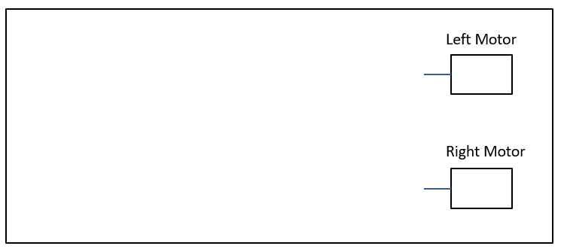
The motor inputs will be pulsing between center and left output from the sensors. The right wheel will toggle between slower or same as the left wheel as the FSM would constantly toggle between trying to turn right and not turning.

- Section 7.3. Figure 10. Fix the bug in the 11-state FSM design.
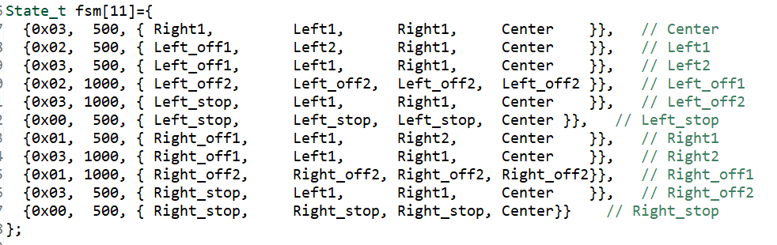
- //OHL
- State_t fsm[11]={
- {0x03, 500, { Right1, Left1, Right1, Center }}, // Center
- {0x02, 500, { Left_off1, Left2, Right1, Center }}, // Left1
- {0x03, 500, { Left_off1, Left1, Right1, Center }}, // Left2
- {0x02, 5000, { Left_off2, Left_off2, Left_off2, Left_off2 }}, // Left_off1
- {0x03, 5000, { Left_stop, Left1, Right1, Center }}, // Left_off2
- {0x00, 500, { Left_stop, Left_stop, Left_stop, Left_stop }}, // Left_stop
- {0x01, 500, { Right_off1, Left1, Right2, Center }}, // Right1
- {0x03, 500, { Right_off1, Left1, Right1, Center }}, // Right2
- {0x01, 5000, { Right_off2, Right_off2, Right_off2, Right_off2}}, // Right_off1
- {0x03, 5000, { Right_stop, Left1, Right1, Center }}, // Right_off2
- {0x00, 500, { Right_stop, Right_stop, Right_stop, Right_stop}} // Right_stop
- };

- Section 7.3. What is the purpose of toggling LED within the main routine or ISR?

It acts as an indicator LED to visually show that the routine is actively running as long as the LED is toggling off and on, it helps to monitor the system activity in real time.

