1. Singularity Waveforms & Energy Proofs
- Waveform Sketching ($u\left(t\right)$ & $r\left(t\right)$):
  - Step $u\left(t-t_{0}\right)$: Instantaneous vertical jump of $+1$ at $t=t_{0}$.
  - Ramp $r\left(t-t_{0}\right)$: Slope increases by $+1$ starting at $t=t_{0}$.
  - Strategy: Construct time intervals bounded by critical points (where steps/ramps trigger). Track the cumulative value and slope across each interval.
- Energy Signal Verification:
  - Condition: A signal $x\left(t\right)$ is an energy signal if its total energy satisfies $0<E<∞$.
  - Method: Split integration across piece-wise intervals determined in the sketch:
$$E=\int_{-∞}^{∞}{|}x\left(t\right)|​^{2} dt=\sum_{i}{\int_{t_{i}}^{t_{i+1}}{|}}x_{i}\left(t\right)|​^{2} dt$$
  - Result: Evaluate definite integrals; if $E$ yields a finite positive number, $x\left(t\right)$ is an energy signal.
2. Double-Sided Amplitude & Phase Spectra
- Conversion to Canonical Cosine Form:
  - Expand product terms using product-to-sum identities:
$$\sin\left(A\right)\cos\left(B\right)=\frac{1}{2}\left[\sin\left(A+B\right)+\sin\left(A-B\right)\right]$$
  - Convert all sine terms to cosine using $\sin\left(θ\right)=\cos\left(θ-\frac{π}{2}\right)$.
  - Absorb negative leading coefficients into phase using $-\cos\left(θ\right)=\cos\left(θ±π\right)$.
- Euler Expansion to Exponential Form:
  - Substitute each term $A\cos\left(ωt+θ\right)=\frac{A}{2}e^{j\left(ωt+θ\right)}+\frac{A}{2}e^{-j\left(ωt+θ\right)}$.
- Plotting Spectra ($f$-axis in Hz):
  - Frequencies: Calculate $f_{k}=\frac{ω_{k}}{2π}$ for positive and negative pairs ($±f_{k}$).
  - Amplitude Spectrum: Plot vertical stem of height $|c_{k}|=\frac{A_{k}}{2}$ at $f=±f_{k}$.
  - Phase Spectrum: Plot vertical stem of angle $θ_{k}$ at $f=+f_{k}$ and $-θ_{k}$ at $f=-f_{k}$.
3. Continuous LTI System Responses via Convolution
- Convolution Integral:
$$y\left(t\right)=x\left(t\right)*h\left(t\right)=\int_{-∞}^{∞}{x}\left(τ\right)h\left(t-τ\right) dτ$$
- Step Response $s\left(t\right)$ [where $x\left(t\right)=u\left(t\right)$]:
  - Set integral bounds over active step duration ($0≤τ≤t$ for $t≥0$):
$$s\left(t\right)=\left(\int_{0}^{t}{h}\left(τ\right) dτ\right)u\left(t\right)$$
- Arbitrary Causal Input Response $y\left(t\right)$:
  - Use $u\left(τ\right)$ and $u\left(t-τ\right)$ to establish non-zero integration bounds (typically $\left[0,t\right]$).
  - Expand integrand algebraically before integrating.
  - Evaluate limits at $τ=t$ and $τ=0$, then append $u\left(t\right)$ to enforce causality.
4. System Analysis via Linearity & Time-Invariance (LTI)
- Core Principles:
  - Time-Invariance: If $x\left(t\right)→y\left(t\right)$, then $x\left(t-t_{0}\right)→y\left(t-t_{0}\right)$.
  - Linearity: If $x\left(t\right)=a⋅x_{1}\left(t\right)+b⋅x_{2}\left(t\right)$, then $y_{out}\left(t\right)=a⋅y_{1}\left(t\right)+b⋅y_{2}\left(t\right)$.
- Step-by-Step Method:
  - Deconstruct Input: Express non-standard input (like rectangular pulse $Π$) as a sum of shifted unit steps:
$$Π\left(\frac{t-t_{0}}{W}\right)=u\left(t-\left(t_{0}-\frac{W}{2}\right)\right)-u\left(t-\left(t_{0}+\frac{W}{2}\right)\right)$$
  - Shift Known Response: Replace $t$ in the given step response $y\left(t\right)$ with $\left(t-t_{1}\right)$ and $\left(t-t_{2}\right)$.
  - Superimpose: Subtract the delayed responses to obtain total system output.
5. Fourier Series, Periodicity, & Parseval's Power Theorem
- Fundamental Period ($T_{0}$) & Harmonically Related Terms:
  - Individual periods $T_{i}=\frac{2π}{|ω_{i}|}$.
  - Fundamental period $T_{0}=\text{LCM}\left(T_{1},T_{2},…\right)$. Fundamental frequency $f_{0}=\frac{1}{T_{0}}$.
- Extracting Fourier Coefficients ($c_{k}$):
  - Match terms directly to complex exponential Fourier series $x\left(t\right)=\sum{c_{k}}e^{jkω_{0}t}$.
- Parseval's Power Theorem:
  - Average Power $P$ equals the sum of squared magnitudes of all Fourier coefficients:
$$P=\frac{1}{T_{0}}\int_{0}^{T_{0}}{|}x\left(t\right)|​^{2} dt=\sum_{k=-∞}^{∞}{|}c_{k}|​^{2}$$
- Invariance Rule:
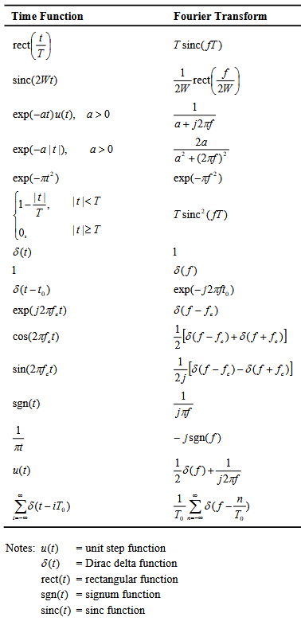
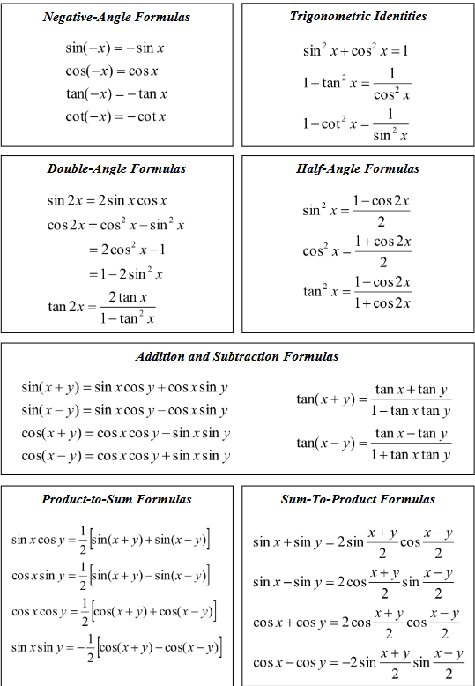
  - Modifying phase angles ($θ_{k}$) or rearranging component frequencies does not change total average power $P$, because $|c_{k}|​^{2}$ remains unaffected.

