SC2107 Lab3 Assignment Sheet (to be submitted to NTULearn before next lab)

Name: Jonathan Low Seng Kian Lab Group: TCMA Date: 06/10/2025

- Section 6. Exception handling in ARM processor is handle at three levels (Global, NVIC, and Peripheral). Which are the two registers that configure the exception handling at a global level? Explain whether we need to configure these registers in our lab exercise.
At the global level, exception handling in the ARM Cortex-M (used in MSP432) is controlled by the PRIMASK and BASEPRI registers. In the lab, we do not need to configure these, because their default reset values already allow all interrupts to occur.

- Section 6.2. The bump switch used in the lab is shown below. Pin 1 and 3 of the bump switch are connected to the MSP432. Draw the internal circuit of the bump switch and describe how the MSP432 GPIO can be used to detect that the switch is closed?

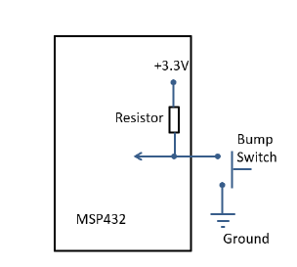
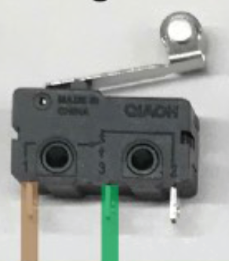
While idle, GPIO input reads logic high due to the pull up resistor. When bump switch is pressed, it shorts the pin to ground, pulling the voltage to ground, thus GPIO reads logic 0.
- Section 6.3. Write down the GPIO configuration used for pins connected to the Bump switches IF they are connected to Pin6.1 to P6.6.
Each pin must be configured as GPIO input.
Pull-up resistors are enabled because bump switches connect to ground when pressed (active low).
Interrupts may be enabled on falling edges (if the bump switch triggers an interrupt).
P6->SEL0 &= ~0x7E; // GPIO
P6->SEL1 &= ~0x7E;
P6->DIR &= ~0x7E; // Input
P6->REN |= 0x7E; // Enable pull resistors
P6->OUT |= 0x7E; // Pull-up resistors
- Section 6.3. What is the frequency of the clock source of systick timer? Explain how systick timer is configured to interrupt the system at 1000Hz frequency. Illustrate with detail calculations and APIs used.
The frequency of source clock is 48MHz which we will set systick timer to 48000. Therefore, the system interrupt frequency will be 48000000/48000=1000 Hz = 1ms.
The configuration is done using the API:

SysTick_Init(48000, 1);
- Section 6.3. What is the advantage the method of reading Reflectance sensor (in Lab3 section 6.3) has compared to the method used in Lab2?
In Lab 2, the main function uses a clock delay to trigger Reflectance_Read(). In Lab 3, a SysTick interrupt triggers the measurement instead. This reduces CPU utilization and improves timing precision, because SysTick uses a hardware timer that is more accurate and non-blocking

- Section 6.4. Reference to PWM_Init34() in PWM.c, what is the timer base clock used to increment the counters in Timer_A0? Show the details of how this base clock of Timer_A0 is derived, starting from processor clock. Note that SMCLK=12Mhz.
The Timer_A0 module uses SMCLK as its clock source running at 12Mhz
Within PWM_Init34() (in PWM.c), Timer_A0 further divides SMCLK by its input divider settings at ID = 8, IDEX = 1. Timer base clock=12/(8*1)​=1.5MHz, period = 1/1.5Mhz = 666.7ns

- Section 6.5. What is the PWM frequency generated to the motor? illustrate with detail working.
In up–down mode, the timer counts from 0 to the period value and back down to 0, resulting in two ticks per PWM cycle. Timer clock period = 666.7 ns, Period register = 7,500. The total time per PWM cycle is T=2×7,500×666.7ns=10ms. the PWM frequency is f=10ms1​=100Hz.
- Section 6.5. Is interrupt mechanism used in the PWM generation via Timers?
No interrupts are used in the PWM generation process.
In PWM.c, neither the Timer_A Interrupt Enable (TAIE) bit in the CTL register nor the Capture/Compare Interrupt Enable (CCIE) bits in the CCTL registers are set.
Thus, the PWM signal is generated entirely by the hardware timer without CPU intervention, ensuring continuous output with minimal overhead.
- Section 6.5. What is the IRQ number you need to reference to if Timer_A2 instead of Timer A1 is used in Lab3_TimerCompare_Motor project? What is the corresponding Exception number? Hint: Check Table 6-39 at Pg117 MSP432 Datasheets
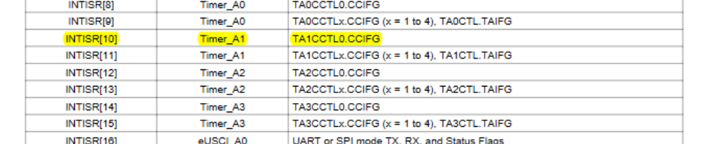
IRQ of Timer A2 is 12. Exception number is 12+16 = 28, since NVIC start at 16.

