

SC4172 INT OF THINGS: Tiny Machine Learning
Report

Course Project Report: Fall & Call - Multimodal Emergency Detection

By: Jonathan Low Seng Kian

1. Aim
The goal of this project is to develop a power-efficient, privacy-centric emergency detection system for the Arduino Nano 33 BLE Sense. The system utilizes a multi-stage "Sensory Gating" architecture, it first monitors for a high-G impact and significant orientation change using an IMU. If triggered, it employs a TinyML motion model to verify a physical fall. Only upon verification is the microphone activated to perform Keyword Spotting (KWS), allowing the user to confirm the distress signal ("Help") or dismiss false positives ("Cancel"). This architecture ensures that power is saved as the sensor modules and model inference are only activated when needed.

2. Data Preparation and Processing

2.1 Dataset used
- IMU Data: A custom dataset was collected using IMU_Fall_Capture.ino. It consists of 120-sample windows (~1.01 seconds) at a sampling rate of ~119Hz. This captures the three critical phases of a fall: descent, impact, and post-fall stillness. Classes include "Fall" and "Normal" (comprising activities like sitting, jumping, and punching).
  - Total of 300 samples collected (150 Fall, 150 Normal)
- Audio Data: A custom voice dataset was collected using Audio_Keyword_Capture.ino. It consists of 1-second audio recordings (16,000 samples). The dataset includes three primary classes: "HELP", "CANCEL", and "BACKGROUND" (noise, silence and random conversations). These classes allow the system to verify an emergency or allow the user to dismiss a false positive trigger.
  - Total of 300 samples collected (100 Help, 100 Cancel, 100 Background)

2.2 Selecting and setting the parameters
The following parameters were utilized for the two-stage detection pipeline:
Stage 1: IMU Classifier (Fall Detection)
- IMPACT_THRESHOLD = 4.5G
- WINDOW_SIZE = 120 samples
- PRE_SAMPLES = 40
  - A circular buffer maintains 40 samples (~0.33s) of data prior to impact to capture the weightless descent/freefall phase.
- POST_SAMPLES = 80
  - 80 samples (~0.67s) are captured after the trigger to analyze the impact and subsequent lack of movement.
Stage 2: Audio Classifier (MFCC)
- SAMPLING_RATE = 16000
- N_MFCC = 13
- N_MELS = 26
- FRAME_SIZE = 512
  - Corresponds to a 32ms window at 16kHz.
- HOP_LENGTH = 256
  - Corresponds to a 16ms step, providing a 50% overlap between successive frames
- NUM_FRAMES = 61

2.3 Extracting data to be used
For the IMU model, data was normalized during inference using a linear scaling factor ( for acceleration and for gyroscope) to ensure the input features fell within a range for the TFLite model.
For the Audio model, data was collected using a 65/35 split strategy:
- 65% Clean Samples: Recorded in quiet environments to establish a high-fidelity baseline for the keywords "HELP" and "CANCEL".
- 35% Augmented Samples: Recorded with common household background noises (TV, fans, kitchen noise) to ensure robustness against environmental interference.
The audio snippets were processed into MFCCs using the same pipeline implemented in the Arduino code (Hanning windowing, FFT, and Discrete Cosine Transform). This ensures that the features used during training perfectly match the features extracted on-device. The combined dataset was split into a 60:20:20 ratio for training, validation, and testing to ensure the model generalizes well to unseen speakers and environments.

3. Model Training

3.1 Model Architecture
To ensure high performance within the strict memory and power constraints of the Arduino Nano 33 BLE Sense, both stages of the detection pipeline utilize Separable 2D Convolutional Neural Networks (CNNs). This architecture significantly reduces the number of trainable parameters compared to standard CNNs or dense MLPs, while maintaining high feature extraction accuracy.
Stage 1: IMU Fall Detection Model (CNN)
The IMU model is designed to analyze a 120-sample window across 6 sensor channels (accelerometer and gyroscope).
- Input Layer: tensor, representing the temporal sequence of motion data.
- Cross-Axis Feature Extraction: The first layer employs a SeparableConv2D with a kernel size of 3x3. This specific height-to-width ratio is designed to span all 6 sensor axes simultaneously, allowing the model to find instantaneous correlations between linear acceleration (G-force) and rotational velocity (Gyro).
- Temporal Filtering: Subsequent layers use kernels and Max Pooling. Since the cross-axis correlation is established in the first layer, these subsequent layers focus exclusively on the "time" axis to identify the sequential phases of a fall (descent, impact, and post-fall stillness).
- Global Average Pooling: Instead of a standard Flatten layer, GlobalAveragePooling2D is used to condense the feature maps. This drastically reduces the parameter count of the following Dense layers, minimizing the model's RAM footprint.
- Output: A Softmax layer provides probabilities for the two classes: Fall and Normal.
This leads to having a total number of parameters of 14990, about 60 KB of arena size needed.
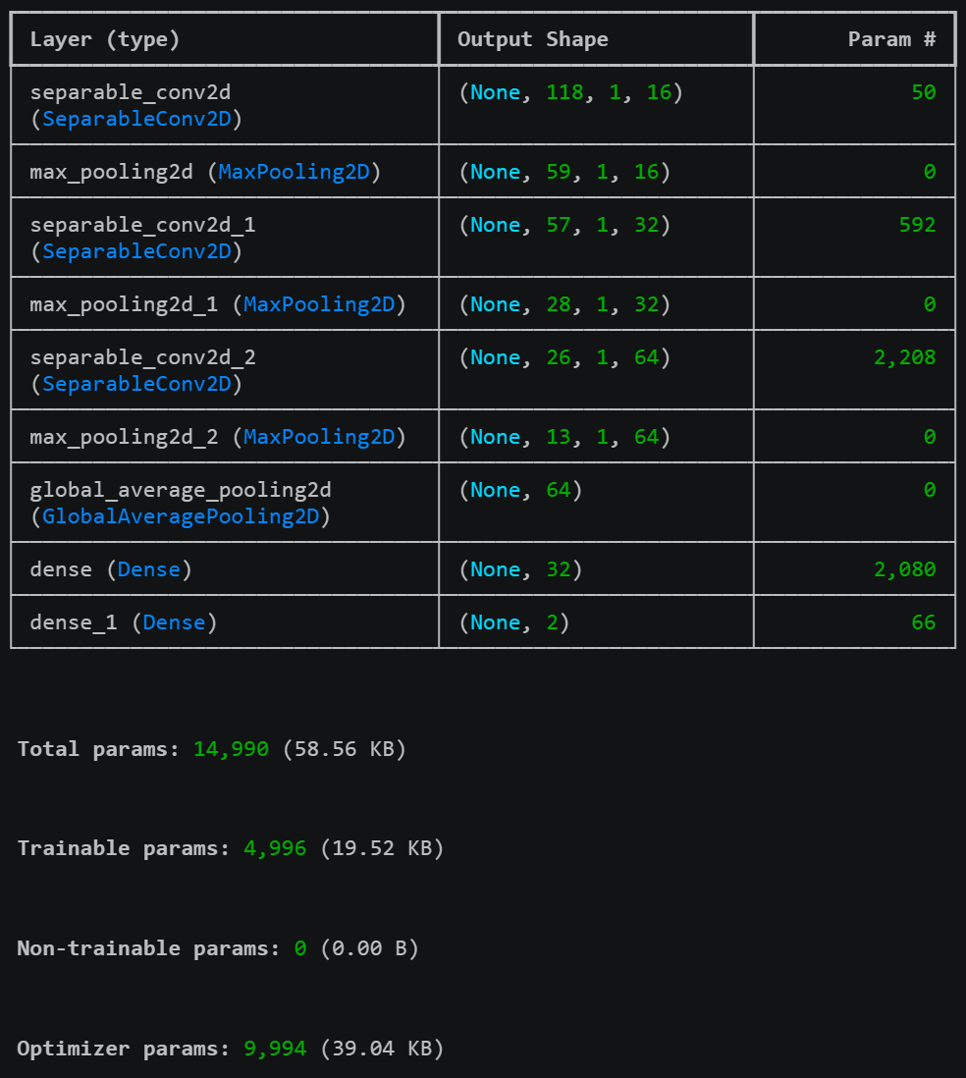
Stage 2: Audio Emergency KWS Model (CNN)
The audio model processes the MFCC spectrogram generated from the sensory-gated microphone input.
- Input Layer: tensor (N_MFCC N_FRAMES).
- Spectral-Temporal Extraction: The architecture uses multiple SeparableConv2D layers with kernels (with padding='same') to detect patterns in both frequency bins and time.
- Dimensionality Reduction: Each convolutional block is followed by a Max Pooling layer. This effectively reduces the spectrogram size by half in each stage, allowing the model to learn increasingly abstract representations of the target keywords ("HELP", "CANCEL").
- Parameter Efficiency: By utilizing Separable Convolution, the model separates spatial and depth-wise convolutions. This is critical for the Audio model, as it allows for a deeper feature extraction pipeline (64 filters in the final layer) without exceeding the 80 KB tensor arena allocated on the Arduino.
- Classification: The final architecture concludes with a Dense layer of 32 neurons and a Softmax output for the three target classes: Help, Cancel, and Background.
This leads to having a total number of parameters of 14990, about 64 KB of arena size needed.
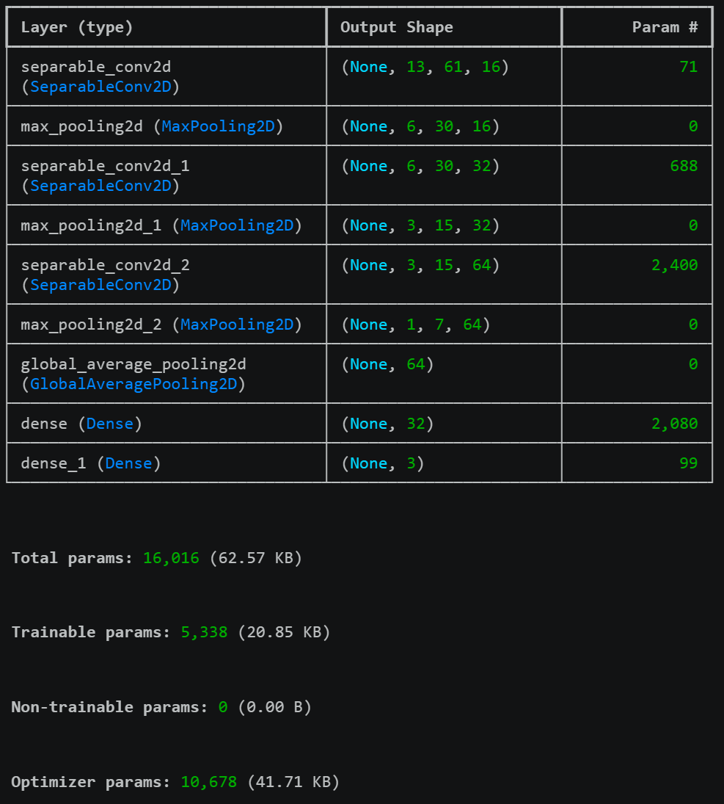
Both models prioritize Depthwise Separable Convolutions, which break down a standard convolution into two smaller operations. This choice was deliberate: it allows the "FallAndCall" system to run two distinct neural in rapid succession) without triggering a memory allocation on Arduino Nano 33 limited SRAM.

3.2 Training results

3.2.1 IMU “Fall” model
At the final epoch, the IMU classification model achieved a training accuracy of 95.43% (Loss: 0.1135) and a validation accuracy of 83.33% (Loss: 0.2895). While the validation loss indicates a slight degree of variance, the model’s performance is optimized for its specific role as a primary trigger in a multi-stage system. This performance gap suggests that the current dataset size of 300 may not fully encompass the high variance inherent in human fall dynamics, such as varying impact angles and descent speeds. Consequently, further iterative training with a larger, more diverse dataset would be required to narrow this generalization gap.
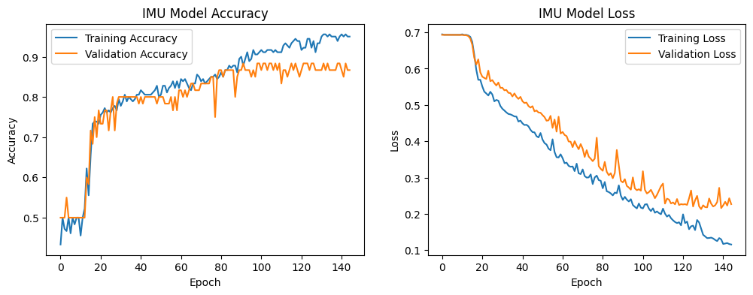
Despite this variance, the model’s performance is strategically optimized for its role as a primary "Sensory Gate." An analysis of the confusion matrix reveals a Recall of 86.67% and a False Positive Rate (FPR) of 20.00%. In a safety-critical application like "FallAndCall," a high FPR is an acceptable engineering trade-off to ensure maximum sensitivity. By prioritizing Recall, the system ensures that hazardous events are rarely missed. The resulting 20% false alarm rate is effectively mitigated by the Stage 2 Audio Model, which performs high-precision verification. This tiered architecture allows the system to maintain rigorous safety standards while remaining computationally and power efficient.
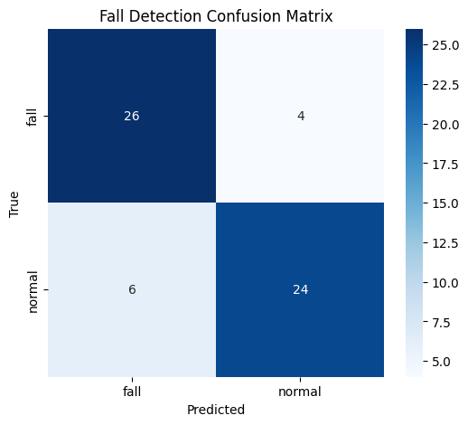
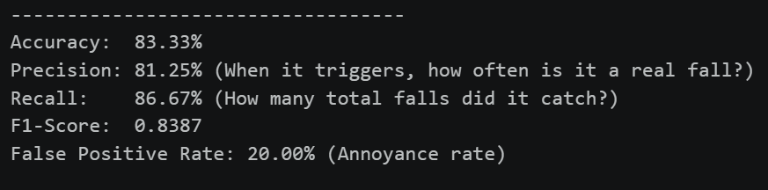

3.2.2 Audio “Emergency” model
At the final epoch, the audio classification model achieved a training accuracy of 100.00% (Loss: 0.0002) and a validation accuracy of 98.36% (Loss: 0.0314). These results indicate that the Separable CNN architecture is exceptionally robust at identifying spectral patterns within the MFCC spectrograms. The minimal validation loss suggests that the model has successfully generalized across the various environmental noise profiles integrated into the augmented dataset to ensure real-world reliability.

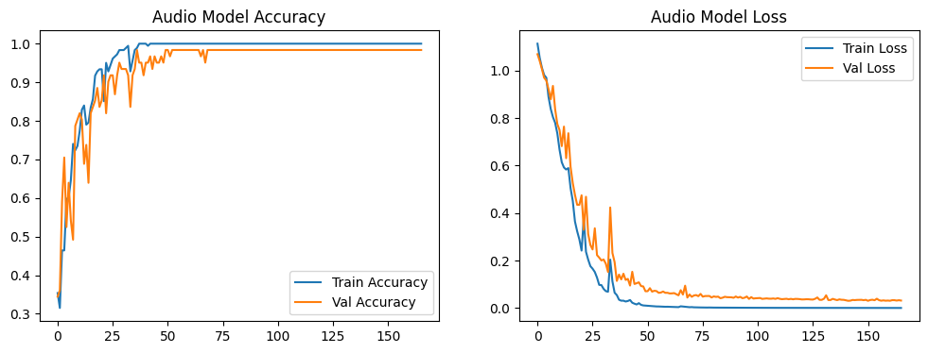
The performance of this second stage was further validated using a dedicated test set of 61 samples, where the model achieved an overall accuracy of 95.00%. An analysis of the classification report reveals high precision across all target keywords, specifically achieving a 95.00% precision for the "HELP" class. This high level of certainty is critical as it serves as the final verification layer of the "FallAndCall" pipeline. While the IMU model is biased toward high sensitivity to ensure no physical falls are ignored, the audio model is optimized for high precision to prevent unnecessary emergency dispatches.
The model demonstrated a 100.00% recall for the "BACKGROUND" class, ensuring that environmental noise is effectively filtered out and does not trigger false alarms. Furthermore, the 90.00% recall for the "CANCEL" class provides a dependable fail-safe, allowing users to manually dismiss the alert. By achieving near-perfect F1-scores across all categories, the system effectively mitigates the false positives generated by the initial sensory gate, ensuring the device remains both trustworthy and power-efficient.
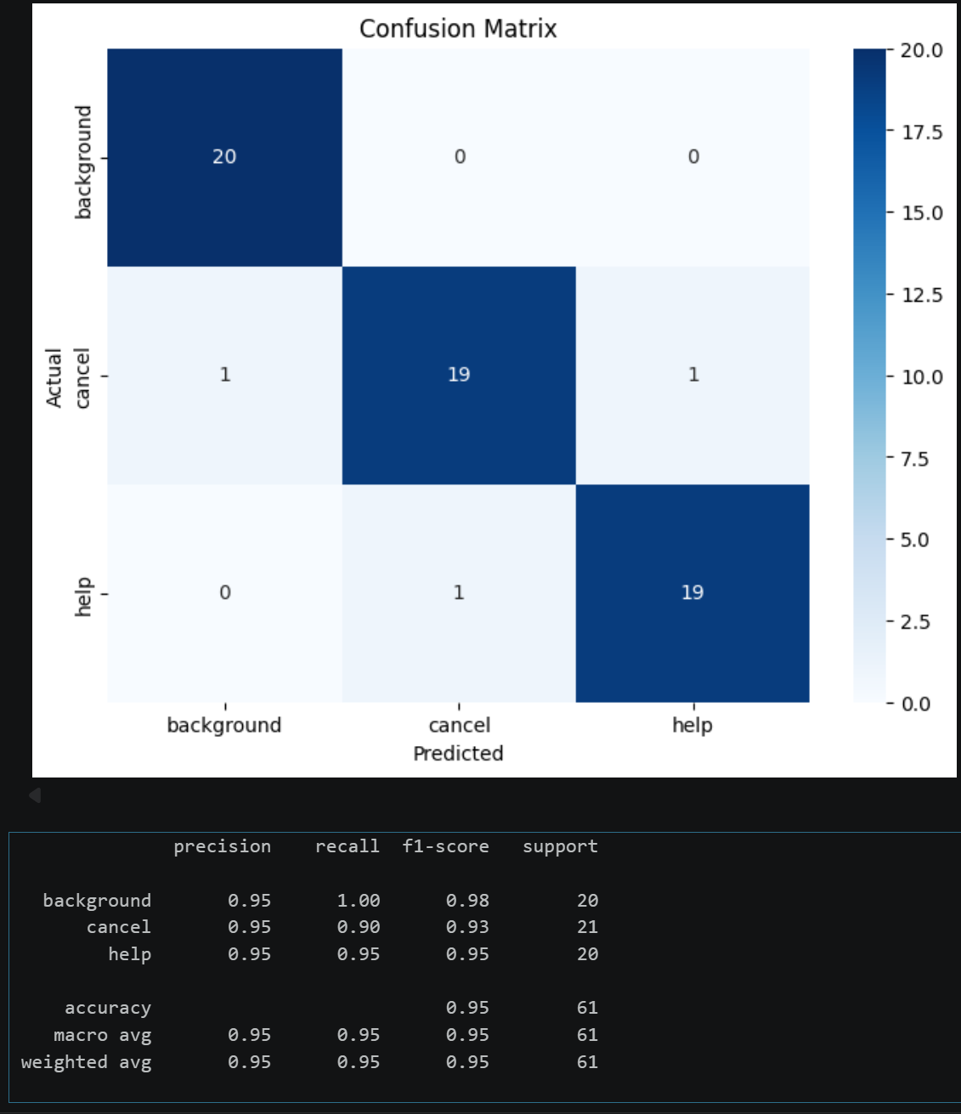

4. TensorFlow Lite Model Conversion
Both models were converted to .tflite format using the TFLiteConverter.
- Final Model Sizes:
  - fall_model.tflite (25708 bytes)
  - emergency_model.tflite (27064 bytes)
Both models were then converted to C header files for use on the Arduino Nano 33.
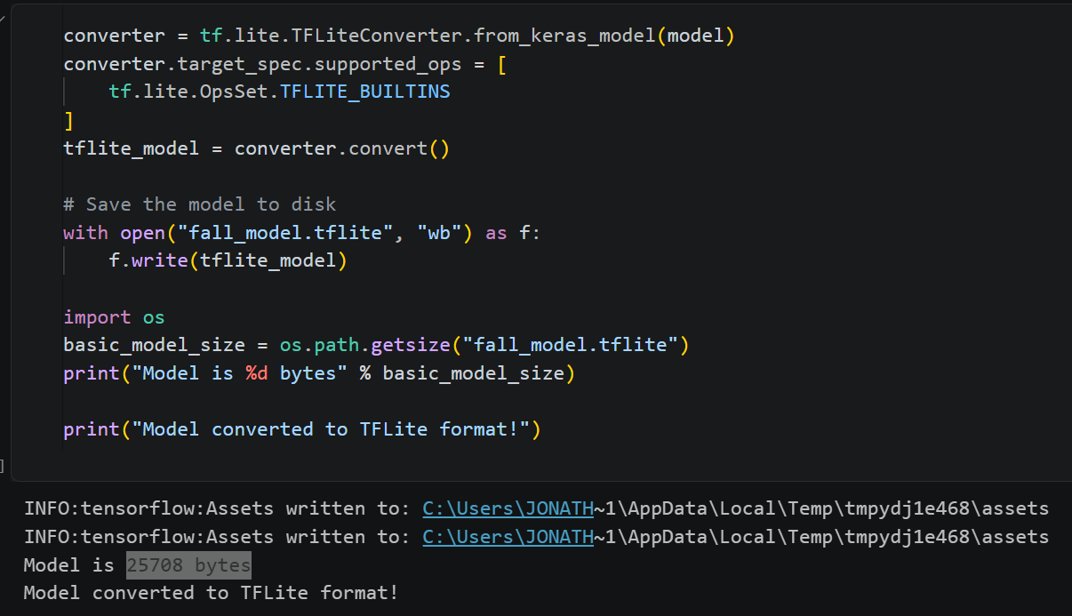
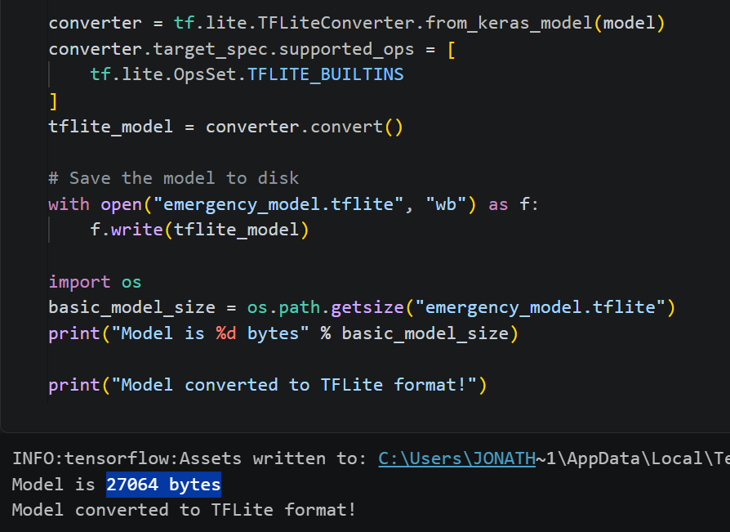

5. Arduino Implementation

5.1 System State Machine
The system is governed by a finite state machine (FSM) to manage hardware resources and computational load. By transitioning between states, the device ensures that the high-power PDM microphone and audio inference engine are only active when physically necessary.
- IDLE: The default low-power state. The system continuously polls the LSM9DS1 IMU at ~119Hz, populating a circular buffer of 120 samples. The state transitions to VERIFYING only if the resultant acceleration magnitude exceeds the IMPACT_THRESHOLD of 4.5G.
- VERIFYING: Once an impact is detected, the system captures 80 additional "post-impact" samples. After a 1.5-second delay, it performs two checks: a tilt angle calculation and the Stage 1 IMU CNN Inference.
- LISTENING: If the IMU model confirms a fall, the PDM microphone is activated. The system extracts MFCC features and runs the Stage 2 Audio CNN Inference every 0.5 seconds to detect keywords.
- ALARM: If "HELP" is recognized with high confidence (set at >0.75), the system triggers the emergency alert, indicated by a sustained high-intensity LED signal. The actuator can be improved and implemented in the future.
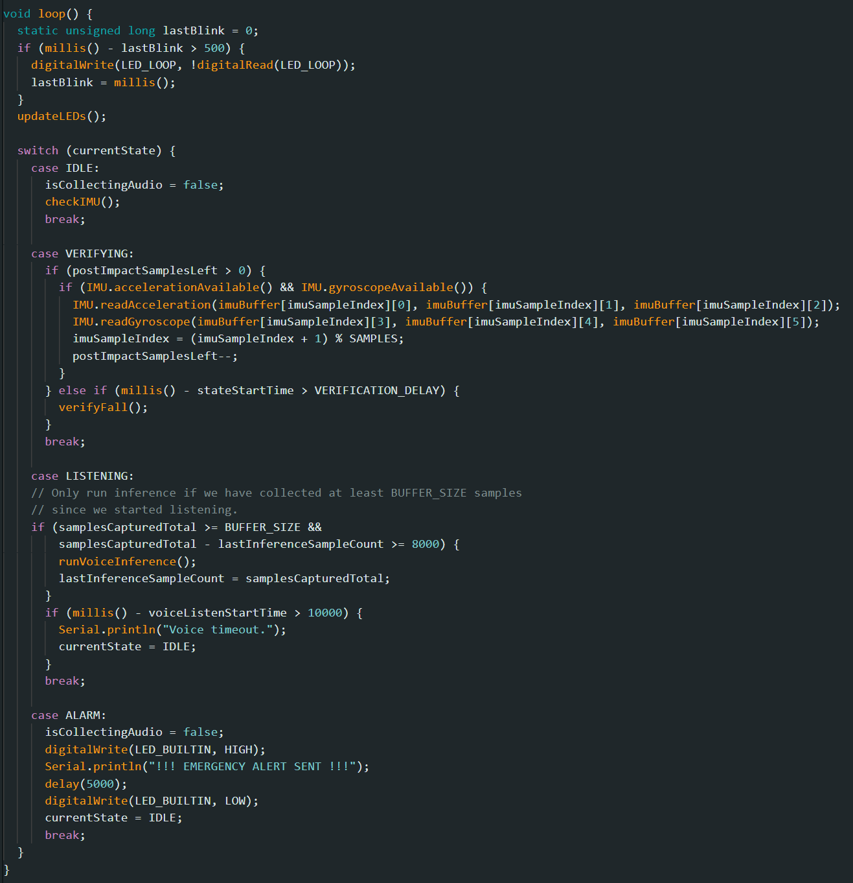
5.2 Real-time Data Handling: Circular Buffers and Sliding Windows
To process continuous sensor data on a resource-constrained microcontroller, the system employs circular buffers. This allows the device to keep a "rolling window" of the most recent data without needing to shift large arrays in memory, which would be computationally expensive.

5.2.1 IMU Pre-Impact Window
The system maintains a imuBuffer[120][6]. In the IDLE state, the IMU constantly overwrites the oldest data. When an impact is detected, this buffer already contains the ~40 samples (approx. 0.33s) of data immediately preceding the impact. This "look-back" capability is crucial for the CNN to identify the weightless "free-fall" phase that occurs before the 4.5G hit. Then it will record the rest of the 80 samples, following exactly how the model was trained.
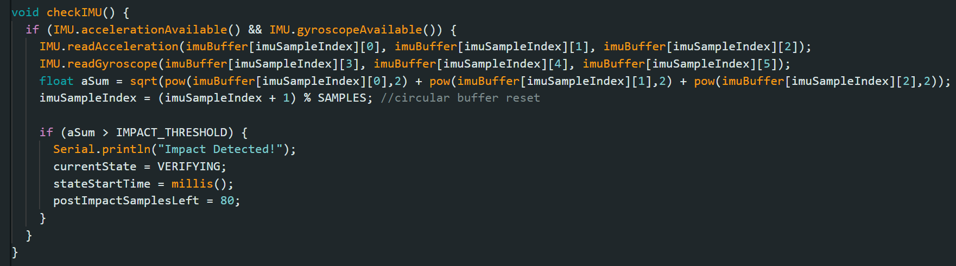
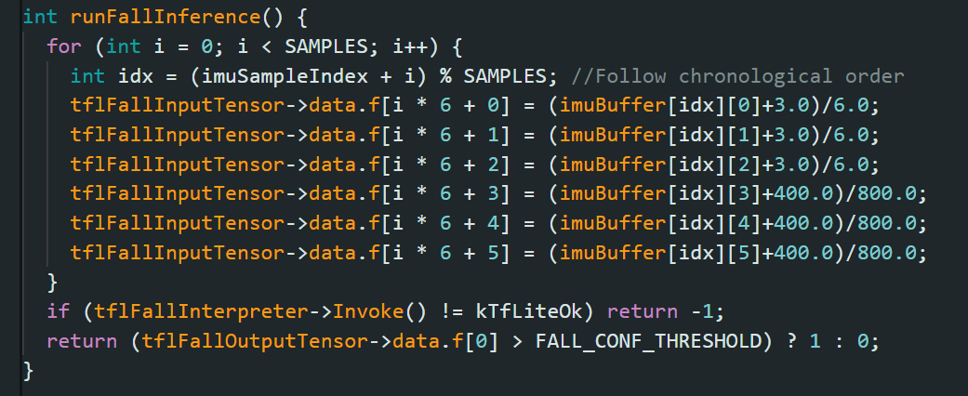

5.2.2 Audio Sliding Window Inference
For the Audio Stage, a circular audio_buffer stores the incoming PDM samples. Because speech keywords can occur at any time, the system uses a Sliding Window Inference approach. Every 500ms, the system "slides" its focus across the buffer to perform MFCC extraction.
- Overlap: By triggering inference more frequently than the length of the window (1 second), the system ensures that a keyword like "HELP" is captured even if it was split across two buffer cycles.
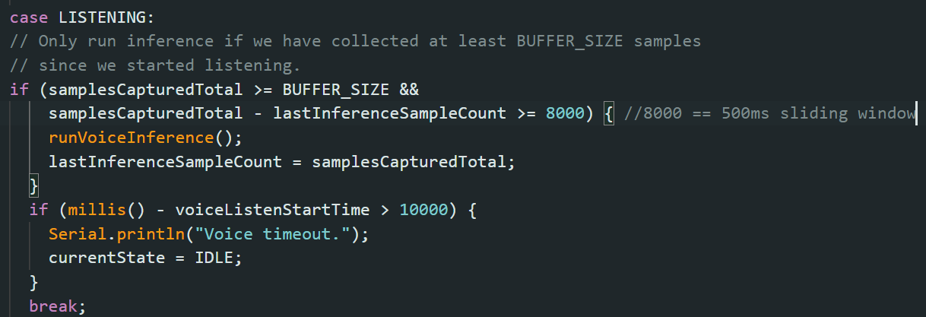

5.3 Special Features

5.3.1 Orientation and Stillness Verification
To supplement the neural network and reduce false triggers from simple device drops, a physics-based orientation check is performed using a Dot Product calculation. If the angle is greater than 60 degrees and the magnitude remains near 1.0G (indicating the user is now lying still), the system proceeds to ML inference.
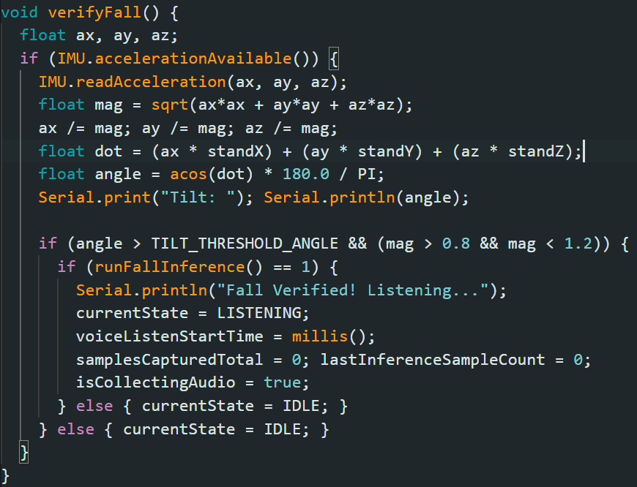

5.3.2 Memory Optimization: Shared Tensor Arena
The Arduino Nano 33 BLE has 256 KB of SRAM, which must accommodate PDM buffers, MFCC tables, and model tensors. A critical optimization is the use of a Shared Tensor Arena. Both the Fall and Emergency models are allocated to the same 80 KB tensorArena. Because the FSM ensures that Stage 1 and Stage 2 never infer simultaneously, the memory space is safely reused. This "time-multiplexing" allows for more complex models than if both were resident in memory at once.
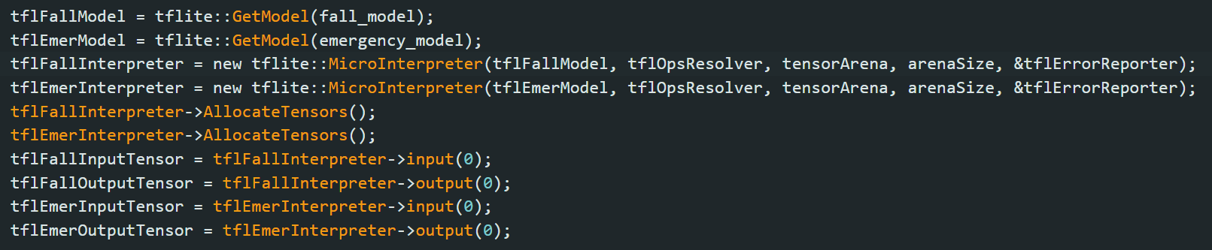
5.4 Overall Execution Flow
The loop() function is designed for high-efficiency polling. By keeping the computationally expensive MFCC extraction and CNN Invoke() calls behind a sensory gate (the IMU trigger), the device minimizes battery drain. Pre-calculated Hanning windows and DCT matrices further accelerate the MFCC pipeline, ensuring the system can process audio in real-time without dropping PDM samples.

6. Conclusion
The "Fall & Call" project successfully demonstrates the efficacy of a multimodal, two-stage "Sensory Gating" architecture for emergency detection on resource-constrained hardware. By combining a physics-based trigger with dual TinyML models, the system achieves a robust balance between safety-critical sensitivity and real-world reliability.
The 2-stage gating mechanism proved to be significantly more effective than a single-stage trigger. While the initial IMU model was intentionally biased toward a high recall (86.67%) to ensure no falls were missed, this resulted in a 20.00% False Positive Rate (FPR). In a single-stage system, this would lead to frequent, intrusive false alarms. However, by implementing the Audio Emergency Model as a second gate, these false positives were effectively mitigated. The audio stage’s high precision (95.00% for the "HELP" class) and the inclusion of a "CANCEL" keyword functionality (90.00% recall) ensure that only genuine emergencies result in an alarm, while the user maintains final control over the system.
Furthermore, the implementation optimized the technical limitations of the Arduino Nano 33 BLE Sense through strategic engineering. The use of Depthwise Separable Convolutions reduced the parameter overhead, and the "time-multiplexing" of a shared 80 KB Tensor Arena allowed both models to coexist within the device's limited SRAM. Ultimately, this project validates that a tiered, multimodal approach not only enhances detection accuracy but also preserves battery life and user privacy by activating power-intensive sensors only when a high-probability event is detected. Future work may focus on expanding the training dataset to improve model generalization or integrating Bluetooth Low Energy (BLE) for remote smartphone notifications.

