

SC4031 INT OF THINGS: COMM & NETWKING
Term Paper (interim)

Topic: Communication Protocols for Smart Home IoT in Personal Area Networks
Jonathan Low Seng Kian, U2321652C
Video link:
Abstract
The Internet of Things (IoT), which refers to a system of devices connected over the internet, has created a shift from individual "smart gadgets" to integrated environments characterized by “Ambient Intelligence” within the residential automation sector. The functionality of these environments relies on the protocols used to facilitate communication between devices within the system. This requirement creates strict energy and hardware limitations, while also requiring support for a dense population of devices to connect with each other over the same communication network. The purpose of this report is to provide a comprehensive review of the Wireless Personal Area Network (WPAN) landscape through the generations of the WPAN technologies available today. I will review the technical architectures (or "protocol stacks") of the following WPANs: Bluetooth Low Energy (BLE), Zigbee, Z-Wave and Thread, as well as provide a comparative analysis of each of these WPANs against high-bandwidth Wireless Local Area Networks (WLAN) such as Wi-Fi. To do this, we will analyze the protocol stacks from the Physical layer to the Application layer to identify significant trade-offs associated with energy efficiency, scalability, and security that exist within the WPAN. We will also explore the impact of the standardization of the Matter protocol, as well as the incorporation of Datagram Transport Layer Security (DTLS) and the Zigbee Cluster Library (ZCL) protocols, on addressing the fragmentation that exists among current WPAN technologies.

1. Introduction
The current residential environment is going through a period of high digitalization. The increase in the demand for the ability to manage their energy consumption, increase home security, and provide a more intuitive experience to the user regarding their interactions with their smart home will lead to a substantially higher density of connected devices within each smart home in less than ten years (i.e., dozens or hundreds of connected nodes) (Lin et al., 2017). The above-described "constrained environments" will challenge the existing methods of communication when attempting to connect and interact with all the connected devices within the home. Most smart home devices (e.g., moisture sensor, smart lock etc.) operate utilizing a single coin cell battery that is expected to last for multiple years and a microcontroller with very little RAM and processing capability.
Consequently, many of the high-throughput protocols (e.g., Wi-Fi) available for Smart Homes are over-engineered for most of the tasks performed in Smart Homes. Overall, Wi-Fi works well with applications using large amounts of data, such as a video system, but Wi-Fi uses a high duty cycle and has a high energy consumption radio. Therefore, it is not appropriate for battery operated devices that consume little or no energy. This need has led to the development of Wireless Personal Area Networks (WPANs), which are designed to use a "low duty cycle", use as little energy as possible, and provide a good, short-use connection. This report attempts to classify these same short-range, low duty cycle WPAN protocols and document their technical foundations under the IEEE 802.15.4 standards, and analyze the trade-offs between performance, power consumption, range, and data throughput, as they relate to the "Iron Triangle" of the Internet of Things (IoT).
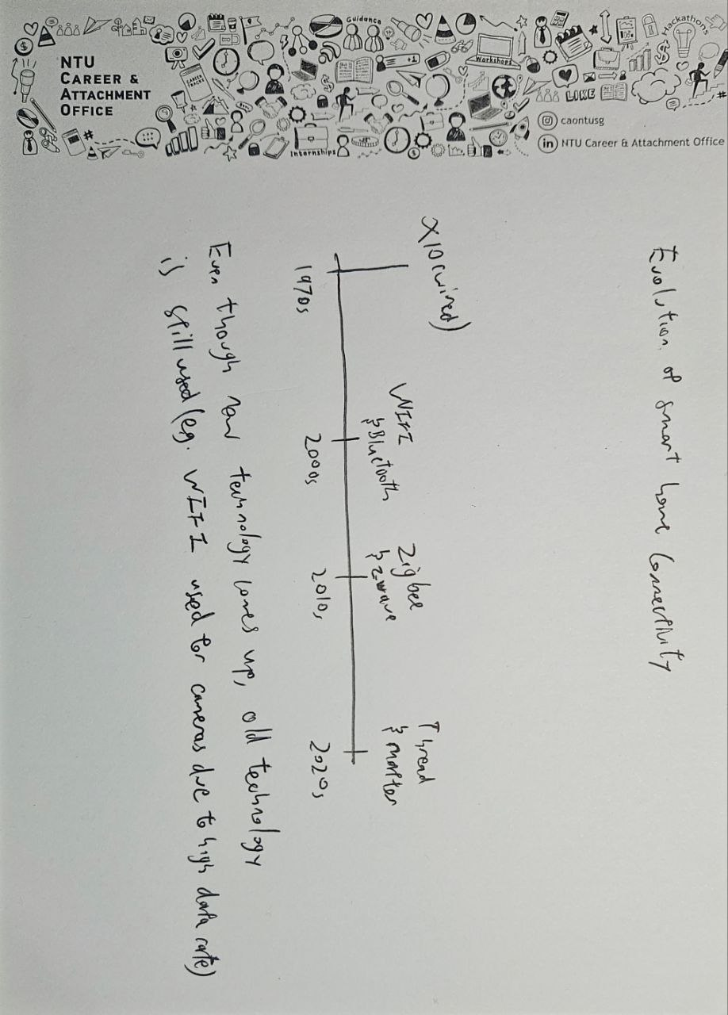
FIGURE 1: Evolution of Smart Home Connectivity.

2. Smart Home IoT Architecture: The Edge-Fog-Cloud Continuum
Current smart home systems operate with a multi-layered structure that balances the needs of local reliability and remote accessibility to manage the complexity of multiple types of, and heterogeneous, devices (Karagiannis et al., 2015).
2.1 The Edge Layer (Perception)
This layer contains the actual hardware for the physical environment where sensors, such as Passive Infrared and DHT22, collect data pertaining to environmental factors, such as temperature or activity, and actuators, such as smart relays and motorized blinds, execute an action on behalf of a user. Devices at the edge layer generally utilize Wireless Personal Area Network (WPAN) protocols, since edge devices typically require the strictest power management as they operate from battery or other low power sources.
2.2 The Fog Layer (Local Coordination)
At the Fog layer of the model, there are "intelligent" Hubs or Border Routers to provide local intelligence to an entire home. Fog-based devices bridge the local WPAN, from the Edge layer, to the primary Internet Protocol (IP) of the home. Furthermore, the Fog layer can ensure "Local Survivability" of a home's devices (Gomez & Paradells, 2010). This means, for example, if a home loses its Internet connection, then a local motion detector will still be able to turn on a light bulb, as long as there is a connection to the local gateway.
2.3 The Cloud Layer (Remote Intelligence)
The Cloud provides long term storage, complex logic processing, and synchronization of mobile applications. Additionally, the Cloud has been termed the main interface for a user to communicate with devices. However, the Cloud is now being seen as more of a resource for conducting advanced analytics on the data collected and less as a means for controlling devices in real-time, which will be left to the Fog layer.
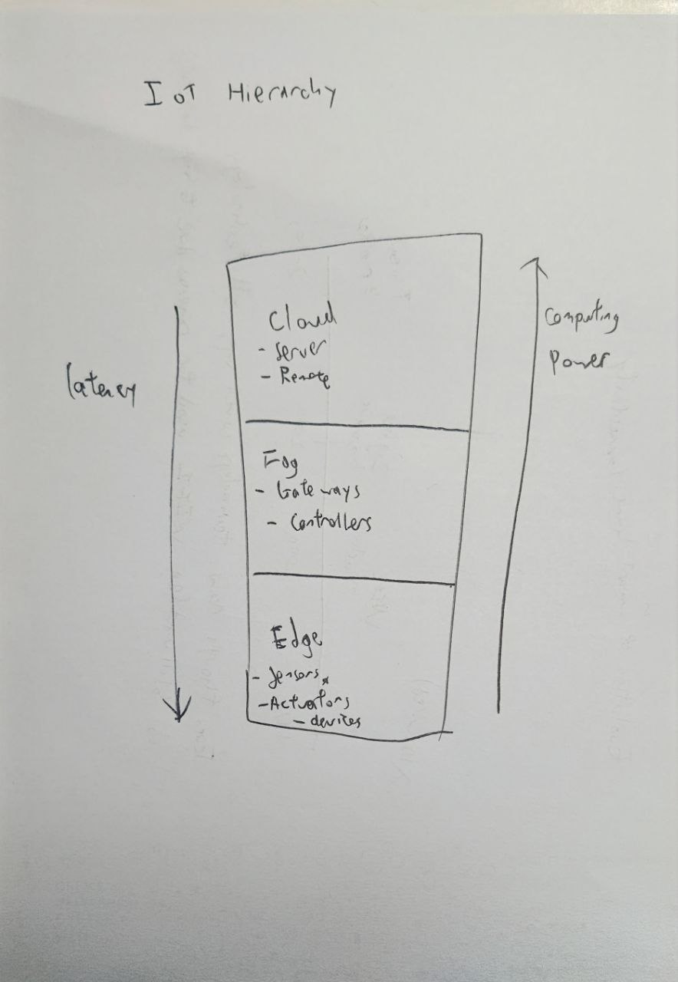
FIGURE 2: The 3-Layer IoT Hierarchy.

3. Technical Foundations: The IEEE 802.15.4 Standard
Low power wireless protocols such as ZigBee and Thread use both the physical layer (PHY) and the medium access control (MAC) layer from the IEEE 802.15.4 standard (IEEE, 2020).
3.1 The Physical Layer (PHY)
The PHY layer operates primarily in the 2.4GHz Industrial, Scientific, and Medical (ISM) band and uses Direct Sequence Spread Spectrum (DSSS). DSSS improves the robustness against interference caused by Wi-Fi and Bluetooth because it spreads a signal over a wider band of frequencies, thereby making the signal more robust against interference from other signals which operate on that bandwidth. The maximum effective data throughput for IEEE 802.15.4 is 250 kbps, which minimizes power consumption by reducing the amount of time that a radio is transmitting and the number of times that a radio must transmit large amounts of data.
3.2 The MAC Layer and CSMA/CA
The IEEE 802.15.4 standard uses CSMA/CA to control access to the channel. When a device wants to send data over an IEEE 802.15.4 network, it will determine if the channel is being used. If the channel is being used, the device will wait a random period of time before trying to retransmit. This allows multiple devices to use the same channel simultaneously, and helps maintain high density networks; however, this introduces additional latency when the network is congested (Baronti et al., 2007).
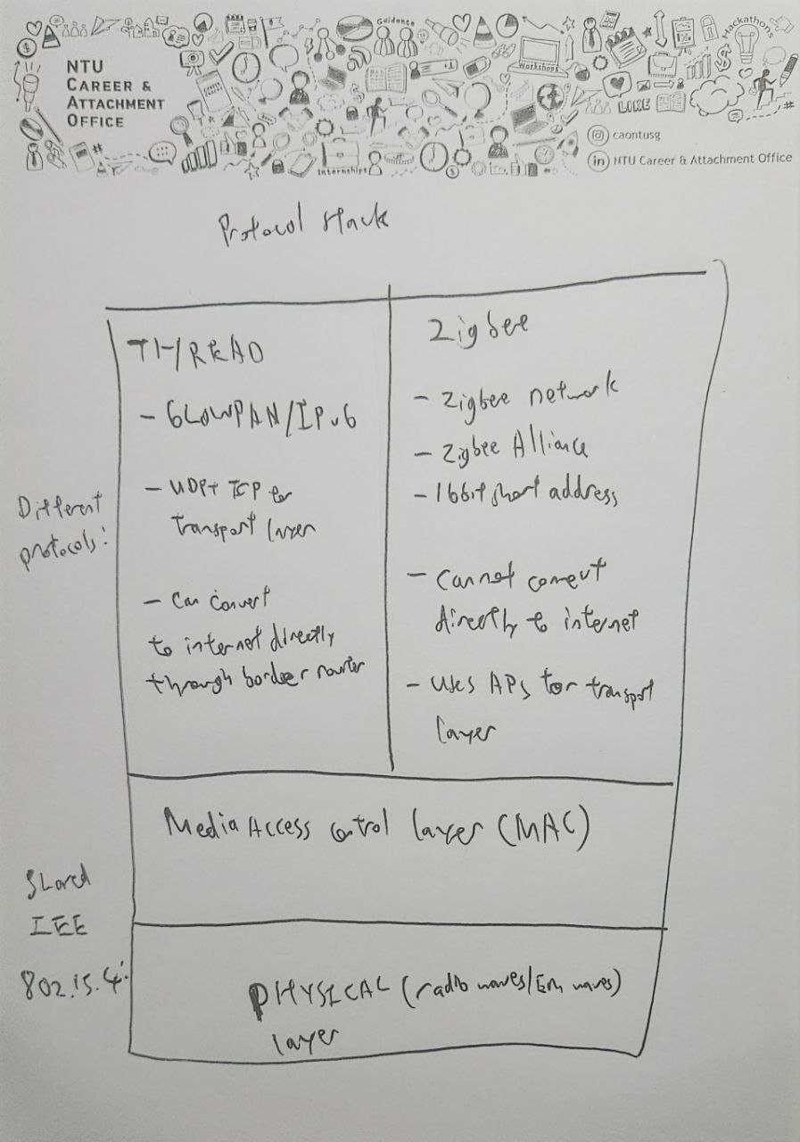
FIGURE 3: The IEEE 802.15.4 Protocol Stack. (only Zigbee and Thread)

4. Analysis of Major Protocols
4.1 Wi-Fi (The Connectivity Baseline)
Wi-Fi is the most ubiquitous protocol in the modern home. Its primary strength lies in its native IP support, allowing devices like smart speakers or cameras to connect directly to the internet without a specialized hub. However, for a sensor meant to run on a coin-cell battery for two years, Wi-Fi's power overhead remains a critical barrier.
4.2 Bluetooth Low Energy (BLE)
Bluetooth Low Energy (BLE) is designed to operate with very low duty cycles, which allows sensors to run on coin cell batteries for years at a time while consuming less power than the other protocols. By spending up to 99% of their operational time in a deep sleep state, BLE consumes the least amount of power of any of the protocols that were reviewed. Upon waking from deep sleep, BLE devices communicate through a very short (1-3 milliseconds) burst of time to send small amounts of data, then return to deep sleep. BLE operates in the 2.4 GHz ISM band using 40 channels spaced 2 MHz apart. BLE utilizes Adaptive Frequency Hopping (AFH) to minimize the effects of interference from high traffic Wi-Fi signals by dynamically hopping away from "noisy" channels to maintain the stability of the link. BLE is largely limited to the star topology, this means that there is one master central device that connects via point-to-point links to many BLE peripherals. This star architecture makes BLE the leading option for localized "personal" Internet of Things (IoT) applications, that is, applications for wearables or health monitors. One of the challenges of the star topology is that as you move farther away from the master device, the signal quality can degrade. Therefore, to achieve whole-home automation with BLE, you must deploy specialized repeaters. In order to provide a solution to this problem of scalability, the BLE Mesh standard was developed, which provides a way to communicate in a manner like the self-healing mesh capabilities of Zigbee or Z-Wave. The commissioning phase uses BLE almost exclusively. The reason this is the case is because nearly all modern smartphones have a BLE radio, thus the smartphone serves as a secure out-of-band channel for the device on which the BLE radio is implemented to receive the network credentials (such as Wi-Fi password or Thread security key) from the smartphone.

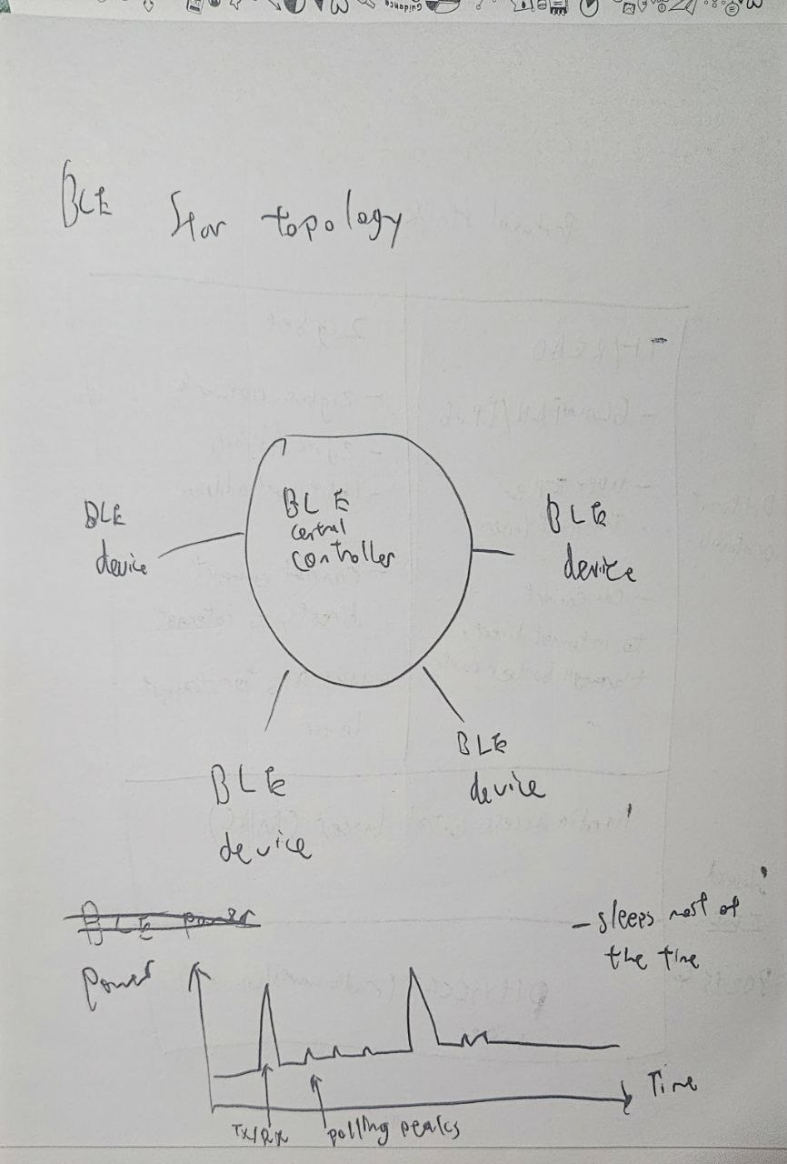
FIGURE 4: BLE Star Topology & Energy Consumption
4.3 Zigbee
Zigbee is an existing mesh network protocol. A Zigbee network consists of two parts which are a Network (NWK), which is a logical way for devices on the same Zigbee network to communicate and how to get that communication to the Internet if desired, to an Application Support Sub-Layer (APS). The Zigbee Cluster Library (ZCL) is also a very critical component of the success of Zigbee (Zigbee Alliance, 2019).
The Zigbee Cluster Library is the standard language that devices use to communicate with one another. This is very important because there can be many different manufacturers of devices in the Internet of Things (IoT) but if one manufacturer's hub sends a command to "turn on" another manufacturer's light bulb, the command will be understood the same way. The ZCL standardizes how devices from different manufacturers can function together.
These devices are clumped together into Clusters (e.g. On/Off Cluster, Level Control Cluster) and assigned Attributes (e.g. "Current State") and Commands (e.g. "Toggle"). The devices are grouped together with other similar types of devices and functions. By standardizing Clusters in this manner Zigbee is able to move the interoperability problem from the network layer to the application layer so that the developer can concentrate on functionality and not translating between protocols. An example of this would be the Temperature Measurement Cluster, which defines how many decimal points a Manufacturer should be able to display for a Temperature Measurement Device, thereby creating device consistency across multiple Manufacturers.
This standardization enabled the interoperability of devices, which has made Zigbee the primary protocol for smart lighting devices and providing monitoring capability for industrial sensors. The ZCL also allows for a technique known as "Binding" where a switch (device) can directly control a light (device) without using the central coordinator. By using this technique to bind devices together it reduces the amount of time (latency) needed for a command to be executed and increases the overall reliability of the Zigbee system.
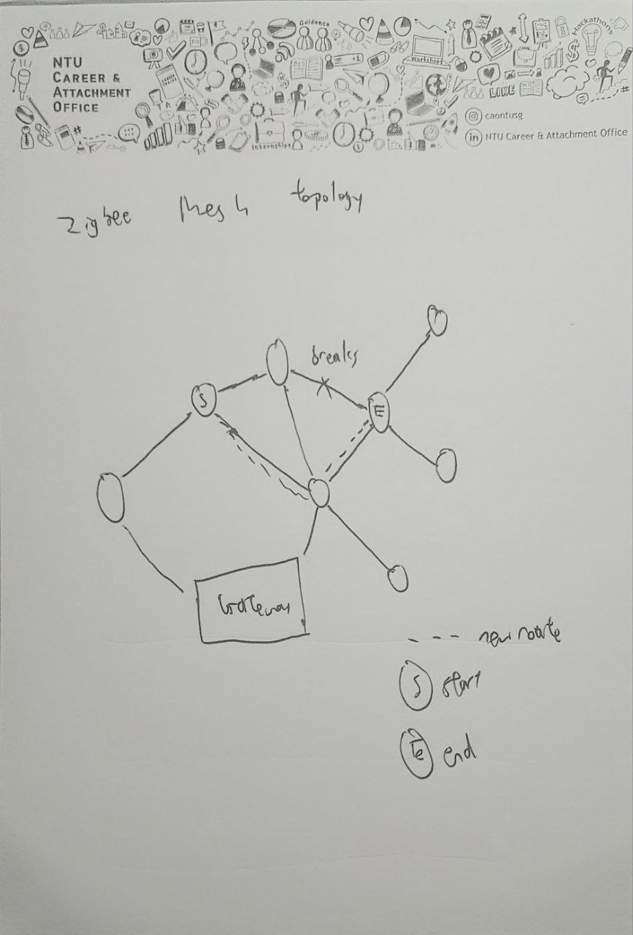
FIGURE 5: Zigbee Mesh Network Resilience.
4.4 Z-Wave
All other protocols discussed operate on a crowded international frequency range of 2.4 GHz, whereas Z-Wave's primary distinguishing feature is its operating frequency in the sub-gigahertz (900 MHz) range. Since lower frequency waves have longer wavelengths than higher frequencies, their signals attenuate less through common building materials (e.g., concrete and wood) than higher frequency waves (Z-Wave Alliance, 2021). Therefore, by using a lower operating frequency than Zigbee or Wi-Fi, Z-Wave devices will have improved range when used indoors and enhanced ability to penetrate floors in multi-story residential buildings, where the signals of higher frequency devices may have problems doing so ("dead zones").
In addition to having an advantage at the physical layer, Z-Wave's "Interoperability by Mandate" philosophy sets it apart from Zigbee. Historically, Zigbee manufacturers could implement non-standard software clusters, whereas Z-Wave requires that every device go through a validated certification program and be tested by a centralized authority to ensure that it is compatible with every other Z-Wave device manufactured. This creates an ecosystem that is highly stable for the customer, but has resulted in Z-Wave being a "closed" standard for many years, resulting in higher costs than its counterparts while having lower data rates (100kbps)).
From a networking perspective, Z-Wave employs a Source-Routed Mesh architecture. As a result, the central controller must determine the best route for a given packet and embed that route in the transmission, which reduces the processing overhead for the small, battery powered sensors. However, source routing limits the maximum number of hops to four and thus the total network capacity to a maximum of 232 nodes.
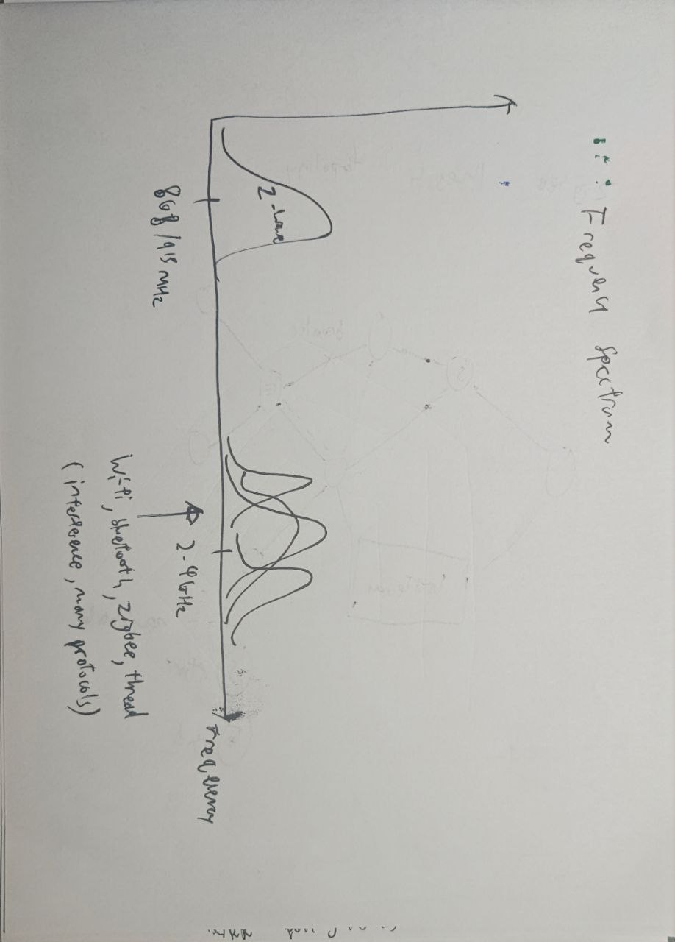
FIGURE 6: Frequency Spectrum Comparison
4.5 Thread
Thread uses 6LoWPAN (IPv6 over Low-Power Wireless) in place of custom networking layers. To conserve resources, Thread employs UDP instead of TCP and requires Datagram Transport Layer Security (DTLS) (Rescorla & Modadugu, 2012).
DTLS is a variant of TLS designed for use with unreliable datagram transports like UDP. Standard TLS assumes reliable transport like TCP thus it cannot run on UDP as it does not guarantee order and delivery, so DTLS implements its own sequence numbers and retransmission timers specifically for the handshake phase.
In a Thread network, DTLS provides "bank-grade" security between a device and the commissioner. When a new device connects to the mesh, it will securely exchange encryption keys via DTLS. DTLS also prevents replay attacks and man-in-the-middle eavesdropping by encrypting the payload and providing a small enough overhead to allow it to fit within a 127-byte frame of IEEE 802.15.4. Without DTLS, Thread's native IPv6 addressing is an open door for attackers, making Thread one of the most secure protocols in the Internet of Things (IoT) ecosystem, while enabling end-to-end encryption from a sensor directly to the cloud, something that Zigbee failed to accomplish without introducing complex application-layer gateways.
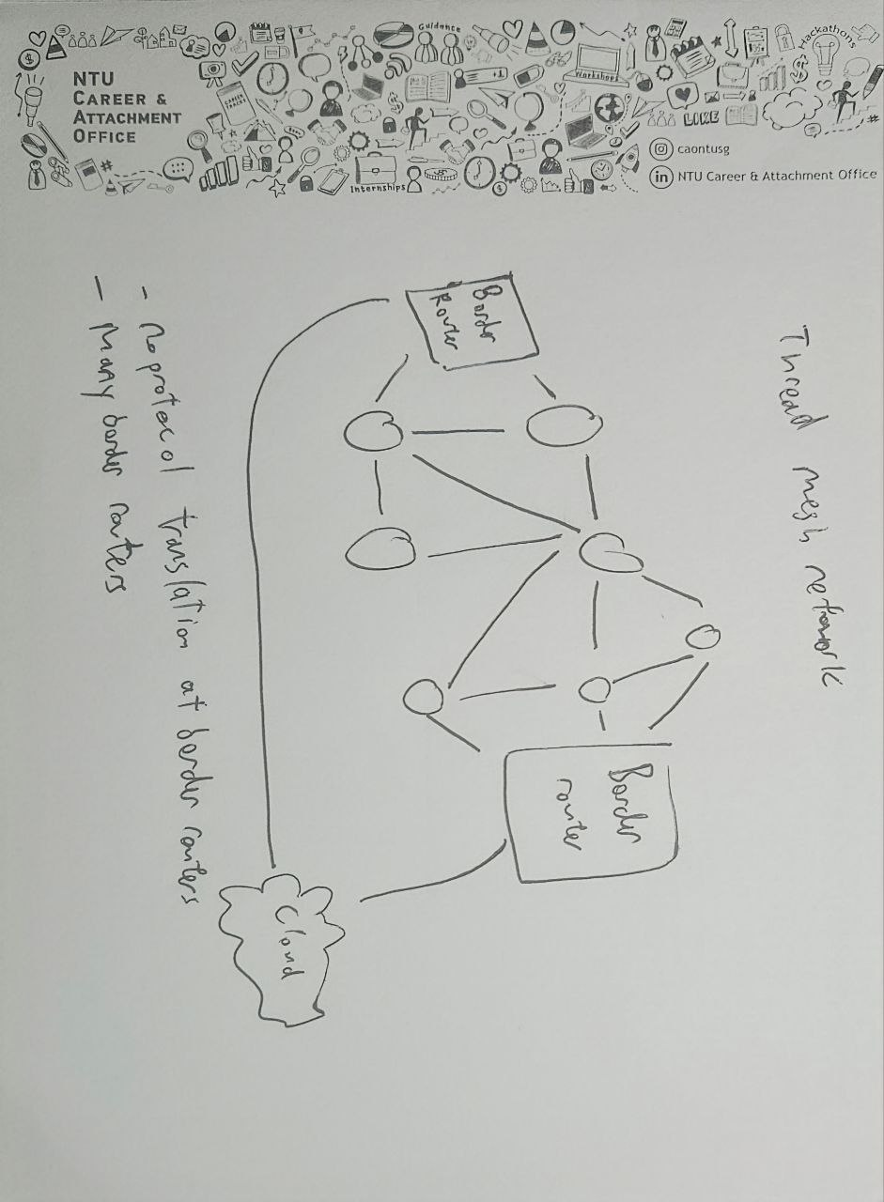
FIGURE 7: Thread and the IPv6 Advantage

5. Comparative Analysis: Performance and Trade-offs
The following analysis examines the critical trade-offs between bandwidth, power, range, scalability and interoperability as visualized in the Performance Radar Chart.
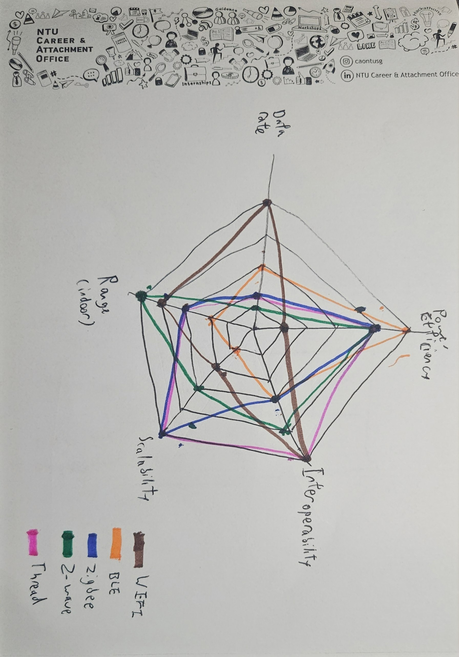
FIGURE 8: Performance Trade-off Matrix.
5.1 Critical Comparison Analysis
The "Smart Home Protocol Wars" are characterized by competing interests from disparate elements within the smart home ecosystem, as illustrated in Figure 8. Wi-Fi is an outlier because most of its radar shape is skewed towards throughput and interoperability, with nearly all homes having at least one Wi-Fi router, as a result, the "interoperability" score is particularly strong. However, Wi-Fi scored the lowest in the "Power Efficiency" category in the survey. This creates a divide functionally, Wi-Fi is the protocol primarily used for "Plugged-in" powered devices in the home (e.g. smart speakers, TVs and cameras), it is a poor choice for devices in the home that operate on battery power and therefore require many years of operation without replacing batteries ("Sleeping" IoT devices).
On the other hand, Bluetooth Low Energy (BLE) is the most power-efficient IoT wireless communication protocol available today, by sacrificing scalability and range, BLE can last for many years when running off a single CR2032 (type 2032 battery). This is why BLE has become the dominant choice for wearables, however, when it comes to whole home lighting, for example involving 50 or more light bulbs, BLE has significant latency issues due to the lack of native mesh routing and therefore all traffic travelling through the central controller will create a bottleneck at that point.
Zigbee and Thread position themselves on "Scalability," with a focus on mesh networking. Thread mainly superior due in large part to its "Interoperability" of natively supporting IPv6 while Zigbee uses a translation gateway. Thread also offers end-to-end encryption, which typically makes devices using Thread cost more despite having often identical hardware.
Z-Wave still leads in "Range" and interference resiliency because it operates in the sub-GHz band providing a "clean lane" that is not available to the 2.4 GHz protocols; however, it also has the lowest "Data Rate" of the reviewed protocols.
Most agree that the future of smart homes will look something like a Hybrid of wired and wireless technologies (CSA, 2024; Gomez et al., 2010), with Wi-Fi being the predominant technology for high-bandwidth "Eyes and Ears" (cameras and speakers). In comparison, one would expect Thread or Zigbee to serve as the "Central Nervous System" for the sensors. The introduction of the new Matter standard is expected to merge the two previous extremes by allowing devices to leverage the benefits provided by both networks example, Thread, for low-power mesh stability, and Wi-Fi, for fast cloud synchronisation.

6. Challenges and Future Directions
6.1 The Matter Standard
One of the most significant issues that the Internet of Things (IoT) is facing today is known as "Protocol Siloing." For example, if I have a light bulb that uses Zigbee technology and a motion sensor that uses Thread technology, for these devices to communicate, I will have to develop a complex cloud to cloud integration. Matter, an open standard from the Connectivity Standards Alliance (CSA), is designed to break down these barriers by providing a unified application layer that is built on top of both Wi-Fi and Threads. Each device also implements a common data model so that devices from different manufacturers such as Apple, Google, and Amazon can work together on the same local network.
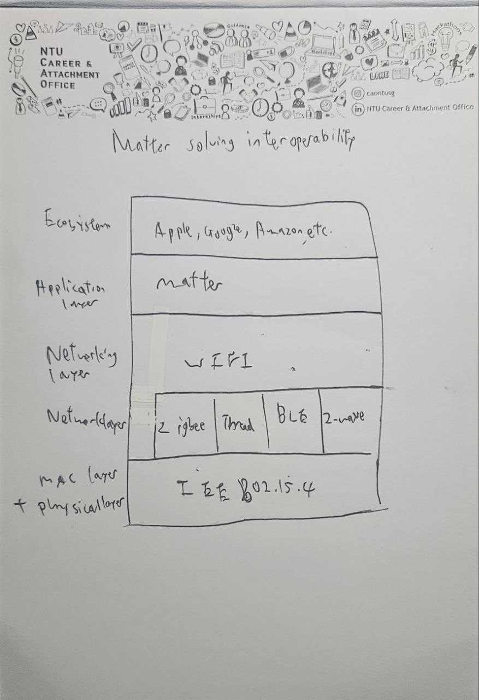
FIGURE 9: The Matter "Universal Translator" Model.
6.2 Edge Computing and 5G
With more devices being connected to the Internet of Things (IoT), the problem of "Cloud Latency" (the time it takes the user's device to send data to the cloud and receive a response back) has become a significant barrier for real-time automation. Future research will involve moving much of the AI and automation software from remote servers to local Edge Servers (Shi et al., 2016). By processing data locally, the homeowner will not only receive a higher level of privacy but will also benefit from millisecond responsiveness because of the local processing. The use of 5G for backhaul will ensure the home's continued connection to the wider world with high reliability.
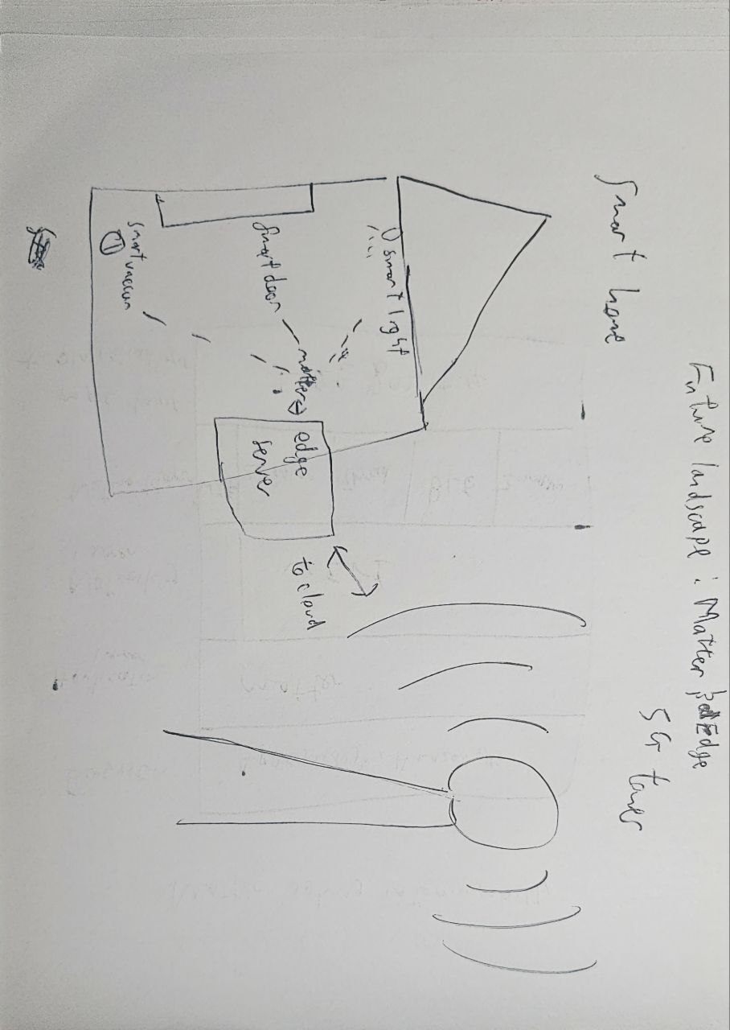
FIGURE 10: The Future Landscape: Matter and Edge.

7. Conclusion
Smart home communication is all about finding the proper balance between competing priorities. Wi-Fi is the dominant technology for media rich applications but Personal Area Networks (PAN) such as Zigbee and Bluetooth Low Energy (BLE) provide the energy efficiency needed for the pervasiveness of IoT. Additionally, the development and adoption of standards like the Zigbee Cluster Library (ZCL) and security frameworks like Datagram Transport Layer Security (DTLS) have helped to establish a foundation for a more robust ecosystem. The IoT industry is moving toward the Matter standard and will begin to shift from basic connectivity to seamless, secure, and vendor-neutral interoperability.
3066 words
References
Al-Sarawi, S., Anbar, M., Almagwashi, K., & Al-Tamimi, A. K. (2017). Internet of Things (IoT) communication protocols: Review. 2017 8th International Conference on Information Technology (ICIT), 685–690. https://doi.org/10.1109/ICIT.2017.8079928
ArXiv. (2026). Zigbee vs. Matter over Thread: Understanding IoT Protocol Performance in Practice. arXiv preprint arXiv:2603.04221v1.
https://arxiv.org/html/2603.04221v1
Baronti, P., Pillai, P., Chook, V. W. C., Chessa, S., Gotta, A., & Hu, Y. F. (2007). Wireless sensor networks: A survey on the state of the art and the 802.15.4 and ZigBee standards. Computer Communications, 30(7), 1655–1695. https://doi.org/10.1016/j.comcom.2006.12.020
Connectivity Standards Alliance. (2024). Matter Specification Version 1.3.0.1. Retrieved from https://csa-iot.org/wp-content/uploads/2024/05/matter-1-3-core-specification.pdf
Gomez, C., & Paradells, J. (2010). Wireless home automation networks: A survey of architectures and technologies. IEEE Communications Magazine, 48(6), 92–101. https://doi.org/10.1109/MCOM.2010.5473869
Gomez, C., Oller, J., & Paradells, J. (2012). IPv6 over BLUETOOTH Low Energy: Standards and challenges. IEEE Communications Magazine, 54(12), 88–95. https://doi.org/10.1109/MCOM.2016.1600210RP
IEEE. (2020). IEEE Standard for Low-Rate Wireless Networks (IEEE Std 802.15.4-2020). IEEE.
Karagiannis, M., Chatzimisios, P., Vazifehdan, M., & Papadopoulos, G. (2015). A survey on communication protocols for IoT. 2015 International Wireless Communications and Mobile Computing Conference (IWCMC), 281–286.
Lin, J., Yu, W., Zhang, N., Yang, X., Zhang, H., & Zhao, W. (2017). A survey on Internet of Things: Architecture, enabling technologies, security and privacy, and applications. IEEE Internet of Things Journal, 4(5), 1125–1142. https://doi.org/10.1109/JIOT.2017.2683200
Rescorla, E., & Modadugu, N. (2012). Datagram Transport Layer Security Version 1.2 (RFC 6347). IETF. https://doi.org/10.17487/RFC6347
Shi, W., Cao, J., Zhang, Q., Li, Y., & Xu, L. (2016). Edge computing: Vision and challenges. IEEE Internet of Things Journal, 3(5), 637–646. https://doi.org/10.1109/JIOT.2016.2579198
Z-Wave Alliance. (2021). Z-Wave Specifications. https://z-wavealliance.org
Zigbee Alliance. (2019). Zigbee Cluster Library Specification. https://zigbeealliance.org
Declaration on Use of GAI (Generative Artificial Intelligence) Assistance

I __Jonathan Low Seng Kian (Student name), ___ _________JLOW100___@e.ntu.edu.sg (NTU email) honestly and sincerely make the following declaration in relation to the following course submission:

- Name of Course: INT OF THINGS: COMM & NETWKING
- Course Code: SC4031
- Course Coordinator: TAN Rui, Ph.D.
- Title of Assignment/Project Submission: Term Paper interim check

In relation to the foregoing I hereby declare that, fully and properly in accordance with the Project Instructions, I have (tick where appropriate):

  - Not used GAI assistance in any way in the development or generation of this
assignment ☐
  - Used GAI as permitted to assist in generating key ideas only. ☐
  - Used GAI as permitted to assist in generating a first text only. ☐
And/or
  - Used GAI to refine syntax and grammar for correct language submission only. ☐

If I have used GAI, I also declare that I have:
- Fully and honestly submitted the digital paper trail required under the assignment/project instructions; and that
- Wherever GAI assistance has been employed in the submission in word or paraphrase or inclusion of a significant idea or fact suggested by the GAI assistant, I have acknowledged this by a footnote; and that,
- Apart from the foregoing notices, the submission is wholly my own work.


Jonathan Low 22/4/2026
_____________________________ _________________
Student Name & Signature Date

