

SC4015 Cyber Physical System Security
Side-Channel Analysis Individual Report
AY25/26 S2

Name | Matriculation Number
Jonathan Low Seng Kian | U2321652C

1- Introduction
The purpose of this laboratory experiment was to examine the vulnerabilities of embedded cryptography implementations with respect to physical security through an evaluation of side channel attacks (SCA). While AES-128 and other cryptographic algorithms are considered cryptographically unbreakable in a practical time frame mathematically, their physical implementation on actual hardware can exhibit a measurable amount of leakage. As part of the laboratory experiment, I did one method of measuring the power consumed by a physical device executing an AES-128 algorithm as it executes an algorithm using power analysis. The measurement of electrical fluctuations in power consumed by a device can be used as an alternative method for retrieving sensitive information like the key being used to implement AES-128. Therefore, this lab was aimed at demonstrating how software based security measures could be entirely circumvented by observing how physical devices behave.

2- Brief Background
Power Side-Channel Attacks
A Power Side Channel Attack utilizes the fact that the instantaneous power consumption of a microcontroller is dependent on the data that it is processing. A CMOS based digital circuit consumes power when logic gates change state. As a result, a CMOS based circuit will consume different power depending on the number of “1” bits of the data being processed or the number of bits transitioning between states. By measuring the instantaneous power consumed by a microprocessor while processing data could be utilized to determine the internal activity of the microprocessor and any confidential or proprietary information being processed without actually breaking into and deciphering the mathematical logic within a cryptographic algorithm.
Target AES-128 Operation
The goal was to target the first round of the AES-128 encryption algorithm. Our main target was to attack the output of the S-Box (Substitution Box) which performs a non-linear substitution operation after the plaintext is XORed with the initial round key (AddRoundKey). This operation occurs after XORing the plaintext with the first key and produces the first intermediate value from the secret key to the known plaintext, making it an excellent target for an attack. The S-Box is also non-linear in its design, so any single-bit change in the input will cause a large change in the output, which generates the power leakage necessary for statistical correlation.
Correlation Power Analysis (CPA)
Correlation Power Analysis is a statistical technique used to isolate and identify the correct key from the numerous electrical waves produced in a circuit. Correlation power analysis uses a Power Model, typically the Hamming Weight (HW) which counts the number of “1” bits in a binary number. Since the power consumed by the chip is proportional to the HW of the binary data processed, we can construct hypothetical power models of the 256 possible byte values that could be used in a key. When we look at the hypothesized power models and correlate them to the actual power trace using the Pearson correlation coefficient, the key that has the strongest statistical correlation with the actual power trace will be the correct key.

3- Lab Proceedings
Experimental Setup and Communication
The experiment employed a combination of hardware and software within the experimental environment, and my target was a microcontroller programmed with a standard AES-128 implementation. I created a serial communication link (UART) between the host PC and target device using the communication_with_target.py Python script to send a random 16-byte plaintext to and receive the ciphertext from the target. The power supply line of the target was connected to the digital oscilloscope via a shunt resistor to capture the instantaneous voltage drop across the resistor during the AES encryption process. Once the communications between the PC and oscilloscope was established, then we apply the trigger signal to synchronize the acquisition of traces with the SCPI commands provided by the microcontroller.
Power-Trace Collection
The collection of trace data transitioned from manual calibrating of data acquisition instruments to automated data collection. Initially, I used the oscilloscope to manually adjust the horizontal time scale, vertical gain, and trigger threshold until I obtained the desired trace of power consumption from the 10 rounds of AES encryption. I then automated the process by generating multiple traces through the implementation of a Python script (sca_working_example.py) that applied SCPI command syntax to retrieve raw waveform data from the oscilloscope and convert the data to a NumPy array for plotting purposes. I discovered that it is necessary to capture multiple traces because the collected single trace will be distorted by random variations in the acquisition system, thus, it is ideal to average or statistically process a large number of traces so the correlation can isolate the signal from noise.
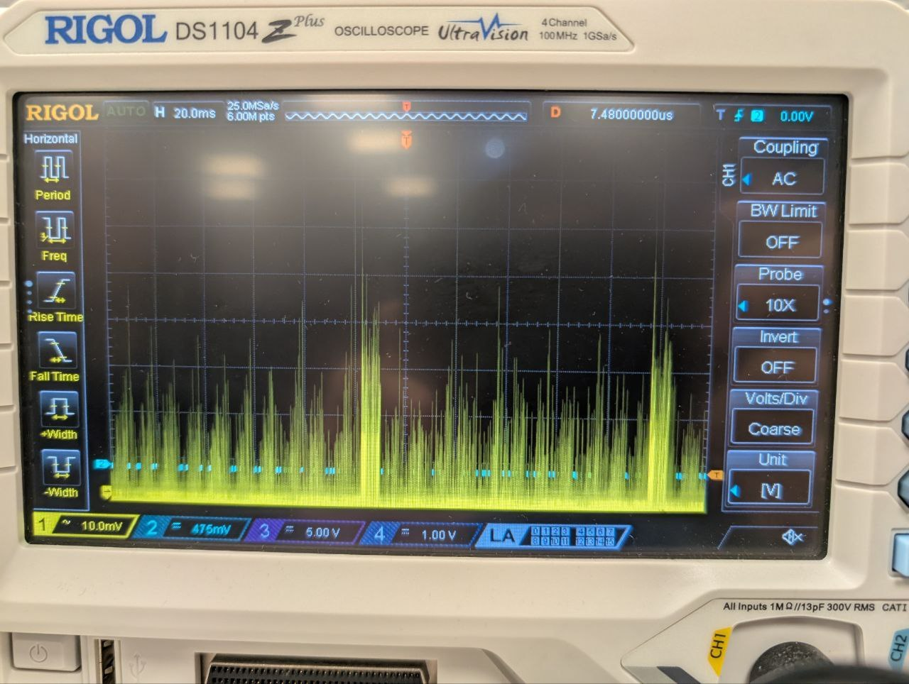
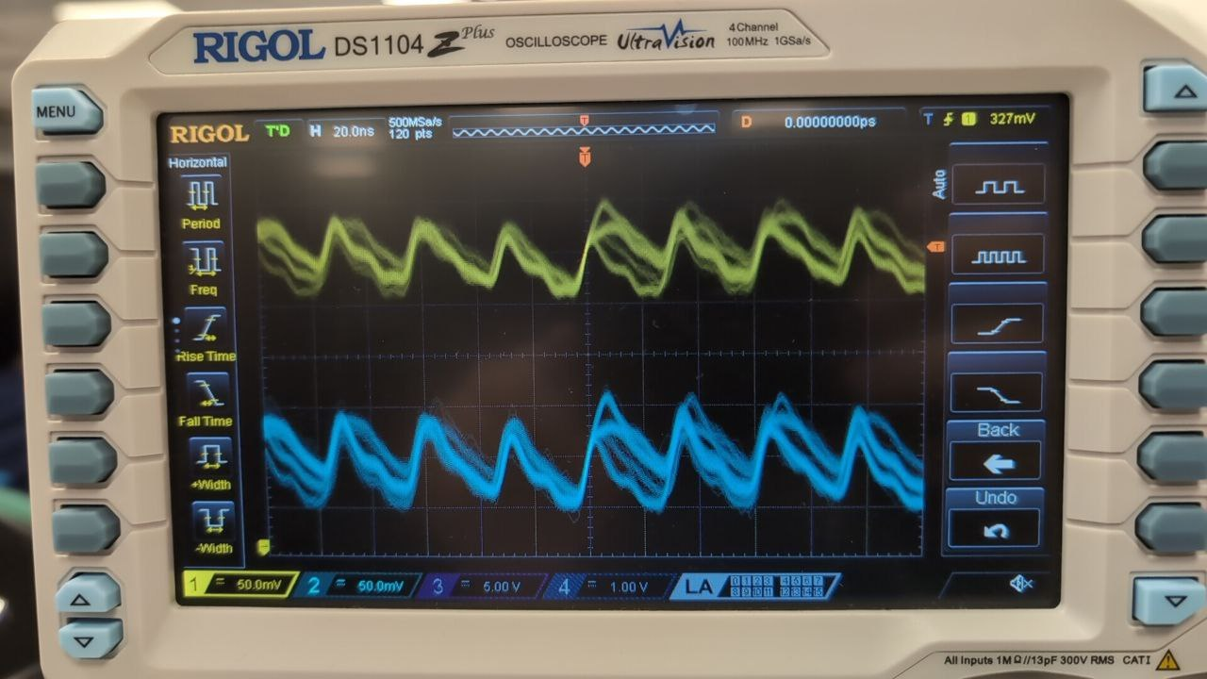
CPA Methodology and Implementation
The analysis was carried out programmatically via the cpa_implementation.py file using a rigorous mathematical workflow. The workflow consisted of three main components:
- Intermediate Value Prediction: For each possible key guess (0-255), I calculated the expected output value of the S-Box based on the publicly available plaintext data.
- Hamming Weight Mapping: Then, I converted the 8-bit expected values into their respective Hamming weights to generate a theoretical power consumption matrix.
- Statistical Correlation: Next, I used the scipy.stats.pearsonr function to measure the correlation between the theoretical matrix and the true captured power traces.

As I processed more and more traces, the correlation coefficient for the correct key guess became substantially higher than the noise created as a result of incorrect key guesses. This provides visual evidence of the attack, as there was clearly a peak in the correlation plot corresponding to the byte value of the secret key.

4- Inference and Conclusion
The findings of this lab are of great significance for hardware security. Namely, the key takeaway is that mathematical complexity does not equal physical security. An algorithm as strong as AES can be attacked in a matter of minutes assuming no countermeasures have been implemented in the hardware. Thus, this experimentation presents critical evidence in support of the need for robust side-channel protections in the design of embedded systems such as smart cards, IoT devices, and secure enclaves. As such, understanding how to defend against these types of attacks is essential to developing defensive mechanisms like masking or hiding techniques. This lab ultimately shows that security is a multi-layered discipline and that the physical attributes of the device are just as important as the code executing on it.

