

SC4015 Cyber Physical System Security
Smart Card Individual Report
AY25/26 S2

Name | Matriculation Number
Jonathan Low Seng Kian | U2321652C

1- Introduction
This laboratory session focused on evaluating and investigating two primary components necessary to enable contactless smart card technologies, communication protocols and security frameworks. Using the hardware reader of a smart card and various software interfaces, this laboratory session provided the ability for the host computer and the smart card to interface using Application Protocol Data Units (APDUs). The laboratory evaluated how three different types of smart cards perform these operations (the MIFARE Ultralight, MIFARE Classic, and CEPAS 2.0), with the objective of confirming the difference in security of the hardware and organization of the data associated with the smart cards use in current identification and payment systems.

2- Brief History
Evolution from Magnetic Stripes to Chip Based Cards
The difference in data integrity and security between magnetic stripe cards and smart cards, as is immediately apparent when comparing the two technologies, is significant. Magnetic stripe cards, the original version of the smart cards, were used for a great number of years, had no active processing capabilities in their magnetic stripe and were purely a passive means of storing information. The lack of ability for these cards to perform an active processing function meant that the devices would have no capability to perform complex cryptographic handshakes or mutual authentication as a means of preventing unauthorized access to or cloning of their data. While the invention of smart cards allowed for these capabilities.
Memory Maps and Card Features of Each Card
The memory map of each card examined in this lab has been created in accordance with specific factories and applications. MIFARE Ultralight, for instance, is a very low-cost solution specifically designed for limited-use types of cards, as in the example of a transit card. The structure of its internal EEPROM memory is a simple structure of sixteen pages, with four bytes per page.

MIFARE Classic, however, is a much more permanent card type used for more permanent types of applications such as an access card. It has a more complex hierarchy of sixteen sectors which are further divided into four blocks of sixteen bytes.

In the case of the MIFARE Classic, its security is managed via the sector trailer, which contains the Key A and Key B for authentication.

In the example of the CEPAS card, it is a specialized e-purse card in Singapore. The CEPAS card is constructed with a very secure architecture, allowing for the secure financial transactions of users while still allowing authorized readers to access specific fields within the data portion of the card (purse balance, transaction logs etc.).

3- Lab Proceedings
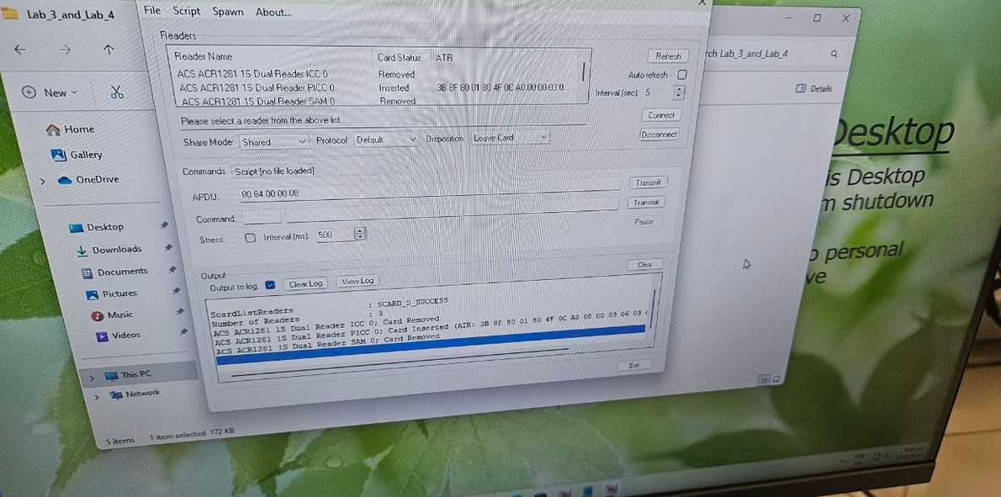
The data retrieval and modification procedures used in this lab were a multi-tool approach. The first set of tests conducted on MIFARE Ultralight were with the ACS Smart Card Reader Tool, where I could see the ATR (Answer to Reset) and view the memory pages of the card. I discovered that MIFARE Ultralight does not have a robust authentication layer and, therefore, allows for the direct reading or writing of data to the user pages as long as the lock bytes have not been set. This allowed for a clear demonstration of the memory card with free access to data on the card and where security was considered secondary to cost and convenience.
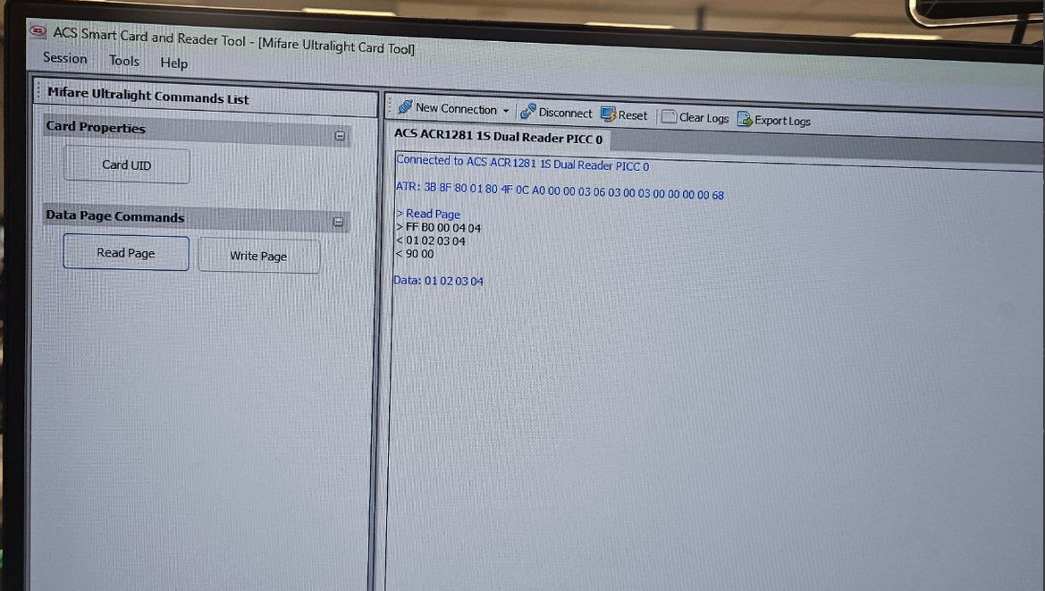
In transitioning to a Security-Focused Methodology for the MIFARE Classic, I realised that, as opposed to the Ultralight, the MIFARE Classic card will not allow any read or write attempts until it is properly authenticated. I learned how to load security keys into the reader and authenticate commands to specific sectors within the card (i.e., Sector Level Authentication). It is crucial to understand the role of the Sector Trailer in controlling Block Level Permissions.
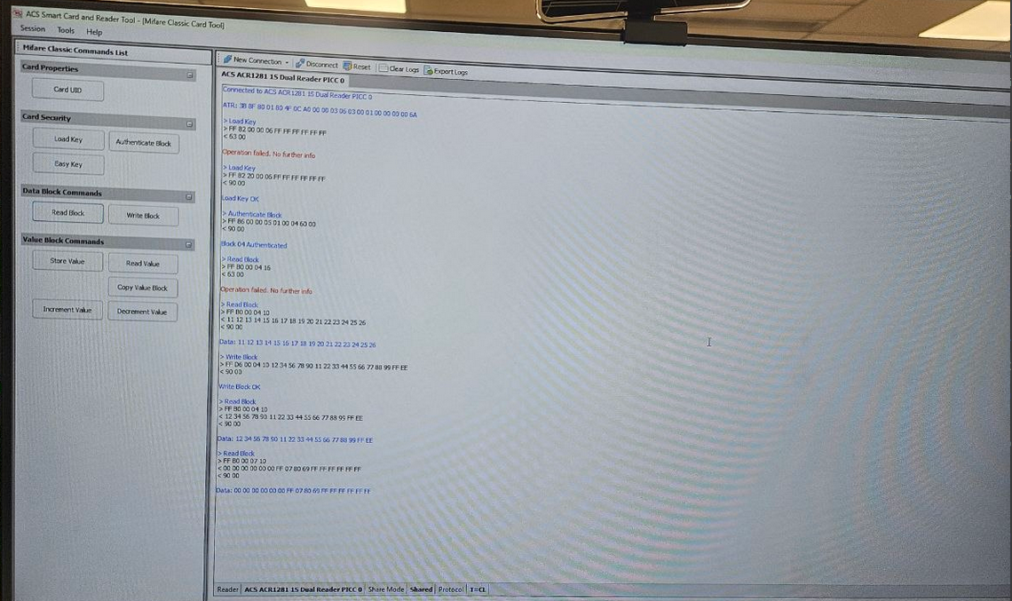
Furthermore, the lab taught us that by using Python scripts, we are able to automate the above interactions. By utilizing the pyscard Library, I learned how to establish a connection programmatically and parse raw hexadecimal (hex) response data. With the CEPAS card, I ran a script to extract the purse balance from the card by sending an APDU Command (Application Protocol Data Unit) and mathematically processing the hex response to identify where the value was stored in the payload and convert it to a human-readable decimal representation to show how much money remains on the card.

4- Security Comparison Between MIFARE Classic and MIFARE Ultralight
In terms of security, MIFARE Classic and MIFARE Ultralight represent two distinct security philosophies, security for MIFARE Ultralight (UL) depends on UL's limited capacity for memory storage and a simple set of lock bits that allow UL to prevent overwriting of previously stored data. This allows the UL card to be easily susceptible to unauthorized reading and/or cloning since there is no cryptographic barrier to stop anyone from dumping out the contents of a UL card. Security for the UL card is virtually limited to the physical security of having the UL cards in your possession and the anticipated short cycle life of the data stored on the UL card.
The MIFARE Classic card takes a much stronger stance in providing security mechanisms by requiring that all sectors undergo authentication through either Key A or Key B to access data. Therefore, any physical interception of the card will not yield unencrypted access to its data. Additionally, the technology allows for different sets of "access bits" to be defined within the sector trailer allowing for much more granular control over what access can be provided to both read and write functions, thus allowing for making a block "read-only" for public access while requiring higher level functions to allow for block writing. Even though MIFARE Classic's proprietary encryption scheme has known weaknesses when used in higher levels of security, it still has much greater overall security compared with Ultralight due to its structured multi-layered permission framework.

