Repadmin Tool  
Checking Active Directory Replication Status

To keep your Active Directory domain in a healthy state, you should periodically check the replication between domain controllers using the repadmin and dcdiag tools (we looked at using the dcdiag utility in a previous post. The Active Directory replication is fully automated, and proper planning and configuration of the AD architecture, sites, and replication schedules almost does not require manual replication management by system administrator. Indeed, in small AD domains with several DCs (2-5), there are usually almost no problems with replication. But in large infrastructures out of tens and hundreds of domain controllers, the domain administrator often has to intervene in the replication process and correct errors.

The repadmin command line tool can be used to monitor replication, track replication failures between domain controllers, and force data replication.

The repadmin utility in Windows Server 2003 was included in the Support Tools package, which needed to be downloaded and installed manually. In Windows Server 2008 R2 and higher, the repadmin tool is automatically installed on the domain controller when you install the ADDS (Active Directory Domain Services) role.

You can install repadmin on desktop Windows versions (Wndows 10/8.1/7). To do this, install RSAT and enable the AD DS and AD LDS Tools option.

# Use

To use repadmin, open a command prompt as administrator. You can list the full syntax of the command by typing:

Repadmin / ?

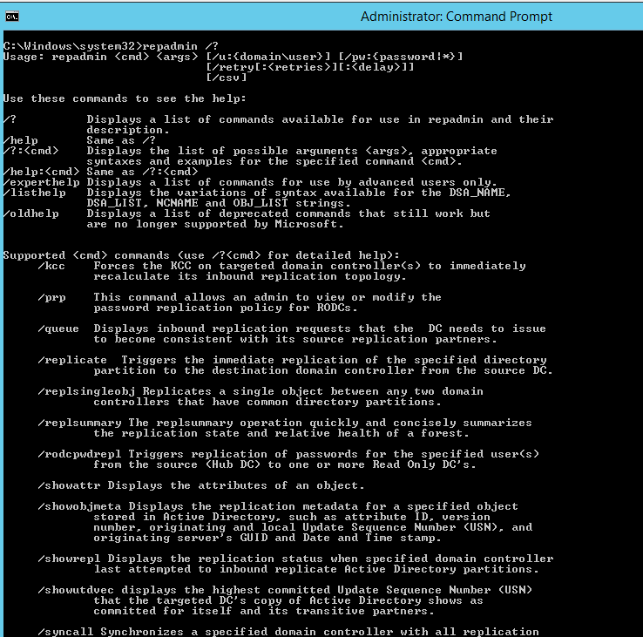

As you can see, the command has quite a few options. Let’s try to study some useful examples of using repadmin.

# Summary

Repadmin /replsummary

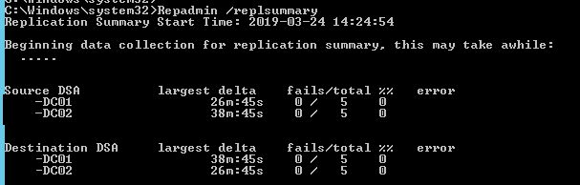

As you can see, there are only 2 domain controllers in the AD domain, between which there are currently no replication errors. Each server acts as a Source DSA and Destination DSA.

# Queue

Repadmin /Queue

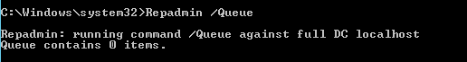

# Showrepl

Repadmin /Showrepl

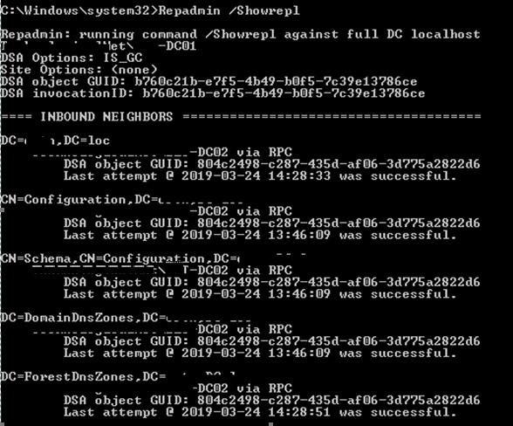

Using the command Repadmin /Showrepl, you can display the replication status for the current DC. It displays the time of the last attempt to replicate Active Directory partitions. If you think that some kind of domain controller is not receiving replication updates, run this command for it.

**Tip.** To display detailed information in any command, use the parameter /verbose.

The basic availability of the LDAP directory on a specific DC can be checked with the command:

repadmin /bind dc1.theitbros.com

# SyncAll

You can force the replication of the specified domain controller with all DC replication partners using the command:

Repadmin /syncall

It is not recommended to run this command in large Active Directory domains, since you can cause a heavy load on the network.

# SyncAll /Aes

To start replicating all Active Directory partitions across the entire forest, run the command:

Repadmin /syncall /AeS

When using this command, high load on communication channels is also possible.

# Repadmin /kcc

The Repadmin /kcc command tells the KCC (Knowledge Consistency Checker) on the specified DC to immediately recalculate the incoming replication topology (it runs automatically every 15 minutes).

# Repadmin /replicate

The Repadmin /replicate command allows you to replicate a specific directory partition from the source DC to the target. For example:

repadmin /replicate dc1.theitbros.com dc2.theitbros.com dc=theitbros,dc=com

Quelle :

<https://theitbros.com/repadmin-tool/>