COSC480 Project: New Zealand Population Information Application

Name: Xin Gao

Student No.: 43044879

How did I do the project?

At the very beginning, I was interested in various statistics about New Zealand population from the website StatsNZ because it helps me understand more about New Zealand. It would be interesting to do some analysis with those numbers using python. Then with the knowledge learnt from COSC131, as a beginner, I realised that I can do little about data analysis with the codes we learnt so far. Although the basics are fundamental and beneficial for us beginners, I decided to create something new so that my project looks like a real application or like everyone would expect as an application. So, I started to create a user interface to present the data.

I did not focus on plotting various figures because that is what we do in COSC131. In this project, I try to develop the whole application instead of focusing on the details, we can polish them later anyway. I spent a lot of time studying from websites and watching videos. Ultimately, I found a python library called “tkinter” which is quite handy and practical.

By choosing “tkinter”, I used label, button, entry, text and combo box as the elements to create the whole window object. The first thing I need to consider is how to arrange the layout of the dashboard. There are two ways, using either “.pack()” or “.grid()”. As the latter one can put each element in a spreadsheet-like layout so that the whole dashboard looks tidy, I chose “.grid()” to arrange everything. Then the difficulty is how to link the button with a function and show the result on dashboard in a proper way. Basically, you need to add the function name after the command argument in the button definition. The thing I learnt is to remove the “()” at the end of the function name, otherwise the function would be triggered automatically. Another thing is to filter the wrong input and give a warning message so that the application is easier to use.

I also used the skills from COSC131. Creating different classes and defining various functions within the class are probably the most important skills that I used in this project. Not only the method itself, but the way of developing a project using object-oriented programming is really beneficial and efficient. Matplotlib is another library we learnt that is extremely helpful. But I did not plot many fancy charts because I think this is supposed to be done in COSC131. I also used “np.loadtxt” to read the data, loops to print out the searching results and if sentences to filter the wrong inputs.

The data I downloaded from StatsNZ include:

New Zealand population between 1991 and 2020 (male, female and total)

Total personal income grouped by regions and New Zealand as a whole.

The limitations：

As a beginner of programming, it is a bit difficult to start a project at this stage. For example, the class definition and object-oriented programming is really helpful especially in a project. However, we only started to learn it from the last week of this semester. Although I have many fancy ideas, we still need some basics to start the project. However, our knowledge and skills are really limited. The good thing is that we started to explore something new out of COSC131 to carry out the results that we need in the project. I assume this maybe the real situation in our work in the future that you always need to learn how to solve problems by yourself from multiple ways you can access. And finally, there must be a way. I believe this ability is the most important skill throughout our whole life. In addition, I never thought about having my own application before, even a small one. This project pushed us to give it a go and we have made it at the end. I appreciate the change to encourage us to have this small and big step. And of course, we still have a lot to improve in the future.

Instructions of the Application:

Run the program, you will see the interface below:

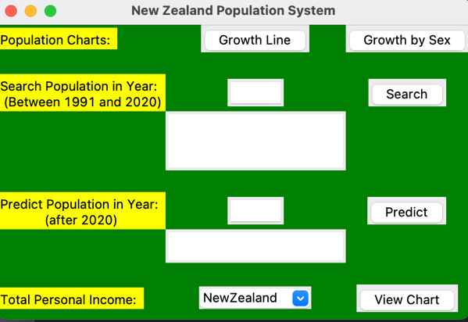

From the dashboard, you can see four main functions in yellow background:

1. **Population Charts**

By clicking the “Growth Line” button, the application will pop up a line graph showing the population growth in New Zealand between 1991 and 2020:

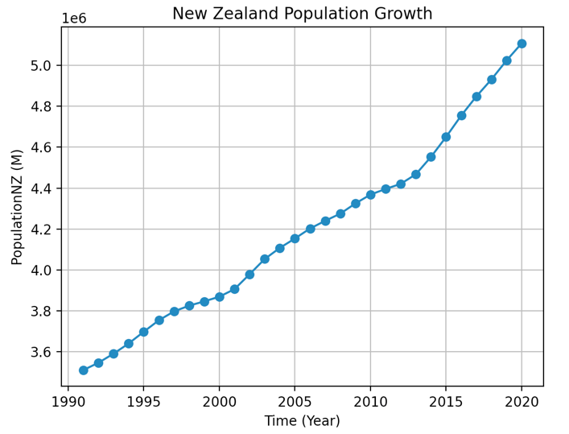

By clicking the “Growth by Sex” button, it will show the population growth grouped by sex:

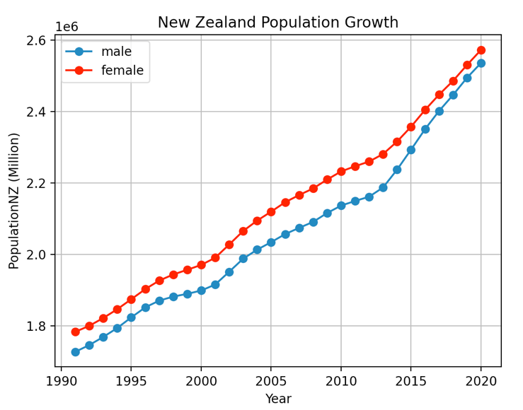

1. **Search Population in Year: (Between 1991 and 2020)**

If you want to know the population detail in a particular year, just simply enter the year the box and click “search” button and the information will show up in the text box below:

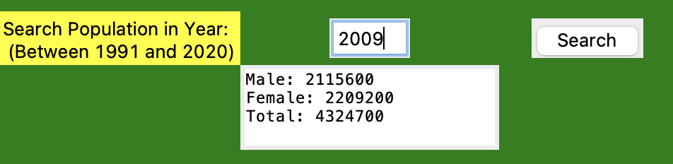

As the database is only about 1991 to 2020, if you entered a year out of this, the wrong information would show:

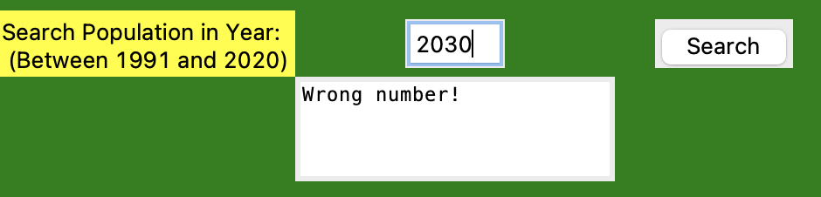

1. **Predict Population in Year (after 2020)**

Fitting with a linear model, you can predict the population in future. Just enter a year after 2020 and click the “predict” button, you can see the predicted population in that year:

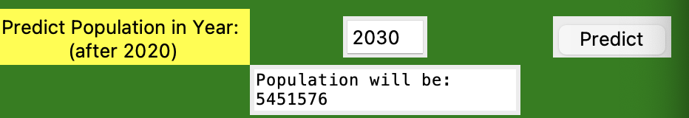

1. **Total Personal Income**

If you want to explore more about New Zealand population, here is a section about total personal income in New Zealand. You can see the stats in the whole country or in specific regions:

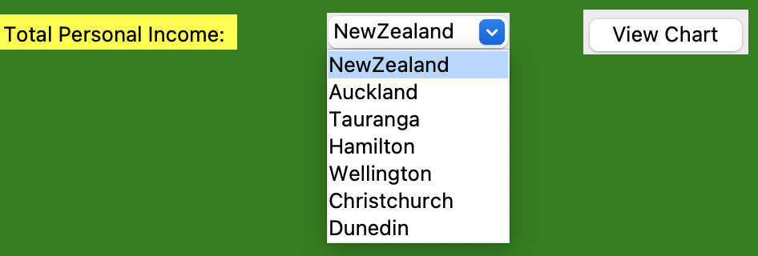

If you choose a region, say Auckland, it would show you the income breakdown in that region:

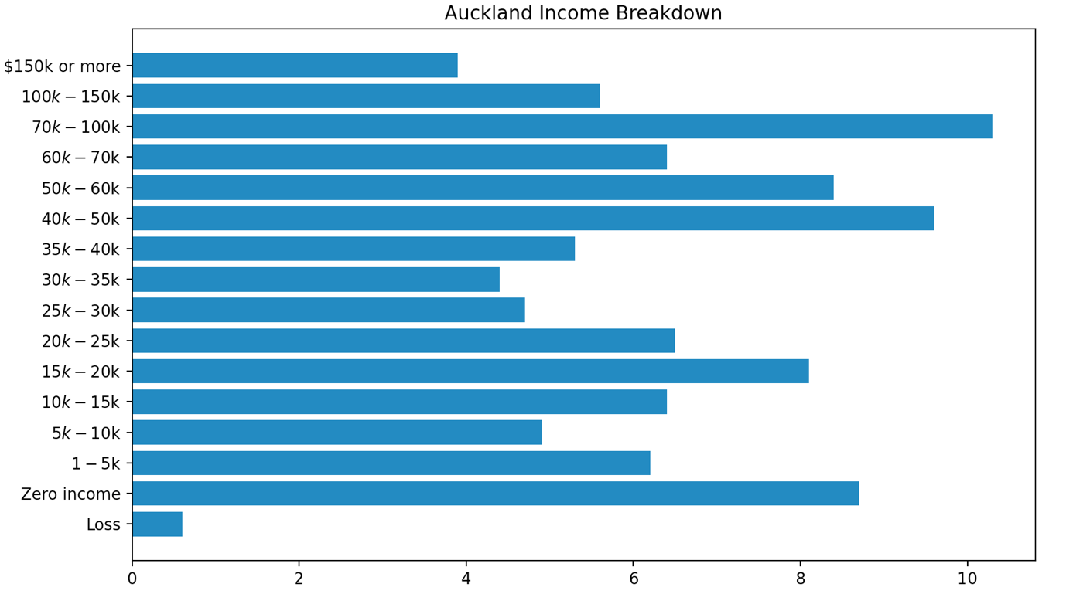

At the end:

I just ended up with these functions. I believe that, with these techniques, it would be easy to add some new functions and data sets to make the application more informational and applicable. I assume it could be an easy way to lookup information and view various charts in many applicable situations such as small companies or grocery shops.