GPS DataLogger Control - Documentation
The program described in this documentation can be downloaded from http://sf.net/projects/bt747 .
The program is subject the GPL License (for further information, see the program).
This documentation incomplete . It is currently written by Mario De Weerd, the author of the program.

Connection tab

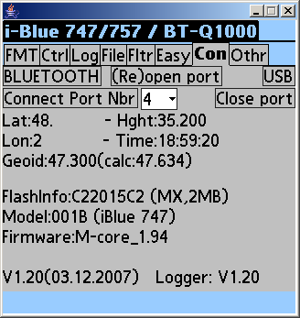
This tab is used to open the connection.
“BLUETOOTH”:
Useful on a PDA like a Palm: will open a Bluetooth connection when clicking on it. Normally you get a pop up window managed by the embedded device. On some devices, you need to associate the GPS logger with your PDA outside the application (setting the Bluetooth key to ‘0000’ for example)).

“(Re)open COM port”:
Closes the port if it is open and opens it again.

“Connect Port Nbr” :
Will connect to the port number selected on the right (“4” in the example). The port number can be selected from the pull down menu.

“USB”:
Not really useful (legacy). The use of the port number is preferred. Some people may still be using it (opens COM4: by default on PC in the ‘win32comm’ configuration)

“Lat”,”Hght”,”Lon”:
Current latitude, altitude and longitude received from the GPS device (in the GPGGA NMEA string).
If no values are shown here, either reception from your device does work or (less likely) your device does not output the GPGGA NMEA string.

“Time”:
The time returned by the device (UTC). This can be used to adjust your camera.

“Geoid”:
height of the geoid (mean sea level) above the WGS84 ellipsoid reported by the GPS device.
“(calc:”:
height of the geoid (mean sea level) calculated by the SW. This calculated value is the one used by the SW to correct the height logged by the device in its log memory. The height logged by the device is: height above geoid + the value mentioned under ‘geoid’.
The calculated value of the geoid and the one reported by the device should be similar. The calculated one might be more precise (the difference I observe is about 0.3 meters which is negligeable).

“FlashInfo:”:
A specific string returned by the serial flash indicating its manufacturer and type.
If the device is known by the SW, it will show the manufacturer and the memory size (MACRONIX and 2 megabyte in this example (=16Megabit).

“Model”:
The model number as returned by the device and a guess what device you are connected to.

“Firmware”:
The MTK firmware version.

“V1.20(03.12.2007)”
Information about the version of the SW discussed in this document.

“Logger: V1.20”:
The SW version of the logger (not the MTK device, but the SW responsible for filling the flash on the device).

“Close port”:
Closes the serial connection – otherwise it stays open.

Command line options:
It is possible to define the path to the serial port on the command line. This will partially or completely override any selection you may make on the connection tab.
The command line options are provide to the java virtual machine:

-Dbt747_prefix=STRING
Sets the prefix of the port to STRING. The port number on the connection tab will be postpended to this string.
Example, if you launch java like this (with some other relevant options and parameters):
java –Dbt747_prefix=“/dev/ttyUSB”
And you select port 2 in the connection tab, the serial port that will be opened is ‘/dev/ttyUSB2’

-Dbt747_port=STRING
Overrides the port number and the prefix.
Example, if you launch java like this (with some other relevant options and parameters):
java –Dbt747_prefix=“/dev/ttyUSB”
And you select port 2 in the connection tab, the serial port that will be opened is ‘/dev/ttyUSB’ (the 2 is disregarded).

After connection, the application automatically jumps to the ‘Log’ tab, but when you return to the connection tab, you’ll see some extra information.

The model number, the firmware version and (depending on your device), the MainVersion will be displayed. This corresponds to replies on the ‘PMTK604’ and ‘PMTK605’ commands.
The device identification between parentheses is an educated guess based on the model number.

Log tab
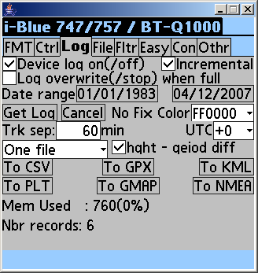

The log tab is the tab you will use often to download the log information and to save it in the format of your choice.

“Device log on(/off)” tick box
When this box is ticked, the GPS Datalogger is filling its memory with GPS information. By unticking it, the device will stop logging until it is powered off and on again, or until it wakes up from standby mode or until you tick this box again.
While downloading information from the device you probably are not interested in filling your device’s memory with ‘useless’ information, so you can untick this at that time – remember to tick it ‘on’ again or to apply a ‘power cycle’ to your device if you want logging to be active.

“Incremental”
Usually you’ll download data from the device without subsequently erasing the log. When downloading data from the device a second time, the ‘official application’ downloads all the data. By ticking ‘Incremental’ in this application, the data already downloaded will not be downloaded again, but simply ‘appended’ too.
There is a smart checking of course: the first 512 bytes of useful data in the first block of data on the device are downloaded and checked against the data previously downloaded. If this data is different, then the download will start from byte 0, if it is the same, the program will look for the first series of empty data in the previously downloaded log and start downloading from there.
This option is ‘on’ by default.

“Log overwrite(/stop) when full”:
When this option is ticked, the device will overwrite its internal data when it is full, if not ticked, it will stop logging when it is full.

“Date range” dates
When clicking on a date, a popup will allow you to select another date.
The two dates determine the range of dates that will be written to the output format. The range does not limit the amount of data downloaded from the device – all the data is downloaded.
The indicated dates are ‘inclusive’ – in order to select one date for the data output, the start date and the end date must be the same.
By default the first date is in 1983 which is before any data that you will be able to log at this point in time, the last date is the current date (at the time of starting the program).

“Get Log”:
Starts the download of the log. The download does not block program execution.

“Cancel get”;
Stops the download of the log. It might be useful to cancel the get and start “Get Log” again if downloading suddenly gets very slow (the error recovery mechanism may get messed up – corrections have been introduced in the program but are difficult to ‘validate’).
When you cancel the download, it can be completed later.

“Trk sep”:
If two log records are separated by a time bigger than the time for this item, it is considered that a new track is started with the later record. This setting is used when selecting “One file / trk”.

“UTC” (+0,+1,…,-1,-2):
The time offset to apply to the written data. Example, if the UTC time in the downloaded log is 2:00, and the requested offset is ‘+2’, then the time written in the output format will be ‘4:00’.

“No Fix Color”:
The color to use (in GMAP currently) for the line between two valid fix points when there were invalid fix points (like when driving in a tunnel or when in a building).

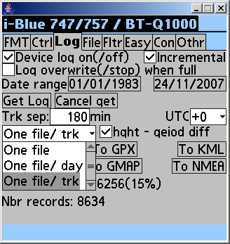
“One file”, “One file / day”, “One file/trk” pull down menu:
- One file: all records will be written to one single file;
- One file/day: records will be written to several files, each grouping one day;
- One file/trk: upon a track separation condition (see Trk Sep above), a new file is created for the next track.

“hght – geoid diff”:
The height data logged in the device is the height above the geoid. What you expect (as well as Google Earth for example) is the height above the mean sea level (MSL).
When this box is checked, the program will compute the MSL above the geoid and substract that value from the logged height data before writing it to the output file. That way the height above the MSL is logged.
Formula: (height above MSL) = (height above geoid) – (MSL above geoid).

“To …..”
Some general comments for exporting data:
Only selected data will be exported. There are several filters that can be controlled by the user and they all limit the data that will be written:
- Date range;
- Fltr:
  - Defines the trackpoints;
    - In formats like ‘KML’, trackpoints will be used to draw the track.
    - For formats like CSV, these are the points that will be written (waypoints are ignored)
  - Defines the waypoints.
    - In formats like ‘KML’, waypoints will show as clickable bullets on the map with point information popping up;
    - Waypoints are ignored in formats like CSV.
- The downloaded data:
  - When you abort the download, only the downloaded points can be converted.

“To CSV” (uses the Trackpoint filter):
Export the downloaded data to CSV files (CSV=Comma Separated Value). Such a file is readable by excel and a number of other programs.
The format is improved over the original format:
- The units are mentioned in the header only and records have numerical values only for most fields;
- Some data transformed incorrectly in the original application is transformed correctly here;

“To GPX” (Uses the trackpoint and the waypoint filter):
Exports the downloaded data to GPX files. The GPX format is required or understood by most applications that use GPS data. Google Earth can also read it for example.

“To KML” (Uses the trackpoint and the waypoint filter):
Exports to KML format for Google Earth.

“To PLT” (Uses the trackpoint filter):
Exports to Oxiexplorer PLT format.

“To GMAP” (Uses the trackpoint and the waypoint filter):
Exports to HTML files that call the Google Maps API to show the points on a map (no need for Google Earth and can be sent by mail).

“To NMEA” (Uses the trackpoint filter):
Outputs (part of) the data to standard NMEA strings. Some applications that do not understand the GPX format, understand the NMEA strings. These strings are similar to the data sent by a generic GPS device. Currently satellite date is not written, only position, time and error data.
You can select NMEA strings to be written in the ‘NMEA File’ tab that you can find inside the ‘Othr’ tab. That way you can reduce the file size or make it suitable for simple text treatment.

“Mem used”:
Currently supposes that there is 16Mb of memory. Some devices have less memory. The amount of memory available would need to be guessed today from the model number as the command to retrieve available memory is unknown today.
The memory used shows the absolute amount of memory used in the GPS DataLogger and the percentage of usefull memory used (i.e., not taking into account the block headers that can not hold GPS information).

“Nbr records”:
The number of points logged in the device.

“Progress bar”
When downloading data a progress bar will appear. When the progress bar disappears, download either completed or was interrupted.

File tab
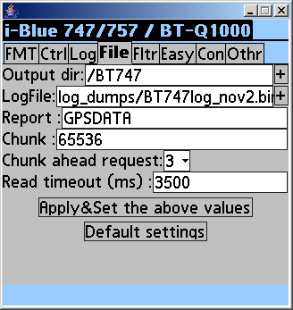
The directory separator is ‘/’ on all systems (including windows).
Settings on this tab are taken into account only when doing “Apply&Set the above values”.

“Output dir”
The base directory for all output files (and input log files).
Click on ‘+’ will popup a list of directories on your system.
If you do not know where to start, erase the directory listed and click on ‘+’, you will be shown directories starting from root.
You may need to use ‘+’ multiple times – it will add at least one extra hierarchy at a time and sometimes more.

“Log file”
The filename for the raw log data. By changing the name here you can archive and reference all your log data. For example, you can add the date in the raw log file name.
If you prefer the data to be in a subdirectory you can add an extra level by writing for example: “rawdata/20070708iBlue.bin”
You can use “+” to select an existing file.

“Report”
The base name for the exported data. A date will be added to this basename and an extension depending on the output format.

“Chunk”:
Defines the block size requested for download. On USB this can be a value of up to 65536, over Bluetooth it is about maximum 650. The optimum for Bluetooth depends on other settings and your devices. The author found it to be 220, in combination with a ‘Fix period’ of 500ms and limited ‘NMEA output’ strings.

“Chunk ahead requests”:
Defines how many requests will be pipelined. Pipelining will (should) improve performance for small chunks (like when you use Bluetooth), and have a negative impact on performance for big chunks. Therefore, when the chunk size is big, this value is ignored (supposed to be ‘0’);

“Read timeout (ms)”:
Time after which a request without response is considered as failed. A small value that is too small will result in re-requesting data too fast. A big value may slow down communication too much in case of an error.

“Apply&Set the above values”
This must be click to apply the values modified on this tab. If not clicked, they will not be used.

“Default settings”:
Computes the settings as if the program was launched for the first time.

ON PALM DEVICES:
“Card/Volume”:
Allows you to access the hard disk or expansion card. “-1” indicates the last storage device on the PDA, which is usually the expansion card and which is internal memory if there is no expansion card (or hard disk like in the Palm Lifedrive). Cards are detected only at the start of the program.

Filter tab
On this tab you define the filters to define what are trackpoints and what are waypoints. Generally, the waypoint filter is ignored if the output format does not distinguish between trackpoints and waypoints. In that case, only the trackpoint filter is used.
The settings on this tab are saved to the configuration file at the end of the application.
“Trkpt | Waypt” buttons
The highlighted button indicates which filter setting type is being defined: ‘Trackpoints’ or ‘Waypoints’. By default waypoints are defined as points with a valid fix that have been requested by the user (=Button).
‘Trackpoints’ are by default all valid points.

Standard Filter
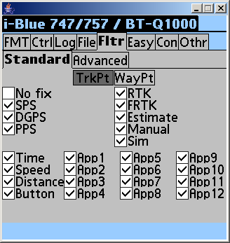
The standard filter operates on two kinds of information:
- Fix information;
- Log reason.

If the data on which the filter would operate is not logged, the selection condition is considered true. The filter will still operate on the logged points that have the relevant data.

Fix information
The fix information indicates what kind of fix was reached for the logged point:
- No fix: There was no fix for the point. There may be time information and satellite information available. In general a user is not interested in ‘no fix’ points, so this is inactive by default;
- SPS: Standard Position Service ;*
- DGPS: Differential … Position Service;
- PPS: Precise Positioning Service (= Military – will probably not occur);
- RTK: Will likely not occur
- FRTK: Will likely not occur
- Estimate: The position is not precise, it is an estimate : does happen! You might want to unselect this.
- Manual: Will likely not occur (added for completeness)
- Sim: Simulation Will likely not occur (added for completeness)

Log reason
The log reason indicates why the point was logged. This is related to the settings on the control tab.
A log point can have multiple log reasons.
If the checkbox next to a log reason is ticked, any log point that has been logged for that reason will selected for the point type.

- Time: The item was logged because the specified time had expired;
- Speed: The item was logged because the measure speed was above the required speed;
- Distance: The item was logged because the distance condition was reached;
- Button: The item was logged because the user pushed the log button.
- App...: The item was logged because the user requested an application specific reason (see “Easy”).

Advanced Filter
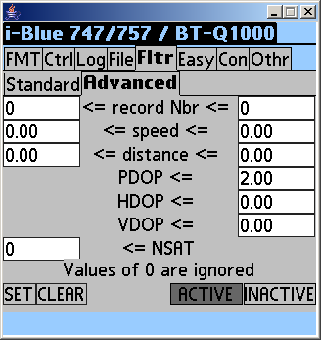
The advanced filter must be activated (ACTIVE/INACTIVE butoons) and operates on types of information not used by the standard filter. Activating the Advanced filter on a PDA could result in longer treatment times for the different output files.

Any value of '0' indicates that the particular constraint is to be ignored. All conditions are grouped in an AND function, i.e., they must all be true for a record to be transcribed to the output. At the same time, the Standard filter must succeed too.

- “record Nbr”: specifies the range of records to keep in the output. You could use this to select subranges of the data based on the record number.
- “speed”: specifies the range for the records with a given speed to keep. If the speed is not logged, the specific record is selected.
- “distance”: specifies the range for the 'distance' field of a record.
- PDOP, HDOP, VDOP: Could be used to select records that are precise enough for your application (See http://en.wikipedia.org/wiki/Dilution_of_precision_(GPS))
- NSAT: Minimum number of satellites in use

‘Other’ tab

‘Flash’ tab (inside ‘other’ tab)
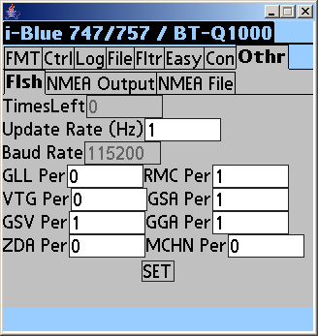

This tab simply reflects the settings programmed in the flash of the GPS device. This was added on request of a user who thought that these settings could be reprogrammed.
As the value ‘TimesLeft’ reads ‘0’, this indicates that the values can not be reprogrammed to flash (=permanently). They can however be reprogrammed dynamically (i.e., when removing the battery, dynamic settings are lost). To change the settings dynamically, look at other places in the program interface.
- Update rate (Hz): Default fix rate of the device.
- Baud rate: serial communication speed. This setting should not be changed as this is the baud rate internally on the device: between the GPS chip and the USB chip, between the GPS chip and the BT chip. It does not define the USB or BT speed directly. Changing this setting would make the device unoperational.
- GLL, VTG, GSV, ZDA, RMC, GSA, GGA, MCHN Per = The default periods of these standard NMEA sentences. The period is expressed in terms of fix periods. If the fix frequency is 5Hz, then the fix period is 200ms. Therefore, if the ZDA period would be 3, then the ZDA sentence would be sent every 600 ms. The default periods are 1 and 0 generally.

“SET”
The settings can be changed if timesleft is different from 0. This function is untested and could result in a malfunction of your device. The program does not allow you to change the baud rate as this would most certainly break your device.

‘NMEA output’ tab
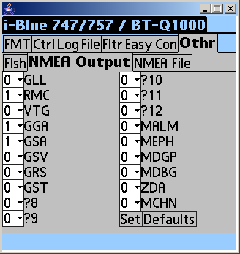
There is some similarity with the ‘Flash’ tab: the periods of the sentences are mentioned again. Only, this time there are more sentences and the periods are configurable. The settings here will be kept until the device looses power (battery removed or empty), when it is in the off position, the values are still kept.

Be careful to have at least one regular sentence set to a value other than 0, otherwise the Bluetooth connection will no longer work. If you set all values to 0 by accident, then you either need to configure the device by using the USB interface or you can simply remove the battery and put it back in place again (you will loose some of the other settings too).

The MDBG sentence is not regular (or not activated), while the ZDA string is a regular one.
For documentation, look on the internet.

‘NMEA File’ tab

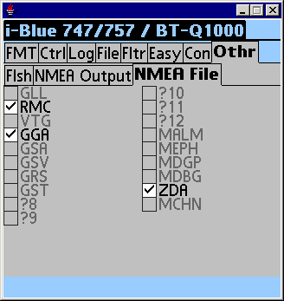
On this tab you can select the NMEA strings that will be written to the NMEA file when converting the log.
Some of the types are grayed out as they are not available for this output format (yet).
Some applications only need ‘RMC’, so selecting just this reduces the file size while being often quite sufficient.
By selecting one NMEA string type, it is also easier to treat the data in scripts or in tabulated software such as excel.

‘Format’ tab
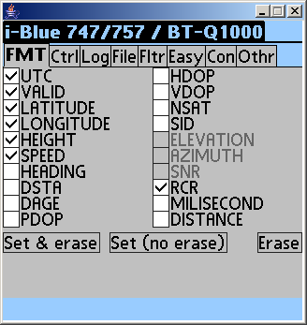
The format tab defines which information will be logged in the device’s memory.
Upon entry to this tab, the application requests the current status from the device. As soon as the device replies, any entry previously done in this tab will be overwritten. Communication problems are not handled (if there is no response, the data is not requested again). In that case, change temporarily to another tab and select the format tab again to get the current information.
“Set & erase”
Clicking on this button will set the format in the device and erase the log content on the device.
This is what is done in the official application delivered with the device and guarantees compatibility with the official application.

“Set (no erase)”
Clicking on this button will set the format in the device but not erase the log. If the format changed, then the original application will not be able to interpret the log data.
A warning message as shown below appears (the example is old, the CSV format is now compatible with this mode).

“Erase”
You can erase the log data on the device without changing the log format.

“UTC”
Log the time
“Valid”
Log the fix type (no fix, SPS, DGPS, Estimated)
“LATITUDE”
Log the latitude
“LONGITUDE”
Log the longitude
“HEIGHT”
Log the altitude above the geoid.
“SPEED”
Log the speed measured by the device
“HEADING”
Log the heading
“DSTA”
DGPS satellite information
“DAGE”
DGPS data age information
“PDOP”
See http://en.wikipedia.org/wiki/Dilution_of_precision_(GPS)
“HDOP”
See http://en.wikipedia.org/wiki/Dilution_of_precision_(GPS)

“VDOP”
See http://en.wikipedia.org/wiki/Dilution_of_precision_(GPS)
“NSAT”
Log the number of satellites in view and used
“SID”
Log satellite id information, required to be able to log elevation, azimuth or SNR data for each satellite. (The SID field also has the number of satellites logged in the device, this is the reason why the field is needed – otherwise the log can not be interpreted successfully under all conditions).
“ELEVATION”, “AZIMUTH”,”SNR”
Specific information concerning a satellite in view is logged.
“RCR”
Log the ‘log reason’ (RCR=ReCord Reason).
This identifies whether the data was logged because the time, speed, distance or button condition was met.
“MILLISECOND”
Log the millisecond information concerning the point. The precision of the UTC field is ‘second’, so this increases precision. This field should be set if the fix frequency is higher than 1 Hz (fix period smaller than 1000ms) in order to have the precise time information for each logged field.
“DISTANCE”
Distance difference with previous fix (?)

‘control’ tab (ctrl)
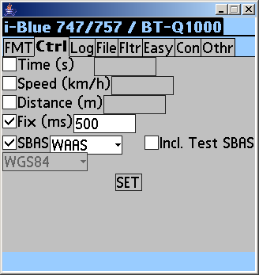
When entering this tab, the application will request the current status from the device.

“Time”
The time period at which GPS data will be logged (if active). Exemple, a value of 8 will log GPS data every 8 seconds.
The time period can be fractional. A value of ‘0.2’ will log the data every 200 ms. That would correspond to a frequency of 5Hz. If the fix frequency is also 5Hz, then you have 5Hz logging.
“Speed”
If the speed is higher than the speed you set here, the gps fix data will be logged. Logging occurs for each ‘fix’ that satisfies the condition. If your fix frequency is 5Hz then up to 5 points may be logged per second.
“Distance”
As soon as the distance with the previously logged point is higher than the distance here, then the point will be logged. Again, this test is performed for each fix. If you are in an airplane flying at 800 km/h, the speed is 222 m/s. If the fix frequency is set to 5Hz, you would log one point every 600 ms (=every 133 meters).

“Fix”
You can set the fix period here. By default it is 1000 ms (1Hz), you can set it to any value above 200ms.

“SBAS”
Select the type of DGPS information you want to use. The only usefull settings are ‘No DGPS’ to deactivate DGPS or WAAS. The WAAS setting includes EGNOS (European system).

“Incl. Test SBAS”
The EGNOS system is not officially deployed yet. By ticking this box, you’ll activate the usage of the satellites in test. In that case, precision is not guaranteed.

“WGS84” (or TOKYO…)
This indicates the DATUM used and is generally WGS84.

“Set”
Clicking on this button will send the settings to the device. The new status is requested from the device – any setting that was unsuccessful can be detected this way.

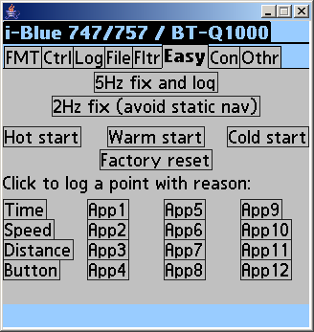
“5Hz fix and log”
Sets 5Hz fixing and logging by the click of one button. You can observe the changes in the ‘control’ tab.

“2Hz fix (avoid static nav)”
The author thinks that setting the fix frequency to 2Hz, the static navigation feature does not work. Clicking on this button does just that – no need to know what value you need to set on the ‘control’ tab.

“Hot start”
Reuse stored satellite information. If the data is current, the fix can be fast.
“Warm start”
Reuse stored almanac information.
“Cold start”
Do not use any stored information.
“Factory reset”
Performs a factory reset and a cold start of the device. The precise effect of this command is unknown and untested by the author. Use at your own risk (like any other function of this program, but this one is particularly risky).

“Time”, “Speed”, “Distance”, “Button”:
Record a position on the device with as log reason the one indicated. These log reasons are the ones that can be logged by the device in an autonomous way.

“App...”:
Log a position on the device with an application specific reason. For example, you could choose App1 if you find a lot of fish at a location, App2 if you find a lot of birds at a location. [Currently these reasons are not transcribed in any of the output formats, but you can use them as a filter reason already.

Menu (click at the top of the window, on ‘i-Blue 747’)
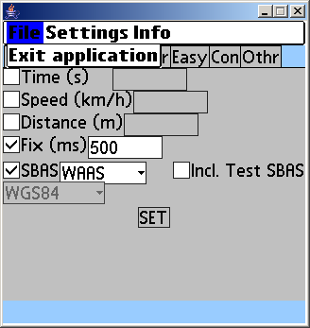
“File -> Exit application”
Exits the application in a clean way. You will get some confirmation windows

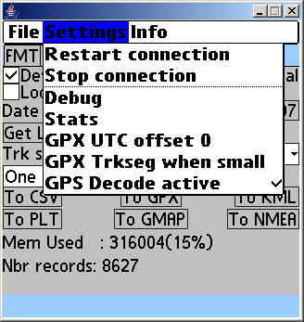
“Settings –> Restart connection”
Restarts the connection. Can be done on the connection tab too.
“Settings-> Stop connection”
Stops the connection.
“Settings-> Debug”
Activate debugging functionality – extra messages will be sent to the console or a file on your device.
“Settings-> Stats”
Logs statistics concerning file download. Currently (V1.05) it does nothing.

“GPX UTC offset 0”
In principle the GPX output should always have UTC time. By checking this option, the UTC offset request is always ignored for the GPX format.

“GPX Trkseg when small”
By default a track separation is done in the GPX file if 'record' are not selected in between two records. Activating this option will not make this separation for records where the time difference is smaller than the one specified in the 'Trk sep' option.

“GPX Decode Active”
this activates the decoding of the GPRMC and GPGGA NMEA strings which results in more processing power needed by the program. When decode is active, the current location and time are available on the location tab (information reported by the GPS device).

“Info -> About BT747”
Information about the application and application version in the window title.
Build date and time in the window content.
“Info -> About SuperWaba VM”
Information about the SuperWaba Virtual machine
“Info -> Info”
Disclaimer and license reference.

GOOGLE EARTH
When you have exported data and you are reading it in Google Earth, you may be wondering why you do not see the data. If you do not see the data, check the date range shown by Google Earth (there is a timeline with a start ‘bar’ and end ‘bare). Also check if the waypoint and trackpoint data is activated. Further, some track are only visible if you zoom in enough. If you still can’t seen anything, check if there are points in the output file that was written. If there are not enough points according to you, check the ‘Filter’ tab and check all the items to ensure that everything is written to the output log.

Final word
Freeware and open source can only exist if everybody participates.
If you take something, give something back to the community. You do not need to be a programmer to be able to do so. You could improve this documentation, improve the web site, share your experience on the forums, etc . Think about it!

