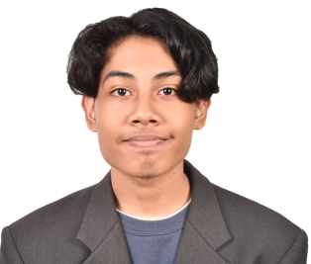

Introduction

Detail-oriented Information Technology student with solid technical background in front-end development, inclusive of creating dynamic and interactive user interfaces. Proficient in HTML5, CSS3, JavaScript and C++. Skillful in implementing responsive designs, accessibility standards and Cross-Browser Compatibility. Has excellent problem-solving abilities and commitment to write clean, scalable code.

Profile

Details | Description
IC No | 050910-10-0699
Age | 20
Date of Birth | 10.09.2005
Sex | Male
Height | 168 cm
Weight | 47 kg
Nationality | Malaysia
Marital Status | Single
Email | muhammad_22011767@utp.edu.my
Address | No. 6 Jalan Elektron U16/38B,  Seksyen U16, Denai Alam,  40160 Shah Alam, Selangor
Telephone No | 017-6270487

Education

Course | Year
Bachelor of Information Technology  University Technology Petronas | 2025 - 2029
Foundation of Information Technology  University Technology Petronas | 2023 - 2024

Skills -joshua, please use list
- HTML
- Java Programming
- Web application
- Microsoft office (word, excel, power point)

Projects

Details | Description
Hackaton | I develop a website for Hackaton program
database | Me and my group develop a database files as our assignment
business | Me and my group did a coffee business as part of our co-curricular final assignment
theater | Me and my group did a theater performance as part of our co-curricular final assignment.

