Work Guide No. 01 (Interface Design)  
**“Construction of Interfaces"**

Sebastián Fernando Revelo Meneses

Ariadna Cardona Martínez

José Camilo Pérez Daza

Software Engineering, University Manuela Beltrán

Tch. Carlos Eduardo Mujica Reyes

72434: Interface Design

Colombia, Bogotá D.C.

August 18, 2025

TABLE OF CONTENTS

Introduction 2

Archetypes 5

Project definition 9

1. Evaluate advantages and disadvantages. 9

2. General definition of the project. 10

A. Problem definition: 10

B. Solution offered: 11

C. Justification: 13

D. Final user: 14

E. Utility: 14

3. Workspace. 14

4. Initial requirements specification. 15

A. Background: 15

B. Functional requirements: 16

C. Non-functional requirements: 17

D. Scope of the system: 18

E. Selected technologies: 19

F. Project page: 20

Guiding questions 20

**LIST OF FIGURES**

Figure 1. *Conceptual map Problem statement* 12

Figure 2. *Pie chart showing justification for ERP in the retail market* 15

Figure 3. *Functional requirements of ERP retail market* 18

Figure 4. *ERP Retail Market Logo* 19

**LIST OF TABLES**

Table 1. *Advantages and disadvantages of ERP in the retail market* 11

Table 2. *ERP solution offered for the retail market* 13

Table 3. *Justification for ERP in the retail market* 14

Table 4. *Background of ERP in the retail market* 17

# Introduction

Small and medium-sized businesses in the retail sector face difficulties in efficiently managing their sales, inventory, and accounting processes due to their reliance on manual records or outdated systems. This leads to errors, wasted time, and reduced competitiveness.

The main stakeholders are business owners and managers, along with employees in charge of sales, purchasing and inventory, who require tools that facilitate their daily work. The availability of accessible development technologies and the experience acquired in our careers are identified as facilitators; while the main obstacles are time constraints, financial resources, and technical training for end users.

**Objective:** To design and develop a modular and centralized ERP prototype that integrates critical retail management functions, enabling greater control, error reduction, and time savings in store operations.

**Proposed Solution:** The project consists of a Windows desktop application developed in C#, called "MyMarket". The solution consists of a core module and five optional modules (customer, employee, purchasing, inventory, and accounting), which can be purchased independently.

* **Who are the users?**

The users targeted by this retail market ERP would be store owners and managers, administrative staff, sales employees, warehouse staff, and marketing teams, as the modules of this ERP are designed with them in mind; that is, each group uses the system according to their specific functions within the organization.

* **What are their tasks and goals?**

The tasks and goals of these users revolve around managing inventory, tracking sales and orders, administering purchases, improving customer service, and generating reports to optimize operations and make informed decisions.

* **What level of experience does users have?**

The level of user experience varies from operators with basic knowledge who perform everyday tasks to managers and analysts with advanced experience who handle complex planning, finance, and analysis modules, allowing for progressive adaptation to the system.

* **What features do they need?**

The users will require features like simple, yet easy to understand, interfaces, as well as some sub-services for managing data storage, users, roles, and the capability to handle multiple instances running at the same time.

* **What information does users need and how?**

The user will only need the instructions in how to manipulate the ERP software, instructions that will be written in special documentations, provided to the customer along with the software.

* **How is it expected to work?**

It will all start by initializing the core process of the software, from where all the functionalities, as well as the modules, will be load. From there, the users will be able to use multiple visual interfaces to interact with the ERP (Marketing, Stock, etc.).

* **What are the most adverse cases?**
* Stock shortages or excess stock, leading to financial losses.
* Billing or accounting errors, with the risk of legal penalties.
* Delays in sales and customer service, affecting satisfaction and loyalty.
* Outdated or duplicate data, hindering decision-making.
* **Will several tasks be performed at the same time?**

Yes. The implementation of an ERP seeks to manage multiple processes in parallel: while a sale is being recorded, the system updates inventory, generates invoices, and reflects the movement in accounting. This allows for agility, integration, and a reduction in most repetitive manual works.

# Archetypes

**Archetype 1: “The operations manager”.**

**Justification for choice:** This archetype represents the person in charge of daily operations in retail stores who needs an efficient ERP system to control inventory, sales, and logistics. It is essential to maintaining the uninterrupted flow of business, making this profile well suited to the project.

**User type:** Buyer.

**Identifying phrase:** "I need full control and real-time visibility to make quick decisions for all kinds of situations."

**Goals:**

* Optimize inventory management to avoid shortages or excesses.
* Improve accuracy and speed in sales processing.
* Minimize operational errors and reduce downtime.

**Motivations:**

* Keep the store running smoothly.
* Meet sales and cost-cutting goals.
* Ease of reporting results to management.

**Frustrations:**

* Slow or unwieldy systems.
* Lack of integration between management tools.
* Fragmented or outdated information.

**Technical skills:**

* Software management: 3
* PC Device Use: 3
* Internet and Online Platforms: 4

**Archetype 2: “The proprietary** **pyme”.**

**Justification for choice:** Owners of small or medium-sized businesses in the retail sector looking for a comprehensive solution to manage their business without needing to be a technology expert.

**User Type:** Buyer / Decision Maker.

**Identifying phrase:** "I want a simple system that helps me grow my business without many complications."

**Goals:**

* Centralize financial, sales, and inventory management.
* Reduce operating costs through automation.
* Have clear reports to make strategic decisions.

**Motivations:**

* Grow the business with control and less stress.
* Obtain reliable information without relying on third parties.
* Save time on administrative tasks.

**Frustrations:**

* Complicated systems or those that require a long learning curve.
* Lack of support or customization.
* Hidden or unclear costs.

**Technical skills:**

* Software management: 2
* PC Device Use: 3
* Internet and Online Platforms: 3

**Archetype 3: “The retail data analyst”.**

**Justification for choice:** A user focused on analytics and metrics to optimize business performance requires an ERP that provides detailed, real-time data.

**User Type:** Buyer / Specialized User

**Identifying Phrase:** "Data is the key to understanding the business and anticipating opportunities."

**Goals:**

* Access automated and customized reports.
* Detect purchasing patterns and customer behavior.
* Improve inventory turnover based on accurate analysis.

**Motivations:**

* Make informed decisions based on concrete data.
* Quickly identify market trends.
* Optimize promotions and stocks.

**Frustrations:**

* Incomplete or difficult to extract the information.
* Limited access to reliable historical data.

**Technical skills:**

* Software management: 5
* PC Device Use: 4
* Internet and Online Platforms: 5

**Archetype 4: “The salesperson at the point of sale”.**

**Justification for choice:** Operational user who manages the ERP system at the checkout and in direct contact with the customer. They need a simple and fast interface to facilitate sales and customer service.

**User Type:** Operational User / Salesperson

**Identifying Phrase:** "I want a system that allows me to sell quickly and without complications."

**Goals:**

* Streamline the billing and collection process.
* Check stock availability in real time.
* Improve the customer experience with prompt service.

**Motivation:**

* Serve the customers efficiently and quickly.
* Avoid errors in pricing or billing.

**Frustrations:**

* Slow or unintuitive interfaces.
* Lack of connectivity or system crashes.
* Long processes that affect attention.

**Technical skills:**

* Software management: 2
* PC Device Use: 3
* Internet and Online Platforms: 2

# Project definition

## 1. Evaluate advantages and disadvantages.

Provide a comparison and justify the validity of developing an ERP in your chosen field. Consider technical aspects, the relevance of the problem to be solved, the value delivered to the end user, etc.) to justify the validity of developing an ERP in your chosen field.

Table 1.  
*Advantages and disadvantages of ERP in the retail market*

|  |  |  |
| --- | --- | --- |
| **Aspect** | **Traditional methods (Excel, manual records, isolated software)** | **ERP in the retail market** |
| **Inventory management** | Susceptible to errors, data duplication, lack of real-time visibility. | Centralized control, real-time inventory, automatic low-stock alerts. |
| **Sales and billing** | Slow, fragmented processes that are difficult to integrate with other systems. | Sales automation, instant invoice generation, integration with inventory and finance. |
| **Customer Service** | Dispersed information, customer history difficult to consult. | Integrated CRM: purchase history, preferences, and improved post-sale follow-up. |
| **Scalability** | Limited: the greater the volume of data, the greater the complexity of control. | Scalable: Supports business growth, multiple branches and users. |
| **Analysis and reports** | Manual reporting, time-consuming, and risk of inconsistencies. | Real-time dashboards, key metrics for strategic decisions. |
| **Information security** | Vulnerability due to lack of backups and poorly controlled access. | Role-based access control, cloud backup, operations auditing. |

**Note:** Own work.

## 2. General definition of the project.

### A. Problem definition:

Retail markets, as we know them in Colombia, continue to face certain problems in terms of operational and administrative management that affect the productivity and profitability of companies. Markets continue to rely on manual processes or obsolete systems, which are not the best option and lead to multiple errors, inefficiencies, and missed opportunities. The lack of an ERP system hinders real-time visibility of stock, leading to shortages or excess merchandise. In addition, the disconnect between sales, purchasing, and accounting prevents agile and accurate management, resulting in duplication of work and outdated data.

All these problems lead to a poor user experience, in which customers are affected, there may be delays in purchases, billing errors, or simply not having the product they were looking for. On the legal and accounting side, it becomes more complex without automated tools, increasing the risk of fines or penalties.

Now let's look at a diagram that summarizes the main problems:

Figure 1.  
*Conceptual map Problem statement*

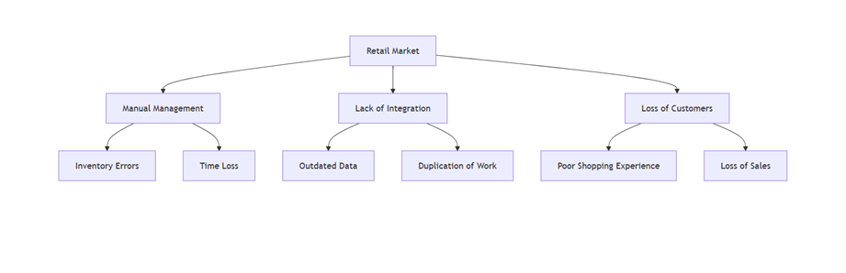

**Note:** Own work.

### B. Solution offered:

(What does the system to be developed consist of? What needs does the system meet? What is the expected product? What purpose does it serve?):

We want to create an ERP system for the retail market, which will be an integrated system that will unite and automate key business processes, designed specifically for the needs of our retail markets.

Table 2.  
*ERP solution offered for the retail market*

|  |  |
| --- | --- |
| **Necessity** | **ERP solution** |
| **Inventory Control** | Real-time inventory module, low stock alerts, supplier management. |
| **Agile sales** | Integrated point of sale, electronic invoicing, promotion management. |
| **Data integration** | Single database for sales, purchasing, accounting, and reporting. |
| **Analysis and reports** | Sales indicators, inventory turnover, profit margins (statistics). |
| **Regulatory compliance** | Automatic generation of tax reports, electronic invoicing in accordance with regulations if required. |
| **Customer experience** | Customer purchase history, complaint management, and suggestions. |

**Note:** Own work.

**Expected product:** Modular ERP software, accessible from mobile and desktop devices, with an intuitive interface and the ability to scale as your business grows.

**What is it for?**

* To reduce time and errors in operational processes.
* To improve decision-making with real-time data.
* To increase customer satisfaction and sales.
* To ensure legal and tax compliance.

### C. Justification:

(Explain the value generated by the project; why is it worth doing?):

Table 3.  
*Justification for ERP in the retail market*

|  |  |
| --- | --- |
| **Benefit** | **Impact** |
| **Operational efficiency** | 30-50% reduction in time spent on administrative tasks |
| **Cost reduction** | Fewer losses due to obsolete or poorly managed inventory |
| **Greater competitiveness** | Tools for competing with large chains |
| **Sustainable growth** | Technological basis for opening new branches or product lines |
| **Sustainability** | Less paper use, more environmentally friendly processes |

**Note:** Own work.

Figure 2.  
*Pie chart showing justification for ERP in the retail market*

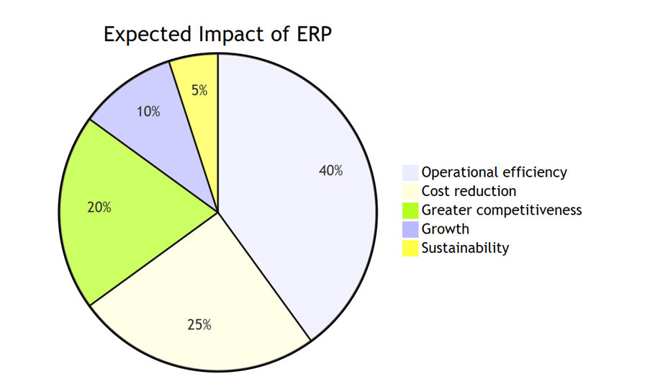

**Note:** Own work.

### D. Final user:

The ERP system is primarily aimed at managers and owners of retail markets in Colombia, who need to improve the operational, administrative, and accounting management of their businesses. It also indirectly benefits employees by reducing manual tasks, and end customers by ensuring product availability, faster purchasing, and improved service.

### E. Utility:

An ERP allows you to centralize and automate key processes (inventory, sales, purchasing, accounting, and customer service), reducing errors and increasing operational efficiency. Its main purpose is to:

* Real-time inventory control.
* Integration between departments (sales, purchasing, and finance).
* Time and cost savings by avoiding duplication of work.
* Better customer experience thanks to more agile and reliable processes.
* Legal and accounting compliance through accurate and automated reporting.

## 3. Workspace.

Create a repository for the project. All group members must be linked to the repository. Build a page to store documentation. It's recommended to use tools like GitLab Pages, GitHub Pages, Notion, or Read the Docs.

**GitHub repository:** Here we provide the link to the GitHub page we have created to store our respective documentation:

* [Documentación del Proyecto — ERP Mercado Minorista](https://softcoder-sebas.github.io/Dis_Interfaces_A3/)

## 4. Initial requirements specification.

### A. Background:

Each team member should research at least one application like the one they plan to develop. Create a comparison chart describing the applications they reviewed and the features they offer. Follow the template below.

Table 4.  
*Background of ERP in the retail market*

|  |  |  |  |  |  |  |
| --- | --- | --- | --- | --- | --- | --- |
| **Application** | **COST** | **MOD. SUPPLIERS** | **MOD. RRHH** | **MOD. INVENTORY/WAREHOUSE** | **MOD. SALES** | **MOD. CRM/CUSTOMERS** |
| SAP S/4HANA Retail | High | Advanced supplier management | The entire employee cycle, payroll, attendance | Comprehensive inventory and warehouse control | Sales, contract management, pricing | Integrated CRM for customer service and relations |
| Oracle NetSuite | Halfway High | Automate orders and purchases | Centralized employee and payroll management | Real-time inventory, multiple locations | Omnichannel sales and integrated POS | Complete customer and sales management |
| Microsoft Dynamics 365 Retail | Halfway | Suppliers and purchasing automation | Full RRHH (recruitment, payroll, performance) | Inventory, warehouse, stock optimization | Orders, sales, price control | CRM and integrated marketing |
| Epicor ERP Retail | Halfway | Purchasing and supply optimization | RRHH with payroll, performance, and attendance | Advanced inventory, warehouses, and replenishment | Sales, contract, and price management | CRM with history and automation |

**Note:** Own work.

### B. Functional requirements:

Consider the functional requirements of the application. These features should be consistent with the analysis performed in the previous section and provide added value compared to existing applications. Represent the functional requirements using a functional decomposition tree (maximum 4 levels deep).

Figure 3.  
*Functional requirements of ERP retail market*

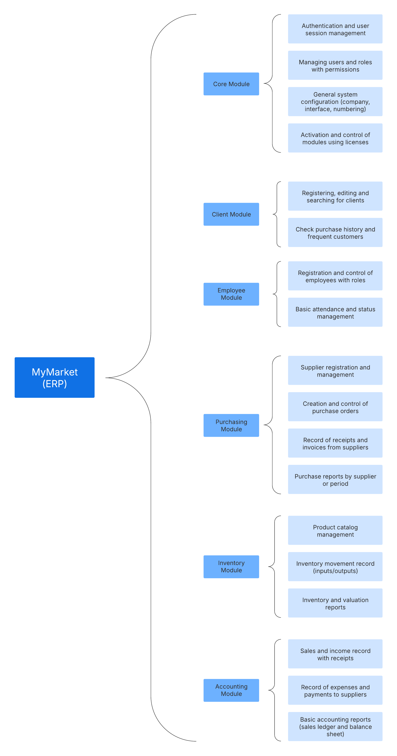

**Note:** Own work.

### C. Non-functional requirements:

Mention the most relevant non-functional requirements for the project context. Justify your answer. NOTE: The ERP must have a name, logo, or brand image, and an interface design consistent with a color scheme.

* **Platform:** Dedicated application for Windows 11.
* **Development language:** C# with .NET Framework/Core.
* **Performance:** Main operations should execute in less than 3 seconds.
* **Security:** Authentication system with encrypted passwords.
* **Usability:** Simple graphical interface, suitable for non-technical users.
* **Scalability:** Ability to add new modules without modifying the system base.
* **Availability:** Does not require internet access to operate.
* **“Branding”:**
  + **Name:** “My Market”.
  + **Color palette:** Red, Black, White.
  + **Logo:**

Figure 4.  
*ERP Retail Market Logo*



**Note:** Own work.

### D. Scope of the system:

The limitations and scope of development according to previously established objectives (consider the triple constraint)

**Scopes:**

* Complete development of a modular ERP application in C# for Windows.
* The system is designed to be delivered within a maximum of 4 months.
* Delivery of basic installation and usage documentation.
* Implementation of a central core plus five main modules (customer, employee, purchasing, inventory, and accounting).

**Limitations:**

* No mobile applications or web versions will be developed.
* The system will be operable by multiple users at the same time.
* No external integrations with other accounting systems will be implemented.
* The accounting module will be basic (it will not include advanced tax processes or integration with specific tax regulations).

**“Triple restriction”:**

* **Time:** Maximum limit of 4 months forces to prioritize basic functions.
* **Cost:** Free services/tools will be used (SQL Server Express).
* **Scope:** Only the defined modules will be covered, avoiding extensions that compromise on-time delivery.

### E. Selected technologies:

Mention the development environments, platforms and tools used in the implementation of the system.

* **Programming language:** C# (.NET 8).
* **Development environment:** Visual Studio Community Edition.
* **Database:** Microsoft SQL Server Express.
* **Graphical interface:** Windows Forms (WinForms).
* **Version control:** Git, GitHub.
* **Report generation:** Native .NET tools for exporting to PDF/Excel.
* **Visual design:** Figma.

### F. Project page:

Build a presentation (10-15 min format) where you present your project idea (the presentation must contain the information from points 1, 2, 3 and 4 in English).

*Link to presentation created in Canva:*

<https://www.canva.com/design/DAGwKISsoG0/F_32r2pJxx8LAH-Srji2nQ/edit?utm_content=DAGwKISsoG0&utm_campaign=designshare&utm_medium=link2&utm_source=sharebutton>

# Guiding questions

**Why prototype? How to prototype? What should we expect to evaluate with the user? Why evaluate?**

Prototyping involves creating a preliminary version in order to get a preview of the product or software in this case that you want to create, that is, to have a preview so you can see it before its final development. This allows us to see opportunities for improvement and detect possible errors or problems before investing so much time and resources in the development stage, so that the team can make the necessary early adjustments and validate ideas quickly and economically.

To make a prototype, you must start by defining the main objectives and functionalities, which we do with functional and non-functional requirements. After that, we create initial prototypes such as wireframes or digital sketches to see the overall structure and flow. Then, we can use Figma or any similar application to make interactive prototypes that simulate the real user experience without programming. Finally, this goes through several tests to polish details and improve usability.

The user will be the one to evaluate usability, such as how intuitive and easy to navigate the interface is, things like that, to be clear and efficient and to ensure that the functionalities fulfill their purposes. This is the best way to identify errors and for the team to improve that prototype. This design must meet the real expectations and needs of those who will use the software.