Work Guide No. 02 (Interface Design)  
**“Design Paradigms, User-Centered Analysis"**

Sebastián Fernando Revelo Meneses

Ariadna Cardona Martínez

José Camilo Pérez Daza

Software Engineering, University Manuela Beltrán

Tch. Carlos Eduardo Mujica Reyes

72434: Interface Design

Colombia, Bogotá D.C.

August 31, 2025

TABLE OF CONTENTS

Archetypes 2

Procedure And Methodology Of The Practice 6

BENCHMARKING 6

USERFLOW 7

ACTIVITY USING FIGMA 8

Figma ERP 8

INFORMATION ARCHITECTURE 9

Card Sorting Activity 9

Dendrogram Activity 9

Self-Employed Work Activity 10

Infographic Article Guide-Lab No. 02 11

# Archetypes

**Archetype 1: “The operations manager”.**

**Justification For Choice:** This archetype represents the person in charge of daily operations in retail stores who needs an efficient ERP system to control inventory, sales, and logistics. It is essential to maintaining the uninterrupted flow of business, making this profile well suited to the project.

**User Type:** Buyer.

**Identifying Phrase:** "I need full control and real-time visibility to make quick decisions for all kinds of situations."

**Goals:**

* Optimize inventory management to avoid shortages or excesses.
* Improve accuracy and speed in sales processing.
* Minimize operational errors and reduce downtime.

**Motivations:**

* Keep the store running smoothly.
* Meet sales and cost-cutting goals.
* Ease of reporting results to management.

**Frustrations:**

* Slow or unwieldy systems.
* Lack of integration between management tools.
* Fragmented or outdated information.

**Technical Skills:**

* Software management: 3
* PC Device Use: 3
* Internet and Online Platforms: 4

**Archetype 2: “The proprietary pyme”.**

**Justification For Choice:** Owners of small or medium-sized businesses in the retail sector are looking for a comprehensive solution to manage their business without needing to be a technology expert.

**User Type:** Buyer / Decision Maker.

**Identifying Phrase:** "I want a simple system that helps me grow my business without many complications."

**Goals:**

* Centralize financial, sales, and inventory management.
* Reduce operating costs through automation.
* Have clear reports to make strategic decisions.

**Motivations:**

* Grow the business with control and less stress.
* Obtain reliable information without relying on third parties.
* Save time on administrative tasks.

**Frustrations:**

* Complicated systems or those that require a long learning curve.
* Lack of support or customization.
* Hidden or unclear costs.

**Technical Skills:**

* Software management: 2
* PC Device Use: 3
* Internet and Online Platforms: 3

**Archetype 3: “The retail data analyst”.**

**Justification For Choice:** A user focused on analytics and metrics to optimize business performance requires an ERP that provides detailed, real-time data.

**User Type:** Buyer / Specialized User

**Identifying Phrase:** "Data is the key to understanding business and anticipating opportunities."

**Goals:**

* Access automated and customized reports.
* Detect purchasing patterns and customer behavior.
* Improve inventory turnover based on accurate analysis.

**Motivations:**

* Make informed decisions based on concrete data.
* Quickly identify market trends.
* Optimize promotions and stocks.

**Frustrations:**

* Incomplete or difficult to extract the information.
* Limited access to reliable historical data.

**Technical Skills:**

* Software management: 5
* PC Device Use: 4
* Internet and Online Platforms: 5

**Archetype 4: “The salesperson at the point of sale”.**

**Justification For Choice:** Operational user who manages the ERP system at the checkout and in direct contact with the customer. They need a simple and fast interface to facilitate sales and customer service.

**User Type:** Operational User / Salesperson

**Identifying Phrase:** "I want a system that allows me to sell quickly and without complications."

**Goals:**

* Streamline the billing and collection process.
* Check stock availability in real time.
* Improve the customer experience with prompt service.

**Motivation:**

* Serve the customers efficiently and quickly.
* Avoid errors in pricing or billing.

**Frustrations:**

* Slow or unintuitive interfaces.
* Lack of connectivity or system crashes.
* Long processes that affect attention.

**Technical Skills:**

* Software management: 2
* PC Device Use: 3
* Internet and Online Platforms: 2

# Procedure And Methodology Of The Practice

## BENCHMARKING

|  |  |  |  |  |  |
| --- | --- | --- | --- | --- | --- |
| **App** | **Vocabulary (Clarity)** | **Navigability (Steps)** | **Design (Interface)** | **Strengths** | **Weaknesses** |
| **Odoo ERP** | Clear but technical in some modules | 3–5 steps on average | Modular, can look overloaded | Flexible, large community, wide integration | Steep learning curve, requires customization |
| **SAP Business One** | Very technical and corporate | 6–8 steps, complex | Sober, not very intuitive | Stable, robust, scalable | Expensive, difficult for SMEs, slow adoption |
| **Zoho ERP Suite** | Simple and accessible | 2–4 steps, intuitive | Minimalist and organized | Easy adoption, affordable, e-commerce integration | Limited features, internet dependent |

## USERFLOW

A “UserFlow” is a visual representation of the path a user follows to complete a task within an application or system. In the context of an ERP (Enterprise Resource Planning System), this can be very useful for understanding how employees interact with the system and optimizing efficiency.

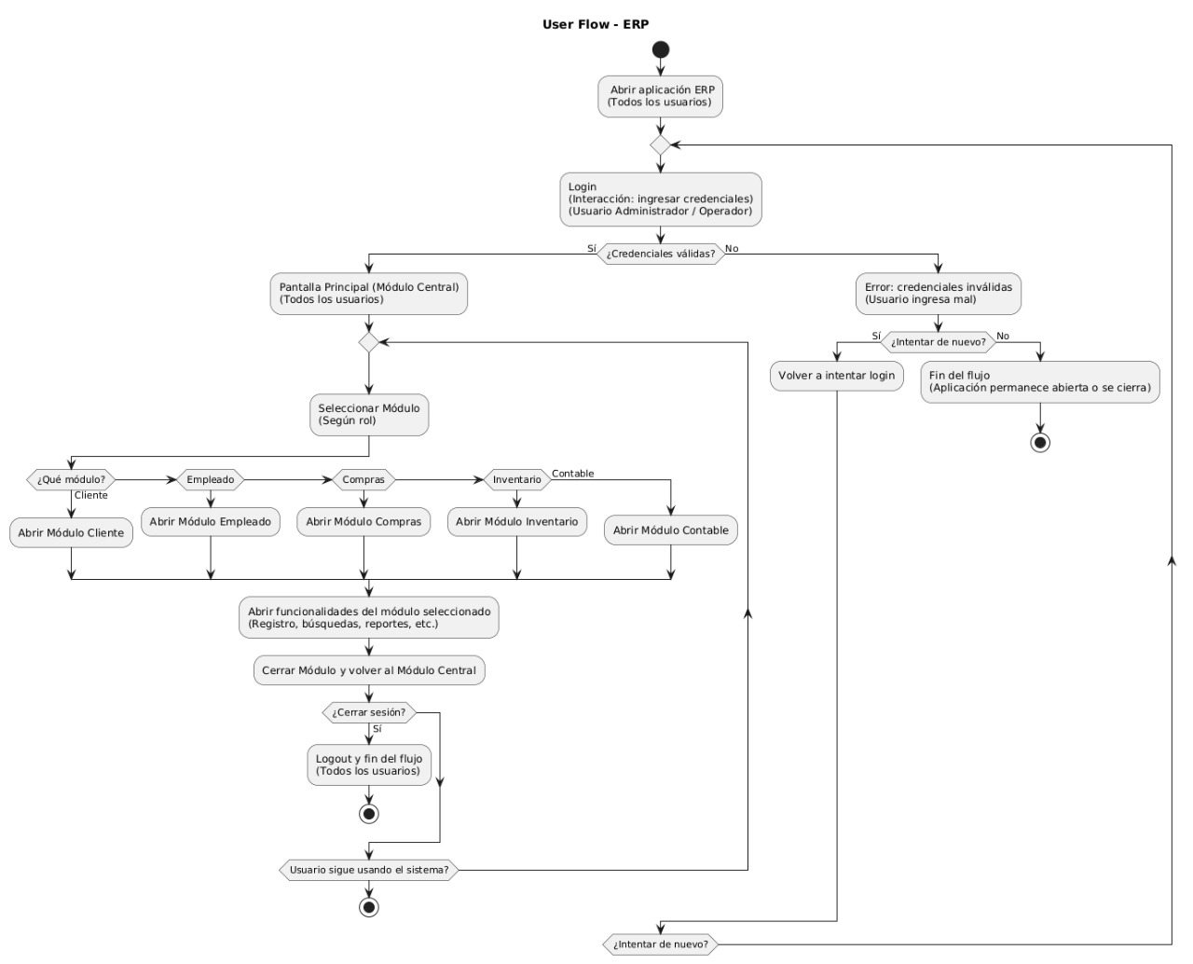

## ACTIVITY USING FIGMA

### Figma ERP

Here is the link to the FIGMA:

<https://www.figma.com/proto/sOgSJ1p5mvqSmGLK4QnZQC/Dise%C3%B1o-de-interfaces?node-id=0-1&t=ScKjAZ4tcU9xIaKN-1>

## INFORMATION ARCHITECTURE

### Card Sorting Activity

Here is the link to the card sorting diagram:

<https://www.canva.com/design/DAGxfHqkjuo/mbTKAPlbHb-oJPXvv31emw/edit?utm_content=DAGxfHqkjuo&utm_campaign=designshare&utm_medium=link2&utm_source=sharebutton>

### Dendrogram Activity

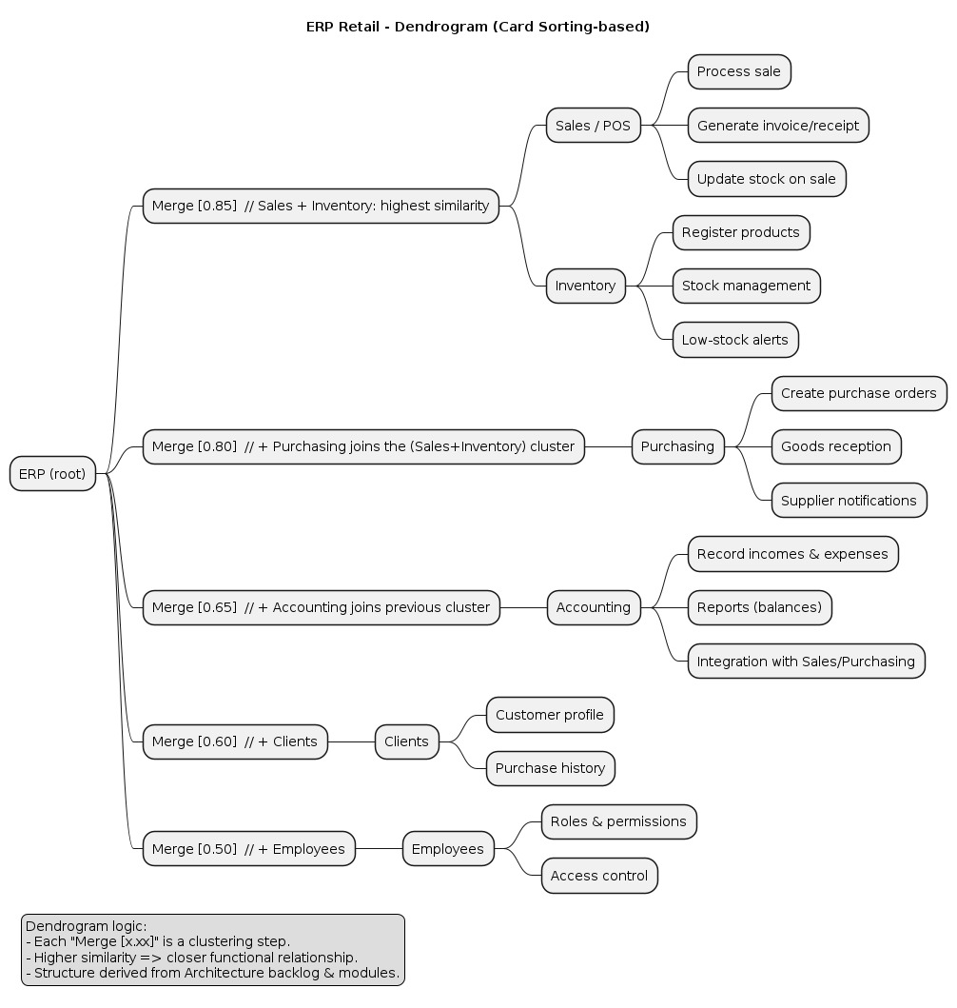

# Self-Employed Work Activity

Read the following article from SCIENCEDIRECT: "Design Thinking Integrated in Agile Software Development: A Systematic Literature Review" https://www-sciencedirect-

com.proxy.umb.edu.co/science/article/pii/S1877050918317484

* Create an infographic in English of the article and/or a summary with the most relevant points.
* Each student MUST record a video in English, using the platform or technology of their choice, in which they introduce themselves and comment on (explain) the content of the article. The video is individual, and your face must be visible.
* The link to the video recording must be uploaded to the Canvas platform forum designated for this purpose and named FORUM Guide-Lab 2.

## Infographic Article Guide-Lab No. 02

