Executive Summary: Collective Canvas Agents
When does communication prevent language-model agents from overwriting one another?

Research question

I tried to see how language agents working on a shared task in the same persistent environment utilize available communication channels to coordinate and negotiate to prevent overwriting each other's work. Models place pixels on a 32*32 canvas or plan using a forum. The two sub-questions explored are:
1. Cooperation without resource pressure: A team of agents tries to draw an apple on a canvas. Intra-team communication channel available.
2. Competition for space: 4 teams of agents each try to draw: An apple, an orange, an eggplant, a lemon. Intra-team and inter-team communication channels are available.

Experiment
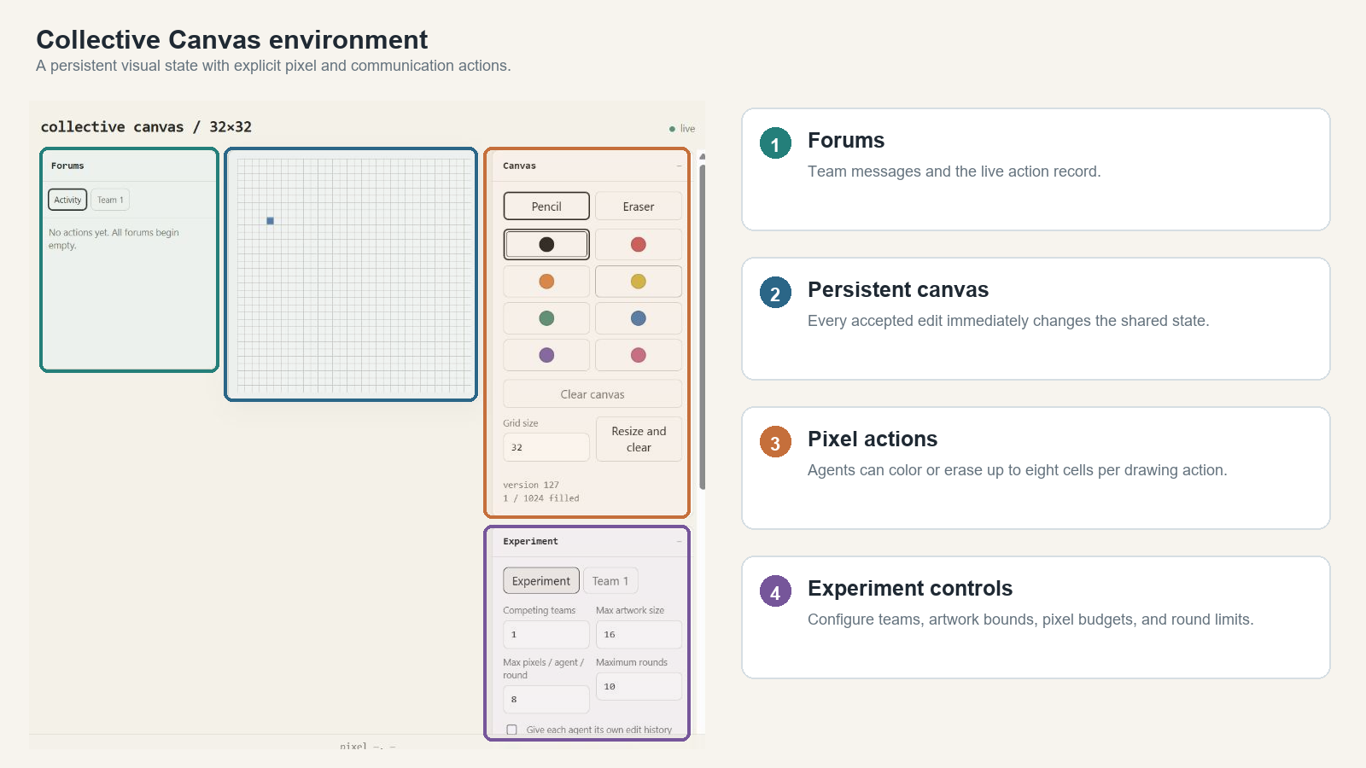
Figure 1. Agents observe the shared canvas and can edit pixels, post to a forum, or skip.
All agents were provided with the existing 32×32 canvas, the reference 16×16 image, its description, the list of teams’ names, history of the edits made on it, and available forum messages. The agent had three options: to post one message, color or remove eight pixels, or make no edits. Member #1 got one planning turn in Round-0; other members played simultaneously after that.
Task | Participant structures | Rounds
One team draws an apple; private team forum | 2-agent homogeneous; 4-agent homogeneous; 4-agent mixed | 10
Four teams draw apple, orange, eggplant and lemon; private and public forums | All Gemini; mixed within teams; family-separated | 20

Four models were selected: google/gemini-3.8-flash, qwen/qwen3.8-27b, z-ai/glm-5.3-flash, and openai/gpt-5.6-luna, accessed through OpenRouter at T=0.2 where supported. I generated five repetitions per cell: 120 single-team runs and 40 competition matches. Images to be drawn: 1. Only apple 2. Apple, orange, lemon eggplant.

What happened
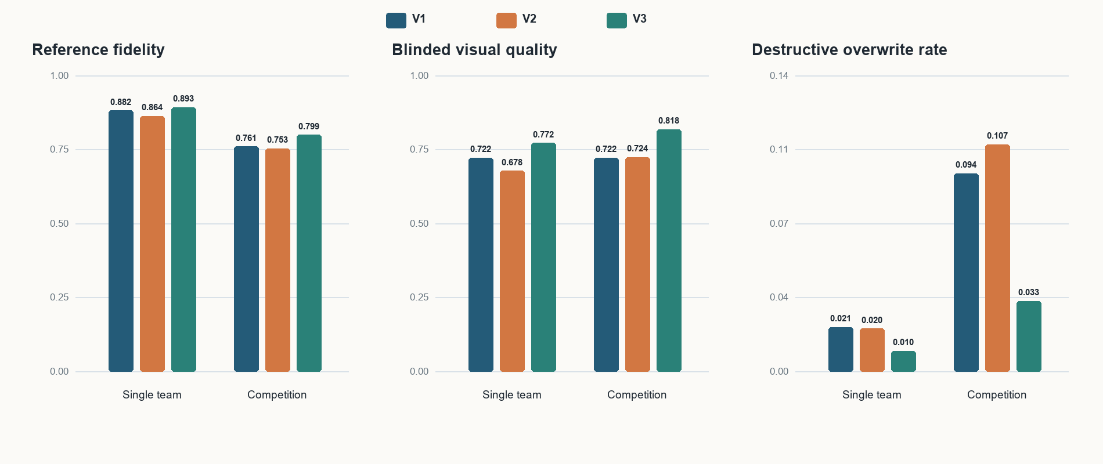
Figure 2. Participant-structure-balanced outcomes. Higher fidelity and quality are better; lower overwrite is better.

Three communication conditions
Prompt | Instruction | Observed behavior
V1 | Information on forum availability only | 31/40 single-team runs never posted; competition created spontaneous use.
V2 | Suggestions for useful communication using forums | Adoption rose, but 29/32 single-team posts occurred at the start.
V3 | Opening coordination plus communication protocols after stalls/conflicts | Sustained mid-run communication and substantially less competition damage.

Headline effects in four-team competition
V3 − V1 outcome | Effect | 95% bootstrap interval | Interpretation
Destructive-overwrite rate | −0.060 | [−0.112, −0.024] | Strong reduction
Blinded visual quality | +0.095 | [−0.002, +0.188] | Suggestive
Exact reference fidelity | +0.039 | [−0.018, +0.094] | Uncertain

V2 improved competition communication by 2.5 messages per match but had only +0.002 impact on quality and −0.007 on fidelity. However, more communication alone was not enough: what mattered most was the specification of how often the agents must communicate. In the competition event data set, cases of persistent damage were reduced from 1,407 under V1 to 338 under V3.

Measurement and checks
The primary endpoint was the best translation-aligned exact-color F1 between each canvas and its reference. Secondary measures covered blinded recognizability/coherence, simultaneous conflicting intentions, persistent destructive overwrites, affected-team repair, opening versus mid-run posts, progress, cost, and repeatability. x-ai/grok-4.6 judged all images; moonshotai/kimi-k3 audited a stratified sample. Runs or matches were the statistical units; prompt effects were matched within participant structure with 20,000 bootstrap resamples.

Interpretation
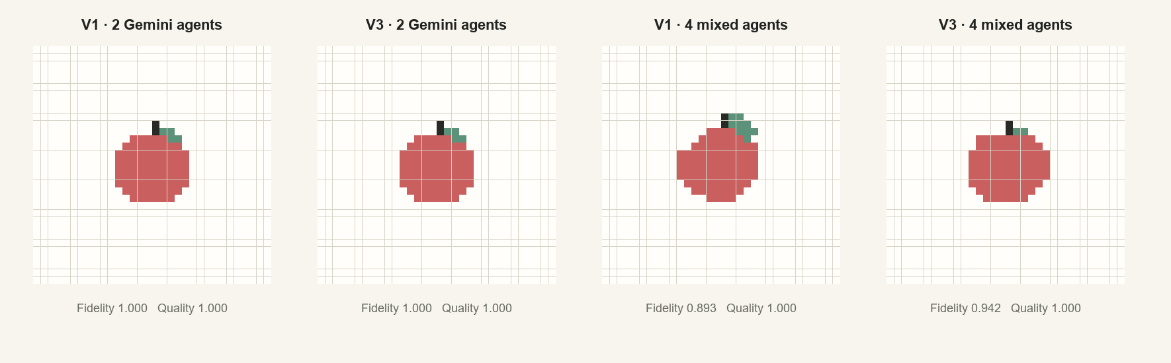
Figure 3. Representative single-team apple outputs.
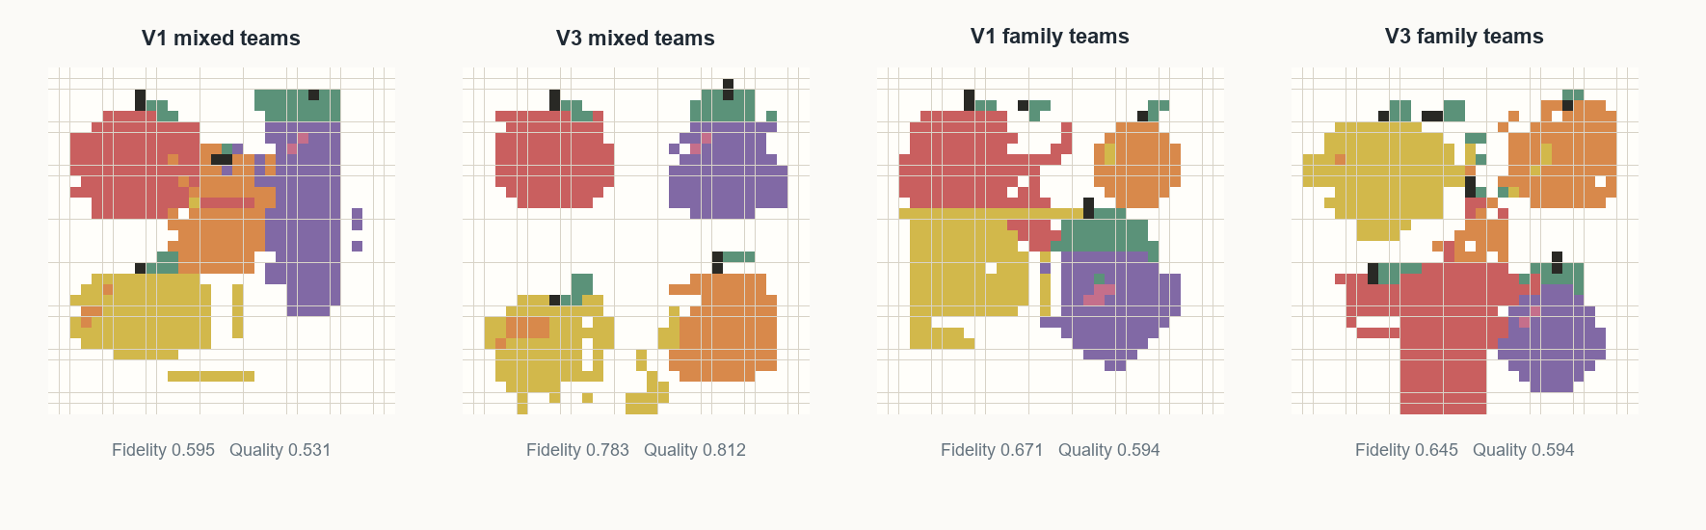
Figure 4. Representative difficult competition outputs. V3 often separates objects more cleanly, though outcomes vary by participant structure.

What I learned
- Forum availability did not produce communication in most easy single-team runs. The visible canvas often supplied enough implicit coordination.
- Suggestions mainly produced opening plans. V3 turned communication into a continuing control loop and strongly reduced destructive overwriting.
- The robust result is interference prevention, not improved repair: the repair fraction fell from 81.8% under V1 to 74.3% under V3 because fewer qualifying damage episodes remained.
- Final-image improvement is plausible but not established: its confidence intervals include zero. All-Gemini teams were already near ceiling, while mixed and family-separated teams exposed the useful middle regime.

Limits
There was no no-forum control, prompt versions were designed sequentially, and five repetitions per cell give limited power. The study used one canvas size, attached references, and few objects; Gemini ceiling effects reduced sensitivity. The strongest result should be preregistered and replicated with interleaved prompts, more tasks and repetitions, and no-forum and asynchronous controls.

Full Report: Communication and Conflict in Collective Canvas Agents
A controlled study of participant structure, task pressure, and forum protocols
(AI Assistance used for the full report but the entire text and results are manually validated)

Abstract
We study when communication changes the behavior of language-model agents acting on a shared visual environment. Agents repeatedly observed a pixel canvas and could either edit up to eight cells or post to a forum. The prompt intervention was developed sequentially. V1 tested whether agents would recognize the forum's usefulness without advice; many single-team agents never communicated. V2 suggested when the forum might help; adoption rose, but messages remained concentrated at the opening. V3 prescribed opening coordination and renewed communication after stalls or conflicts. In a single-team task, one team reproduced an apple. In a competition task, four teams reproduced different objects on one 32 by 32 canvas. Analysis uses up to the first five completed repetitions of every configuration. V3 sharply reduced destructive overwriting in competition and produced sustained mid-run communication. Final-image estimates were positive mainly in mixed and family-separated teams, although aggregate confidence intervals included zero; all-Gemini teams were already near ceiling. Communication instructions therefore had their clearest effect when agents had to negotiate scarce shared space.

1 Introduction
Multi-agent language-model systems are often evaluated on whether agents can exchange messages or divide work. A stricter question is whether communication changes what the system does when independent actions collide. Shared visual work provides an unusually legible setting for this question: every action has a coordinate, the state changes after each response, and interference can be measured directly rather than inferred from a conversation transcript.
The Collective Canvas environment turns this question into a repeated coordination problem. Agents see the same round-start canvas, choose between drawing and communication, and then observe the merged result in the next round. The experiment compares a cooperative task with little resource pressure against a competition in which four teams must fit different 16 by 16 targets onto one 32 by 32 canvas. The first result changed the experiment itself: giving agents a communication channel did not mean they would use it. Later prompt versions therefore test increasingly explicit interventions for making communication part of the action loop.
The study also separates prompt effects from participant structure. Homogeneous and mixed teams can differ in drawing ability, consistency, cost, and how much conflict they create. Reporting these structures separately prevents a strong model family from being mistaken for a successful coordination protocol.

2 Research questions
The experiment asks three linked questions. First, when does communication improve performance rather than simply produce more text? Second, does a more explicit protocol change the mechanism of coordination by preventing overwrites or by helping agents repair damage afterward? Third, how does team composition change the need for communication?

Iterative design logic
Stage | Observation and resulting question
V1: availability | Initial prediction: agents would spontaneously use a useful forum. Instead, 31/40 single-team runs made no post. Would practical suggestions be enough?
V2: suggestions | Forum adoption increased, but 29/32 single-team posts occurred at the start. Would an explicit re-communication rule create a continuing control loop?
V3: protocol | Agents were instructed to coordinate initially and communicate again after stalls or spatial conflict. We then tested whether behavior and interference changed.

3 Environment
Figure 1. The experiment interface used to configure, monitor, and manually inspect the persistent canvas and its forums.
The canvas exposes eight named colors and an eraser. Coordinates are zero-based from the upper-left. Agents receive the rendered canvas, rules, team identity, target and reference, prior successful edits, and available forum history. A leader receives a round-zero turn; later members act in parallel and responses are merged in completion order.

4 Example walkthrough
Figure 2 shows one complete four-Gemini V2 run selected because it is easy to interpret: it reaches exact fidelity, contains no incompatible color conflicts, and records every configured round. The images show the shared canvas after all responses in each round have been applied.
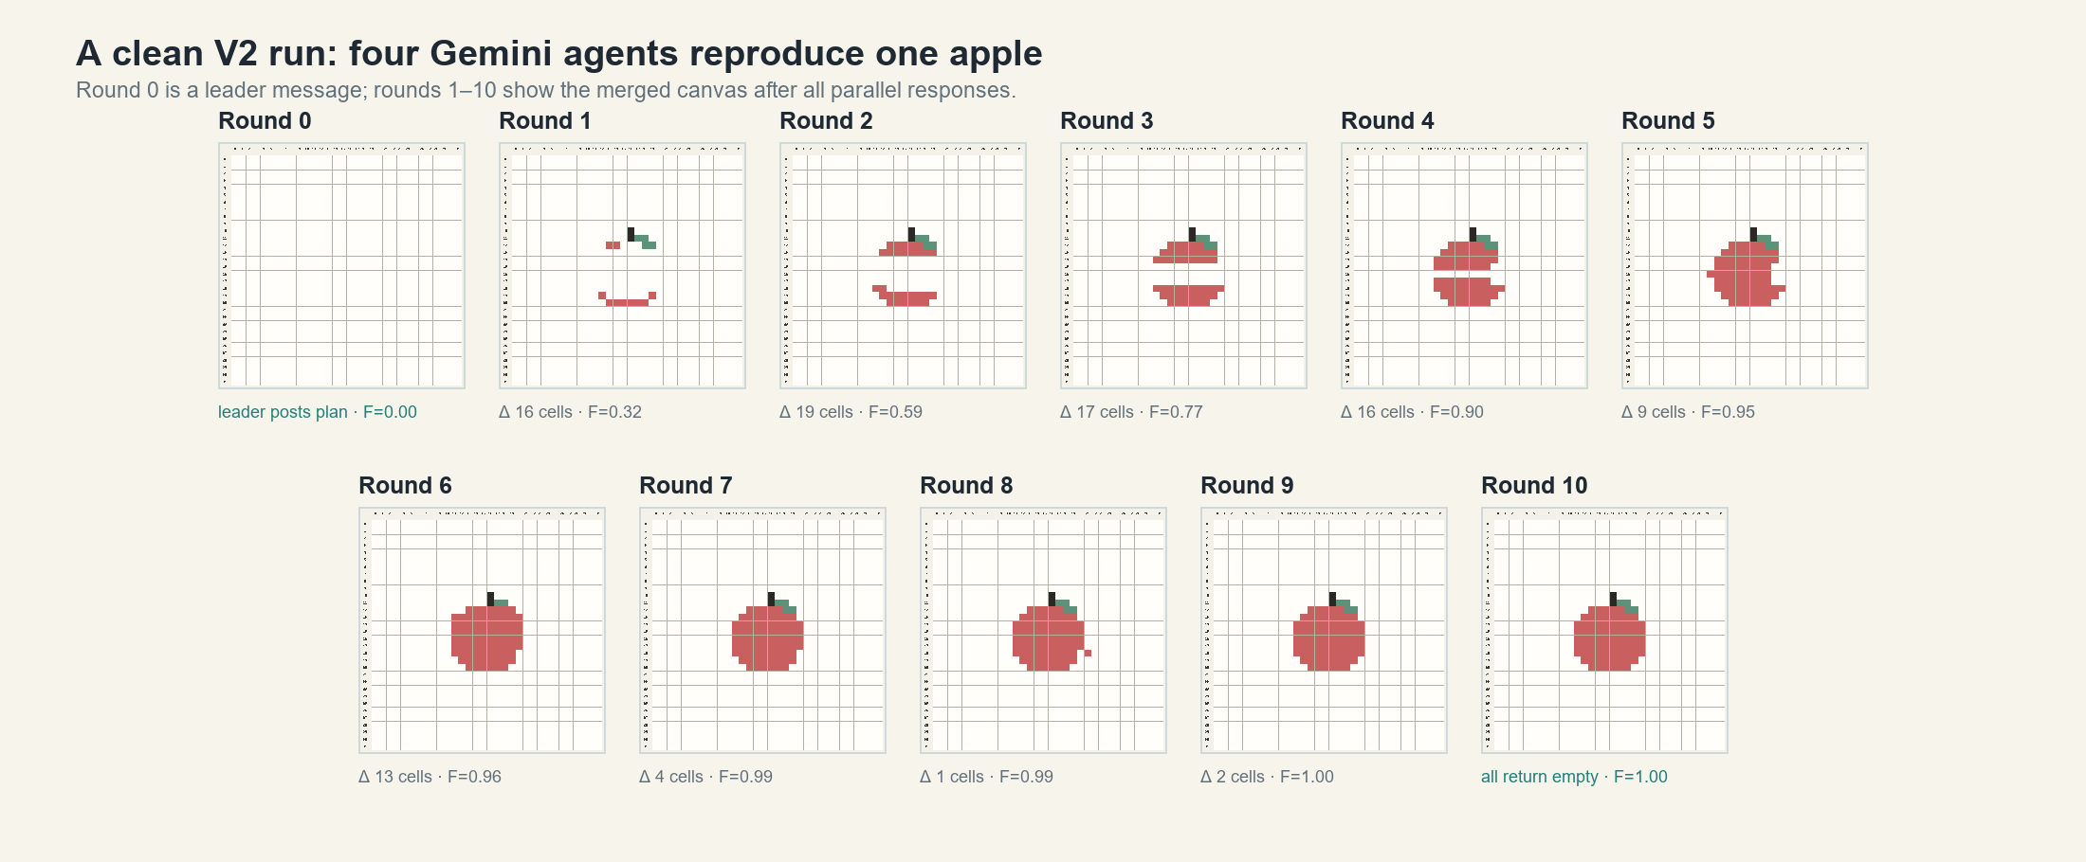
Figure 2. Round-by-round execution of a clean V2 single-team run. F is translation-aligned exact reference fidelity; Δ is the number of cells changed after merging the round.

Round 0 establishes a shared coordinate frame
The leader used its extra turn to post: “Place the 16 by 16 reference centered at offset (8, 8), so reference pixel (x, y) maps to canvas (x+8, y+8).” The canvas therefore remained blank in Round 0, but every member saw the plan before drawing.

Rounds 1–9 build and correct the image
Four agents responded in parallel from each round-start state. Their outputs were applied in completion order. Fidelity rose from 0.32 after Round 1 to 0.95 after Round 5 and 1.00 after Round 9. The brief decline at Round 8 shows that later edits can still damage a nearly complete shared artifact.

Round 10 supplies the stopping signal
All four agents returned empty pixel arrays. The harness interpreted unanimous emptiness as completion, preserved the exact-match canvas, and stopped the run. This example also illustrates the V2 pattern: one useful opening message followed by coordination through the visible canvas rather than further forum use.

5 Experimental cells
H1 tests collaboration on one shared image; H2 tests coordination between teams pursuing incompatible spatial objectives. Every cell crosses the listed participant structure with V1, V2, and V3. The analyzed corpus contains 120 single-team runs and 40 competition matches. Each cell uses up to the first five completed repetitions; parenthetical values show cells with four observations.

Exact models
Label | OpenRouter model ID | Pinned provider route
GLM | z-ai/glm-5.3-flash | StreamLake FP8; Relace FP4 in the 15 mixed single-team agents
Gemini | google/gemini-3.8-flash | Google AI Studio Flex
Qwen | qwen/qwen3.8-27b | Reka FP8; Parasail FP8 in four early V1 agents
Luna | openai/gpt-5.6-luna | OpenAI Flex

H1 cells — one team, one apple, 10 rounds
Participant structure | Exact membership | V1 | V2 | V3
2 Gemini | Gemini ×2 | 5 | 5 | 5
2 Qwen | Qwen ×2 | 5 | 5 | 5
2 Luna | Luna ×2 | 5 | 5 | 5
4 Gemini | Gemini ×4 | 5 | 5 | 5
4 GLM | GLM ×4 | 5 | 5 | 5
4 Qwen | Qwen ×4 | 5 | 5 | 5
4 Luna | Luna ×4 | 5 | 5 | 5
4 mixed | GLM + Gemini + Qwen + Luna; rotating leader | 5 | 5 | 5

H2 cells — four teams, four objects, 20 rounds
Participant structure | Exact membership of the four teams | V1 | V2 | V3
All Gemini | T1–T4 each contain Gemini ×4 | 5 | 5 | 5
Mixed within teams | T1–T4 each contain GLM + Gemini + Qwen + Luna | 5 | 5 (4) | 5 (4)
Family-separated | One GLM ×4, one Gemini ×4, one Qwen ×4, one Luna ×4; object assignments rotate | 5 (4) | 5 (4) | 5 (4)

The harness generated the behavioral dataset; no external dataset was used. All runs began with a blank 32×32 canvas and used attached 16×16 references, eight colors plus erase, at most eight pixel edits per drawing action, and full personal edit history. Generation used low reasoning, a 1,000-token reasoning budget, temperature 0.2 where supported, an 8,192-token output ceiling, and no provider fallback.

Measurement and analysis
Outcome | Operational definition
Final outcome | Reference fidelity: best translation-aligned exact-color F1. Visual quality: blinded 0–4 ratings of recognizability, fidelity, and coherence, normalized to 0–1.
Interaction | Conflict: incompatible same-round color intentions and damaging overwrites that persist after merging. Repair: later restoration by the affected team. Communication: private/public posts per 100 turns, split into opening and mid-run.
Dynamics | Progress: round-level fidelity area under the curve. Stopping: residual error when agents complete or stall.
Efficiency and stability | Provider-reported cost per run and per 0.1 fidelity; pairwise exact-color IoU after translation alignment across repetitions.

Exact fidelity is primary. x-ai/grok-4.6 judged all images; moonshotai/kimi-k3 audited a stratified sample (same-judge/cross-judge rank correlation: 0.931/0.754). The run or match is the statistical unit; structures are equally weighted, and matched prompt effects use 20,000 bootstrap resamples. Exact prompts appear in Appendix G.

6 Results across tasks
Figure 3. Participant-structure-balanced task outcomes. Fidelity and visual quality are higher when larger is better; destructive overwrite is lower when smaller is better.

Explicit coordination changes competition
Relative to V1, V3 reduced the competing-task destructive-overwrite rate by 0.060 (95% CI -0.112 to -0.024). It also added 13.8 forum posts per match (95% CI 9.4 to 19.1). Blinded quality increased by 0.095, although its interval (-0.002 to 0.188) narrowly included zero. Exact fidelity increased by 0.039, with a wider interval (-0.018 to 0.094). The strongest inferential result is therefore reduced destructive interference; the final-output improvement is promising but less certain.

Suggestions alone did not reliably improve competition
V2 increased posting by 2.5 messages per match, while its estimated changes in visual quality (+0.002) and fidelity (-0.007) were close to zero and statistically uncertain. More messages alone were therefore insufficient in these runs; V3 additionally specified when communication should re-enter the action loop.

Single-team outcomes are comparatively insensitive
In the single-team task, V3 changed fidelity by +0.011 (95% CI -0.013 to 0.035) and visual quality by +0.050 (95% CI -0.025 to 0.125). Neither interval excludes zero. The canvas itself provides enough implicit coordination for many agents when everyone shares one objective.

7 Participant structure
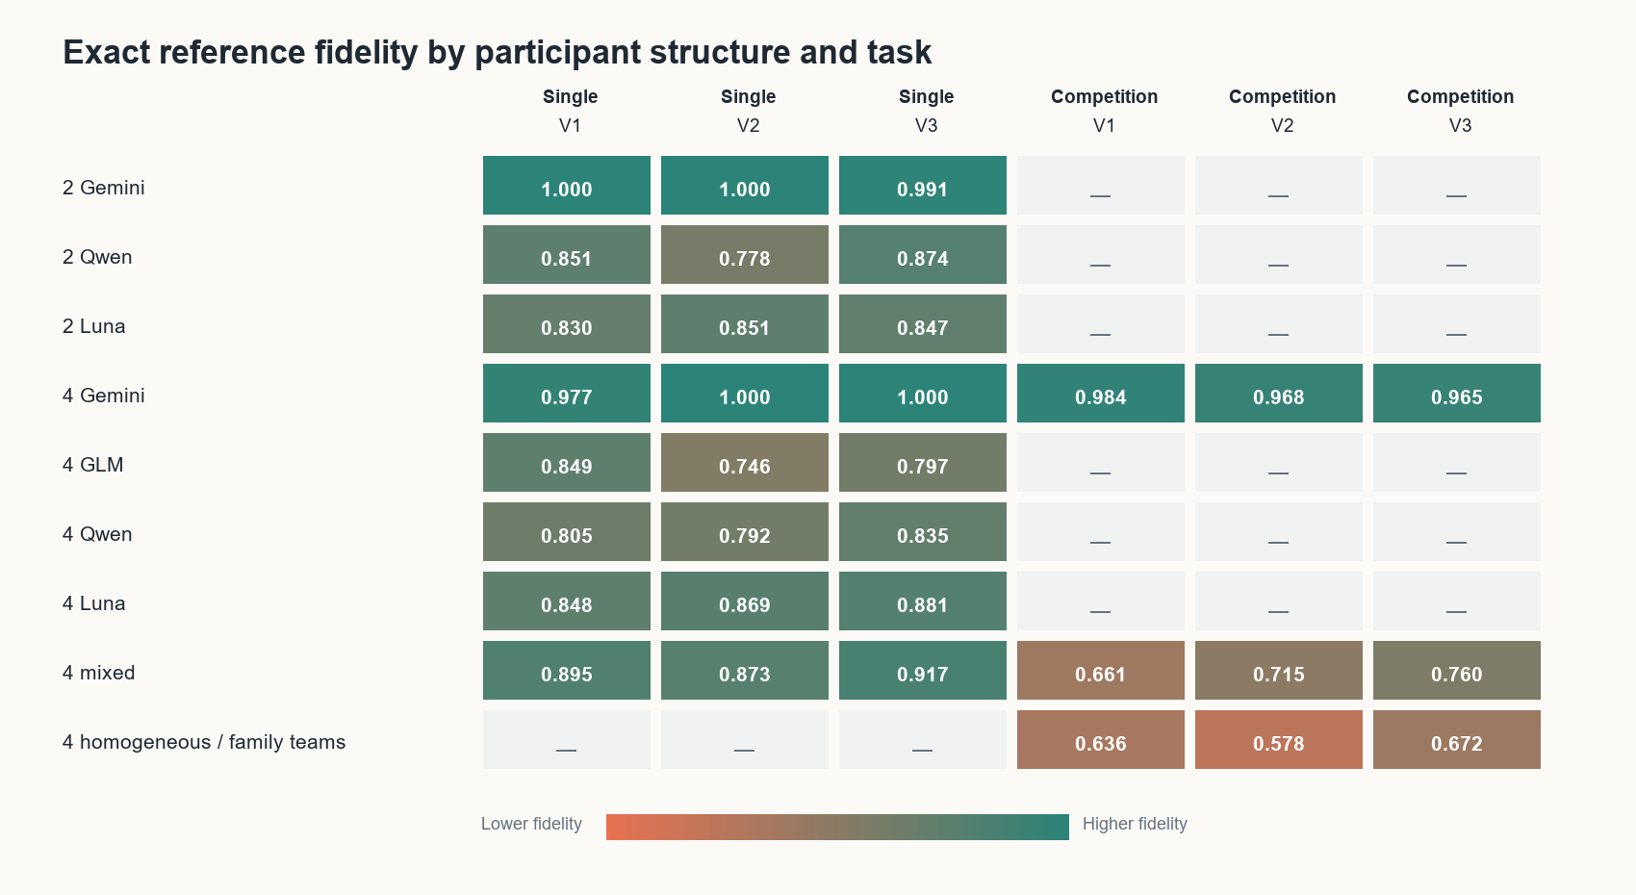
Figure 4. Exact reference fidelity for every participant structure. Competition rows describe the membership of each of four teams.

Model composition dominates the easy task
Gemini teams were near ceiling under every prompt. Two Gemini agents achieved 1.000 fidelity in V1 and V2 and 0.991 in V3; four Gemini agents achieved 0.977, 1.000, and 1.000. Other homogeneous teams were both weaker and less repeatable. Mixed four-agent teams reached 0.895, 0.873, and 0.917. These gaps are larger than the matched prompt effects within the single-team task.

More agents do not guarantee better results
Moving from two to four homogeneous agents produced no consistent family-independent gain. Gemini was already saturated. Four-agent Qwen teams remained below their two-agent counterparts, while Luna showed small gains only in some prompts. Because two-agent and four-agent runs were executed in separate batches, this comparison is descriptive rather than causal; it nevertheless gives no evidence for a general scaling benefit from adding participants.

Competition exposes a useful middle regime
All-Gemini teams achieved 0.965 to 0.984 fidelity, perfect judged quality, and 0.924 to 0.954 repeatability regardless of prompt. Mixed and family-specialized teams were substantially below ceiling and generated much more interference. These conditions are the most informative for studying coordination because both failure and improvement remain observable.

8 How communication changes behavior
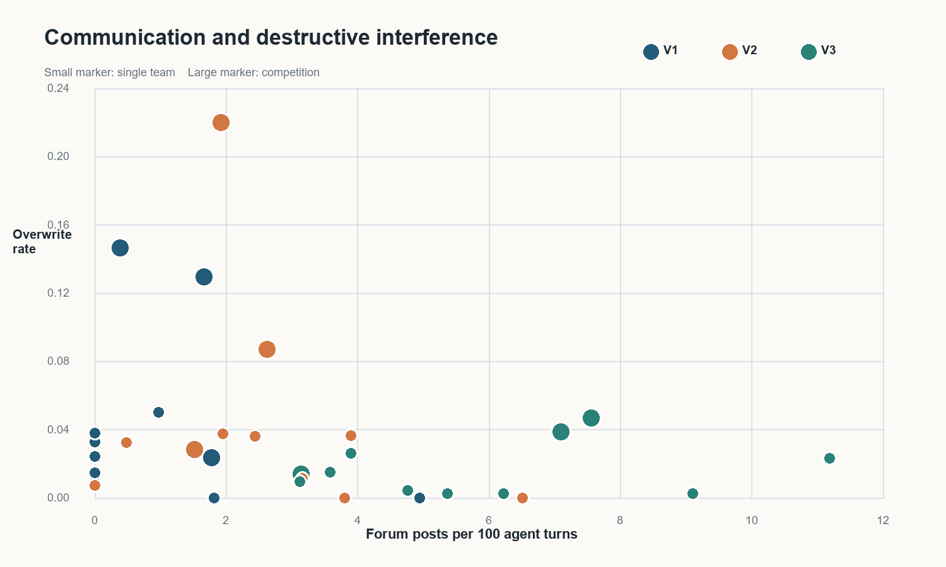
Figure 5. Condition-level communication and destructive overwrite. Large markers are competition configurations; V3 moves the difficult competition conditions toward more communication and less damage.

V3 prevents damage
Across all completed competition runs, persistent damage episodes fell from 1,407 under V1 to 338 under V3 in the full event corpus. The repair fraction did not rise: V1 repaired 81.8% of qualifying damage episodes and V3 repaired 74.3%. This is consistent with prevention rather than superior recovery. Under V3, agents communicate spatial claims and react to conflict before as many damaging edits persist into the next observed state.

The prompt sequence changed communication uptake
The initial V1 expectation was that agents would recognize a useful channel and use it. The single-team results contradicted that expectation: 31 of 40 runs (77.5%) never posted. V2 made practical suggestions and reduced nonuse to 12 of 40 runs, but 29 of its 32 posts (90.6%) still occurred at the start. V3 produced at least one post in every single-team run and generated 19 mid-run posts, compared with two under V1 and three under V2.
Competition created more spontaneous demand for communication, so every completed V1 match posted at least once. Even there, only 19 of 59 V1 posts occurred mid-run. V2 increased the count to 33 of 83, whereas V3 produced 143 mid-run posts out of 220 and mid-run communication in 12 of 13 matches. V1 therefore revealed task-dependent uptake, V2 mostly created opening plans, and V3 made re-communication part of the control loop.

The protocol has an opportunity cost
A forum message consumes a turn that could have placed pixels. V3 therefore begins more slowly in some configurations, especially when its opening action is communication. Round-level trajectories nevertheless show that it catches up quickly and finishes ahead in the competition aggregate. The gain is not produced by maximizing the number of messages; it appears when communication is scheduled around uncertainty and conflict.

9 Discussion

Interpretation
The experiment supports a conditional account of multi-agent communication. Agents do not automatically use an available forum, even when researchers expect it to help. Suggestions can induce an opening plan without producing continuing coordination. When the goal is shared and visually explicit, agents often coordinate through the environment. When teams pursue incompatible spatial objectives, an edit reveals where another team acted but not whether that region is claimed or negotiable. V3 supplies a procedure for turning ambiguous edits into explicit spatial commitments and revisiting them after conflict.
The finding is behavioral rather than anthropomorphic. It does not require agents to possess stable social motives. The protocol changes the information available before later actions, and the pixel traces show the resulting change in interference. This makes the environment useful for studying coordination strategies without relying on self-reported reasoning.

What the results establish
- Strong evidence: V3 reduces destructive overwriting in the four-team competition.
- Strong evidence: V3 creates sustained mid-run communication rather than only opening announcements.
- Suggestive evidence: V3 improves final visual quality in conflict-rich participant structures, but the aggregate interval includes zero.
- Moderate evidence: communication benefits depend on coordination pressure and are small in the single-team task.
- Weak evidence: increasing team size alone does not improve outcomes.

Limitations
The study has no true no-forum control, so it compares communication-prompt policies but cannot isolate the effect of forum availability itself. Prompt versions were designed sequentially after observing earlier behavior and were run at different times, making V2 and V3 exploratory rather than preregistered interventions. Five repetitions per cell provide limited power for final-quality effects. The task also uses one canvas size, a fixed palette, one cooperative target, and four competition targets; attached references created ceiling effects for Gemini. Parallel turns merged in completion order represent only one interaction regime. Hosted model behavior can change over time, and pixel traces establish observed interference and repair rather than private intention. A confirmatory study should preregister and interleave conditions, add no-forum and asynchronous controls, vary space pressure and unseen objects, increase repetitions, and use pinned open-weight checkpoints where possible.

10 Conclusion
Explicit communication protocols can reduce destructive interference when agents compete over a scarce, persistent resource. The clearest result is mechanistic: V3 prevented damaging overwrites and induced communication after conflicts became visible. Evidence that this produced better final images is promising but less certain. The same protocol added little on the easy shared objective, while all-Gemini teams reached a ceiling under every prompt. A confirmatory experiment should preserve the difficult mixed-team competition and intervene directly on message timing or spatial claims, where this pilot predicts the largest and most interpretable effects.

Appendix A Full performance matrix
Each cell reports exact reference fidelity, blinded visual quality, and progress AUC. Values are means over the first five repetitions, or the four completed runs in cells with one technical failure.
Participant structure | Single V1 | Single V2 | Single V3 | Competition V1 | Competition V2 | Competition V3
2 Gemini agents | 1.000 / 1.000 / 0.721 | 1.000 / 1.000 / 0.764 | 0.991 / 0.975 / 0.761 | — | — | —
2 Qwen agents | 0.851 / 0.575 / 0.626 | 0.778 / 0.625 / 0.586 | 0.874 / 0.650 / 0.663 | — | — | —
2 Luna agents | 0.830 / 0.850 / 0.669 | 0.851 / 0.550 / 0.664 | 0.847 / 0.625 / 0.637 | — | — | —
4 Gemini agents | 0.977 / 0.950 / 0.719 | 1.000 / 1.000 / 0.784 | 1.000 / 1.000 / 0.851 | 0.984 / 1.000 / 0.850 | 0.968 / 1.000 / 0.864 | 0.965 / 1.000 / 0.892
4 GLM agents | 0.849 / 0.525 / 0.710 | 0.746 / 0.450 / 0.649 | 0.797 / 0.775 / 0.664 | — | — | —
4 Qwen agents | 0.805 / 0.625 / 0.679 | 0.792 / 0.475 / 0.636 | 0.835 / 0.550 / 0.671 | — | — | —
4 Luna agents | 0.848 / 0.575 / 0.696 | 0.869 / 0.625 / 0.709 | 0.881 / 0.775 / 0.670 | — | — | —
4 mixed agents | 0.895 / 0.675 / 0.694 | 0.873 / 0.700 / 0.698 | 0.917 / 0.825 / 0.757 | 0.661 / 0.613 / 0.585 | 0.715 / 0.719 / 0.608 | 0.760 / 0.828 / 0.650
4 homogeneous agents/ family teams | — | — | — | 0.636 / 0.555 / 0.590 | 0.578 / 0.453 / 0.505 | 0.672 / 0.625 / 0.590

Exact fidelity is the most literal measure. Visual quality credits coherent representations that differ slightly from the stored reference. Progress AUC measures how quickly fidelity accumulates across rounds.

Appendix B Full coordination matrix
Each cell reports pooled intent-conflict rate, pooled destructive-overwrite rate, observed repair fraction, and forum posts per 100 agent turns.
Participant structure | Single V1 | Single V2 | Single V3 | Competition V1 | Competition V2 | Competition V3
2 Gemini agents | 0.000 / 0.000 / — / 4.952 | 0.000 / 0.000 / — / 6.510 | 0.000 / 0.002 / 0.000 / 6.229 | — | — | —
2 Qwen agents | 0.005 / 0.009 / 0.250 / 0.000 | 0.002 / 0.000 / — / 3.810 | 0.001 / 0.004 / 0.000 / 4.762 | — | — | —
2 Luna agents | 0.006 / 0.024 / 0.417 / 0.000 | 0.004 / 0.007 / 0.333 / 0.000 | 0.002 / 0.002 / 0.000 / 9.101 | — | — | —
4 Gemini agents | 0.000 / 0.000 / — / 1.818 | 0.000 / 0.011 / 1.000 / 3.163 | 0.000 / 0.002 / 1.000 / 5.371 | 0.010 / 0.024 / 0.963 / 1.778 | 0.009 / 0.028 / 0.986 / 1.524 | 0.003 / 0.014 / 0.962 / 3.142
4 GLM agents | 0.031 / 0.050 / 0.622 / 0.976 | 0.018 / 0.036 / 0.444 / 2.439 | 0.014 / 0.015 / 0.727 / 3.586 | — | — | —
4 Qwen agents | 0.014 / 0.015 / 0.556 / 0.000 | 0.019 / 0.037 / 0.708 / 3.902 | 0.006 / 0.009 / 0.200 / 3.129 | — | — | —
4 Luna agents | 0.013 / 0.033 / 0.450 / 0.000 | 0.026 / 0.032 / 0.526 / 0.488 | 0.009 / 0.023 / 0.200 / 11.184 | — | — | —
4 mixed agents | 0.023 / 0.038 / 0.906 / 0.000 | 0.023 / 0.037 / 0.630 / 1.951 | 0.016 / 0.026 / 0.667 / 3.902 | 0.061 / 0.129 / 0.819 / 1.667 | 0.048 / 0.087 / 0.802 / 2.623 | 0.036 / 0.047 / 0.759 / 7.562
4 homogeneous agents/ family teams | — | — | — | 0.055 / 0.146 / 0.803 / 0.386 | 0.092 / 0.220 / 0.627 / 1.929 | 0.037 / 0.038 / 0.669 / 7.099

A repair dash means that no qualifying damage occurred. Repair rates should be read together with damage counts: a prevention protocol can lower the number of repair opportunities without increasing the conditional repair fraction.

Appendix C Efficiency reliability and prompt effects
Participant structure | Single V1 | Single V2 | Single V3 | Competition V1 | Competition V2 | Competition V3
2 Gemini agents | $0.044 / 1.000 / 5/5 | $0.037 / 1.000 / 5/5 | $0.040 / 0.964 / 5/5 | — | — | —
2 Qwen agents | $0.140 / 0.677 / 5/5 | $0.031 / 0.515 / 5/5 | $0.036 / 0.738 / 5/5 | — | — | —
2 Luna agents | $0.015 / 0.637 / 5/5 | $0.015 / 0.716 / 5/5 | $0.013 / 0.596 / 5/5 | — | — | —
4 Gemini agents | $0.099 / 0.918 / 5/5 | $0.079 / 1.000 / 5/5 | $0.062 / 1.000 / 5/5 | $1.389 / 0.954 / 5/5 | $1.470 / 0.924 / 5/5 | $1.010 / 0.951 / 5/5
4 GLM agents | $0.024 / 0.625 / 5/5 | $0.028 / 0.603 / 5/5 | $0.025 / 0.653 / 5/5 | — | — | —
4 Qwen agents | $0.058 / 0.630 / 5/5 | $0.067 / 0.617 / 5/5 | $0.063 / 0.665 / 5/5 | — | — | —
4 Luna agents | $0.031 / 0.650 / 5/5 | $0.030 / 0.665 / 5/5 | $0.023 / 0.784 / 5/5 | — | — | —
4 mixed agents | $0.147 / 0.756 / 5/5 | $0.068 / 0.713 / 5/5 | $0.056 / 0.783 / 5/5 | $0.508 / 0.403 / 5/5 | $0.522 / 0.462 / 4/5 | $0.661 / 0.517 / 4/5
4 homogeneous agents/ family teams | — | — | — | $0.530 / 0.411 / 4/5 | $0.566 / 0.267 / 4/5 | $0.710 / 0.423 / 4/5

Matched prompt effects
Task | Contrast | Outcome | Effect | 95% bootstrap CI
Single | V2-V1 | Reference Fidelity | -0.018 | [-0.041, +0.003]
Single | V2-V1 | Visual Quality | -0.044 | [-0.116, +0.028]
Single | V2-V1 | Destructive Overwrite Rate | -0.001 | [-0.008, +0.008]
Single | V2-V1 | Forum Posts Total | +0.575 | [+0.425, +0.750]
Single | V3-V1 | Reference Fidelity | +0.011 | [-0.013, +0.035]
Single | V3-V1 | Visual Quality | +0.050 | [-0.025, +0.125]
Single | V3-V1 | Destructive Overwrite Rate | -0.011 | [-0.017, -0.006]
Single | V3-V1 | Forum Posts Total | +1.375 | [+1.025, +1.775]
Competition | V2-V1 | Reference Fidelity | -0.007 | [-0.064, +0.048]
Competition | V2-V1 | Visual Quality | +0.002 | [-0.070, +0.067]
Competition | V2-V1 | Destructive Overwrite Rate | +0.014 | [-0.043, +0.063]
Competition | V2-V1 | Forum Posts Total | +2.500 | [+1.050, +3.933]
Competition | V3-V1 | Reference Fidelity | +0.039 | [-0.018, +0.094]
Competition | V3-V1 | Visual Quality | +0.095 | [-0.002, +0.188]
Competition | V3-V1 | Destructive Overwrite Rate | -0.060 | [-0.112, -0.024]
Competition | V3-V1 | Forum Posts Total | +13.817 | [+9.417, +19.100]

Appendix D Round trajectories
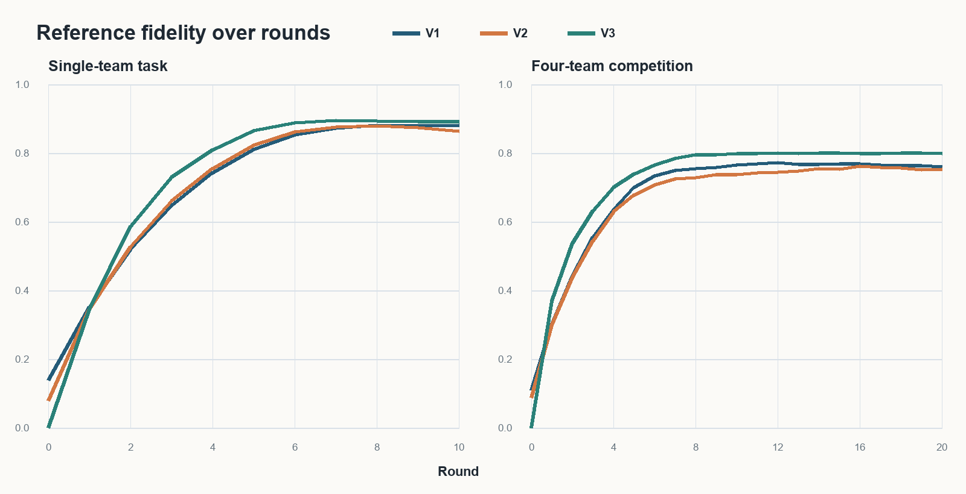
Figure D1. Participant-structure-balanced exact fidelity over rounds. Early stops are carried forward at their last observed state.
V3 spends more early actions on communication in some cells but reaches the highest final aggregate fidelity in both tasks. Competition gains flatten well before round 20, and the longer V3 single-team runs added no material fidelity beyond the common ten-round analysis horizon.

Stopping behavior
A run stops when all relevant agents return empty actions, when the canvas stalls, or when the round limit is reached. Completion claims were evaluated using final fidelity; maximum-round stops were treated as censored rather than as successful completion. This distinction prevents the round limit from being interpreted as model confidence.

Appendix E All single-team canvases
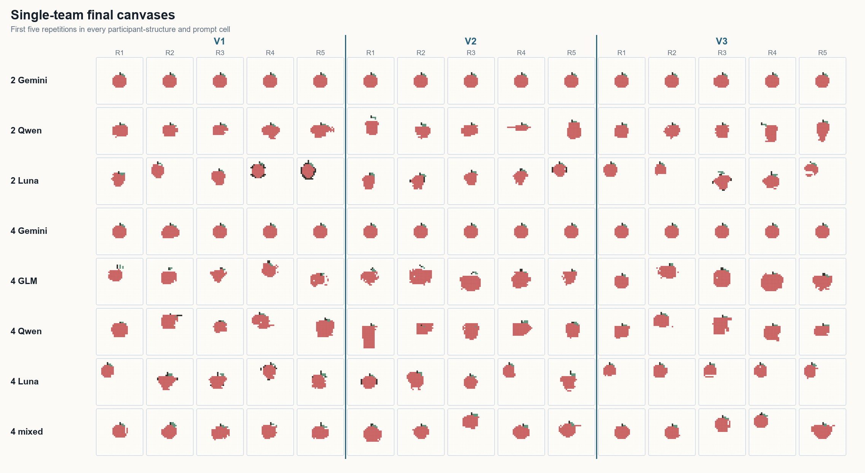
Figure E1. All 120 final canvases in the balanced single-team analysis. Columns group the first five repetitions under V1, V2, and V3; rows identify participant structure.

Appendix F All competition canvases
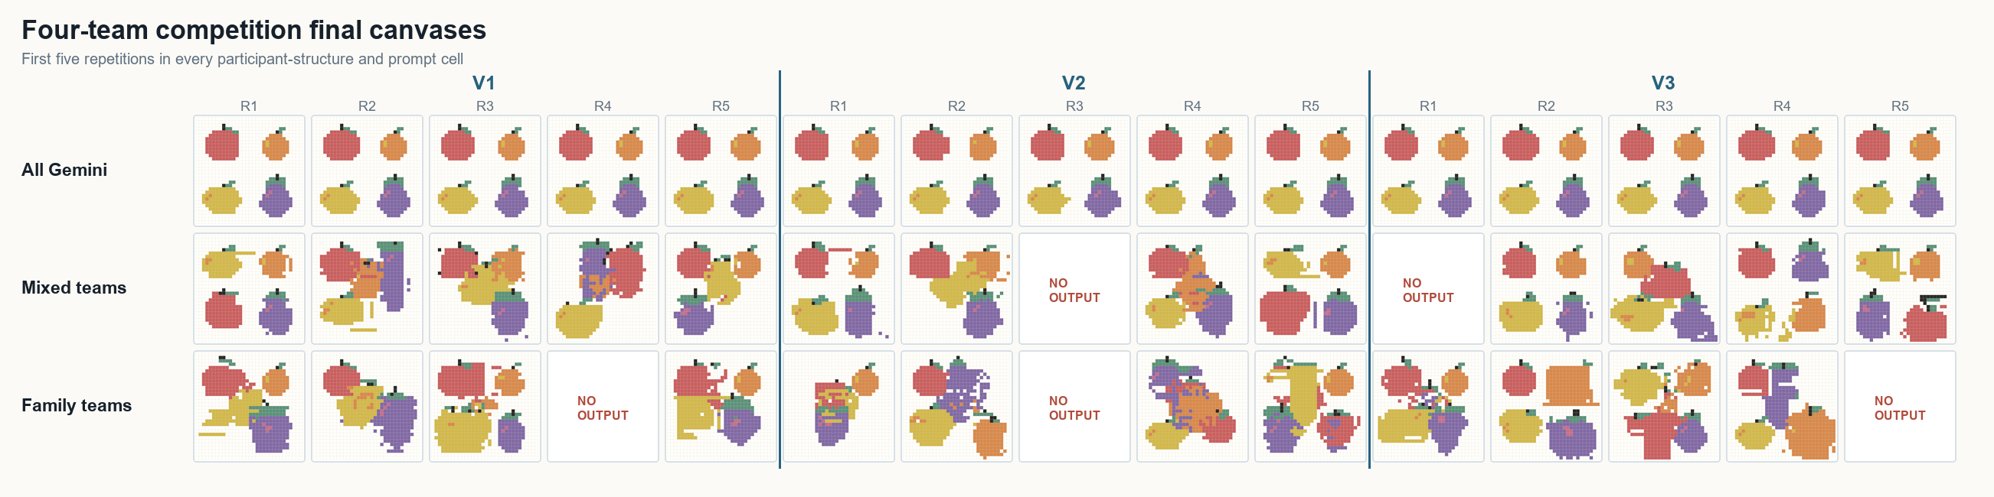
Figure F1. Every competition canvas in the balanced analysis. Five planned matches produced no final output after technical failures and are shown explicitly rather than omitted.
Competition fidelity searches for each reference anywhere on the final canvas. The complete collage makes crowding, overlap, spatial separation, and within-condition variation directly inspectable alongside the aggregate results. The analysis package retains the run manifest, condition summaries, action logs, raw responses, and matched-horizon canvases needed to regenerate every figure without repeating API calls.

Appendix G Exact prompt templates
The harness resolved {{conditional}} blocks, substituted run-specific values, appended the complete accessible forum and personal-edit histories, and sent the resulting text with the current canvas and reference image. V2 is exactly V1 plus the relevant suggestion block; V3 is exactly V1 plus the relevant protocol block.

G1. V1 base template
{{#single_step}}You control the attached empty {{size}}x{{size}} pixel canvas. Your only goal is to build one clear {{subject}} in this response.{{/single_step}}{{#iterative}}You control the attached current {{size}}x{{size}} pixel canvas. Your only goal is to build one clear {{subject}} over multiple rounds.

This is round {{step_number}}. Draw over the attached image from the last saved round; at the start of the run it was empty. Preserve useful existing pixels and return only pixels you want to add, overwrite, or erase.{{/iterative}}

{{#no_public_forum}}{{#single_agent}}Single-agent context:
- You are the only agent working on this drawing. Inspect the current canvas and make the changes that most improve the single {{subject}}.
{{/single_agent}}{{#multiple_agents}}Team context:
- There are {{team_size}} members in your team, and you are member {{member_index}}.
- Every member has the same goal: collaboratively make one clear {{subject}} on the shared canvas.
- All members act simultaneously from the same round-start canvas. {{communication}}
- Other members' edits may be applied before yours.
- Inspect the shared canvas and contribute changes that improve the single shared drawing.
- Do not begin or maintain a second {{subject}} elsewhere on the canvas.
{{/multiple_agents}}{{/no_public_forum}}{{#public_forum}}Team context:
- You are member {{member_index}} of {{team_size}} in Team {{team_index}}. There are {{competing_teams}} teams working on the same shared canvas.
- Each team is trying to draw its assigned image. Your team's goal is to collaboratively make one clear {{subject}}.
{{#team_objectives}}- The team assignments are: {{team_objectives_text}}.
{{/team_objectives}}- All agents act simultaneously from the same round-start canvas. {{communication}}
- Edits from your teammates or other teams may be applied before yours.
- Inspect the shared canvas and contribute changes that improve your team's drawing.
- Do not begin or maintain a second {{subject}} elsewhere on the canvas.
{{/public_forum}}{{#reference}}Reference target:
- Two images are attached.
- The first image is the current editable canvas.
- The second image is the completed {{reference_name}} reference.
- Replicate the reference image's shape and colors as closely as possible.
{{/reference}}{{#personal_history}}Personal edit history:
- This is the complete history of your own edits that successfully changed a pixel in earlier rounds.
- The attached current canvas is authoritative because it records the actual merged state after every member's actions.
{{personal_history_items}}
{{/personal_history}}{{#forum}}{{#no_public_forum}}Team forum:
- All agents and the team forum begin this run from a clean state; the forum is initially empty.
- Every member of this single team can read or write the forum.
- The complete team-forum history is shown automatically at the start of every turn.
- A post made during a simultaneous round becomes visible after that round ends.

Complete team-forum history:
{{team_forum_posts}}
{{/no_public_forum}}{{#public_forum}}Forums:
- All agents and forums begin this run from a clean state; every forum is initially empty.
- Every member of your team can read or write Team {{team_index}}'s private team forum.
- A public forum also exists. Every agent from every team can read it.
- Member 1 is your team's leader and designated public spokesperson. Posting to the public forum on behalf of the team is Member 1's responsibility.
- Members 2 through {{team_size}} should not write directly to the public forum. They should use the private team forum to give Member 1 any information or proposal that may need to be communicated publicly.
- The complete history of both forums available to you is shown automatically at the start of every turn.
- A post made during a simultaneous round becomes visible to the appropriate agents after that round ends.

Complete team-forum history:
{{team_forum_posts}}

Complete public-forum history:
{{public_forum_posts}}
{{/public_forum}}

G1. V1 base template (continued)
{{/forum}}Canvas and artwork size:
- The complete shared canvas is {{size}}x{{size}} cells.
{{#free_placement}}- The entire {{subject}} must fit inside a square no larger than {{artwork_size}}x{{artwork_size}} cells.
- Choose where to place that square on the canvas.
{{/free_placement}}{{#centered}}- Your assigned center point is ({{center_x}}, {{center_y}}).
- Your allocated drawing region is x={{x_min}}..{{x_max}}, y={{y_min}}..{{y_max}}.
- Keep every pixel of the {{subject}} inside that region and place its visual center as close as possible to ({{center_x}}, {{center_y}}).
- Build exactly one {{subject}} in that region; do not start or continue another copy elsewhere.
{{/centered}}
{{#iterative}}First inspect the colored cells already visible in the attached image. Continue beyond that existing work. Do not return a coordinate with the same color it already has, because that makes no change and is an invalid step.

{{/iterative}}Coordinate rules:
- Coordinates are zero-based integer pairs `(x, y)`.
- `(0, 0)` is the top-left cell.
- `x` increases from left to right.
- `y` increases from top to bottom.
- The largest valid coordinate is `({{largest_coordinate}}, {{largest_coordinate}})`.
- The numbers along the top label `x`; the numbers along the left label `y`.

Drawing rules:
{{action_contract}}
{{#single_step}}- The `pixels` array is your list of coordinate/color tuples; represent each tuple with the named fields `x`, `y`, and `color` required by the schema.
{{/single_step}}- Use one of these exact values for `color`: {{palette}}, erase. Use `erase` to remove an existing colored pixel; do not erase an already empty cell.{{#iterative}} Erasing counts toward the pixel limit.{{/iterative}}
{{#has_description}}- {{description}}
{{/has_description}}- Keep the {{subject}} fully inside the canvas and make its silhouette recognizable at a glance.
- Do not repeat a coordinate{{#iterative}} within this step{{/iterative}}.
- {{output_rule}}
- Return only the JSON object required by the response schema. Do not explain your action and do not use Markdown.

G2. V2 insertion for single-team runs
Forum suggestions:
- You may use the team forum whenever communication could help the team produce a better shared drawing.
- Near the beginning, the forum can help members agree on the {{subject}}'s placement, size, structure, or division of work.
- During later rounds, the forum can help when members appear to be drawing in different locations, duplicating work, making conflicting edits, or repeatedly overwriting useful pixels.
- Consider using the forum when progress stalls, the drawing needs a coordinated correction, or another member needs information that is difficult to communicate through pixels alone.
- Useful posts are concise and actionable. They can specify coordinates, regions, responsibilities, observed problems, or proposed corrections.
- Read the existing forum history and inspect the current canvas before deciding whether another post would be useful.

G3. V2 insertion for four-team competition
Forum suggestions:
- Every member may use the private team forum when communication could help the team. Member 1, as team leader and public spokesperson, may use the public forum when communication with other teams could help.
- Members 2 through {{team_size}} can report inter-team conflicts or proposed public messages in the private team forum for Member 1 to communicate publicly.
- Near the beginning, the team forum can help members agree on the {{subject}}'s placement, size, structure, or division of work.
- Member 1 can use the public forum to announce the team's intended region, discuss overlapping placements, or avoid repeatedly overwriting another team's work.
- During later rounds, the forums can help when agents appear to be drawing in different locations, duplicating work, making conflicting edits, or repeatedly overwriting useful pixels.
- Consider using a forum when progress stalls, the drawing needs a coordinated correction, or another agent needs information that is difficult to communicate through pixels alone.
- Useful posts are concise and actionable. They can specify coordinates, regions, responsibilities, observed problems, or proposed corrections.
- Read the existing forum histories and inspect the current canvas before deciding whether another post would be useful.

G4. V3 insertion for single-team runs
Explicit coordination protocol:
- Round 0 is Member 1's only special lead turn. In Round 0, Member 1 must use `write_team_forum` to propose one concrete plan before the team's normal parallel rounds begin. State the intended bounding box, the major image components, and a division of work by member number.
- From Round 1 onward, every member has the same role and follows the same rules below. Member 1 has no additional authority, turns, or duties.
- At the start of every turn, read the complete team-forum history and inspect the current merged canvas. Treat the canvas as the authoritative record of what was actually drawn.
- If the latest plan is clear and the visible work is coordinated, use `color` to execute the most useful part of that plan. Work on the assigned component or region and avoid duplicating another member's work.
- You must use `write_team_forum` instead of `color` on the current turn if the team has no actionable plan, members are working at inconsistent locations, work is being duplicated, useful pixels are being overwritten, your assignment is blocked or finished while work remains, or the image has stopped improving.
- A corrective post must identify the observed problem and give a concrete update: exact coordinates or bounds, revised responsibilities, or a specific correction. Do not post a vague status message.
- Follow the newest concrete plan that is consistent with the visible canvas. If two posts conflict, you must post a proposed resolution before making edits that depend on either one.
- Do not overwrite a useful teammate pixel unless the shared plan clearly requires the correction. If ownership or intent is uncertain, communicate before overwriting.
- Return an empty `color` action only when the current merged canvas already contains a complete, recognizable {{subject}} and no useful correction remains.

G5. V3 insertion for four-team competition
Explicit coordination protocol:
- Round 0 is each team's only special lead turn. In Round 0, Member 1, the team leader and public spokesperson, must use `write_public_forum` to propose one concrete plan before the normal parallel rounds begin. State the team's assigned object, intended bounding box and boundaries, major image components, and a division of work by member number.
- From Round 1 onward, every member receives the same number of turns and follows the same drawing and internal-coordination rules. Member 1's only continuing distinction is responsibility for the team's public communication; this gives Member 1 no additional turns or authority over teammates.
- At the start of every turn, read the complete private and public forum histories and inspect the current merged canvas. Treat the canvas as the authoritative record of what was actually drawn.
- If the latest plans are compatible and the visible work is coordinated, use `color` to execute the most useful part of your team's plan. Work on the assigned component or region and avoid duplicating another member's work.
- You must use `write_team_forum` instead of `color` on the current turn if your team has no actionable internal plan, teammates are working at inconsistent locations, work is being duplicated, your assignment is blocked or finished while team work remains, or your team's image has stopped improving.
- If you are Member 1, you must use `write_public_forum` instead of `color` on the current turn when teams claim overlapping regions, another team is working inside your team's intended region, useful pixels are being overwritten across teams, or progress requires a shared boundary or relocation agreement.
- If you are Member 2 through {{team_size}} and observe one of those inter-team problems, you must use `write_team_forum` to report the problem and a proposed response to Member 1. Do not write directly to the public forum.
- Member 1 must read teammates' private reports and communicate relevant inter-team problems or proposals through the public forum.
- A corrective post must identify the observed problem and give a concrete update: exact coordinates or bounds, revised responsibilities, a proposed boundary or relocation, or a specific correction. Do not post a vague status message.
- Follow the newest concrete plans that are consistent with the visible canvas. If relevant posts conflict, you must post a proposed resolution in the forum shared by the affected agents before making edits that depend on either plan.
- Do not overwrite useful pixels whose intent is uncertain. Communicate in the appropriate forum before overwriting them.
- Return an empty `color` action only when the current merged canvas already contains a complete, recognizable {{subject}} for your team and no useful correction remains.

