We have decided on separating Phase I and Phase II into two different surveys. So let’s focus on Phase I first. The current survey should only include filtering questions and Phase I. All Phase 2 questions can be moved to a separate survey.
Here is a list of things to revise:
- The whole survey seems to have a lot of whitespace on both sides, which results in readability issues. Refer to Zillow https://www.zillow.com/, we shouldn’t need much white space on the two sides, if at all.
- Remove ALL current Phase I instructions and quiz – phase 1 seems to be easy enough.
- Instead, move the “what is maximum willingness to pay?” part in Phase 1 (see photo below) to the instruction page, and serve as the only instruction.
- Make this part of the instruction more clear in terms of wording.
- Phase 1:
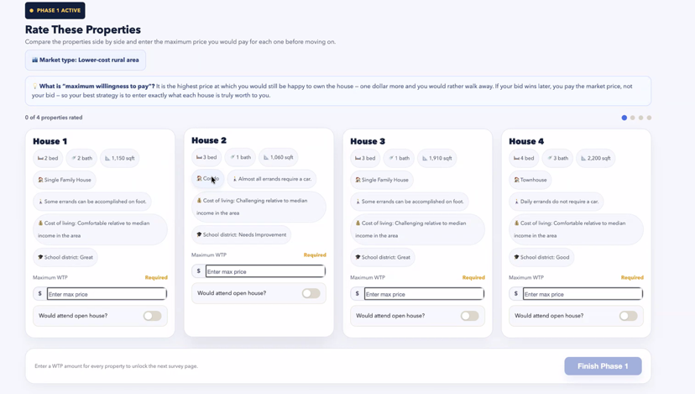
- Title should just be “Rate these properties” & “market type”. No other instructions needed on this page. Make both fonts bigger.
- Change Phase I to 4 rounds, so that it becomes “0 of 4 rounds completed”, and each dot to the right signals 1 round.
- Every round has 3 properties (instead of 4), make all fonts bigger
- All house information should use the same structure like house 1 (bed/bathroom in one line, house type in one line, etc)

