

Tanner Massahos, Joseph Remy, Julian Bell, Tyler Boice, Chase Mosteller

Title of Project: roBOTically efficient

[GitHub](https://github.com/J1411/NAU_CS386)

D.3 Analysis – Due: 2018-03-16

CS386 – Software Engineering – Spring 2018

Dr. Marco Gerosa

1. **Description**

People who are busy with various aspects of their life such as school, work, and other activities often do not have the personal time to invest in grinding through skills and money making in Runescape. However, with the botting program, roBOTically efficient™, any person can easily focus on their work, while a computer handles the minutia of grind in 2007 Runescape. People no longer have to waste precious time trying to go through the boring parts of 2007scape, while also managing their real life engagements. RoBotically handles all of the boring aspects of the game, while leaving the most fun activities for one’s own free time, in order to maximize one’s enjoyment of the game.

RoBOTically efficient™ functions using two core elements, the **Game Client** and the **Game Scripts**. The **Client** runs a given **Script** and also provides the user with a user interface for selecting various scripts. Each **Script** will generatea *Log*, run for a designated *Runtime*, and can be one of two *types*. The two **Script** *Types* are **Skilling** and **Money Making**.

**Skilling Scripts** allow for the user to train a certain skill with the most up to date training methods. Each **Skilling Script** will track *experience gained*, track quantity of *items collected*, display current and designated *Runtime*, and note the *current skill* being trained.

**Money Making Scripts** allow the user to choose from various methods of generating in game currency for any level and for various amounts of gold per hour (GpH). Each **Money Making Script** will track *money gained*, track quantity of *items collected*, display current and designated *Runtime*, show the *method* used to make money, and note *GpH*.

1. **Model**

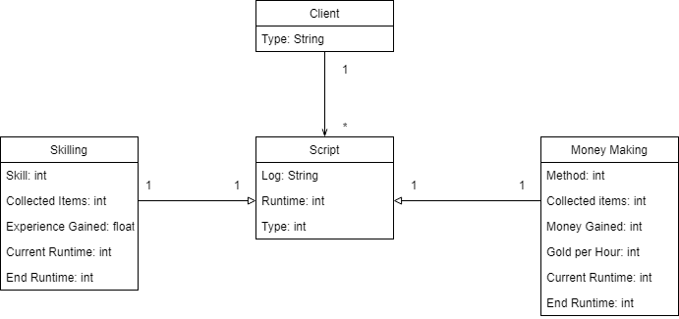

1. **Group Participation**

**Tanner Massahos** – Assisted in creation of UML and oversaw if the description was written correctly by Tyler. *(18.77%)*

**Joseph Remy** – Relayed and verified that all group members were understanding what we had to do for this deliverable, assisted when need be. *(18.76%)*

**Julian Bell** – Drafted up the Google Doc for us to all work on, also made sure the UML and description was correctly made. *(18.75%)*

**Tyler Boice** – Drafted up and finalized the UML and description for the team, as he wanted to take charge of this deliverable. *(25%)*

**Chase Mosteller** – Assisted in reminding individuals to get their work done and helped explain what kind of scripts we would be making for the game since he plays Runescape. *(18.72%)*