poojamishra23
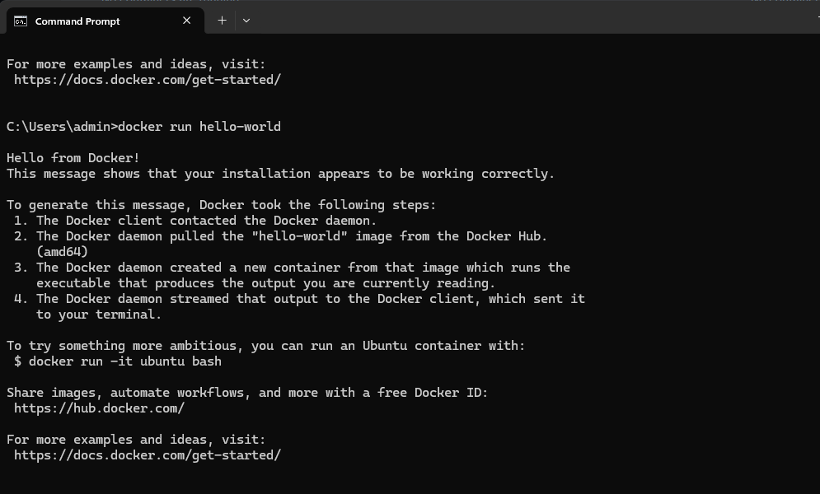
Create a folder name docker_94
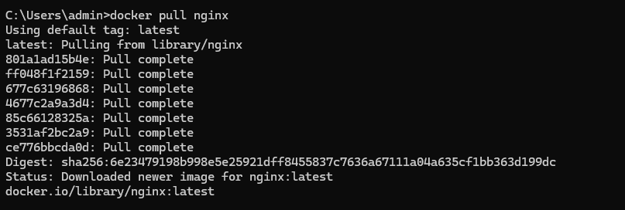
docker images:
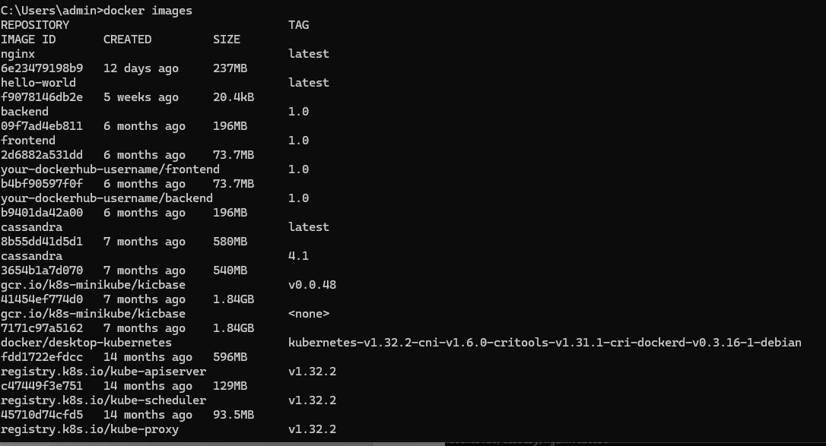
docker ps
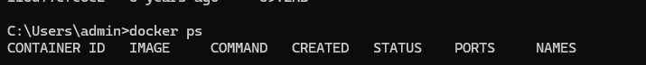

docker ps –a

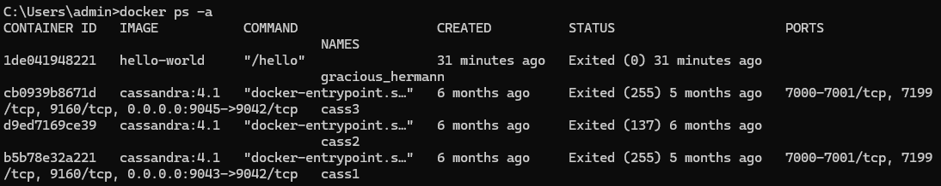
docker run -p 8082:80 nginx
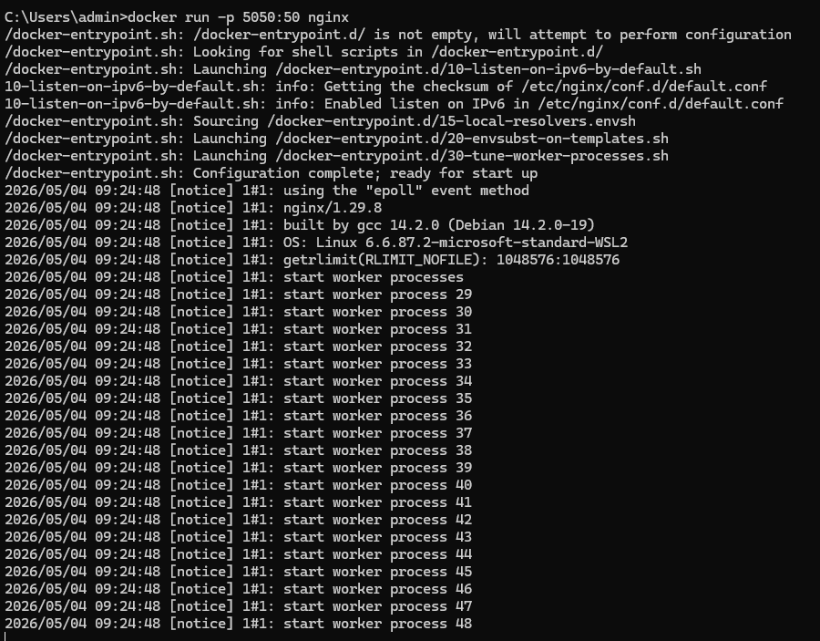

docker run -d -p 8081:80 nginx

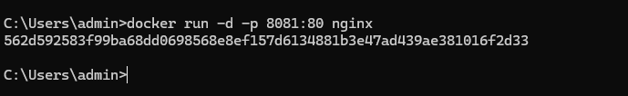
Open Visual studio:
Create a folder->docker_94 -> create a file - Dockerfile
In terminal : mkdir my-docker-app
