|  |  |
| --- | --- |
| **New Zealand Road Crash Analysis** | By Jae Won Kim |

**The project**

The project represents a short analysis of the Crash Analysis System Data, which contains all the crashes that occurred in New Zealand that have been reported by the police. Through the analysis of the data, we will be able to see different factors that contribute to the crash and its severity. We will be looking at the last 10 years, from the year 2012 to the present year 2022, which consists of over 350,000 records.

The data was imported into Microsoft SQL Service Management Studio and the analysis was conducted using MS SQL to retrieve data from the table, which was later imported into Tableau to create visualizations.

The original data was found from the following link:  
<https://opendata-nzta.opendata.arcgis.com/search?tags=CAS>

**The Analysis**

**Number of Casualties**

Firstly, I was interested in the number of casualties caused by road crashes, this includes anyone in all the vehicles involved, cyclists, pedestrians, by passers. What we found out was that the number of casualties were quite uniform throughout the years. Which was interesting because New Zealand were in lock down due to COVID-19. Lock downs from March 2020 to May 2020 with Auckland going back into lock down from August 2020 to October 2020. For the year 2021 New Zealand went back into lock down in August 2021 until September with Auckland staying in lock down until November before going into a less strict lock down.

*Note: At the time of this analysis the original data was last updated in September 2022, thus the number of casualties for the year 2022 will be lower than the rest, this will carry out in the rest of the analysis.*

**Number of Crashes per Year**

We can easily see from the graph below that the number of crashes started to rise from 2015, peaking in 2017. Unlike casualties, the number of crashes for the year 2020 and 2021 are less than the previous years. Most likely due to the lock downs, which could indicate that the number of fatal crashes during 2020 and 2021 were higher in proportion to the number of crashes compared to the previous years.

**The Crash Severity**

As shown in the chart above, more than 2/3rd of all crashes is “*non-Injury”* crashes. Alternatively, only 0.87% of all crashes are “*fatal”.*

As the severity is very important, this is the data that we will look further into. Trying to find out what factors contribute the most to the severity of the crash.

**Speed**

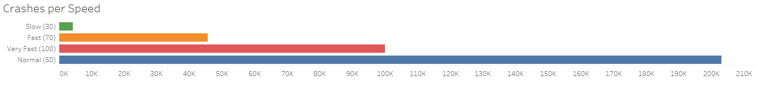We will look at the affect speed has on the severity of the crash. I have categorised the roads speed limit to 4 categories, slow, normal, fast, and very fast.

Roads with normal speed limits have the highest number of crashes. This could be because there are more roads that have a speed limit of 50km/h. Those areas with slow speed limits have the least number of crashes. We can assume this is because of the restriction of the speed making it difficult to get into a crash.

***How does speed limit have an impact on the severity of the crash?***

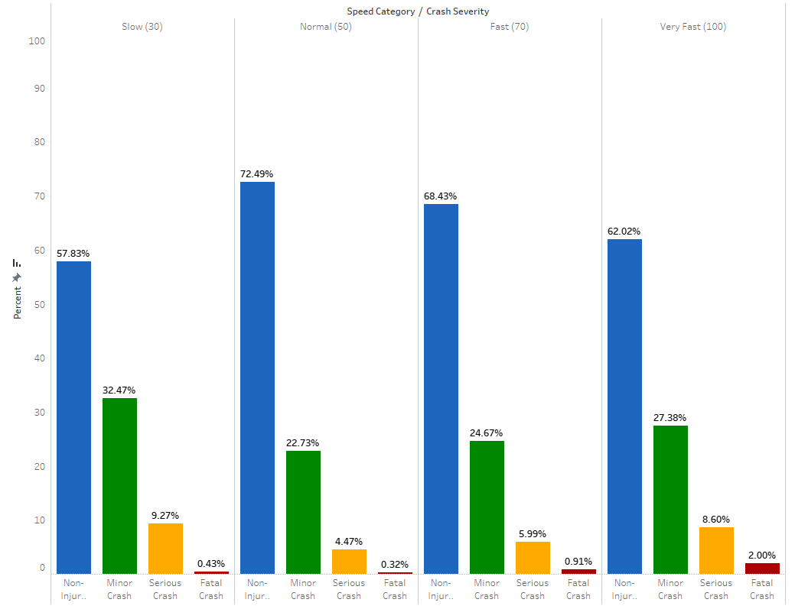To find out, we will look at the number of crashes per speed category, then divide that number per severity of the crash.

From the chart above, we can see that most crashes in each speed category are *“non-injury”* crashes. Only in the *“very Fast”* category do we see *“fatal crash”* being more than 1%, more than double compared to the other speed categories.   
  
As the speed increases, we can see a decrease in *“non-injury”* crashes and an increase in *“minor”,* *“serious”* and *“fatal”* crashes.

Exception being slow speed zones, where it has the highest percentage of *“minor”* crashes and *“serious”* crashes. Only assumption I can make would be that most slow speed zones would be around school zones. With children being more fragile, an accident of any magnitude could be serious and fatal.

Thus, we can say that speed does influence severity. As the speed increases, the greater the severity.

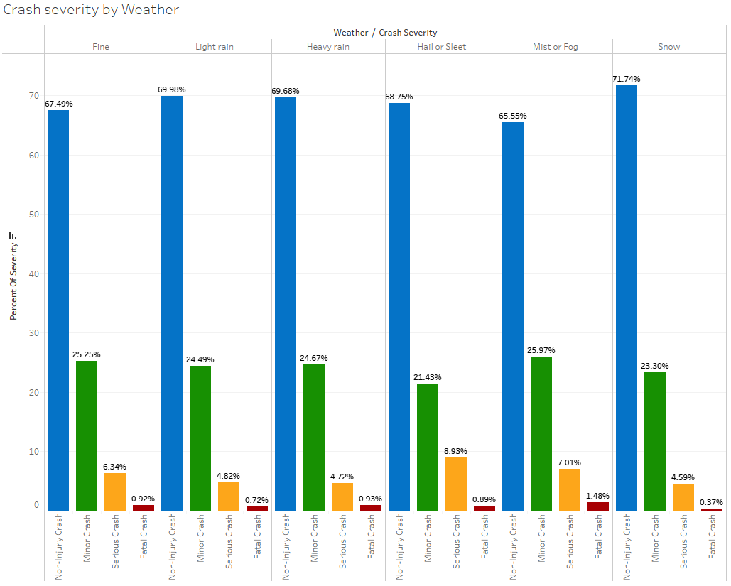***How does the weather affect the severity?***

We cannot clearly say if weather has any significant influence on the severity of a crash based on the chart. What would be considered as “bad” weather, such as *“heavy rain”* has almost the same *“fatal crash”* percentage as the *“fatal crash”* percentage in a “Fine” weather condition. We could assume that in a “bad” weather condition, drivers are more cautious on the road. Only thing that stands out is that in a *“Mist or Fog”* weather condition the percentage of “serious crash” and *“fatal crash”* is much higher compared to the rest. This could suggest that lack of vision could have an influence on the severity.

***How does light condition have an influence on severity?***

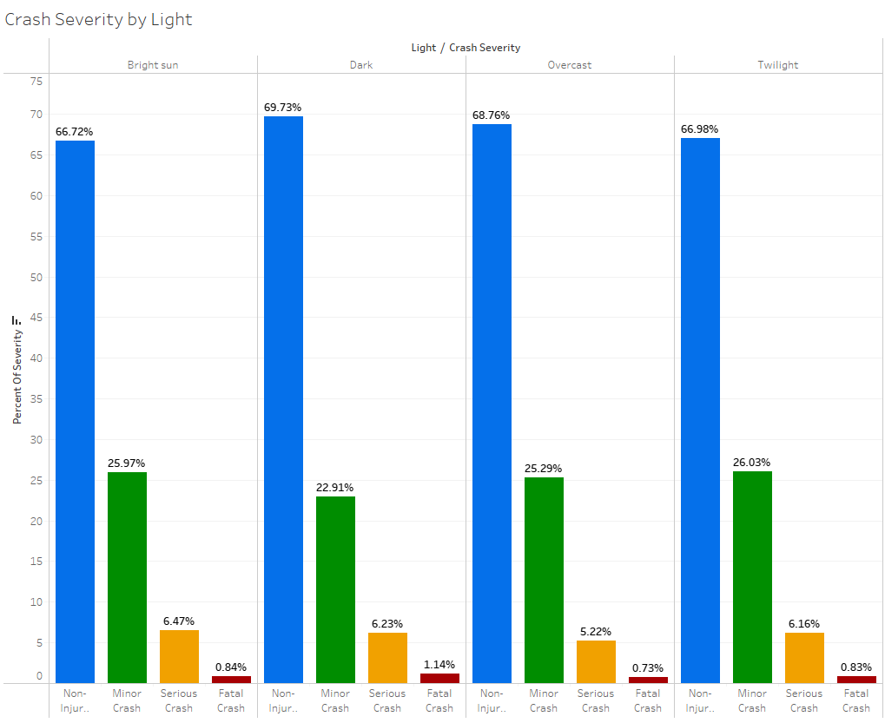

Although the lighting condition with the highest *“fatal crash”* percentage is indeed *“dark”*, I believe we cannot confidently say that light has a significant influence on the severity. This is because the percentage of severity is nearly identical when comparing one lighting condition to another.

**Regions**

Finally, we will look at the number of crashes by region.  
The number of crashes will heavily depend on population density. Auckland having the highest number of accidents and West Coast having the least number of accidents.

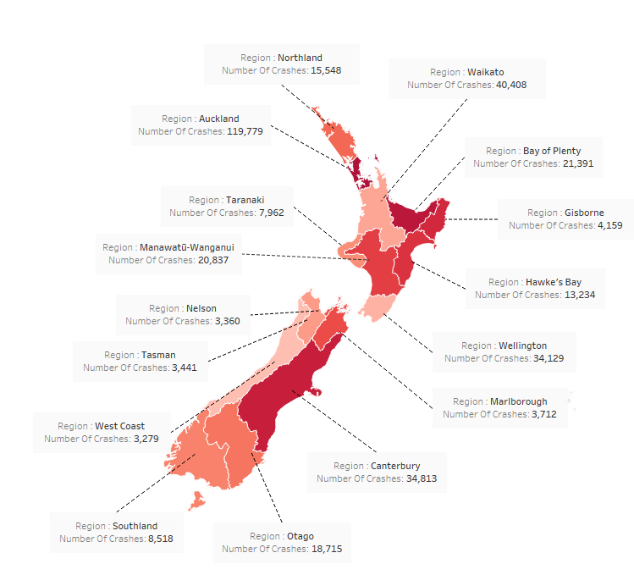

By using the data gathered from the data set, we hope to achieve a safer road for all drivers in New Zealand. With the information, although reducing the speed limit on all roads may make a significant difference on the severity of all accidents, it wouldn’t be practical. As we’ve seen, the most number of crashes happen at *“normal”* speed zones. Thus, we need to make drivers drive slower while keeping the same speed limit. As it is not likely a motorway, suggestions I would make would be to install traffic lights and speed bumps on roads where a lot of crashes occur. This will allow drivers to drive at normal speed whilst also having to slow down or stop when approaching a speed bump or a red light. Installing streetlights and making sure they are functioning correctly and fixing the lights promptly when broken may also help. Hopefully the information and the possible suggestions will reduce the number of crashes, and the number of casualties.