山东大学 2017-2018 学年 2 学期 计算机图形学 课程试卷A
题号一二三四五六七八九十总分阅卷人得分
学院 专业 级 学号 姓名
第 1 页 共 2 页
………………………………………………密………………………………封………………………………线………………………………………………

一. 选择题（可多选） (10 marks)
得分 | 阅卷人

1. 提出“计算机图形学”的一些基本概念和技术，确定了计算机图形学作为一个崭新科学分支的独立地位，从而被称为图形学之父的是： a 。
a. Ivan E. Sutherland b. Pierre Bézier c. Steven A. Coons d. Bui-Tuong Phong

2. 印刷业常用的颜色模型是： b 。
a. RGB b. CMY c. HSV d. 其它

3. 在计算机图形学中，多边形的表示方法通常有： ac 。
a. 顶点表示 b. 内角表示 c. 点阵表示 d. 外角表示

4. 光线跟踪算法的主要计算量在于： d 。
a. 基于Phong模型的明暗度计算 b. 反射方向计算 c. 折射方向计算 d. 求交计算

5. 五个控制顶点的三次 B 样条的节点向量应该由几个节点构成： d ？
a. 5 b. 7 c. 8 d. 9

2. Write out the pseudo code of Bresenham’s algorithm for drawing a line segment. State all assumptions and explain all symbol used. (10 marks)
得分 | 阅卷人

void draw_line(int x0, int y0, int x1, int y1) {
int x, y = y0;
int dx = 2*(x1-x0), dy = 2*(y1-y0);
int dydx = dy-dx, F = dy-dx/2;
for (x=x0 ; x<=x1 ; x++) {
draw_pixel(x, y);
if (F<0) F += dy;
else {
y++;
F += dydx;
}
}
}
3. Derive the rotation transformation of θ degrees about the point (a,b)^{T} in 2D plane. (10 marks)
得分 | 阅卷人

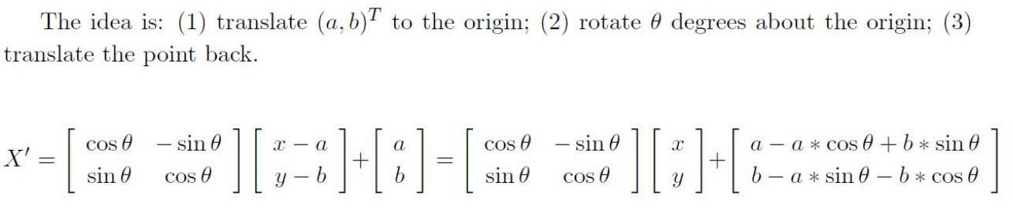
4. Write out the pseudo code of ray-casting algorithm. (10 marks)
得分 | 阅卷人

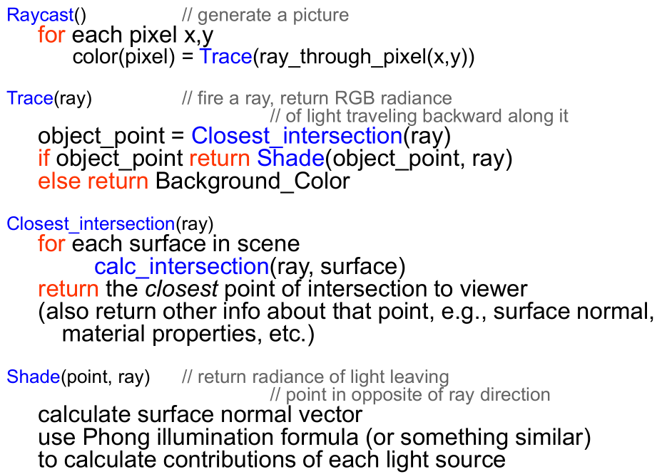

5.计算以(30,0),(60,10),(80,30),(90,60),(90,90)为控制顶点的四次 Bezier 曲线在t=1/2处的值，并画出 de Casteljau 三角形。 (10 marks)
得分 | 阅卷人
值为（75, 34.375）
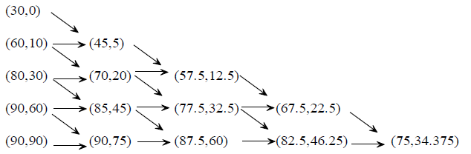

………………………………………………密………………………………封………………………………线………………………………………………
山东大学 2017-2018 学年 2 学期 计算机图形学 课程试卷A

学院 专业 级 学号 姓名
第 2 页 共 2 页
6. 在 Phong 模型
得分 | 阅卷人
中，三项分别表示何含义？公式中的各个符号的含义指什么，并画出示意图。(10 marks)
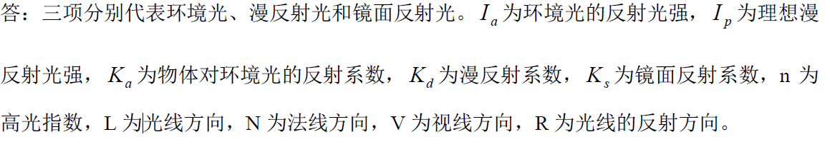
示意图此处从略，请检查打分。

7. (a) Explain why highlights can be missed by the Gouraud shading method.
得分 | 阅卷人
(b) Compare the strengths and weaknesses of the Phong shading method and Gouraud shading. (10 marks)

Gouraud shading method: Use Phong’s illumination equation to compute color intensities at all vertices;
Color intensities of pixels along each edge are linearly interpolated from those at vertices;
Color intensities of pixels within a span on a scanline are linearly interpolated from the color intensities at the two endpoints.
The highlight might be missing by this method on the surface patch. Because the color intensities of pixels inside a facet is computed according to the two connected endpoints, no highlight will be created. When the highlight is on the vertex, this highlight will not miss.

Pros of the Phong shading method:
Phong shading method can be used to provide better highlight rendering result than Gourand shading.
Cons of the Phong shading method:
This method has to calculate normals for each inside positions, which require more time.

8. Consider a circular disc which is defined by the coordinate of it’s center (Cx, Cy, Cz), a direction normal to the disk (Nx, Ny, Nz), and a radius R.
得分 | 阅卷人
(a) All the points on the disc satisfy a plane equation as well as distance constrain, write out the plane equation and the analytic form of distance constrain. (5 marks)
class Vector3D {
public float x, y, z;
// constructors
public Vector3D( );
public Vector3D(float x, float y, float z);
// methods
public static float dot(Vector3D A, Vector3D B);
public static Vector3D cross(Vector3D A, Vector3D B);
public static Vector3D normalize(Vector3D A);
public static Vector3D scale(Vector3D A, float s);
public static Vector3D plus(Vector3D A, Vector3D B);
public static Vector3D minus(Vector3D A, Vector3D B);
}
class Ray {
public static final float MAX_T = Float.MAX_VALUE;
public Vector3D origin;
public Vector3D direction;
public float t;
public Renderable object;
}
class Disc implements Renderable {
Surface surface;
Vector3D center;
Vector3D normal;
float radius;
public Disc(Surface s, Vector3D c, Vector3D n, float r) {
surface = s; center = c; normal = Vector3D.normalize(n); radius = r;
}
public boolean intersect(Ray ray) { // returns false if ray does not intersect
// write your code here
}
}

(b) Given above classes, write a code fragment for the intersect() method of the Disc object. The method should return true in the case of an intersection and update the relevant fields of the Ray object that it is passed. Otherwise, it should return false. Assume that a ray can intersect the disc from either side. (10 marks)
(c) What pre-computation could have been done, and/or instance variables could have been added to the Disc() constructor that would have reduced the amount of work done in the intersect() method? (5 marks)
(d) When you were implementing the disc intersection test you had the choice of testing for intersection with the infinite plane, or testing the distance constraint, first. Discuss the relative merits of each approach. (10 marks)

