Answer A
一．
- (a) -18 (b) -24
- 0.387
- (a) 0.064 (b) 0.032
- (a) F/(m_{A}+m_{B}), (b) m_{A}* F/(m_{A}+m_{B})
- (a)
(b) 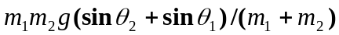
- 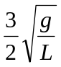

二．
SOLUTION：
1)
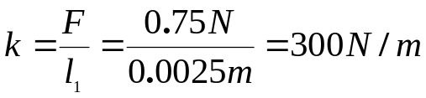
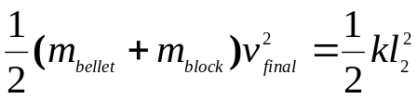
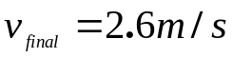
2)
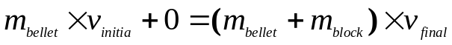
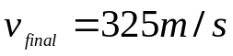

三．
SOLUTION:
Priciple of Impulse and Momentum.
We consider the rod and sphere as a single system and express that the initial momenta of the rod and sphere and the impulses of the external forces are together equipollent to the final momenta of the system. We note that the only impulsive force external to the system is the impulsive reaction at A..
The moments about A:
(1)
Since the rod rotates about A, we have
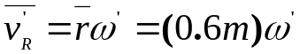
Also,
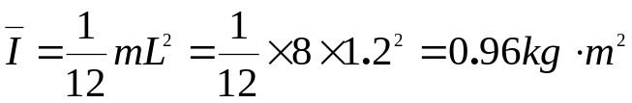
Substituting these values and the given data into Eq. (1), we have
that’s :
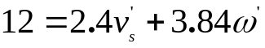 (2)

Relative Velocities.

Choosing positive to the right, we write
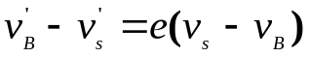
Substituting 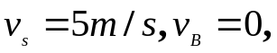 and 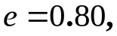 we obtain
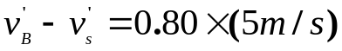 (3)
Again noting that the rod rotates about A, we write
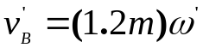 (4)
Solving Eqs. (2) to (4) simultaneously, we obtain
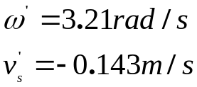

四．
SOLUTION:
We have
W_{A} = m_{A}g = (20 kg)(9.81 m/s²) = 196N
W_{B} = m_{B}g = (40 kg)(9.81 m/s²) = 392N
Sense of Motion.
Although an arbitrary sense of motion can be assumed(since no friction forces are involved) and later checked by the sign of the answer, we may prefer to determine the actual sense of rotation of the pulley first. The weight W_{B}’ of block B required to maintain the equilibrium of the pulley when it is acted upon by the 196 N weight of block A is first determined. We write
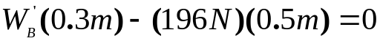
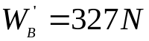
Since block B actually has a weight of 392N, the pulley will rotate counterclockwise.

Kinematics of Motion,
Assuming 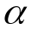 counterclockwise and noting that
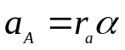 and 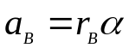
we obtain 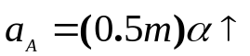 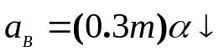
Equations of Motion.
A single system consisting of the pulley and the two blocks is considered. Forces external to this system consist of the weights of the pulley and the two blocks and of the reaction at G. (The forces exerted by the cables on the pulley and on the blocks are internal to the system considered and cancel out.) Since the motion of the pulley is a centroidal rotation and the motion of each block is a translation, the effective forces
reduce to the couple 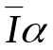 and the two vectors 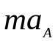and 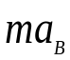,The centroidal moment of inertia of the pulley is
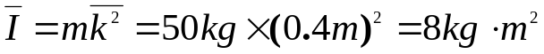
Since the system of the external forces is equipollent to the system of the effective forces, we write

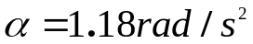
五．
SOLUTION:
a) Because 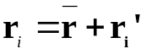 and 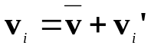
we obtain:
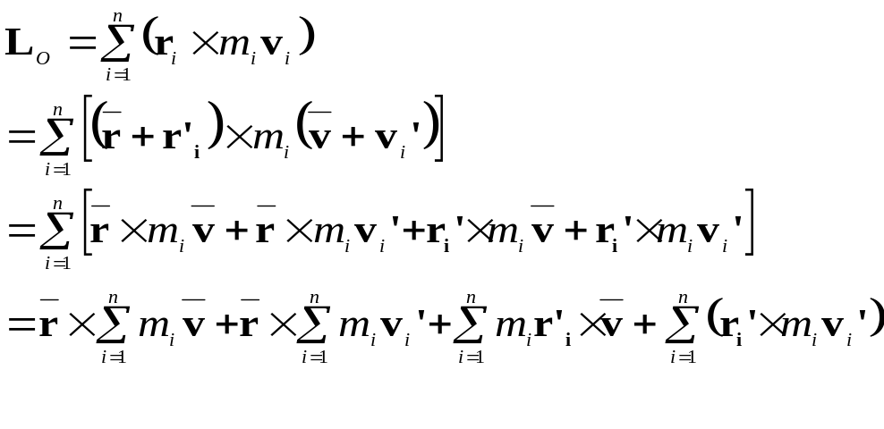
we know that 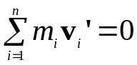
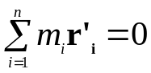
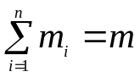
So

b)
