Mechanics: Final Examination (A)

Question 1. This question includes 6 sub-questions. You are asked to outline your answers on scratch paper and write the final results in the indicated blanks.

(1) The position of a particle which moves along a straight line is defined by the relation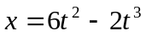, where x is expressed in meters and t in seconds. Determine
a) The speed of the particle at t=3s is m/s.
b) The acceleration of the particle at t=3s is m/s².

(2) A ball with radius r₁=0. 080m and mass 1.00 kg is attached by a light rod 0.400m in length to a second ball with radius r₂=0.100m and mass 2.00kg (as shown in the right figure). Determine the center of mass of this system is meters far away from the center of the left ball.

m₂
m₁
r₁
r₂
0.400m

(3) Four small spheres, each of which can be regarded as a point of mass 0.200kg, are arranged in a square 0.400m on a side and connected by light rods (as shown in figure). Find the moment of inertia of the system about an axis

O
0.200kg
0.400m
B
A
a) Through the center of the square, perpendicular to its plane (an axis through point O in the figure)
kg⋅m².
b) Bisecting(平分) two opposite sides of the square (an axis along the line AB in the figure) kg⋅m².
(4) Two blocks A and B, one with mass m_{A} and the other with m_{B}, sit on the frictionless surface, connected by a light rope (as shown in figure). A horizontal constant force F is acted on block B. Determine
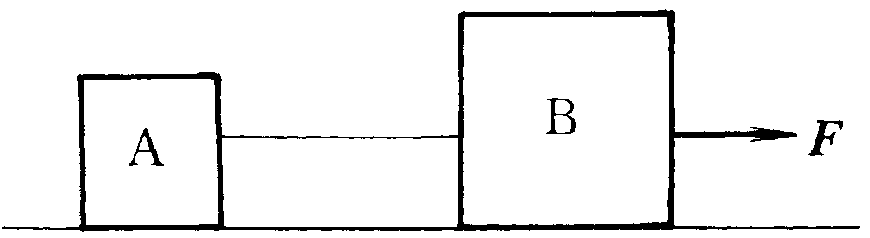
a) The acceleration of the connecting two blocks is .
b) The tension in the rope connecting the two blocks is .

(5) The two blocks, with the mass m₁ and m₂, slide on the two inclined planes with negligible friction. The blocks are connected by a rope that runs around a pulley of negligible mass. Determine
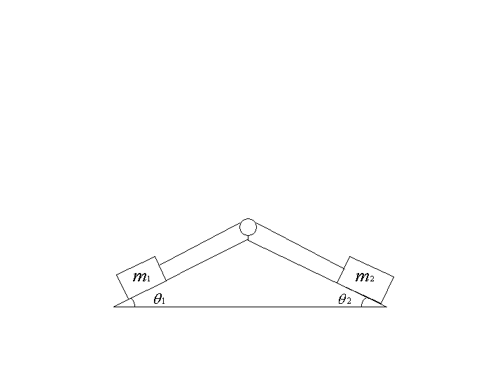
a) The acceleration of block with the mass m₂ is .
b) The tension in the rope is .

(6) A rigid body is made of three identical thin rods, each with length L, fastened together in the form of a letter H, as shown in the diagram. The body is free to rotate about a horizontal axis that runs along the length of one of the legs of the H. The body is allowed to fall from rest from a position in which the plane of the H is horizontal. The angular speed of the body when the plane of the H is vertical is ________________.
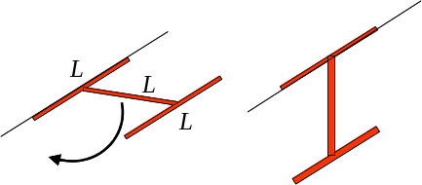

Question 2: A bullet of mass 8.00g strikes and embeds itself in a block of mass 0.992kg that rests on a frictionless horizontal surface and is attached to a coil spring (as shown in figure). The impact compresses the spring 15.0cm. Calibration(标定) of the spring shows that a force of 0.750N is required to compress the spring 0.250cm.

v
15.0cm
a) Find the magnitude of the velocity of the block just after impact.
b) What was the initial speed of the bullet?

Question 3: A 2kg sphere moving horizontally to the right with an initial velocity of 5m/s strikes the lower end of an 8kg rigid rod AB. The rod is suspended from a hinge at A and is initially at rest. Knowing that the coefficient of restitution(恢复系数) between the rod and the sphere is 0.80, determine the angular velocity of the rod and the velocity of the sphere immediately after the impact.

G
B
A
V_{s}
0.6m
1.2m

Question 4: A pulley weighing 50kg and having a radius of gyration(回转半径) of 0.4m is connected to two blocks as shown. Assuming no axle friction, determine the angular acceleration of the pulley and the acceleration of each block.

20kg
40kg
0.3m
B
A
G
0.5m

Question 5: Consider a system of n particles.
1) The angular momentum of the particle system about a fixed point O in an inertial frame is defined by
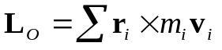
where is the position vector of the i-th particle in the system relative to point O. Prove that 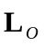 is independent of the position of point O in the inertial frame if the total linear momentum of the system is zero.
2) The torque of the external forces acting on the particle system about a fixed point O in an inertial frame is defined by
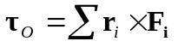
where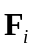 is the resultant external force acting on the i-th particle in the system. Prove that 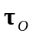 is independent of the position of the point O in the inertial frame if the resultant of the external forces acting the system is zero.

Question 1,(6) 的答案：
We use conservation of mechanical energy. The center of mass is at the midpoint of the cross bar of the H and it drops by L/2, where L is the length of any one of the rods. The gravitational potential energy decreases by MgL/2, where M is the mass of the body. The initial kinetic energy is zero and the final kinetic energy may be written 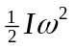 where I is the rotational inertia of the body and ω is its angular
velocity when it is vertical. Thus
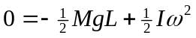
Since the rods are thin the one along the axis of rotation does not contribute to the rotational inertia. All points on the other leg are the same distance from the axis of rotation, so that leg contributes (M/3)L², where M/3 is its mass. The cross bar is a rod that rotates around one end, so its contribution is (M/3)L²/3 = ML²/9. The total rotational inertia is I = (ML²/3) + (ML²/9) = 4ML²/9. Consequently, the angular velocity is
