12.4
If a transaction is very long or when it fetches data from a slow disk, it takes a long time to complete. In absence of concurrency, other transactions will have to wait for longer period of time. Average response time will increase. Also when the transaction is reading data from disk, CPU is idle. So resources are not properly utilized. Hence concurrent execution becomes important in this case. However, when the transactions are short or the data is available in memory, these problems do not occur.
12.5
A cascadeless schedule is one where, for each pair of transactions T_{i} and T_{j} such that T_{j} reads data items previously written by T_{i} , the commit operation of T_{i} appears before the read operation of T_{j} . Cascadeless schedules are desirable because the failure of a transaction does not lead to the aborting of any other transaction. Of course this comes at the cost of less concurrency. If failures occur rarely, so that we can pay the price of cascading aborts for the increased concurrency, noncascadeless schedules might be desirable.
12.7
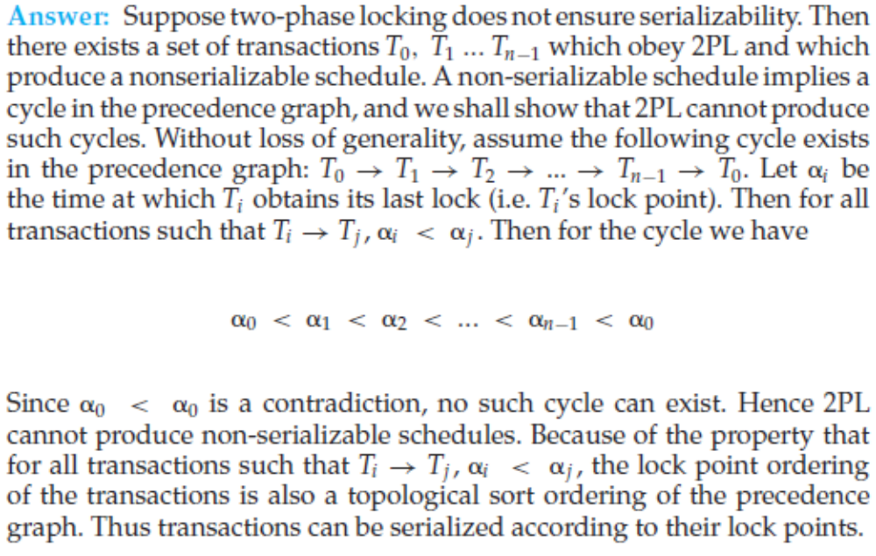
12.8
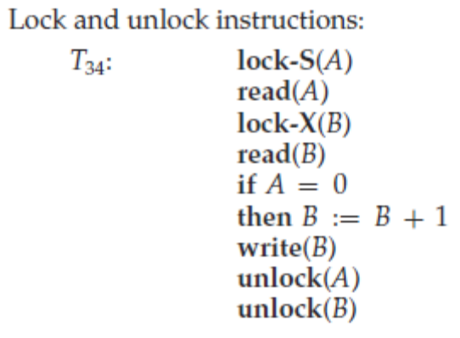
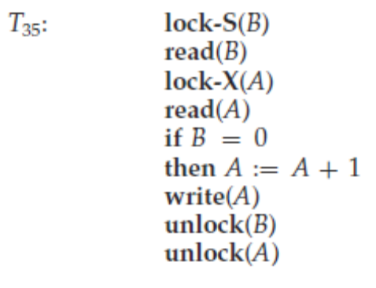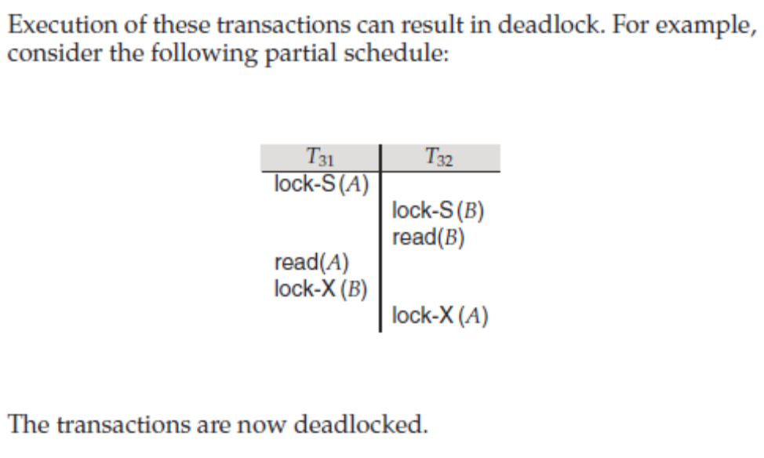
12.9
Rigorous two-phase locking has the advantages of strict 2PL. In addition it has the property that for two conflicting transactions, their commit order is their serializability order. In some systems users might expect this behavior.
12.14
Within a single transaction in undo-list, suppose a data item is updated more than once, say from 1 to 2, and then from 2 to 3. If the undo log records are processed in forward order, the final value of the data item would be incorrectly set to 2, whereas by processing them in reverse order, the value is set to 1. The same logic also holds for data items updated by more than one transaction on undo-list.
Using the same example as above, but assuming the transaction committed, it is easy to see that if redo processing processes the records in forward order, the final value is set correctly to 3, but if done in reverse order, the final value would be set incorrectly to 2.
12.15
Checkpointing is done with log-based recovery schemes to reduce the time required for recovery after a crash. If there is no checkpointing, then the entire log must be searched after a crash, and all transactions undone/redone from the log. If checkpointing had been performed, then
most of the log-records prior to the checkpoint can be ignored at the time
of recovery.
Another reason to perform checkpoints is to clear log-records from stable
storage as it gets full.
Since checkpoints cause some loss in performance while they are being
taken, their frequency should be reduced if fast recovery is not critical.
If we need fast recovery checkpointing frequency should be increased. If the amount of stable storage available is less, frequent checkpointing is
unavoidable.
Checkpoints have no effect on recovery from a disk crash; archival dumps are the equivalent of checkpoints for recovery from disk crashes.
12.16
The ACID properties, and the need for each of them are:
• Consistency: Execution of a transaction in isolation (that is, with no other transaction executing concurrently) preserves the consistency of the database.
This is typically the responsibility of the application programmer who codes the transactions.
• Atomicity: Either all operations of the transaction are reflected properly in the database, or none are. Clearly lack of atomicity will lead to inconsistency in the database.
• Isolation: When multiple transactions execute concurrently, it should be the case that, for every pair of transactions Ti and Tj , it appears to Ti that either Tj finished execution before Ti started, or Tj started execution after Ti finished. Thus, each transaction is unaware of other transactions executing concurrently with it. The user view of a transaction system requires the isolation property, and the property that concurrent schedules take the system from one consistent state to another. These requirements are satisfied by ensuring that only serializable schedules of individually consistency preserving transactions are allowed.
• Durability: After a transaction completes successfully, the changes it has made to the database persist, even if there are system failures.
12.17
The possible sequences of states are:
a. active→partially committed→committed. This is the normal sequence a successful transaction will follow. After executing all its statements it enters the partially committed state. After enough recovery information has been written to disk, the transaction finally enters the committed state.
b. active → partially committed → aborted. After executing the last statement of the transaction, it enters the partially committed state. But before enough recovery information is written to disk, a hardware failure may occur destroying the memory contents. In this case the changes which it made to the database are undone, and the transaction enters the aborted state.
c. active → failed → aborted. After the transaction starts, if it is discovered at some point that normal execution cannot continue (either due to internal program errors or external errors), it enters the failed state. It is then rolled back, after which it enters the aborted state.
12.18
A schedule in which all the instructions belonging to one single transaction appear together is called a serial schedule. A serializable schedule has a weaker restriction that it should be equivalent to some serial schedule. There are two definitions of schedule equivalence – conflict equivalence and view equivalence.
12.19
