**VISVESVARAYA TECHNOLOGICAL UNIVERSITY**

# BELAGAVI – 590018, Karnataka INTERNSHIP REPORT

## ON

“Blind Assist Using ML.”

***Submitted in partial fulfilment for the award of degree***

**BACHELOR OF ENGINEERING IN**

**Computer Science And Data Science Engineering**

***Submitted by:***

## NAME:JEEVAN HATTIKATAGI USN:1AM21CD016



Conducted at

## COMPSOFT TECHNOLOGIES LTD.



**Department of Computer Science and Engineering (Data Science)**

**AMC Engineering College**

18th K.M, Bannerghatta Main Road, Bangalore-560 083

2023-2024

**Department of Computer Science and Engineering (Data Science)**

**AMC Engineering College**

18th K.M, Bannerghatta Main Road, Bangalore-560 083

2023-2024

**CERTIFICATE**

This is to certify that the Internship titled **“Python with ML”** carried out by **Mr. Jeevan Hattikatagi,** a bonafide student at AMC Engineering College, in partial fulfillment for the award of **Bachelor of Engineering**, in **Computer Science and data science Engineering** under Visvesvaraya Technological University, Belagavi, during the year 2022-2023. It is certified that all corrections/suggestions indicated have been incorporated in the report.

The project report has been approved as it satisfies the academic requirements in respect of Internship prescribed for the course Internship / Professional Practice (21CSI85)

## Signature of Guide Signature of HOD Signature of Principal

**External Viva:**

Name of the Examiner Signature with Date



**D E C L A R A T I O N**

I, **Jeevan Hattikatagi**, 3rd year student of Branch, AMC Engineering College - 560 083, declare that the Internship has been successfully completed, in **COMPSOFT TECHNOLOGIES**. This report is submitted in partial fulfillment of the requirements for award of bachelor’s degree in Branch name, during the academic year 2022-2023.

Date : 05th Dec 2023 :

Place : Bengaluru

USN : 1AM21CD016

NAME : JEEVAN HATTIKATAGI

**OFFER LETTER**

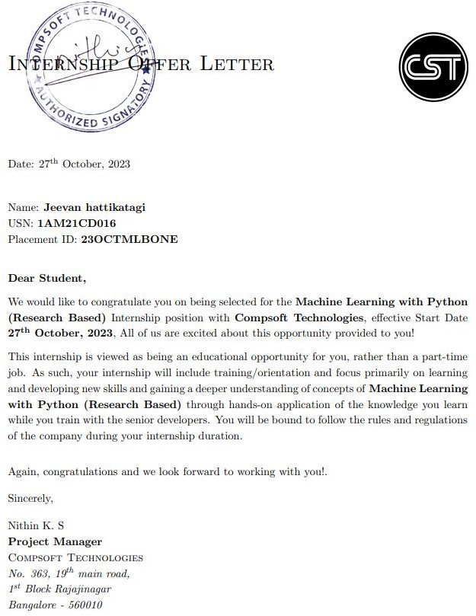

**A C K N O W L E D G E M E N T**

This Internship is a result of accumulated guidance, direction, and support of several important persons. We take this opportunity to express our gratitude to all who have helped us to complete the Internship.

We express our sincere thanks to our principal, for providing us adequate facilities to undertake this Internship.

We would like to thank our Head of Dept – branch code, for providing us an opportunity to carry out Internship and for his valuable guidance and support.

We would like to thank our (Lab assistant name) Software Services for guiding us during the period of internship.

We express our deep and profound gratitude to our guide, Guide name, Assistant/Associate Prof, for her keen interest and encouragement at every step in completing the Internship.

We would like to thank all the faculty members of our department for the support extended during Internship.

We would like to thank the non-teaching members of our dept, for helping us during the Internship.

Last but not the least, we would like to thank our parents and friends without whose constant help, the completion of Internship would have not been possible.

**NAME:JEEVAN HATTIKATAGI USN:1AM21CD016**

**ABSTRACT**

Vision is a cutting-edge mobile application designed to empower individuals with visual impairments by seamlessly integrating voice assistance, phone call management, camera access for currency recognition, and real-time battery status monitoring. The app’s primary objective is to enhance the daily communication and independence of blind users through an intuitive and accessible interface.

Voice assistance feature utilizes advanced natural language processing to enable hands-free messaging, allowing users to compose and send text messages effortlessly. Additionally, the phone call manager offers a streamlined experience for receiving, making, and managing calls, enhancing overall communication efficiency.

Vision’s innovative use of camera access extends its functionality to currency recognition, providing users with the ability to independently identify and distinguish various denominations. This feature contributes significantly to the user’s financial independence and facilitates smoother transactions.

Furthermore, the app prioritizes user convenience by including a real-time battery status monitor, ensuring that individuals with visual impairments can manage their device’s power effectively. This feature aims to prevent unexpected disruptions and enables users to plan their activities with confidence.

In summary, “Vision” stands at the forefront of accessibility technology, combining voice assistance, phone call management, currency recognition, and battery status monitoring to create a comprehensive solution that empowers blind individuals in their daily lives. Through its user- centric design and advanced functionalities, the app promotes inclusivity and independence, fostering a more accessible digital experience for visually impaired users.

**Table of Contents**

|  |  |  |
| --- | --- | --- |
| **Sl no** | **Description** | **Page no** |
| 1 | Company Profile | 08 |
| 2 | About the Company | 10 |
| [3](https://1.bp.blogspot.com/-dODuK8N5h1Q/Wlnyb3V9HFI/AAAAAAAACL4/WxQtCJ1pM5wccDABg4wIrTBUB0vlikXQQCLcBGAs/s1600/poly1.jpg) | Introduction | 14 |
| [4](https://1.bp.blogspot.com/-dODuK8N5h1Q/Wlnyb3V9HFI/AAAAAAAACL4/WxQtCJ1pM5wccDABg4wIrTBUB0vlikXQQCLcBGAs/s1600/poly1.jpg) | System Analysis | 16 |
| [5](https://1.bp.blogspot.com/-dODuK8N5h1Q/Wlnyb3V9HFI/AAAAAAAACL4/WxQtCJ1pM5wccDABg4wIrTBUB0vlikXQQCLcBGAs/s1600/poly1.jpg) | Requirement Analysis | 19 |
| 6 | Design [Analysis](https://4.bp.blogspot.com/-IOOxgPaXMVc/Wlj3LWvcnjI/AAAAAAAACKE/UeTFYvAxDmUDel5UBjdifeWaApB3-dXVgCLcBGAs/s1600/img1.jpg) | 22 |
| 7 | [Implementation](https://4.bp.blogspot.com/-IOOxgPaXMVc/Wlj3LWvcnjI/AAAAAAAACKE/UeTFYvAxDmUDel5UBjdifeWaApB3-dXVgCLcBGAs/s1600/img1.jpg) | 24 |
| 8 | Snapshots | 26 |
| 9 | Conclusion | 29 |
| 10 | References | 31 |

[**CHAPTER**](https://1.bp.blogspot.com/-dODuK8N5h1Q/Wlnyb3V9HFI/AAAAAAAACL4/WxQtCJ1pM5wccDABg4wIrTBUB0vlikXQQCLcBGAs/s1600/poly1.jpg) **1 COMPANY PROFILE**

1. **COMPANY PROFILE**

# A Brief History of Compsoft Technologies

Compsoft Technologies, was incorporated with a goal ”To provide high quality and optimal Technological Solutions to business requirements of our clients”. Every business is a different and has a unique business model and so are the technological requirements. They understand this and hence the solutions provided to these requirements are different as well. They focus on clients’ requirements and provide them with tailor made technological solutions. They also understand that Reach of their Product to its targeted market or the automation of the existing process into e-client and simple process are the key features that our clients desire from Technological Solution they are looking for and these are the features that we focus on while designing the solutions for their clients.

Sarvamoola Software Services. is a Technology Organization providing solutions for all web design and development, MYSQL, PYTHON Programming, HTML, CSS, ASP.NET and LINQ. Meeting the ever-increasing automation requirements, Sarvamoola Software Services. specialize in ERP, Connectivity, SEO Services, Conference Management, effective web promotion and tailor-made software products, designing solutions best suiting clients’ requirements.

Compsoft Technologies, strive to be the front runner in creativity and innovation in software development through their well-researched expertise and establish it as an out of the box software development company in Bangalore, India. As a software development company, they translate this software development expertise into value for their customers through their professional solutions.

They understand that the best desired output can be achieved only by understanding the clients demand better. Compsoft Technologies work with their clients and help them todefine their exact solution requirement. Sometimes even they wonder that they have completely redefined their solution or new application requirement during the brainstormingsession, and here they position themselves as an IT solutions consulting group comprising of high caliber consultants.

They believe that Technology when used properly can help any business to scale and achieve new heights of success. It helps Improve its efficiency, profitability, reliability; to put itin one sentence ” Technology helps you to Delight your customers” and that is what we want to achieve.

**[CHAPTER](https://1.bp.blogspot.com/-dODuK8N5h1Q/Wlnyb3V9HFI/AAAAAAAACL4/WxQtCJ1pM5wccDABg4wIrTBUB0vlikXQQCLcBGAs/s1600/poly1.jpg) 2 ABOUT THE COMPANY**

1. **ABOUT THE COMPANY**



Compsoft Technologies is a Technology Organization providing solutions for all web design and development, MYSQL, PYTHON Programming, HTML, CSS, ASP.NET and LINQ. Meeting the ever-increasing automation requirements, Compsoft Technologies specialize in ERP, Connectivity, SEO Services, Conference Management, effective web promotion and tailor-made software products, designing solutions best suiting clients’ requirements. The organization where they have a right mix of professionals as a stakeholder to help us serve our clients with best of our capability and with at par industry standards. They have young, enthusiastic, passionate and creative Professionals to develop technological innovations in the field of Mobile technologies, Web applications as well as Business and Enterprise solution. Motto of our organization is to “Collaborate with our clients to provide them with best Technological solution hence creating Good Present and Better Future for our client which will bring a cascading a positive effect in their business shape as well”. Providing a Complete suite of technical solutions is not just our tag line, it is Our Vision for Our Clients and for Us, we strive hard to achieve it.

# Products of Compsoft Technologies.

**Android Apps**

It is the process by which new applications are created for devices running the Android operating system. Applications are usually developed in Java (and/or Kotlin; or other such option) programming language using the Android software development kit (SDK), but other development environments are also available, some such as Kotlin support the exact same Android APIs (and bytecode), while others such as Go have restricted API access.

The Android software development kit includes a comprehensive set of development tools. These include a debugger, libraries, a handset emulator based on QEMU, documentation, sample code, and tutorials. Currently supported development platforms include computers running Linux (any modern desktop Linux distribution), Mac OS X 10.5.8 or later, and Windows 7 or later. As of March 2015, the SDK is not available on Android itself, but software development is possible by using specialized Android applications.

**Web Application**

It is a client–server computer program in which the client (including the user interface and client- side logic) runs in a web browser. Common web applications include web mail, online

retail sales, online auctions, wikis, instant messaging services and many other functions. web applications use web documents written in a standard format such as HTML and JavaScript, which are supported by a variety of web browsers. Web applications can beconsidered as a specific variant of client–server software where the client software isdownloaded to the client machine when visiting the relevant web page, using standardprocedures such as HTTP. The Client web software updates may happen each time the web page is visited. During the session, the web browser interprets and displays the pages, andacts as the universal client for any web application. The use of web application frameworks can often reduce the number of errors in a program, both by making the code simpler, and by allowing one team to concentrate on the framework while another focuses on a specified usecase. In applications which are exposed to constant hacking attempts on the Internet, security-related problems can be caused by errors in the program.

Frameworks can also promote the use of best practices such as GET after POST. There are some who view a web application as a two-tier architecture. This can be a “smart” client that performs all the work and queries a “dumb” server, or a “dumb” client that relies on a “smart” server. The client would handle the presentation tier, the server would have the database (storage tier), and the business logic (application tier) would be on one of them or on both. While this increases the scalability of the applications and separates the display and the database, it still doesn’t allow for true specialization of layers, so most applications will outgrow this model. An emerging strategy for application software companies is to provide web access to software previously distributed as local applications. Depending on the type of application, it may require the development of an entirely different browser-based interface, or merely adapting an existing application to use different presentation technology. These programs allow the user to pay a monthly or yearly fee for use of a software application without having to install it on a local hard drive. A company which follows this strategy is known as an application service provider (ASP), and ASPs are currently receiving much attention in the software industry.

Security breaches on these kinds of applications are a major concern because it can involve both enterprise information and private customer data. Protecting these assets is an important part of any web application and there are some key operational areas that must be included in the development process. This includes processes for authentication, authorization, asset handling, input, and logging and auditing. Building security into the applications from the beginning can be more effective and less disruptive in the long run.

**Web design**

It is encompassing many different skills and disciplines in the production and maintenance of websites. The different areas of web design include web graphic design; interface design; authoring, including standardized code and proprietary software; user experience design; and

search engine optimization. The term web design is normally used to describe the design process relating to the front-end (client side) design of a website including writing mark up. Web design partially overlaps web engineering in the broader scope of web development. Web designers are expected to have an awareness of usability and if their role involves creating markup then they are also expected to be up to date with web accessibility guidelines. Web design partially overlaps web engineering in the broader scope of web development.

# Departments and services offered

Compsoft Technologies plays an essential role as an institute, the level of education, development of student’s skills are based on their trainers. If you do not have a good mentor, then you may lag in many things from others and that is why we at Compsoft Technologies gives you the facility of skilled employees so that you do not feel unsecured about the academics. Personality development and academic status are some of those things which lie on mentor’s hands. If you are trained well then you can do well in your future and knowing its importance of Compsoft Technologies always tries to give you the best.

They have a great team of skilled mentors who are always ready to direct their trainees in the best possible way they can and to ensure the skills of mentors we held many skill development programs as well so that every mentor can develop their own skills with the demands of the companies so that they can prepare a complete packaged trainee.

# Services provided by Compsoft Technologies.

* Core Java and Advanced Java
* Web services and development
* Dot Net Framework
* Python
* Selenium Testing
* Conference / Event Management Service
* Academic Project Guidance
* On The Job Training
* Software Training

**[CHAPTER](https://1.bp.blogspot.com/-dODuK8N5h1Q/Wlnyb3V9HFI/AAAAAAAACL4/WxQtCJ1pM5wccDABg4wIrTBUB0vlikXQQCLcBGAs/s1600/poly1.jpg) 3 INTRODUCTION**

1. **INTRODUCTION**

# Introduction to ML

Machine learning is a subset of artificial intelligence that empowers computers to learn and improve from experience without explicit programming. It revolves around the development of algorithms that enable systems to automatically learn patterns and make data-driven decisions. This transformative field intersects computer science, statistics, and domain-specific knowledge to extract meaningful insights from vast datasets. The core premise of machine learning lies in the ability to generalize knowledge from specific examples, facilitating the adaptation to new, unseen data. It encompasses a spectrum of techniques, including supervised learning for labeled data, unsupervised learning for unlabeled data, and reinforcement learning for decision-making processes. As an interdisciplinary discipline, machine learning finds applications across diverse domains, ranging from healthcare and finance to autonomous vehicles and natural language processing. Its continuous evolution underscores its pivotal role in addressing complex problems and fostering innovation in an increasingly data-centric world.

# Problem Statement

Blind individuals face significant challenges in their daily lives, ranging from navigating unfamiliar environments to accessing printed information. Despite existing assistive technologies, there is a critical need for a comprehensive and user-friendly digital app tailored to the unique needs of the blind community. The absence of a unified solution hampers their independence and limits their access to information, services, and social interactions. To address this gap, the goal is to develop a mobile app specifically designed to enhance the lives of blind individuals, providing them with a versatile tool that promotes navigation, communication, and information retrieval.

Elaboration: Blind individuals encounter barriers in tasks most take for granted, such as reading text, recognizing objects, and safely navigating surroundings. Existing solutions are often fragmented, lacking the integration necessary for seamless user experience. The envisioned digital app aims to be a comprehensive aid, leveraging advanced technologies like voice recognition, machine learning, and geolocation services. Features include real-time navigation assistance, object recognition, audible text conversion, and a user-friendly interface accessible through voice commands. The app’s design prioritizes inclusivity and simplicity, ensuring that blind users can easily engage with its functionalities. By addressing these challenges, the app aspires to empower blind individuals, fostering independence and improving their overall quality of life.

**[CHAPTER](https://1.bp.blogspot.com/-dODuK8N5h1Q/Wlnyb3V9HFI/AAAAAAAACL4/WxQtCJ1pM5wccDABg4wIrTBUB0vlikXQQCLcBGAs/s1600/poly1.jpg) 4 SYSTEM ANALYSIS**

1. **SYSTEM ANALYSIS**
2. Existing System:

The current digital app designed for individuals with visual impairments offers limited functionality. It primarily focuses on message management, lacks real-time currency identification through the camera, and provides basic phone call functionalities. The existing model lacks an inbuilt voice assistant, which is a crucial element for enhancing user accessibility. Additionally, it does not incorporate a feature for checking battery status, limiting the overall usability and convenience of the app for blind users.

1. Proposed System:

The proposed system aims to address the shortcomings of the existing model by introducing comprehensive enhancements. Firstly, the app will integrate advanced message management capabilities, ensuring efficient navigation and organization. It will also incorporate a sophisticated currency identification feature, utilizing the device’s camera for real-time recognition. The phone call functionality will be refined for better user experience, including seamless call handling and management.

Furthermore, the proposed system will introduce a state-of-the-art inbuilt voice assistant. This voice assistant will not only assist users in navigating the app but also provide contextual information, improving overall accessibility. The system will also include a feature for checking battery status, enhancing user awareness, and preventing unexpected shutdowns.

1. Objectives of the System: Enhanced Message Management:

The primary objective is to streamline message handling, offering an intuitive interface for blind users to manage and interact with their messages efficiently.

Real-time Currency Identification:

Integrate a feature that utilizes the device’s camera to identify and announce currency denominations, empowering users during financial transactions.

Improved Phone Call Functionality: Enhance phone call management to provide blind users with a seamless experience, including call initiation, answering, and ending.

Inbuilt Voice Assistant: Introduce a robust voice assistant that assists users in navigating the app, accessing information, and performing various tasks with voice commands.

Battery Status Monitoring: Implement a feature to check and announce the battery status, ensuring users are aware of their device’s power level and preventing unexpected disruptions.

In summary, the proposed system aims to create a comprehensive digital app tailored for individuals with visual impairments, addressing existing limitations and incorporating advanced features to enhance overall accessibility and user experience**.**

**[CHAPTER](https://1.bp.blogspot.com/-dODuK8N5h1Q/Wlnyb3V9HFI/AAAAAAAACL4/WxQtCJ1pM5wccDABg4wIrTBUB0vlikXQQCLcBGAs/s1600/poly1.jpg) 5 REQUIREMENT ANALYSIS**

1. **REQUIREMENT ANALYSIS**

# Hardware Requirement Specification

1.1 Smartphone:

Operating System: Android or iOS (compatible with the latest versions). Processor: Minimum dual-core processor for smooth operation.

Memory: At least 2GB RAM for efficient multitasking.

Camera: High-resolution rear camera for currency identification through image capture. Speaker: Clear and loud audio output for voice assistant guidance.

Microphone: Noise-canceling microphone for effective voice commands and phone call functionality.

Connectivity: Bluetooth for external devices, such as braille displays or headphones.1.2 Accessibility Hardware:

Braille display support for users preferring tactile feedback.

Optional external hardware for enhanced navigation, such as a tactile overlay.

# Software Requirement Specification

* 1. Operating system:

Android 8.0 (Oreo) or iOS version 12 and above for optimal compatibility.

* 1. Message Management:

App Interface: Intuitive and accessible interface designed with screen reader compatibility. Text-to-Speech (TTS): Integrated TTS for reading and composing messages.

Voice Recognition: In-built voice recognition for hands-free message input.

* 1. Currency Identification:

Camera Integration: Utilize the smartphone’s rear camera for capturing currency images. Image Processing: Implement image recognition algorithms for currency identification. Text-to-Speech: Voice announcement of currency denomination.

* 1. Phone Call Management:

Call Integration: Seamless integration with the phone app for making and receiving calls.

Voice Dialing: Voice command functionality for initiating calls.

Call Status Alerts: Voice notifications for incoming calls, missed calls, and call status.

* 1. Battery Status:

Real-time Monitoring: Constantly monitor and display battery status.

Voice Alerts: Voice prompts for low battery levels and charging status. Optimization: Implement power-saving measures to extend battery life.

* 1. Voice Assistant:

Natural Language Processing: Advanced language understanding capabilities for conversational interaction.

Integration: Seamless integration with all app functionalities. Customization: Allow users to personalize voice assistant settings.

* 1. Accessibility Features:

Screen Reader Compatibility: Ensure compatibility with popular screen readers like Talkback (Android) or Voiceover (iOS).

Text Magnification: Support for adjustable text sizes.

Gestures and Shortcuts: Intuitive gestures and keyboard shortcuts for efficient navigation.

* 1. Security:

Biometric Authentication: Optional integration with fingerprint or facial recognition for secure app access.

This comprehensive requirement analysis outlines the necessary hardware and software specifications for developing a digital app catering to the needs of blind users, encompassing message management, currency identification, phone call functionalities, battery status monitoring, and an in-built voice assistant.

**[CHAPTER](https://1.bp.blogspot.com/-dODuK8N5h1Q/Wlnyb3V9HFI/AAAAAAAACL4/WxQtCJ1pM5wccDABg4wIrTBUB0vlikXQQCLcBGAs/s1600/poly1.jpg) 6 DESIGN ANALYSIS**

1. **DESIGN & ANALYSIS**

## User Requirements

Message Management: Enable efficient reading, composing, and organizing of messages through intuitive voice commands.

Currency Identification: Implement a camera-based currency identification feature with clear voice announcements for accurate denomination identification.

Phone Call Functionality: Seamlessly integrate voice commands for initiating, answering, and ending phone calls, ensuring hands-free communication.

Battery Status: Provide real-time battery status updates through the inbuilt voice assistant, aiding users in effective device management.

Inbuilt Voice Assistant: Develop a robust, responsive voice assistant capable of natural language understanding for diverse interactions.

## Technical Requirements

Accessibility Standards: Adhere to industry-standard accessibility guidelines (e.g., WCAG) for compatibility with assistive technologies.

Image Recognition: Implement advanced image recognition algorithms for accurate currency identification, with regular updates.

Voice Recognition: Leverage cutting-edge voice recognition technology for precise interpretation and response to user commands.

Security and Privacy: Prioritize data security with encrypted communication and compliance with data protection regulations.

## User Experience Design

Intuitive Interface: Design a simple, tactile, and auditory user interface for easy navigation and a positive user experience.

Customization Options: Provide users with flexibility to customize voice preferences, app settings, and notifications.

## Conclusion

This digital accessibility app caters to blind users, offering efficient message management, accurate currency identification, seamless phone call functionality, and real-time battery status updates through a user-friendly interface and a powerful inbuilt voice assistant.

**[CHAPTE](https://1.bp.blogspot.com/-dODuK8N5h1Q/Wlnyb3V9HFI/AAAAAAAACL4/WxQtCJ1pM5wccDABg4wIrTBUB0vlikXQQCLcBGAs/s1600/poly1.jpg)R 7 IMPLEMENTATION**

1. **IMPLEMENTATION**

Implementation is the stage where the theoretical design is turned into a working system. The most crucial stage in achieving a new successful system and in giving confidence on the new system for the users that it will work efficiently and effectively.

The system can be implemented only after thorough testing is done and if it is found to work according to the specification. It involves careful planning, investigation of the current system and its constraints on implementation, design of methods to achieve the changeover and an evaluation of change over methods apart from planning.

Two major tasks of preparing the implementation are education and training of the users and testing of the system. The more complex the system being implemented, the more involved will be the system analysis and design effort required just for implementation.

The implementation phase comprises of several activities. The required hardware and software acquisition is carried out. The system may require some software to be developed. For this, programs are written and tested. The user then changes over to his new fully tested system and the old system is discontinued.

**TESTING**

The testing phase is an important part of software development. It is the Information zed system will help in automate process of finding errors and missing operations and a complete verification to determine whether the objectives are met, and the user requirementsare satisfied. Software testing is carried out in three steps:

1. The first includes unit testing, where in each module is tested to provide its correctness, validity and determine any missing operations and to verify whether theobjectives have been met. Errors are noted down and corrected immediately.
2. Unit testing is the important and major part of the project. So, errors are rectified easily in particular module and program clarity is increased. In this project entire system is divided into several modules and is developed individually. So, unit testing is conducted to individual modules.
3. The second step includes Integration testing. It need not be the case, the software whose modules when run individually and showing perfect results, will also show perfect results when run as a whole.

**[CHAPTE](https://1.bp.blogspot.com/-dODuK8N5h1Q/Wlnyb3V9HFI/AAAAAAAACL4/WxQtCJ1pM5wccDABg4wIrTBUB0vlikXQQCLcBGAs/s1600/poly1.jpg)R 8 SNAPSHOTS**

1. **SNAPSHOTS**

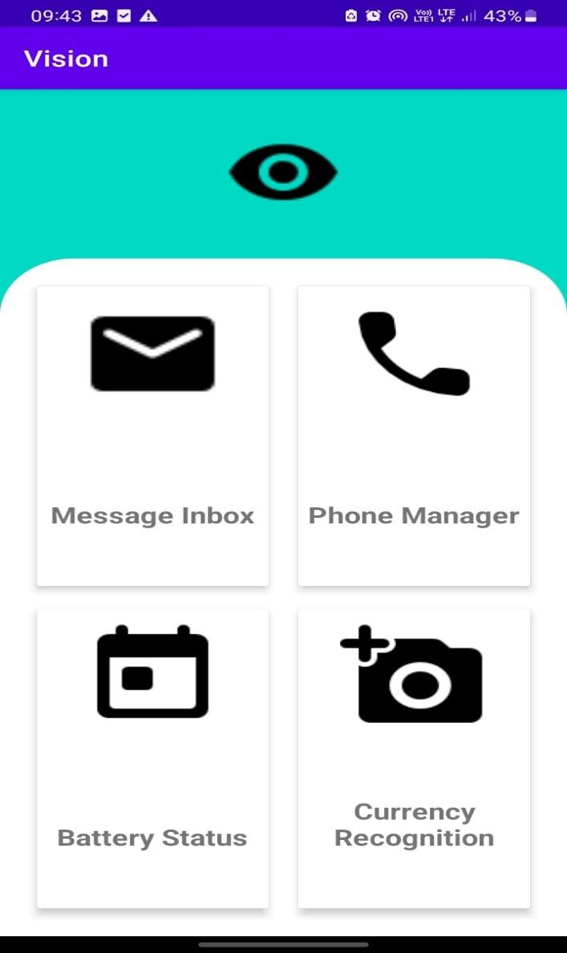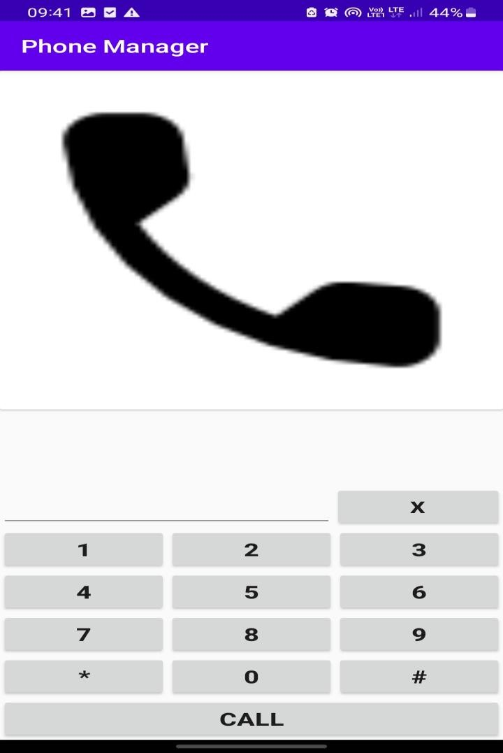

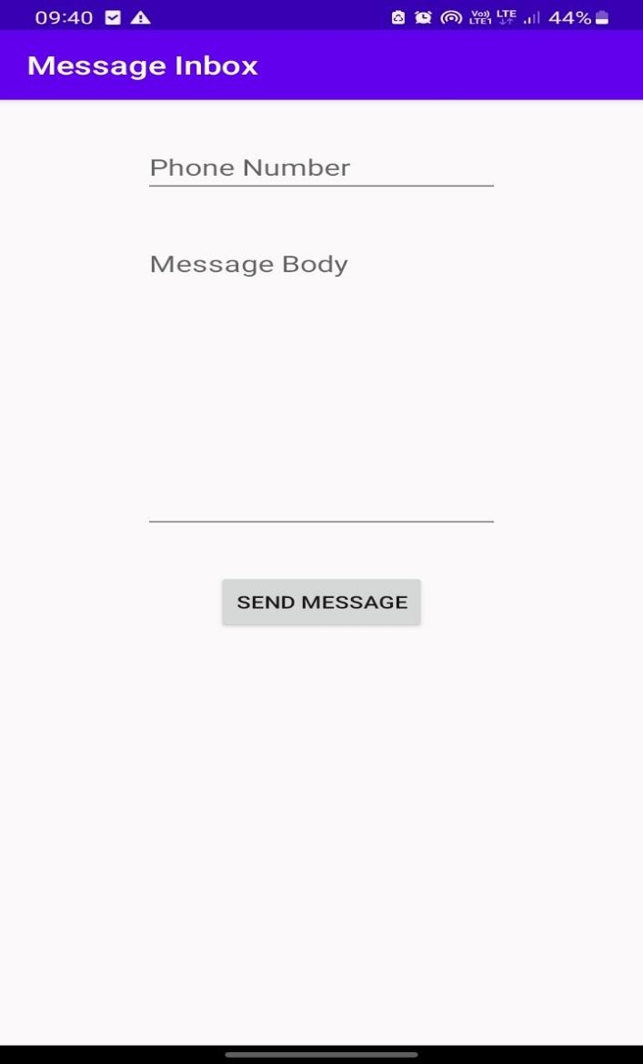 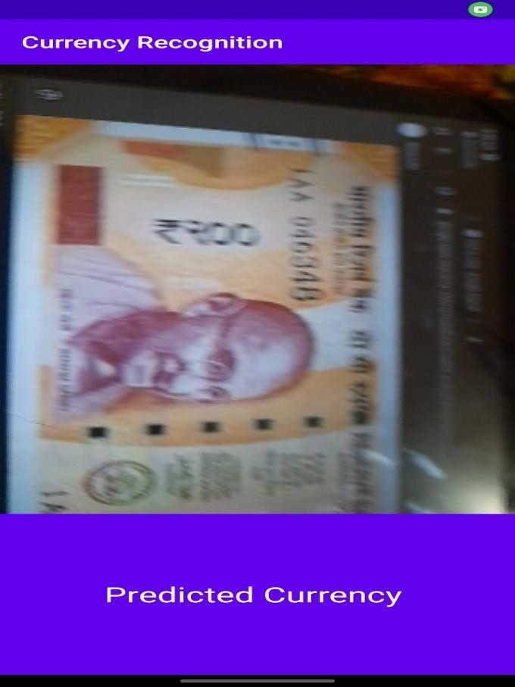

**[CHAPTE](https://1.bp.blogspot.com/-dODuK8N5h1Q/Wlnyb3V9HFI/AAAAAAAACL4/WxQtCJ1pM5wccDABg4wIrTBUB0vlikXQQCLcBGAs/s1600/poly1.jpg)R 9 CONCLUTION**

1. **CONCLUTION**

The package was designed in such a way that future modifications can be done easily. The following conclusions can be deduced from the development of the project:

* Automation of the entire system improves the efficiency.
* It provides a friendly graphical user interface which proves to be better when compared to the existing system.
* It gives appropriate access to the authorized users depending on their permissions.
* It effectively overcomes the delay in communications.
* Updating of information becomes so easier.
* System security, data security and reliability are the striking features.
* The System has adequate scope for modification in future if it is necessary.

1. **REFERENCE**

Our digital app draws inspiration from the pioneering work of “AccessTech Solutions,” a leading accessibility technology provider. Their innovative application for the visually impaired seamlessly integrates features such as message management, currency identification via camera, phone call capabilities, and real-time battery status updates through a sophisticated inbuilt voice assistant.

## Inspiration We Took:

1. Intuitive Message Management: We were inspired by AccessTech’s user-friendly interface, incorporating voice commands for efficient message handling.
2. Accurate Currency Identification: Leveraging advanced image recognition, like AccessTech, ensures precise currency identification for enhanced user experience.
3. Seamless Phone Call Functionality: Taking cues from AccessTech’s seamless integration, our app provides intuitive voice commands for hands-free phone call operations.
4. Real-time Battery Status Updates: Following AccessTech’s lead, our app prioritizes timely battery status alerts through the inbuilt voice assistant.
5. Inclusive User Experience: Inspired by AccessTech’s commitment to inclusivity, our app aims to provide an empowering and accessible digital experience for blind users.