**CSS**

**Need to Know:**

* **Selectors, properties and their values**
* 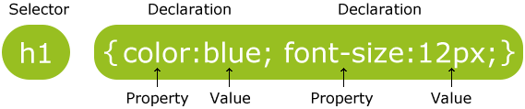
* **CSS**
* **CSS properties (**[**http://www.htmldog.com/reference/cssproperties/**](http://www.htmldog.com/reference/cssproperties/)**)**
* **<style> and the class attribute**
* **Style attribute**
* **Inline and internal styles**
* **The box model**

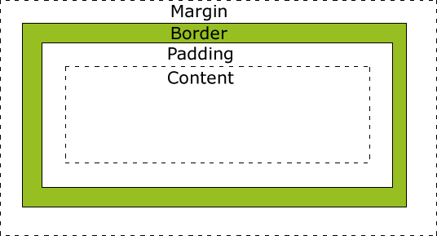

**Questions:**

1. **Compare and contrast the following methods for implementing CSS:**

<!DOCTYPE html>  
<html>  
  
<head>  
<style>  
  body {background- color:lightgrey}  
  h1   {color:blue}  
  p    {color:green}  
</style>  
</head>  
  
<body>  
  <h1>This is a heading</h1>  
  <p>This is a paragraph.</p>  
</body>  
  
</html>

<!DOCTYPE html>  
<html>  
  
<head>  
</head>  
  
<body style=”background-color:lightgrey;”>  
  <h1 style=”color:blue;”>This is a heading</h1>  
  <p style=”color:green;”>This is a paragraph.</p>  
</body>  
  
</html>

The left is internal style and right is inline style.

Both styles is changing the background light grey, h1 blue and p green.

1. **In the above example of using internal style rules, list the selectors, properties and then values.**

Selectors: body, h1, p

Properties: background-color, color

Values: lightgrey, blue, green

1. **List one possible property value for each of the following properties:**
2. **Font:** Bold
3. **Text-align:** Center
4. **Color: ­**Blue
5. **Background-image:** url
6. **Padding:** 10px
7. **Width:** 10%
8. **Top:** 10px
9. **Cursor:** pointer
10. **Visit** [**http://www.htmldog.com/guides/css/beginner/applyingcss/**](http://www.htmldog.com/guides/css/beginner/applyingcss/) **and read through the tutorial on applying CSS. Make sure you understand what a selector is and its properties and values. Understand the different types of values that can be used to represent size, text and colour. Also make sure to review the concepts around the box model i.e. margin, border, padding etc.**

**Exercises:**

Using your knowledge of CSS update your class website. Make sure to stay consistent in regards to appearance across each page in your site i.e. same colours, fonts, sizes, positions etc..

Make sure you have a web page for all your assignments. Add a link from your home page to this page. Make sure to add a title and an image. You will be using this page to submit and link all projects that will be assigned to you in this class. Make sure to style this page similar to all the others.