## The HTML form tag

All the input elements should be enclosed within the opening and closing <form> tags like this:

<form>

The input elements go here….

</form>

## The form input elements

You can have different types of input elements in a form. Examples are: check boxes, radio buttons, simple text boxes etc.

Let us see how to create input elements for a form.

## Single line text box

text input 

A single line text box can be used to collect the name, email, phone number etc from your web site visitors.

Here is the code to create a simple text box:

|  |
| --- |
| <input type="text" id="FirstName" /> |

**type=”text”**  
the ‘type’ attribute tells the browser that a single line text input box should be created.

**id=”FirstName”**  
gives a name to the field. The name is used to identify the field on the server side.

There are some more attributes that you can use with the text box

**value=”default value”**  
The text you give as value will be displayed by default in the text box.

Example:

|  |
| --- |
| <input TYPE="text" id="FirstName" value="Your FirstName here,Please" /> |

**maxlength=”maxChars”**  
Specifies the maximum number of characters the user can enter into this text box.

## jQuery IO

The .val() method is primarily used to get the values of form elements such as input, select and textarea. When called on an empty collection, it returns undefined.

//Get

let bla = $('#txt_name').val();

//Set

$('#txt_name').val(bla);

## Check box

Check box  
  
If you want to add a toggle input item that the user can select or deselect, use a check box input item.

|  |
| --- |
| <input type="checkbox" id="Agree" /> |

**Id=”Agree”**  
The name used to identify this input.

|  |
| --- |
| <input type="checkbox" id="sendmail" /> |

Example:

|  |
| --- |
| <input type="checkbox" id="sendmail"  />  **jQuery IO**  *// Get the value from a checked checkbox*  $( "#id" ).prop(“checked”);  **The prop() function can also be used to set the value of a property i.e.**  **$(“img”).prop(“src”,”car.jpg”);**  **An alternative to prop() is attr(). They both essentially work the same way.** |

## Radio Button

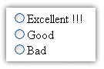

Radio buttons are for selecting one item from a set of choices. Use radio buttons when the choices are not too large (less than 10).  
Each individual button need to be created using input type ‘radio’  
Example:

|  |
| --- |
| <input type="radio" id="gender" value="male"/> |

The buttons in the same group should have the same name.  
Example:

|  |  |
| --- | --- |
| How do you rate the content at this site? | |
| <p> |

|  |  |
| --- | --- |
| <input type="radio" id="rating1"  name=”rating”>Excellent !!! <br/> | |
| <input type="radio" id="rating2"   name=”rating” >Good  <br/> |

|  |  |
| --- | --- |
| <input type="radio" id="rating3"   name=”rating” >Bad  <br/> | |
| </p> |

You can add ‘checked’ attribute to make a radio item selected by default.

**jQuery IO**

*// Get the value from a set of radio buttons*

$( "#id" ).prop(“checked”);

## Drop down list

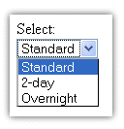

When you want to create a list of items for the user to select from, create a drop down list. Unlike the input tags we saw before, the list has two HTML tags associated – the <select> tag and the <option> tag.

You can create a list using the <select></select> tag and the items in the list using the <option> tag.

An example will make it clear:

|  |
| --- |
| Shipping method: |
| <select id=”unique id”> | |

|  |  |
| --- | --- |
| <option value="1"> standard</option> | |
| <option value="2"> 2-day</option> |

|  |  |
| --- | --- |
| <option value="3"> overnight</option> | |
| </select> |

If you want to make an option selected by default, you can add “selected” attribute to the <option>tag.

|  |
| --- |
| <option value="1" selected='selected'>Standard</option> |

makes the standard shipping method selected by default.

## jQuery IO

*// Get the value from a dropdown select directly*

$( "#id" ).val();

## Multi-line text

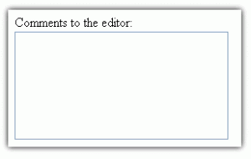

When you want to get a bunch of text from the user, the Textarea can be used.

A TextArea is created using the tag <textarea>

**Attributes:**  
**id=”descr”**  
the name identifies this TextArea.

**cols=”columns”**  
Defines the width (number of characters per line) the text area can accommodate without scrolling.

**rows=”rows”**  
Defines the number of lines (number of rows) the text area can accommodate without scrolling.

**Example:**

|  |
| --- |
| Enter your suggestions here: |
| <textarea id="suggestions" rows="5" cols="25"></textarea> | |

If you want to provide some value in the text area by default, you can give it like this:

|  |
| --- |
| <textarea id="suggestions" rows="5" cols="25">my suggestions are:</textarea> |

## jQuery IO

//Get

let bla = $('#suggestions ').val();

//Set

$('#suggestions ').val(bla);

## Password input

Password Input

Login screens usually have a password field where the user enters his password. You can create a password field by using the input type ‘password’.

A password field can be created using the following code:

|  |
| --- |
| <input type="password" id="pwd" /> |

Other attributes:

**maxlength=”maxChar”**  
the maximum length (in characters) the password can have

**value=”textValue”**  
The default value that should appear in the password field.

**jQuery IO**

$("#passwordName").val(); // Password in cleartext

## General button

A button input just displays a button on the form. To add meaning to the button, we need to add JavaScript code to handle the event when the user presses the button.

An example of button is given below:

|  |
| --- |
| <input type="button"  value="Click!" id=”btnDoSOmething”> |

This code displays a button with label “Click!”.

**HTML <label> Tag**

**This represents a label in which we place text.**

  <label id="other">Other</label>

**jQuery IO**

Use the text function to set its text.

$("#other").**text**(money);

**Questions and Exercises**

1. Create the following form:

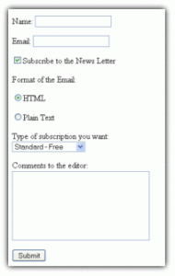

1. Create the following form:

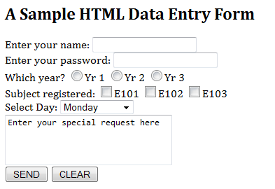

1. Create a program that allows a user to enter two numbers in separate textboxes. When a button is clicked display the sum of these two numbers.
2. Create a program that allows a user to enter how many quarters, dimes, nickels and pennies they have. When a button is clicked display the total value of these coins.
3. Create a program that allows a user to enter the weight of an object in pounds and ounces. It then displays the total ounces and the cost of the object when prices are charged at $0.15 per ounce.
4. Write and design a program that allows the user to input first and last names in two separate text boxes and then displays the last name, a comma, and then the first name in a label.
5. Write and design a program that converts between temperatures in Fahrenheit and Celsius.

Applicable formulae:

**F = 32 + (9/5)C**

**C = (5/9) (F-32)**

Your program will have the following GUI:

|  |  |
| --- | --- |
| http://ajax.comm.virginia.edu/eem2x/comm320/_themes/strtedge/astrbul1e.gif | A text box to enter the temperature |
| http://ajax.comm.virginia.edu/eem2x/comm320/_themes/strtedge/astrbul1e.gif | A button that will convert from Celsius to Fahrenheit |
| http://ajax.comm.virginia.edu/eem2x/comm320/_themes/strtedge/astrbul1e.gif | A button that will convert from Fahrenheit to Celsius |
| http://ajax.comm.virginia.edu/eem2x/comm320/_themes/strtedge/astrbul1e.gif | A label that will display the answer |

HINTS: Start by designing the form. Name every component using proper naming protocols. Set up the appropriate events. Create the necessary variables. Write the code. Test and debug!

1. Write a program that prompts the user to input a username and password. If the user is “krnic” and the password is “ics3u” then display a happy face in an image, otherwise show a sad face!
2. Write a program that allows a user to enter a weight. If they are between 100 and 150lbs then tell them they are a “lightweight”, between 151 and 200lbs a “middleweight” and anything over 200lbs a “heavyweight”.
3. Create a program that allows a user to enter a starting and ending number into two textboxes. When a button is clicked display the sum of all whole numbers between these two numbers ex. Input a 1 and 3, the sum is 1+2+3=6.