Introduction to Flowcharts and Algorithms
PART I: Introduction to flowcharts
A flowchart is a graphical representation of an algorithm. These flowcharts play a vital role in the programming of a problem and are quite helpful in understanding the logic of complicated and lengthy problems. Once the flowchart is drawn, it becomes easy to write the program in any high level language. Often we see how flowcharts are helpful in explaining the program to others. Hence, it is correct to say that a flowchart is a must for the better documentation of a complex program.
Flowcharts are usually drawn using some standard symbols; however,
Symbol | Purpose
 | There will always be only 2 ovals in a flowchart to indicate the start and end of the algorithm. You normally label each with the words “START” and “END”.
 | The arrow is used to connect different parts of the flowchart together and to indicate the direction of logic.
 | It is used to gather INPUT and display OUTPUT.
 | Is used to perform calculations or any updates to variables.
 | This is used to make decisions. Represents a simple “if” “else” statement. It has two arrows exiting it labeled true and false. “Else if’s” are simply additional diamonds added to the starting diamond.
 | Is used to connect different parts of a flowchart together and comes in pairs. Labeled starting at letter a…b…c

The following are some guidelines in flowcharting:
- In drawing a proper flowchart, all necessary requirements should be listed out in logical order.
- The flowchart should be clear, neat and easy to follow. There should not be any room for ambiguity in understanding the flowchart.
- The usual direction of the flow of a procedure or system is from left to right or top to bottom.
- Only one flow line should come out from a process symbol.
- Only one flow line should enter a decision symbol, but two, one for each possible answer, should leave the decision symbol.
- Only one flow line is used in conjunction with terminal symbol.
- If the flowchart becomes complex, it is better to use connector symbols to reduce the number of flow lines. Avoid the intersection of flow lines if you want to make it more effective and better way of communication.
- Ensure that the flowchart has a logical start and finish.
- It is useful to test the validity of the flowchart by passing through it with a simple test data.

Software that can aid the design of flowcharts include:
creately.om
https://www.lucidchart.com
http://www.gliffy.com/
diaportable

PART II: Example of a flowchart:
Problem 1: Write an algorithm and draw the flowchart for finding the average of two positive numbers (check that numbers entered are positive).
Algorithm:

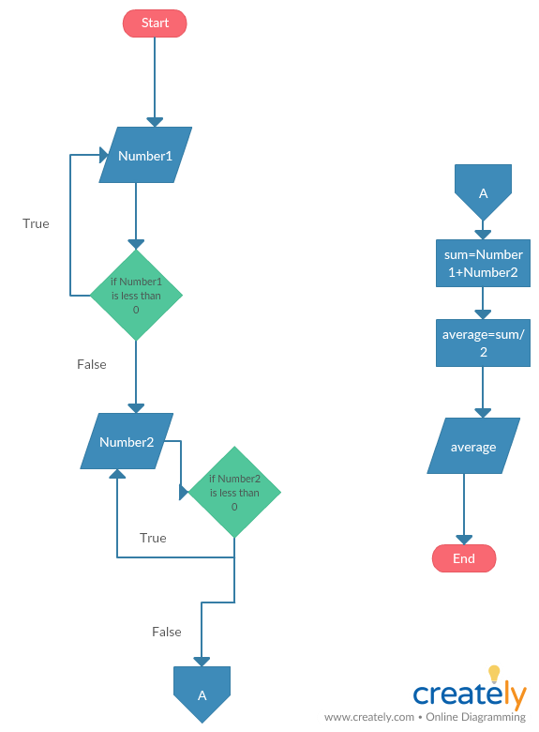

PART III: Problem 2: Write an algorithm for finding the area and perimeter of a rectangle by getting the length and width. If the dimensions represent a square indicate that the area is optimal given the perimeter.
Algorithm:

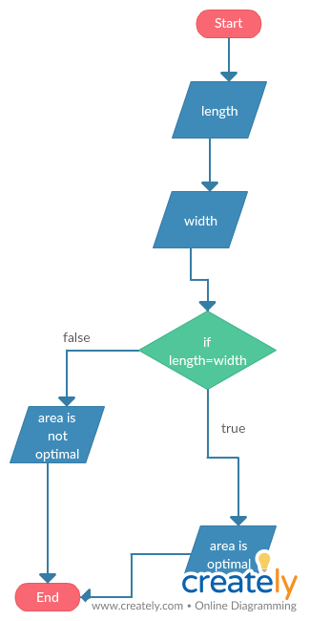

Practice:
1. Design an algorithm and the corresponding flowchart for finding the sum of the
numbers 2, 4, 6, 8, …, n
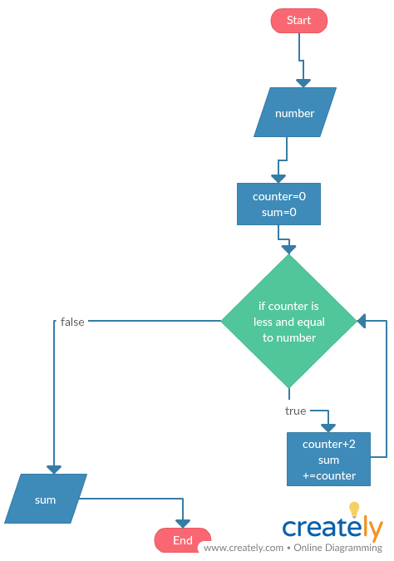
2. Using flowchart, write an algorithm to read 100 numbers and then display the sum.
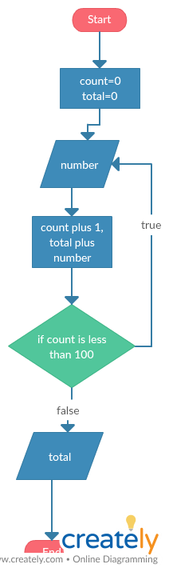
3. Using flowcharts, write an algorithm to read two numbers then display the largest.
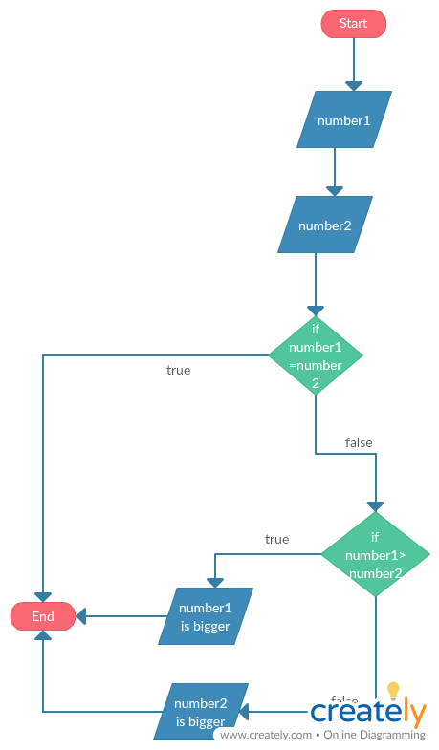
4. Using flowchart, write an algorithm to read two numbers then display the smallest
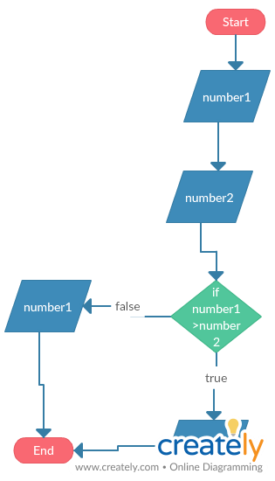
5. Using flowcharts, write an algorithm to read three numbers then display the largest.
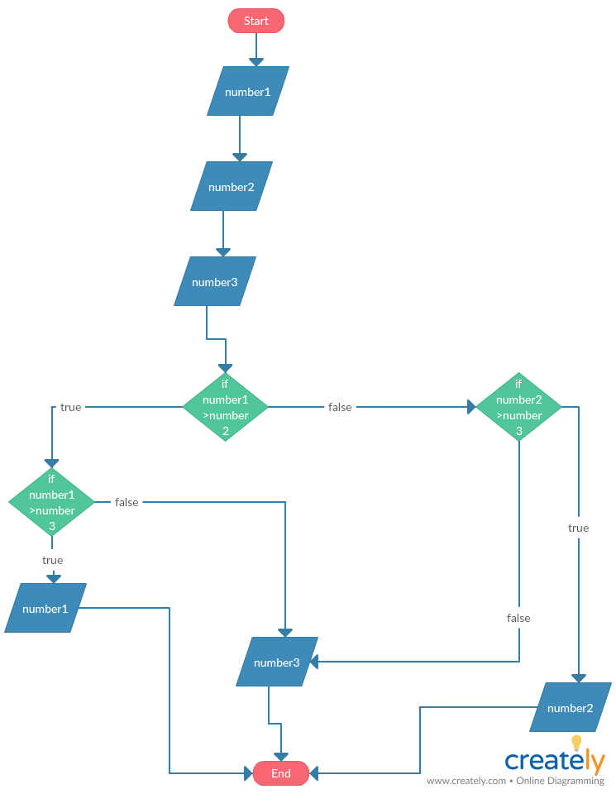
6. Using flowchart, write an algorithm to read 100 numbers then display the largest.
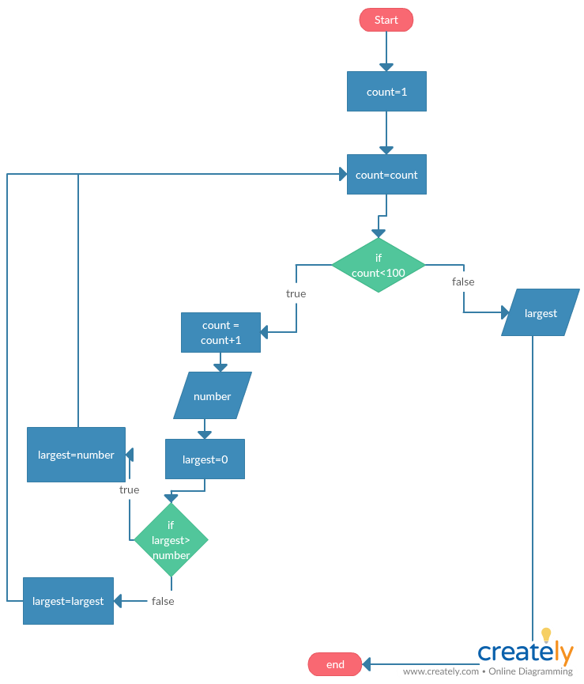
7. Draw a flowchart for a program that will input a list of N test scores (test score >= 0)
and finds the highest test score and finds the number of the students whose score is
50 or above
