**ICS4U PHP Problem Solving Assignment**

Sluggers Two important stats in baseball are the team batting average and the team slugging average. Batting average is defined as the total number of hits (this includes 1 base hits, 2 base hits, 3 base hits and home runs combined) divided by the total number of times at bat (“at bats”) for all players on the team. The team slugging average is defined using the following equation:



Where A is the number of 1 base hits, B is 2 base hits, C is 3 base hits, D is home runs, and E is the number of at bats for all players on the team. Both slugging and batting averages are always presented as decimals rounded to 3 places, leaving off the leading 0 (in theory batting averages can be as high as 1.000, and slugging averages as high as 4.000 but in practice they are both usually well below 1). DATA11.txt (DATA12.txt for the second try) contains the raw data on the top 10 teams during a regular season of Major League Baseball. The first line is the season name, followed by 10 lines for each of the top 10 teams. Each of these lines starts with a team name (single word) followed by 7 integers: Games Played, At Bats, Runs, Hits (total), two-base hits, three-base hits, and home runs. One space character separates each item on each line.

Write a program to produce a report showing the batting and slugging averages for each team in the order they appeared in the input file, and formatted EXACTLY as shown below, including all punctuation and matching upper and lower case exactly. All spacing is done with a single space character. All batting and slugging averages will be less than 1. The final line shows the same averages for all 10 teams combined (computed from the sum of all at bats, hits, etc. for all 10 teams). Note that the two lines of “=” characters each contain 20 characters.

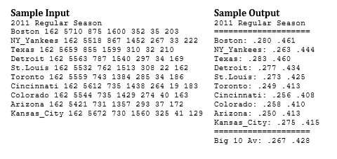

The file DATA10.txt contains the above sample input. Use this to test your code. If done correctly your program should display the sample output.

When you feel like your program is complete your teacher will provide you with other sample input data files (DATA11.txt for your first attempt and DATA12.txt for your last attempt) and check against known outputs. You will be assigned marks based on the following:

Award 4 marks for each exactly correct number (4 * 22 = 88 marks total).

The remaining 12 marks are for correct formatting. Check all colons, spelling and punctuation, and make sure all the lines but the first have the same right margin. Also make sure that no numbers are presented with a leading 0 (e.g. 0.267 instead of .267). Any deviation, even one character, and they lose all 12 formatting marks.

You will lose 2 marks for every class that this problem is not solved, up to a maximum of 10 marks. At this point what code you have will be marked.

**Marks (TI): 100**

Numbers: /88

Formatting: /12

Total: /100