PREDICTING THE HALF MAXIMAL INHIBITORY CONCENTRATION OF VARIOUS DRUGS ON TYROSINE PROTEIN KINASE RECEPTOR USING MACHINE LEARNING MODEL

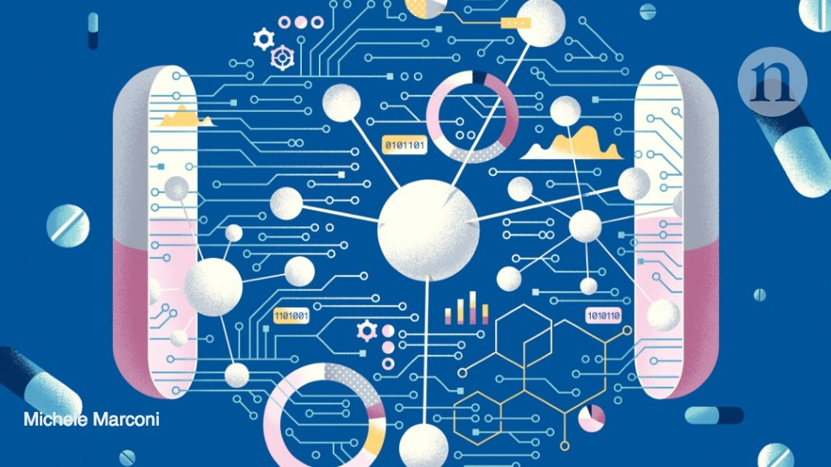

Machine Learning approaches provides a set of tools that can improve drug discovery and decision making for well specified questions with abundant high-quality data. Interpretation of model will allow us to understand how we can design a better drug.

Tyrosine-protein kinase that acts as cell-surface receptor for the cytokine FLT3LG and regulates differentiation, proliferation and survival of hematopoietic progenitor cells and of dendritic cells. The activated receptor kinase subsequently phosphorylates and activates multiple cytoplasmic effector molecules in pathways involved in apoptosis, proliferation, and differentiation of hematopoietic cells in bone marrow. Mutations that result in the constitutive activation of this receptor result in acute myeloid leukaemia and acute lymphoblastic leukaemia.

Half maximal inhibitory concentration indicates how much drug is needed to inhibit a biological process by half, thus providing a measure of potency of an antagonist drug in pharmacological research.

Let’s build a Regression model to predict the half maximal inhibitory concentration for various drugs.