Results for Stats Library Project 2

Poisson:

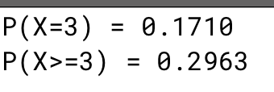

Uniform Probability:

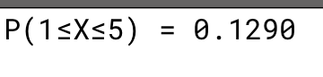

ChebyShev:

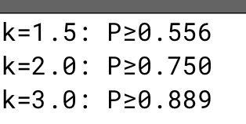

Conditional Probability:

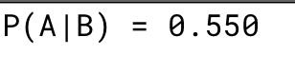

Gamma Distribution:

