**BlueJ:**

**PlotFunction.java**

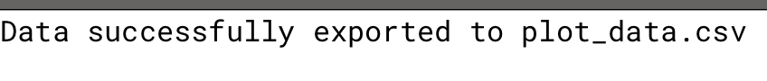

* When running the program, this is the output prompted. In the folder that the .java file is in, creates a csv file after running the program.

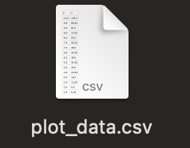

* From here you can view the .csv file that it created for you. I then proceeded to extract this csv file into excel.

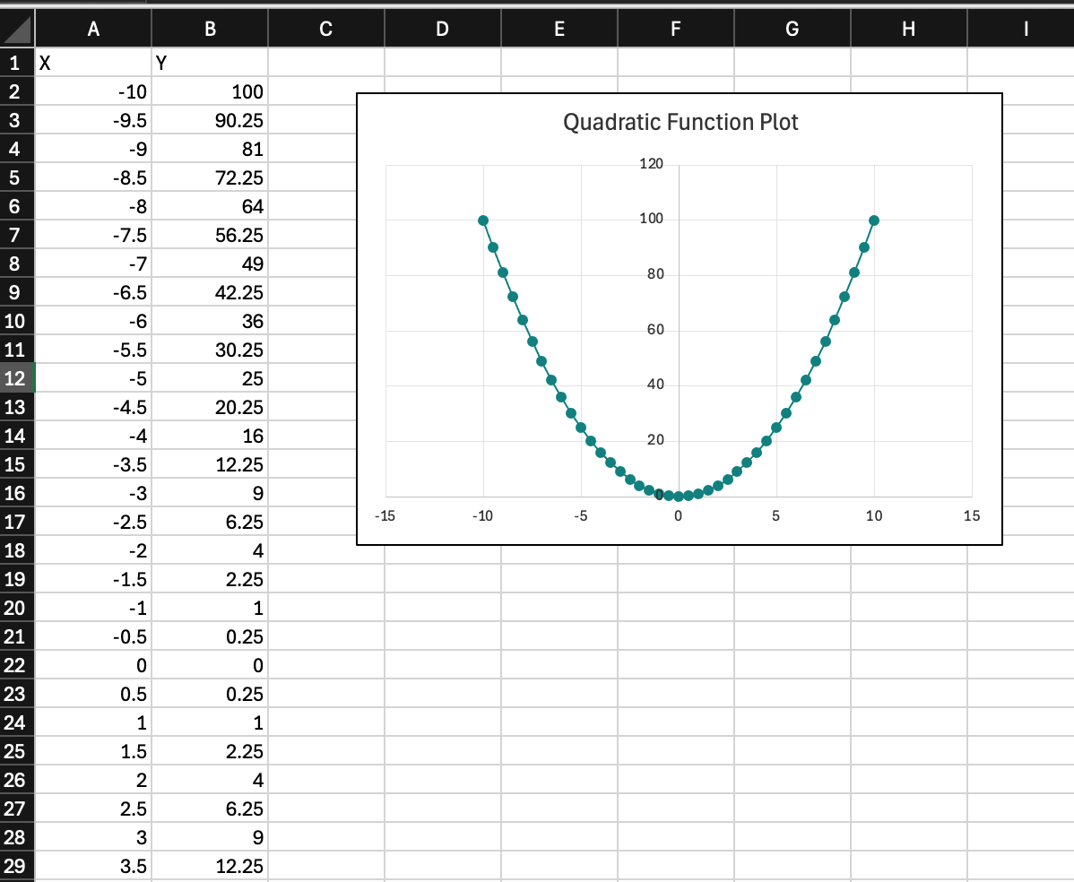

* I was able to make a graph with the points provided in excel after extracting the csv into it.

**DataSalter.java**

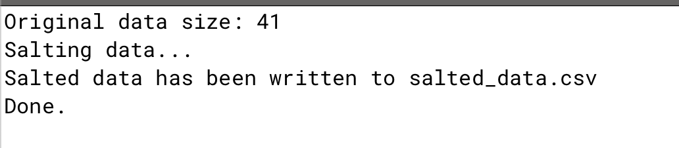

* When running the DataSalter program, this is the output prompted. In the folder that the .java file is in, creates a csv file after running the program.

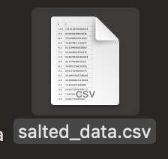

* From here you can view the .csv file that it created for you. I then proceeded to extract this csv file into excel.

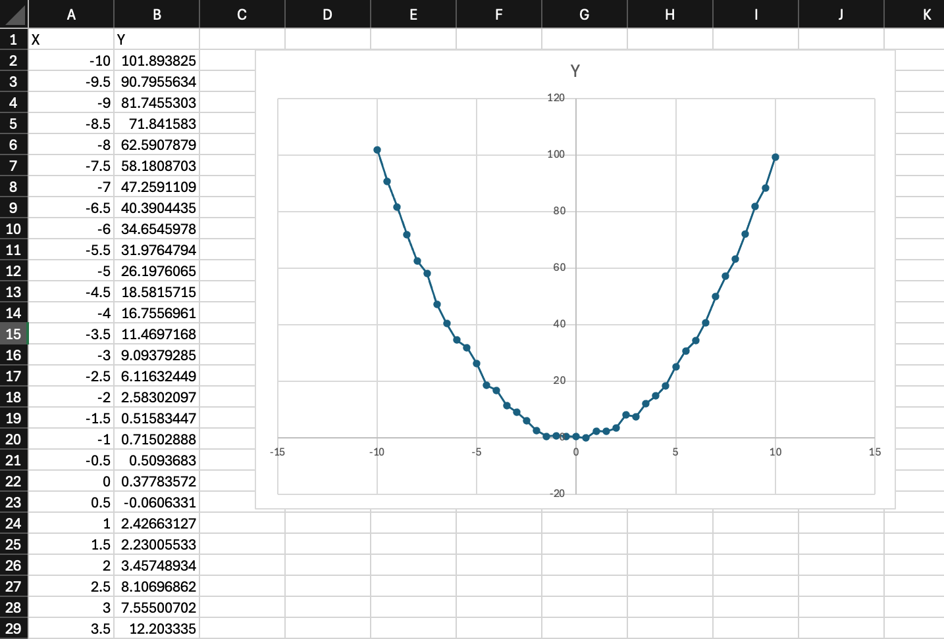

* I was able to make a graph with the points provided in excel after extracting the csv into it.

**Smoother.java**

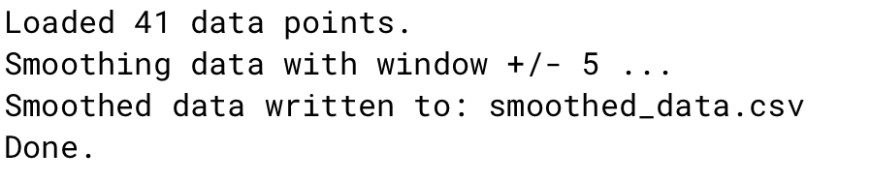

* When running the Smoother program, this is the output prompted. In the folder that the .java file is in, creates a csv file after running the program.

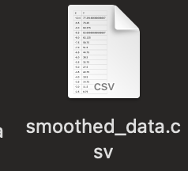

* From here you can view the .csv file that it created for you. I then proceeded to extract this csv file into excel.

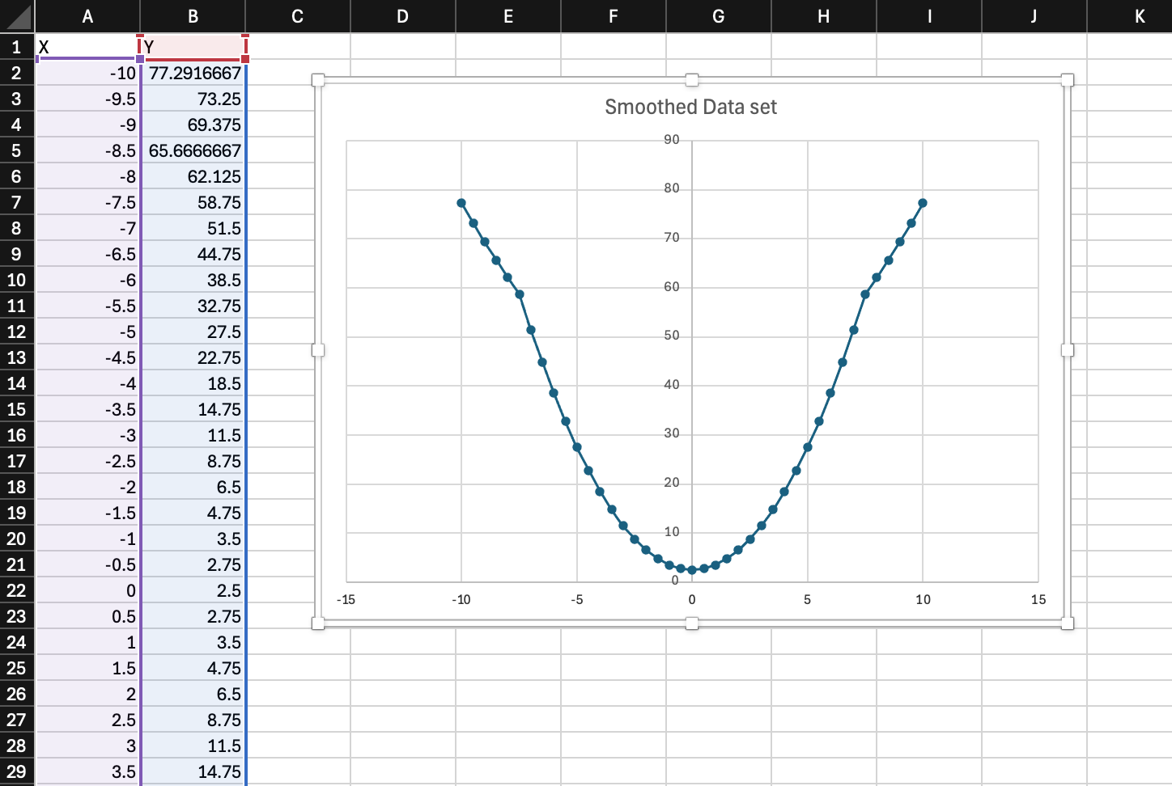

* I was able to make a graph with the points provided in excel after extracting the csv into it.

**DataHandler.java**

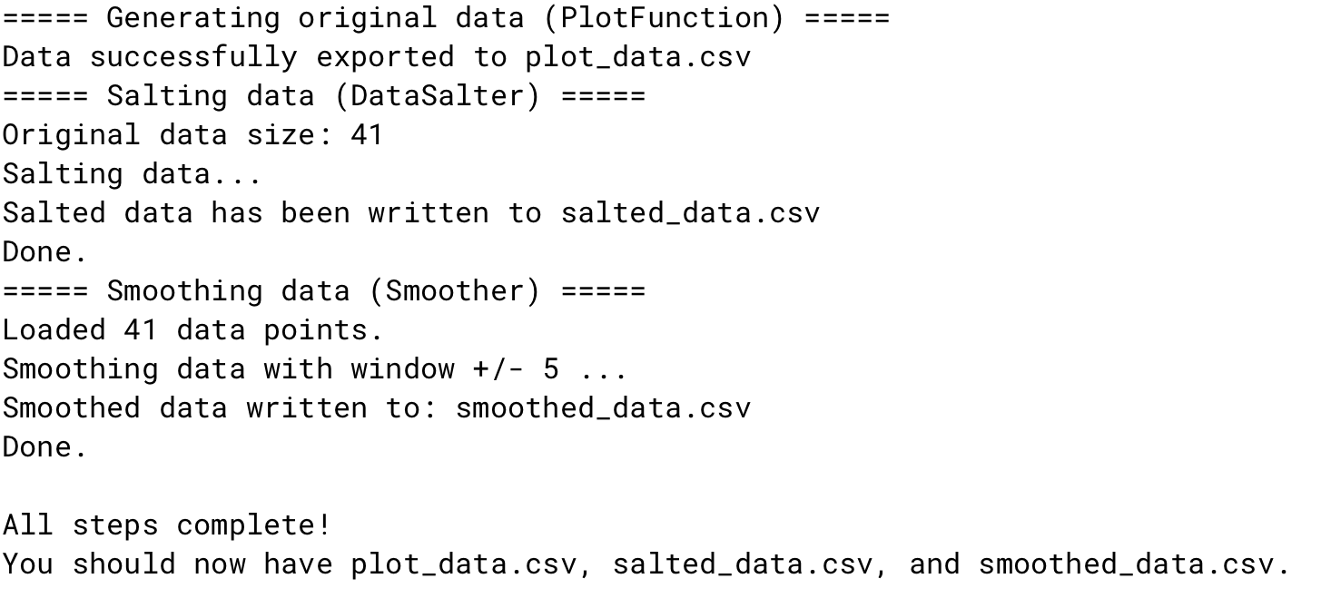

* For the DataHandler class, it provides this output which creates all csv files for each of the programs with just one execution !

**Octave**

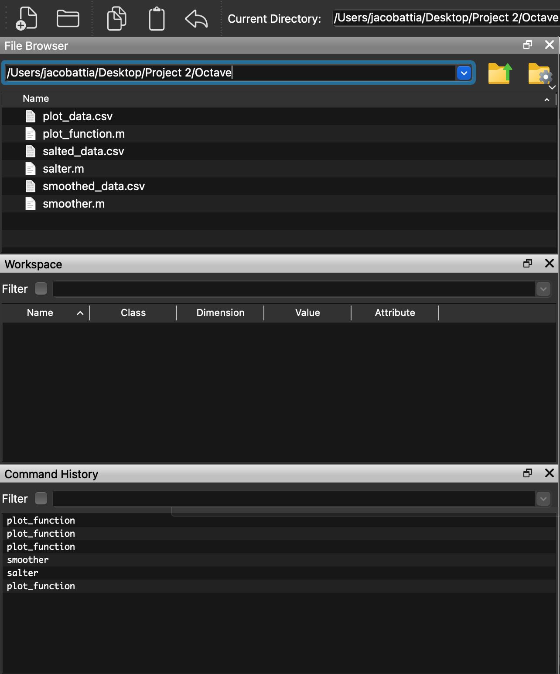

* This is the Octave GUI, once I ran the programs it then created a separate csv file for each.

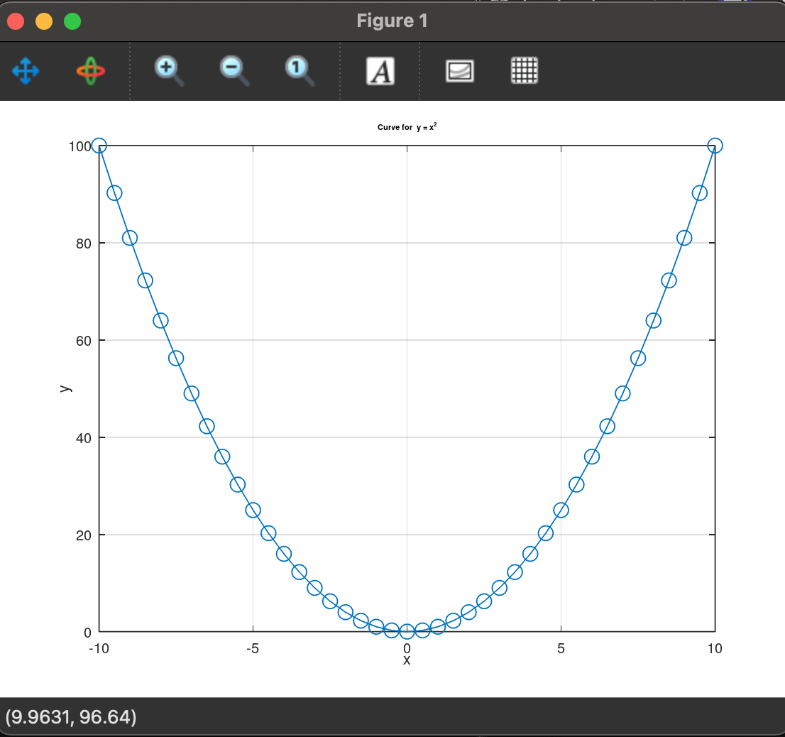

* When running the plot_function.m program, it shows a visual graph and also produces a csv file.

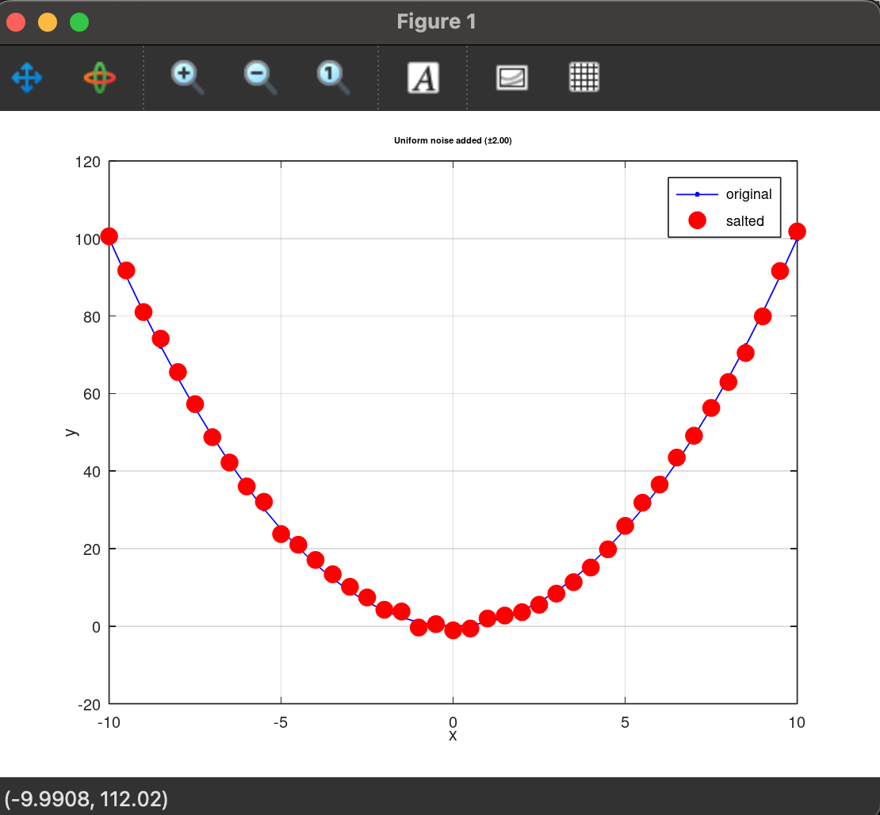

* When running the salter.m program, it shows a visual graph and also produces a csv file.

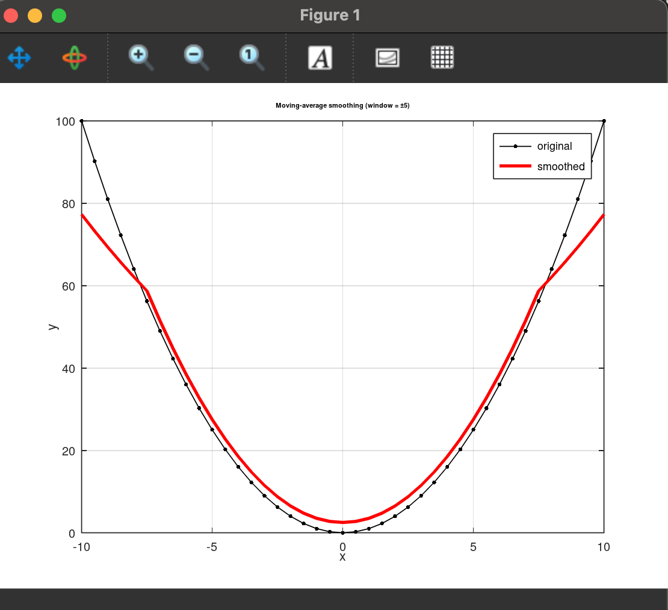

* When running the smoother.m program, it shows a visual graph and also produces a csv file.

**VS Code (JfreeChart + Apache stats library)**

**DataPlotter.java**

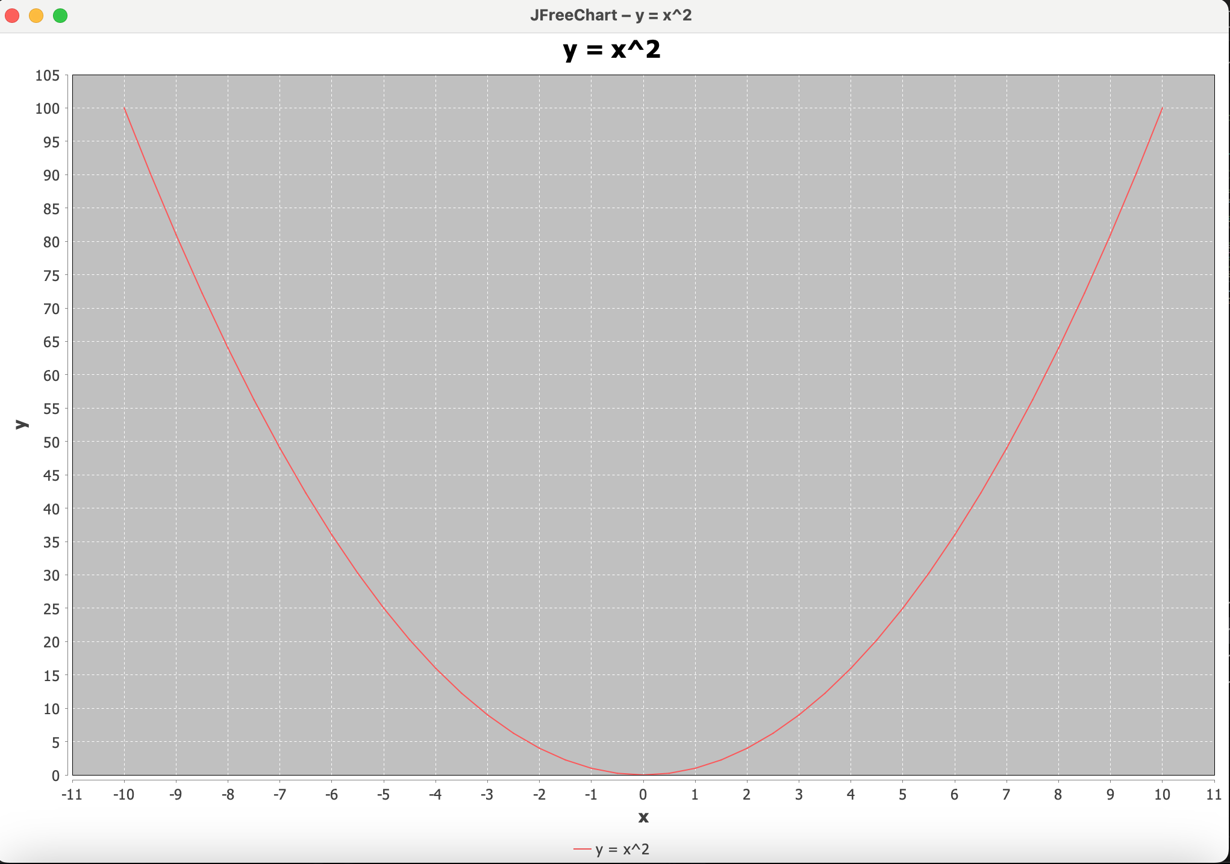

* VS code output with the Jfreechart plugin. When running the program it automatically opens this graph.

**DataSalter.java**

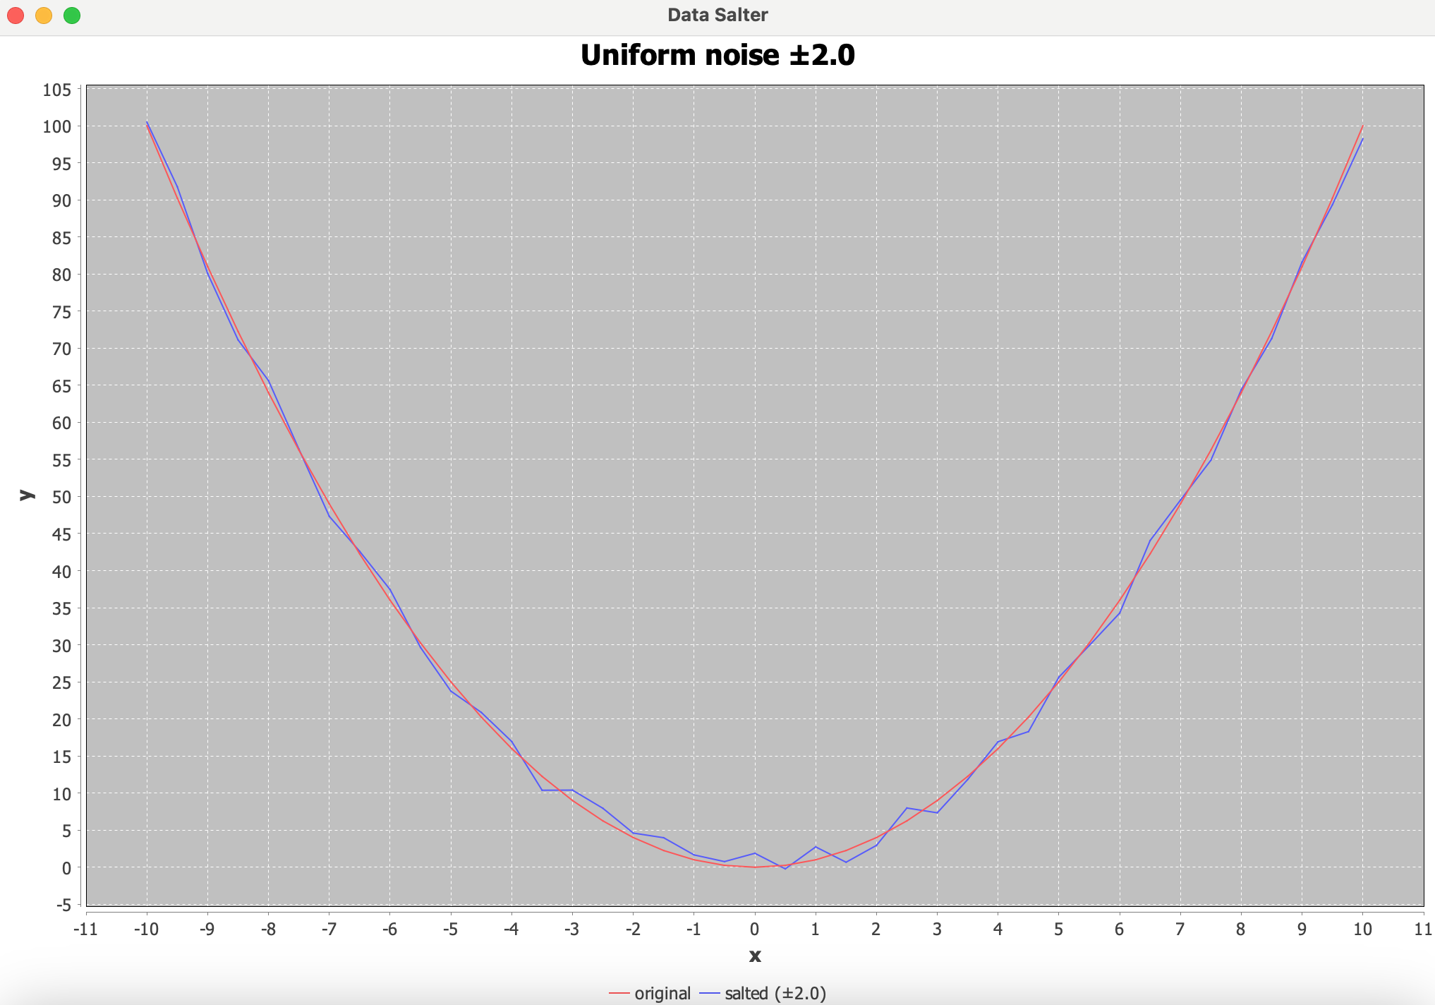

* VS code output with the Jfreechart plugin. When running the program it automatically opens this graph.

**DataSmoother.java**

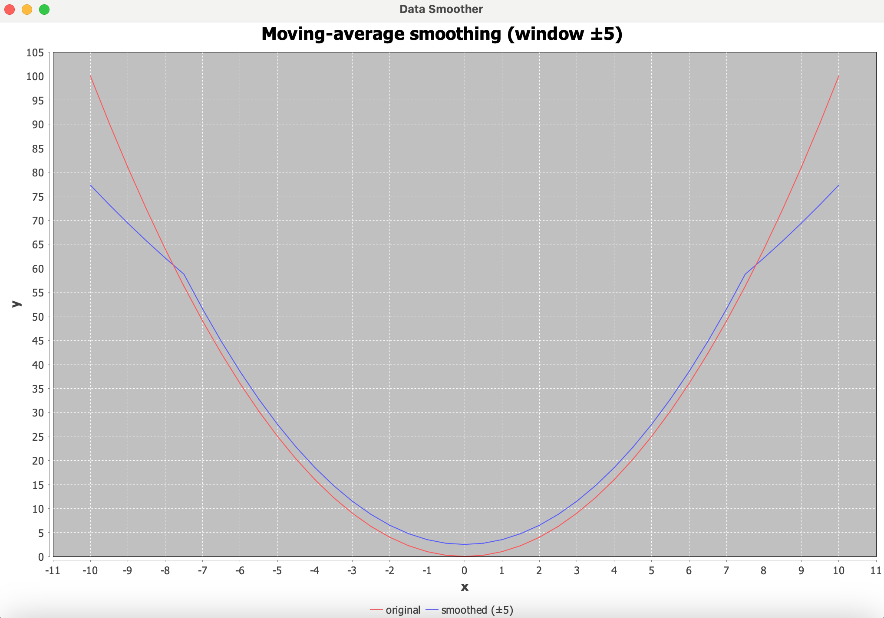

* VS code output with the Jfreechart plugin. When running the program it automatically opens this graph.

**DataPlotter.java (Apache common math implementation)**

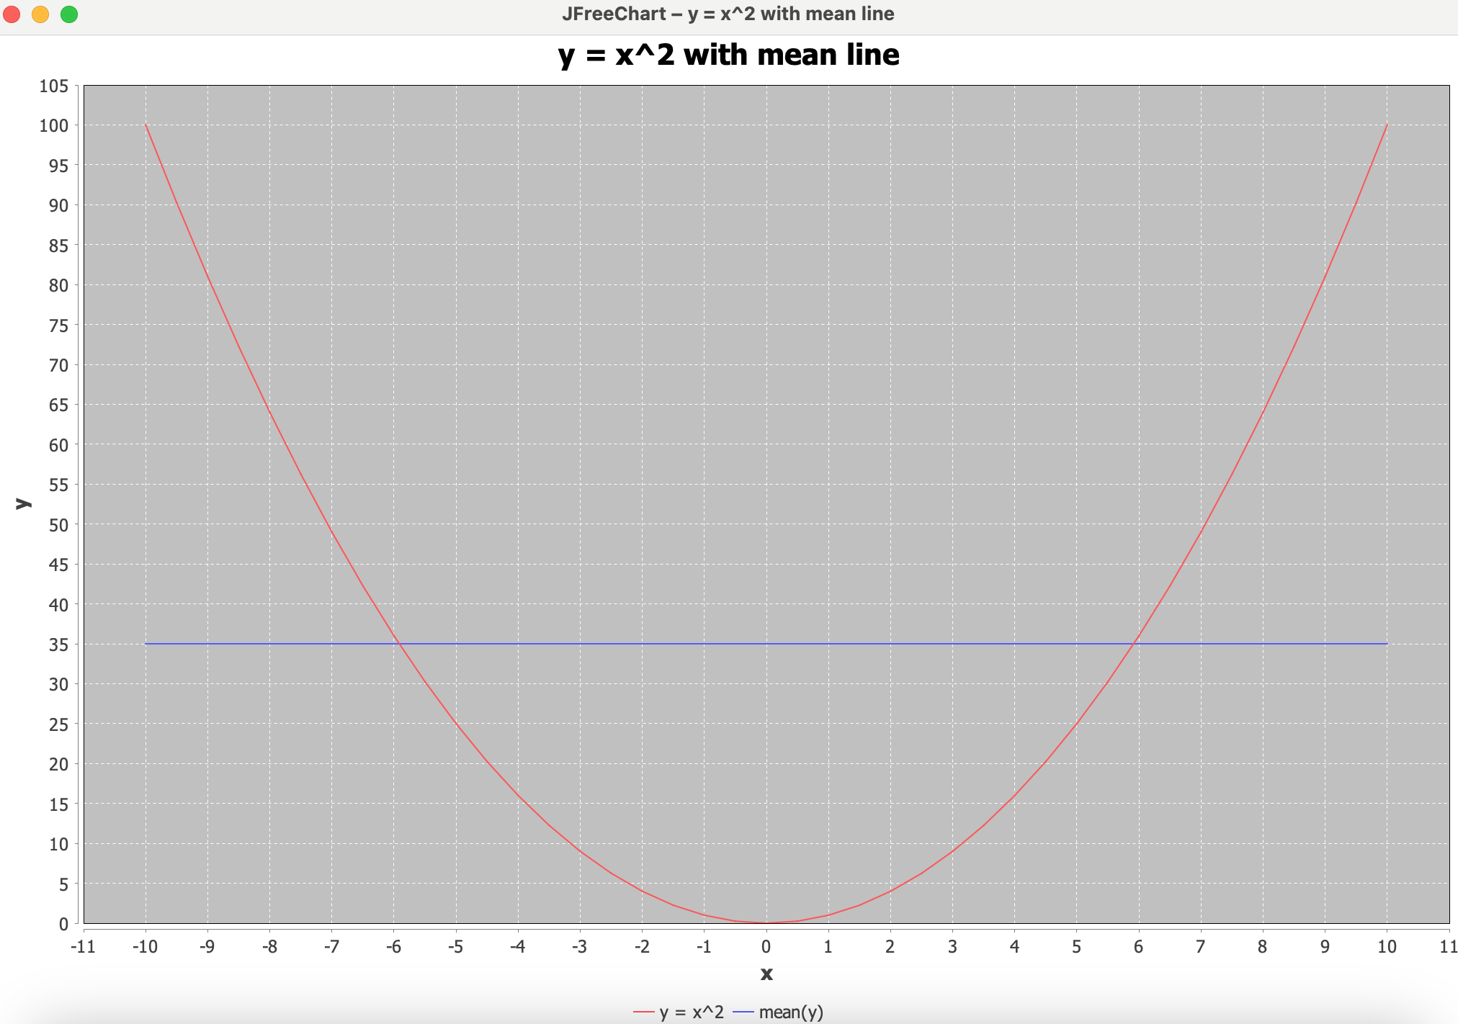

* When apache common math is implemented into the program, it shares a mean line and can show any regression lines when prompted as well. It works in unison with Jfreechart to show a more advanced graphical interface.

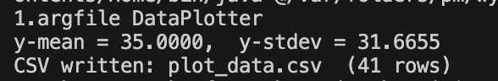

* Apache common math also shares the mean and standard deviation in the console, to these problems when prompted to do so.

**DataSalter.java (Apache common math implementation)**

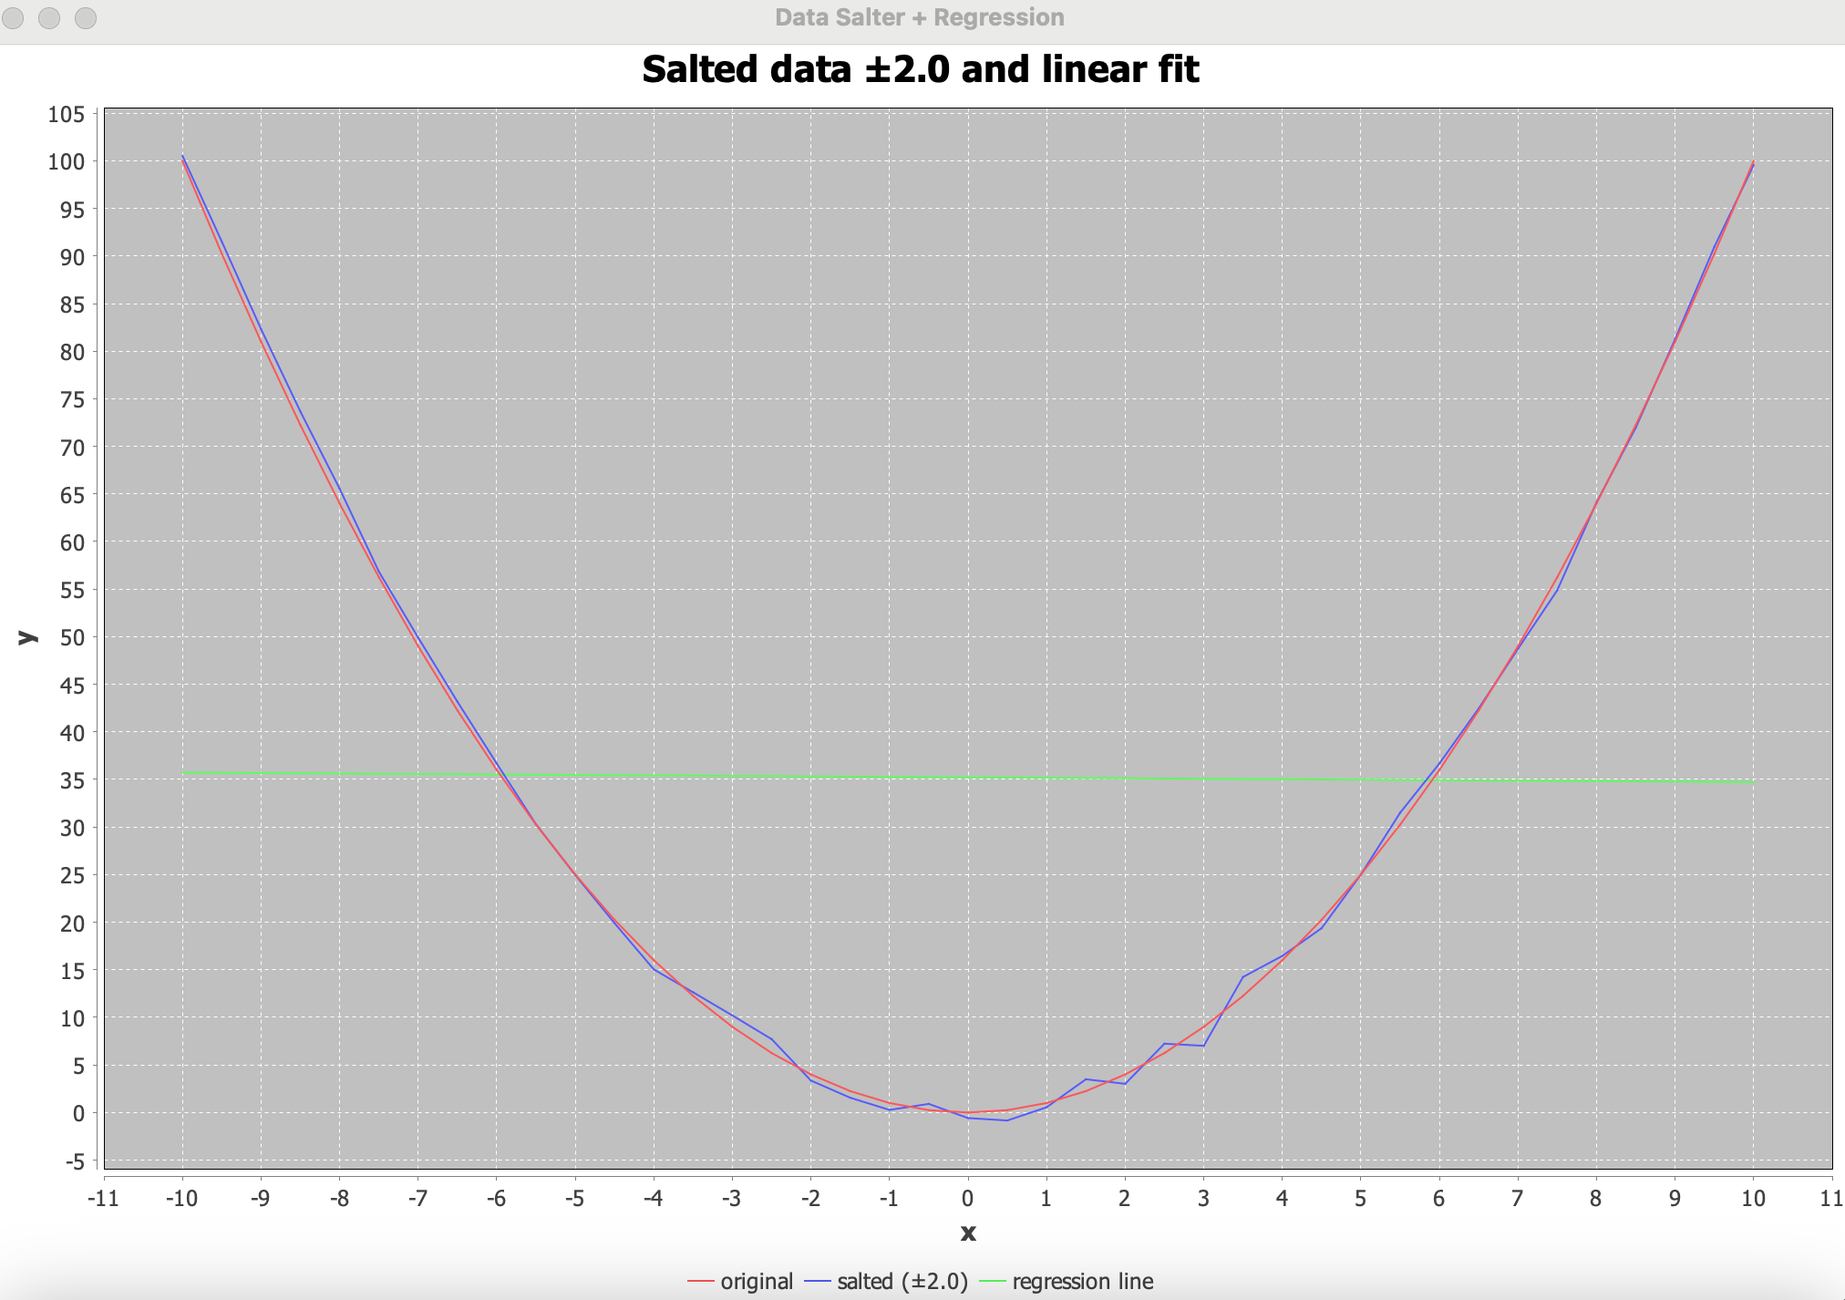

* When adding the apache common math integration, a best‑fit straight line through the noisy points demonstrating a practical use of Apache Commons Math.



* Results of the datasalter + apache common math integration in the console.