Which Samsung Galaxy Buds Are Better?
Sentiment analysis with an interactive comparison dashboard
Course | Big Data Analytics
Prepared by | Javeria
Date | October 2026
Code and data | https://github.com/J247coder/galaxy-buds-sentiment

Summary
This project collects public YouTube comments about five Samsung earbuds, works out whether each comment is positive, neutral or negative, and shows the results in a dashboard where people can compare models. In total, 2,971 cleaned comments were analysed. Viewers speak positively about all five models (53% to 58% positive comments). Galaxy Buds FE scored highest and Galaxy Buds2 Pro lowest, but the gaps between models are small.

1. Introduction
Choosing earbuds is difficult because opinions are spread across many videos and websites. This project turns thousands of public comments into a clear, simple comparison. It has three goals:
- Collect real comments about five Samsung Galaxy Buds models.
- Measure the sentiment of each comment, both overall and for features such as sound, battery and comfort.
- Present the results in a dashboard so a user can compare models and pick the one that suits them.

2. Data Collection
Comments were collected from YouTube using the official YouTube Data API (v3). For each model, the script searched for popular review videos (up to 5 per model) and downloaded top-level comments (up to 150 per video). Using the API is more reliable than reading web pages directly and follows YouTube’s rules.
In total 3,090 comments were collected. After cleaning, 2,971 remained. The 119 removed comments were duplicates or too short to analyse.
Table 1: Earbuds compared and comments analysed
Model | Release year | Comments analysed
Galaxy Buds FE | 2023 | 620
Galaxy Buds2 | 2021 | 703
Galaxy Buds2 Pro | 2022 | 476
Galaxy Buds3 | 2024 | 527
Galaxy Buds3 Pro | 2024 | 645

3. Methodology
The project follows a simple pipeline, with one Python script for each step.
Table 2: Project pipeline
Step | What happens | Tool
Collect | Comments are downloaded from YouTube review videos. | YouTube Data API
Clean | Links, HTML and @mentions are removed. Very short and duplicate comments are dropped. | pandas
Sentiment | Each comment gets a score from −1 (very negative) to +1 (very positive). A score of 0.05 or more is Positive, −0.05 or less is Negative, anything between is Neutral. | VADER
Aspects | Sentences that mention a feature are scored separately. The eight features are sound quality, battery, noise cancellation, comfort and fit, mic and calls, connectivity, price and value, and design and build. | Keyword matching
Database | Everything is stored in six linked tables. | SQLite
Dashboard | Interactive charts to compare the earbuds. | Streamlit, Plotly

4. Database Design (ERD)
The results are stored in a relational database with six tables. Figure 1 shows how they connect.
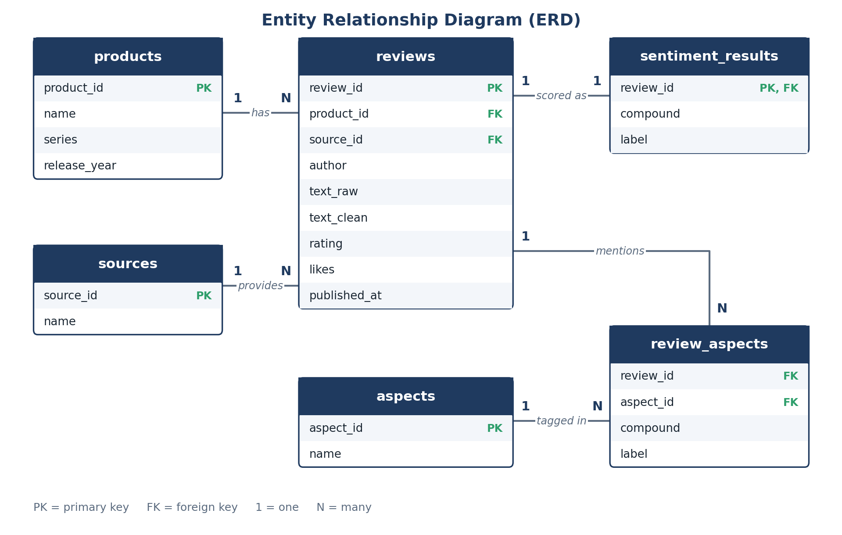
Figure 1: Entity Relationship Diagram of the project database
- products and sources each link to many reviews (one product or source has many reviews).
- sentiment_results holds exactly one score and label for every review.
- review_aspects connects reviews and aspects, because one review can mention several features and one feature appears in many reviews.

5. Dashboard and Results

5.1 Dashboard overview
The dashboard lets the user choose which earbuds to compare from the sidebar. The top of the page shows the number of comments analysed, the number of earbuds compared and the model with the most positive comments. A separate tab, “Find my best pair”, lets the user rate how important each feature is (0 to 5) and then shows the best match.
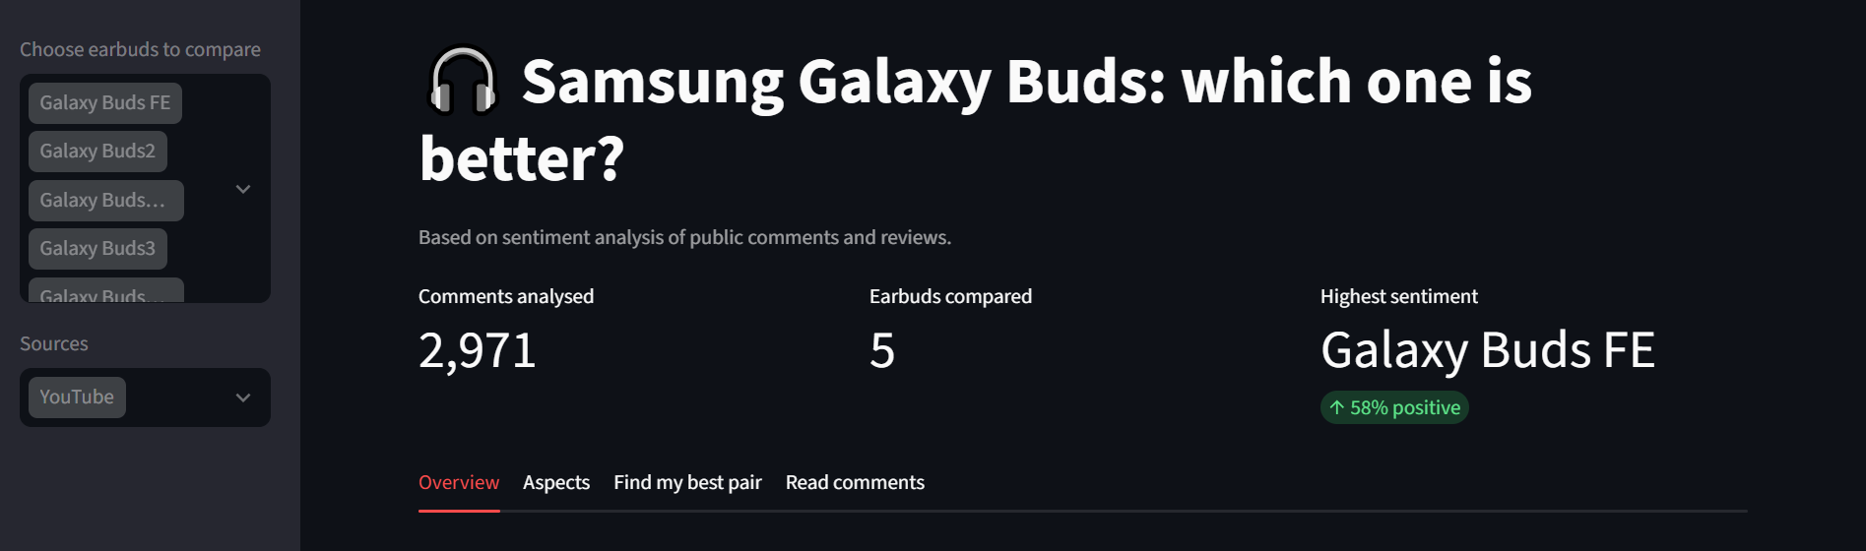
Figure 2: Dashboard overview with the earbud selector and key numbers

5.2 Sentiment by model
Every model has more positive than negative comments. Galaxy Buds FE has the highest average score (0.28) and the fewest negative comments (17%). Galaxy Buds2 Pro has the lowest average score (0.20) and the most negative comments (26%).
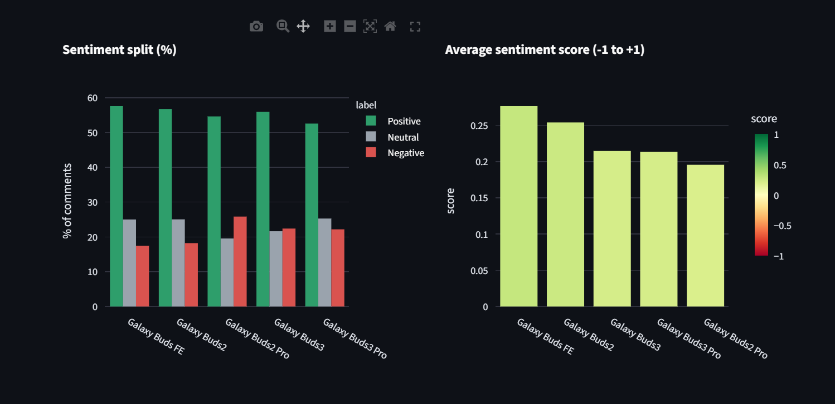
Figure 3: Share of positive, neutral and negative comments, and average sentiment score
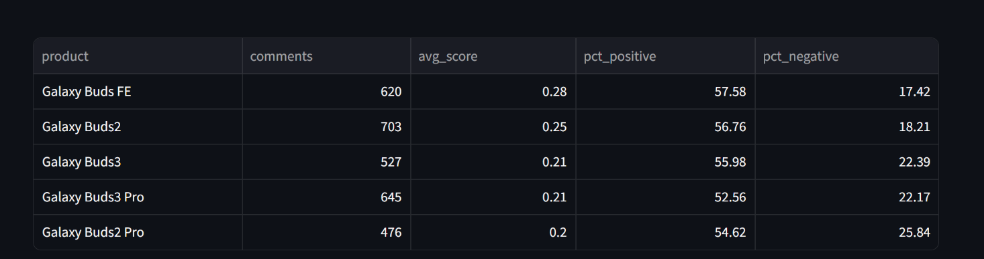
Figure 4: Summary table (comments, average score, % positive, % negative)

5.3 Sentiment over time
The lines move up and down a lot from month to month. This happens because some months have only a few comments, so one very happy or very unhappy comment can shift the average. The overall level of each line is more reliable than any single month.
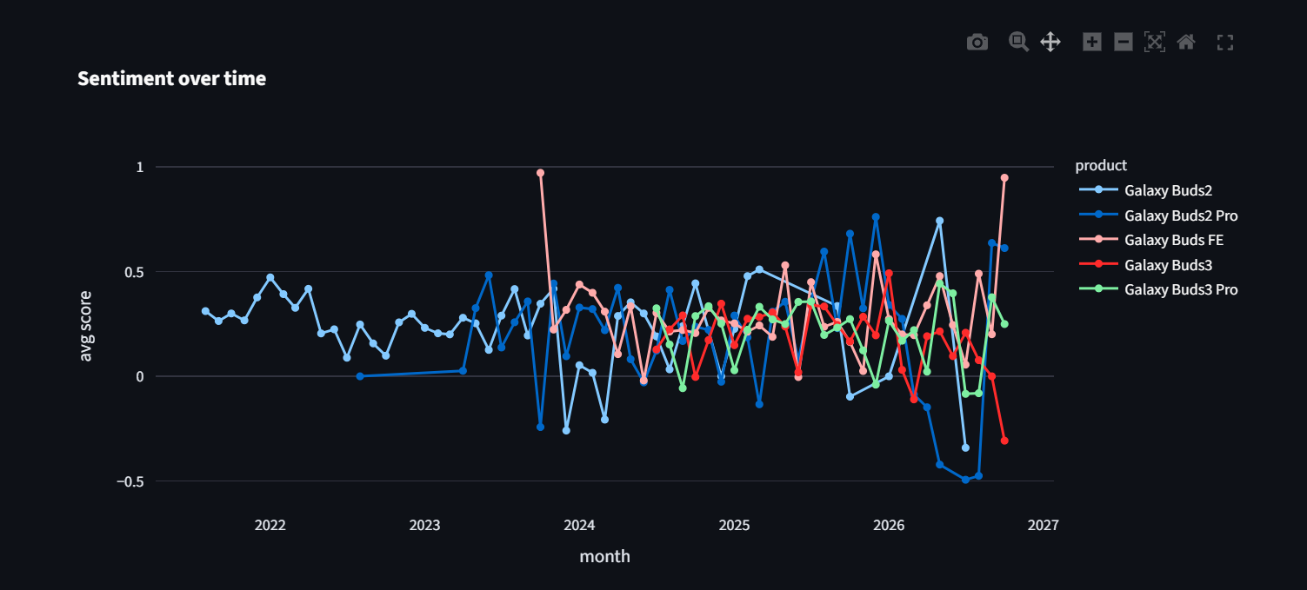
Figure 5: Average sentiment per month for each model

5.4 Sentiment by feature
The heatmap shows how people feel about each feature of each model. Green means liked. Almost every score is positive, but they are all fairly low, which means opinions are mildly positive rather than enthusiastic. Sound quality gets the highest scores overall, while battery and connectivity get the lowest. Connectivity on the Galaxy Buds2 Pro is the only negative score (−0.05).
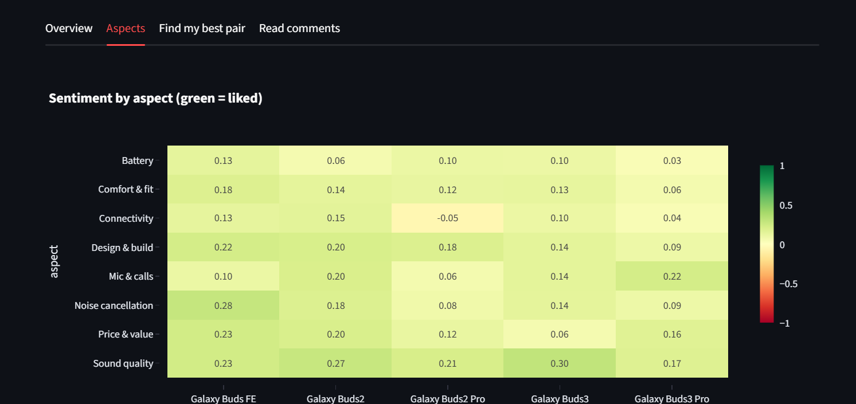
Figure 6: Sentiment score by feature and model
Table 3: Highest-scoring model for each feature
Feature | Best model | Score
Sound quality | Galaxy Buds3 | 0.30
Noise cancellation | Galaxy Buds FE | 0.28
Price and value | Galaxy Buds FE | 0.23
Design and build | Galaxy Buds FE | 0.22
Mic and calls | Galaxy Buds3 Pro | 0.22
Comfort and fit | Galaxy Buds FE | 0.18
Connectivity | Galaxy Buds2 | 0.15
Battery | Galaxy Buds FE | 0.13

5.5 Reading the real comments
Users can also read the actual comments for any model and sentiment, sorted by number of likes. This is useful for checking the scores, and it shows one weakness of the method: some comments are jokes or self-promotion about the video, not about the earbuds, yet they still receive a sentiment score.
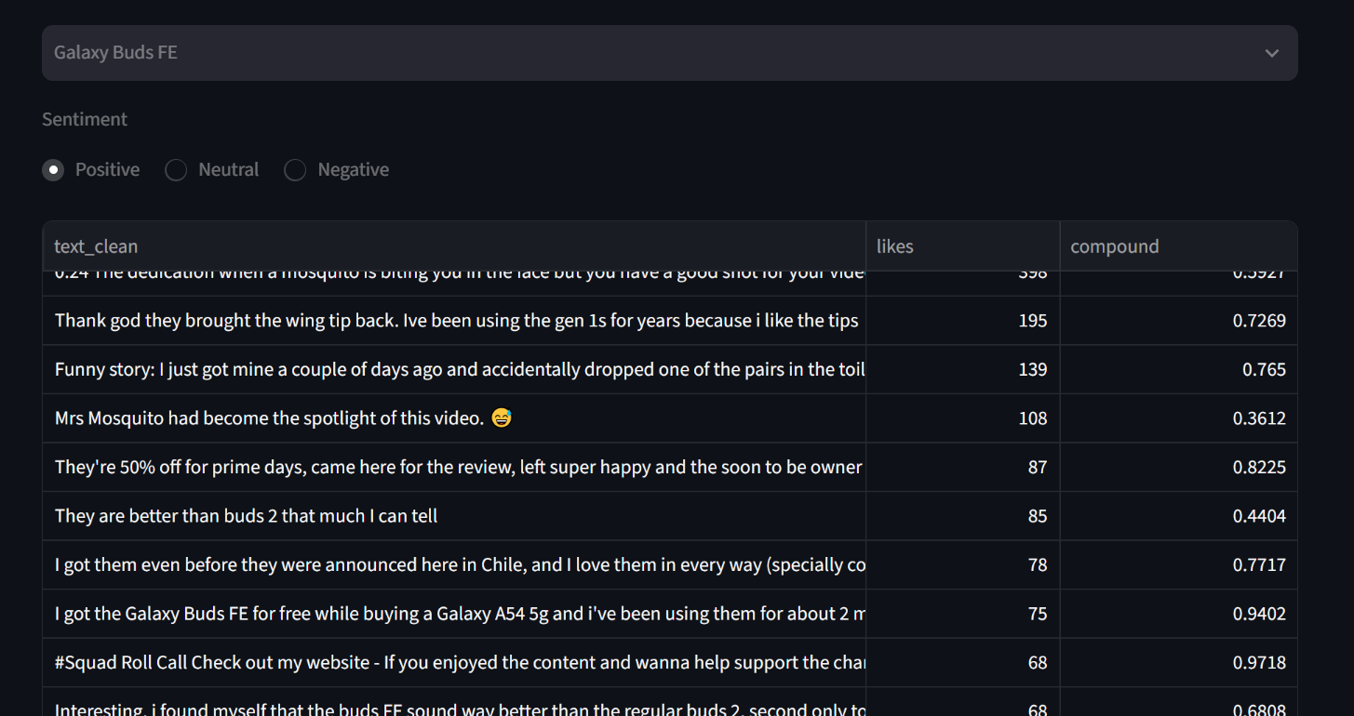
Figure 7: Comment explorer for Galaxy Buds FE (positive comments)

6. Key Findings
- All five models are viewed positively. Between 53% and 58% of comments are positive for every model.
- Galaxy Buds FE ranks first (average score 0.28) and wins five of the eight features. Galaxy Buds2 Pro ranks last (0.20).
- The differences are small. Average scores range only from 0.20 to 0.28, so the ranking shows a tendency, not a firm verdict.
- Sound quality is praised most; battery and connectivity are discussed least favourably.

7. Limitations
- Language: VADER is built for English. Comments in other languages, or Urdu written in English letters, are scored poorly.
- Sarcasm and jokes: the method reads words, not tone, so sarcasm can be scored wrongly.
- Off-topic comments: YouTube comments often react to the video or the presenter, not to the product.
- Approximate features: a feature is detected by keywords, so a sentence can be matched to the wrong feature.
- Limited sample: only people who chose to comment are included, the number of comments differs between models (476 to 703), and the small score differences were not tested statistically.

8. Conclusion
The project shows that public comments can be turned into a simple, visual comparison of earbuds. Galaxy Buds FE received the most favourable comments, Galaxy Buds3 is liked most for sound quality, and Galaxy Buds2 Pro had the most criticism, especially about connectivity. Because the differences are small, the dashboard is best used as a starting point for a buying decision, not as the final answer.
Possible improvements:
- Use a language model that understands several languages and sarcasm.
- Add more sources, such as shop and review websites, to balance the data.
- Filter out comments that are not about the product.
Project repository: https://github.com/J247coder/galaxy-buds-sentiment

