

2020 Census enterprise architecutre and infrastructure transition plan

Count everyone once in the right place



May 1, 2017

Nicholas Vilailack, Linus freeman, Junxiang Wang

George Mason University

INFS 774: Enterprise Architecture  
Professor Barry Barlow

Contents

Census Bureau Mission 2

**What Data We Collect & When** 2

**How Our Data Are Used** 3

The Summary of 2020 Census Enterprise Architecture and Infrastructure Transition Plan(CEAITP) 4

**Summary of the system view from the 2015 NCT to the 2020 Census.** 4

The System View 6

The technical view 12

Team member responsibilities 12

# Census Bureau Mission

The Census Bureau's mission is to serve as the leading source of quality data about the nation's people and economy. We honor privacy, protect confidentiality, share our expertise globally, and conduct our work openly.

We are guided on this mission by scientific objectivity, our strong and capable workforce, our devotion to research-based innovation, and our abiding commitment to our customers.

**Our Authority**

The Census Bureau operates under Title 13 and Title 26 of the U.S. Code.

**Our Goal**

Our goalis to provide the best mix of timeliness, relevancy, quality and cost for the data we collect and services we provide.

**What Data We Collect & When**

**Decennial Census of Population and Housing**

The U.S. census counts every resident in the United States. It is mandated by Article I, Section 2 of the Constitution and takes place every 10 years.

**Economic Census**

The Economic Census is the U.S. government's official five-year measure of American business and the economy.

**Census of Governments**

Identifies the scope and nature of the nation's state and local government sector including public finance and public employment and classifications.

**American Community Survey (ACS)**

The American Community Survey is the premier source for information about America's changing population, housing and workforce.

**Our Surveys & Programs**

Our surveys provide periodic and comprehensive statistics about the nation. This data is critical for government programs, policies, and decision-making.

**Economic Indicators**

The Census Bureau releases fourteen different reports on key economic indicators.

**How Our Data Are Used**

**To determine the distribution of Congressional seats to states.**

* Mandated by the U.S. Constitution
* Used to apportion seats in the U.S. House of Representatives
* Used to define legislature districts, school district assignment areas and other important functional areas

Find out about the 2020 Census Redistricting Data Program

**To make planning decisions about community services, such as where to:**

* Provide services for the elderly
* Build new roads and schools
* Locate job training centers

**To distribute more than $400 billion in federal funds to local, state and tribal governments each year.**

Census data informs how states and communities allocate funding for:

* Neighborhood improvements
* Public health
* Education
* Transportation
* Much more

**To provide Age Search information for:**

* Qualifying for Social Security and other retirement benefits
* Passport applications
* Proving relationship in settling estates
* Researching family history or a historical topic

# The Summary of 2020 Census Enterprise Architecture and Infrastructure Transition Plan(CEAITP)

**Business goals**

The (CEAITP) focuses on multi-year transition from 2015 solution architecture to the 2020 target architecture . The business goals of (CEAITP) are:

* Reengineering Address Canvassing;
* Optimizing Self-Response;
* Utilizing Administrative Records and Third-Party Data; and
* Reengineering Field Operations.

**Purposes and strategy**

The purpose of the 2020 CEAITP is to communicate and inform the transition phases to the stakeholders, to support the 2020 Operational Plan, to guarantee the safety of 2020 Census Program and to meet system requirement for scalability, reliability, and availability.

The 2020 CEAITP is incremental by nature, has detailed timelines for various architecture domains from current architecture to the target architecture and aims to maximize the utility of Enterprise standards, pattern and Programs.

# **Summary of the system view from the 2015 NCT to the 2020 Census.**

The current state (2015 NCT) is a series of tests ranging from small to medium to determine operational readiness of systems. The 2015 NCT is considered the baseline. The main focus of the 2015 NCT was to test out multiple content forms with multiple mails out strategies.

The current state application architecture is a highly complex integration of existing and new solutions having different platforms, hardware and software, multiple data sources with some manual, and little automated process. It provides a context for system development or enhancement. Applications areas within systems represent a useful subdivision of activities, services, and data that can be linked to other objects in the architecture. They are a group of activities and entity types with strong interdependencies such that a single application or more than one application can support the area. In the past applications communicated often via manual processes to manager large transfer of data. Files were transferred manually using ad-hoc transfer solutions, such as FTP.

The Target state (2020 Census)is based on a SOA paradigm where each application will provide services to the overall solution. In providing these services, these applications, can dictate development of technical enhancements and defining design patterns, APIs, Web Services, use of ESB, mobile, and cloud technologies. The ability to allow applications to use integrates enterprise data models to communicate with other systems and share data.

This modernization will consider the interoperability and interfacing elements such as data format, type, size, frequency, and performance elements such as throughput, response time, and quality of service. Future state will utilize Enterprise Integration Patterns based on API, ESB, and Managed File Transfer (MT) software to securely and efficiently share data across systems.

The target state application architecture will be a set of application areas identified to support the 2020 census. It provides a context for system development or enhancement. Application areas represent a useful subdivision of activities, services, and data that can be linked to other objects in the architecture. There will be a group of activities and entity types with strong interdependencies such that a single application or more than one application can support the area.

Target state will consist of both legacy application enhancements and new application development efforts. Projects such as CEDCap will replace multiple legacy systems used during the 2010 Census, while other legacy applications such as CIRA will remain to support the 2020 Census.

# The System View

Current State System Architecture 2015

The current state application architecture is a highly complex integration of existing and new solutions having different platforms, hardware and software, multiple data sources with some manual, and little automated process. It provides a context for system development or enhancement. Applications areas within systems represent a useful subdivision of activities, services, and data that can be linked to other objects in the architecture. They are a group of activities and entity types with strong interdependencies such that a single application or more than one application can support the area. In the past applications communicated often via manual processes to manager large transfer of data. Files were transferred manually using ad-hoc transfer solutions, such as FTP.

Figure 4-2 shows how outputs from some systems feed into other systems via arrows.

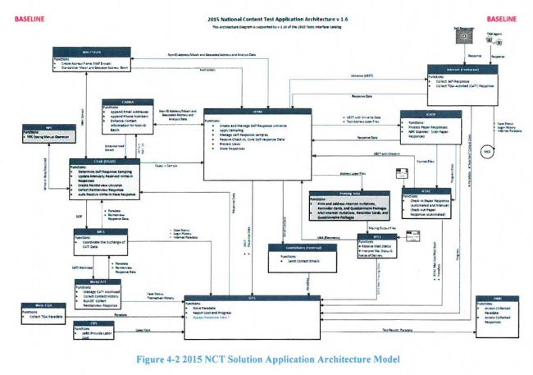

Target State System Architecture 2020

Based on a SOA paradigm where each application will provide services to the overall solution. In providing these services, these applications, can dictate development of technical enhancements and defining design patterns, APIs, Web Services, use of ESB, mobile, and cloud technologies. The ability to allow applications to use integrates enterprise data models to communicate with other systems and share data.

This modernization will consider the interoperability and interfacing elements such as data format, type, size, frequency, and performance elements such as throughput, response time, and quality of service. Future state will utilize Enterprise Integration Patterns based on API, ESB, and Managed File Transfer (MT) software to securely and efficiently share data across systems.

The target state application architecture will be a set of application areas identified to support the 2020 census. It provides a context for system development or enhancement. Application areas represent a useful subdivision of activities, services, and data that can be linked to other objects in the architecture. There will be a group of activities and entity types with strong interdependencies such that a single application or more than one application can support the area.

Target state will consist of both legacy application enhancements and new application development efforts. Projects such as CEDCap will replace multiple legacy systems used during the 2010 Census, while other legacy applications such as CIRA will remain to support the 2020 Census.   
  
Figure 5-4 shows how multiple systems will interact with both the legacy and new systems.

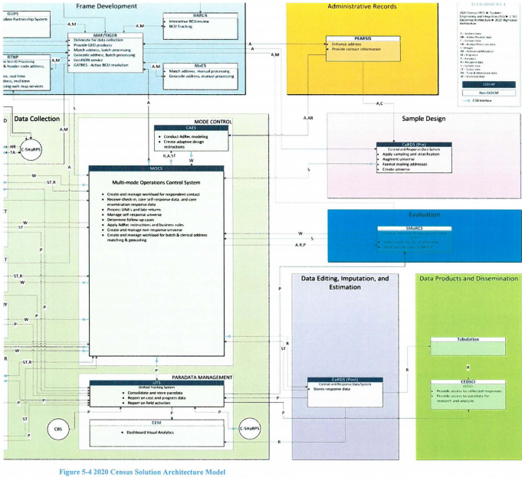

The Census System architecture view from 2015 to 2020 has several tests from current to target state.

2015 National Content Test (NCT)

The 2015 NCT evaluated and compared different census questionnaire content. The main focus was to test out multiple content forms with multiple mails out strategies.

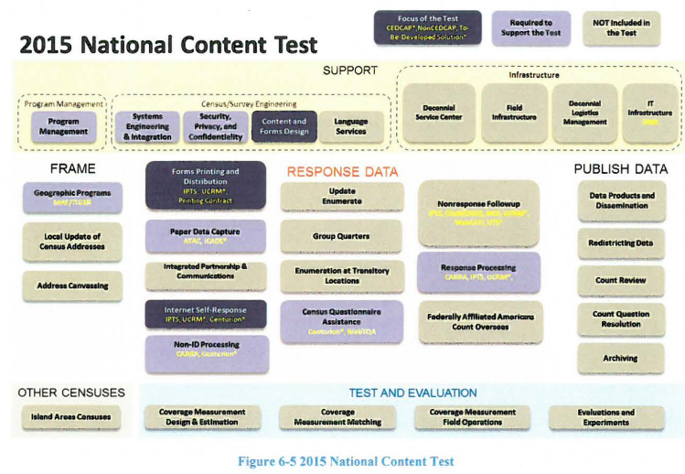

The 2016 National Census Test

Is designed to build on the 2015 NCT and introduce new systems and capabilities into the operational suite. The 2016 test focuses on the integration of self-response and Nonresponse followup operations. The introducing of CEDCap is meant to help with the self-response portion.

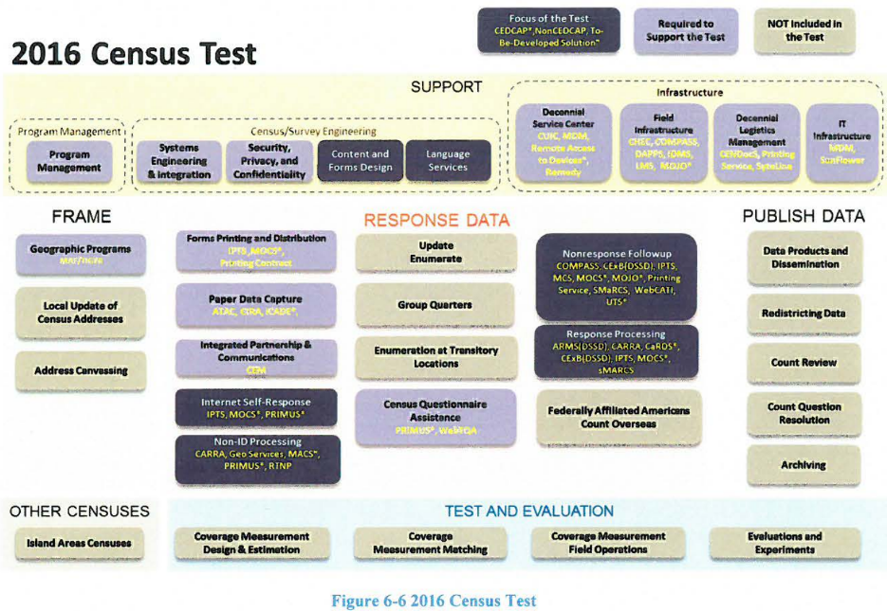

The 2017 Census Test and Address Canvassing (AdCan) Test

In 2017 the Census Bureau starts using the address canvassing (AdCan) test. The AdCan test is designed specifically to exercise new features to allow the Census Bureau to add new addresses to the existing address framework by using geographic information systems, aerial imagery and other data sources instead of sending Census Bureau employees to walk and physically check 11 million census blocks.

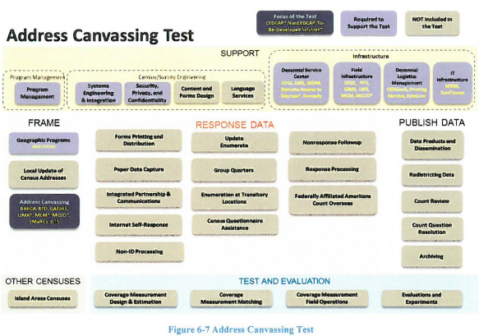

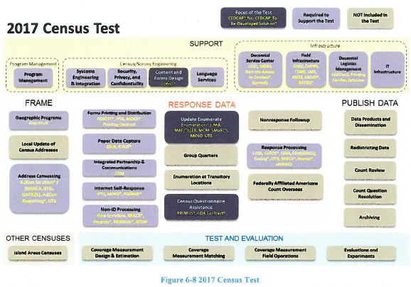

The 2018 End-to-End Census Test

The 2018 test is designed to be a large scale test for the 2020 Census. The intent is to fully exercise all major operations and systems in preparation for the Decennials counts. The goal is to have operational designs ready for production especially from a systems perspective.

The 2018 test is intended to mirror what will happen for 2020. The actual amount of data collected will not be as much as the 2020 census but false data will be used for stress testing. One of the main goals of the 2018 test is to automate some of the systems that were heavily manual in 2010 using the Coverage Measurement System. The Coverage Measurement system will take advantage of the centralized person-matching system that will be created for the 2020 Census efforts.

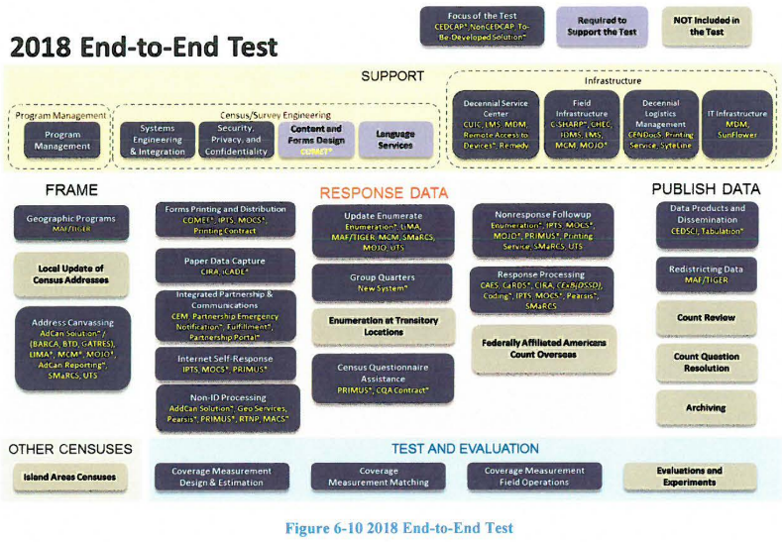

The 2019 Testing

There will be two types of testing for 2019. Defect resolution testing and Post End-to-End performance testing. The defect resolution testing will make sure that any changes made to fix defects from the 2018 test are resolved for the 2020 test. The Post end to end test will ensure that the solution as a whole is satisfied scalability, availability, and reliability.

The 2020 Decennial Census

The 2020 Census will be the actual census conducted to meet the constitutional requirement of determining the United States population every 10 years. The 2020 census will take lessons learned from the past 5 years and hopefully incorporate those into a successful census. That will make best use of resources used, time spent, and overall quality of data.

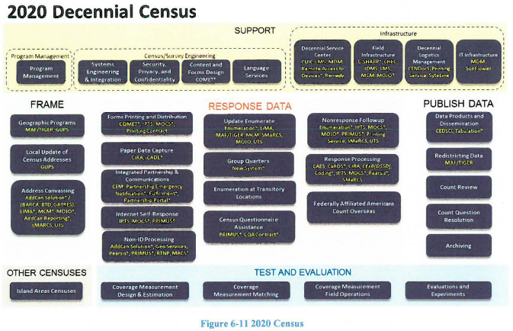

Main systems to be used:

Unified tracking system-Is an existing application used by Field ROs and Headquarters survey managers. The UTS will require changes to the existing interfaces, the ability to generate new reports, change old reports, in order to support the address canvassing operating.

Operational control system-will be used to manage the in-field address canvassing with the ability to create list crews of workers, make assignments, and generate reports both daily and in near real time.

Lima-part of CEDCAP program-Intially built for laptop but will be introduced on a handeld for mobility. Lima captures the GQ data for AdCan test that has not previously been captured.

National Finance Center- will perform payroll/personnel functions for field staff.

MCM-part of CEDCAP program-will be used for mobile case management.

SMaRCS-Based on the MaRCS 2010 system, performs re-interview QC sample selection and re-interview case matching to detect false data.

CARRA-Will be used to support administrative records for modeling and optimizing NRFU workload operations.

CEM-Will be used for data analytics, reporting customer exeriences, and importing response data from the old CaRDs system.

MaCs-Will be introduced to support manual matching and address geocoding of Non-ID cases.

# The technical view

**Scalability**

**Availability**

**Reliability**

**Resilience**

**Security**

# Team member responsibilities

|  |  |
| --- | --- |
| Team Member | Assignment(s) |
| Linus Freeman | EA Framework Selection and Customization  Enterprise Architecture Business View |
| Nicholas Vilailack | Enterprise Architecture System View Project Report Overview |
| Junxiang Wang | Enterprise Architecture Technical View  EA Framework Overview |

Appendices

Bureau, US Census. "What We Do." What We Do. N.p., 30 Jan. 2017. Web. 06 Apr. 2017.