TRACEVEIL

Project Completion Report
Delivery status, system capabilities, verification and remaining acceptance
93.8%  Roadmap complete | 165 / 176  Items implemented | 11  Hardware checks pending

Prepared 25 September 2026
Repository baseline: main at 40627d2 | PR #30
Prepared for project review and academic submission.

Executive Summary
Traceveil has delivered the planned software platform for evidence intake, deterministic investigation, live event delivery and reporting. At the 25 September 2026 repository snapshot, 165 of 176 roadmap items are implemented and verified (93.8%). The remaining 11 items require a physical demonstration and hardware acceptance. A compile-checked ESP32/DHT22 reference sketch now supports that next stage, but it does not replace on-device verification.
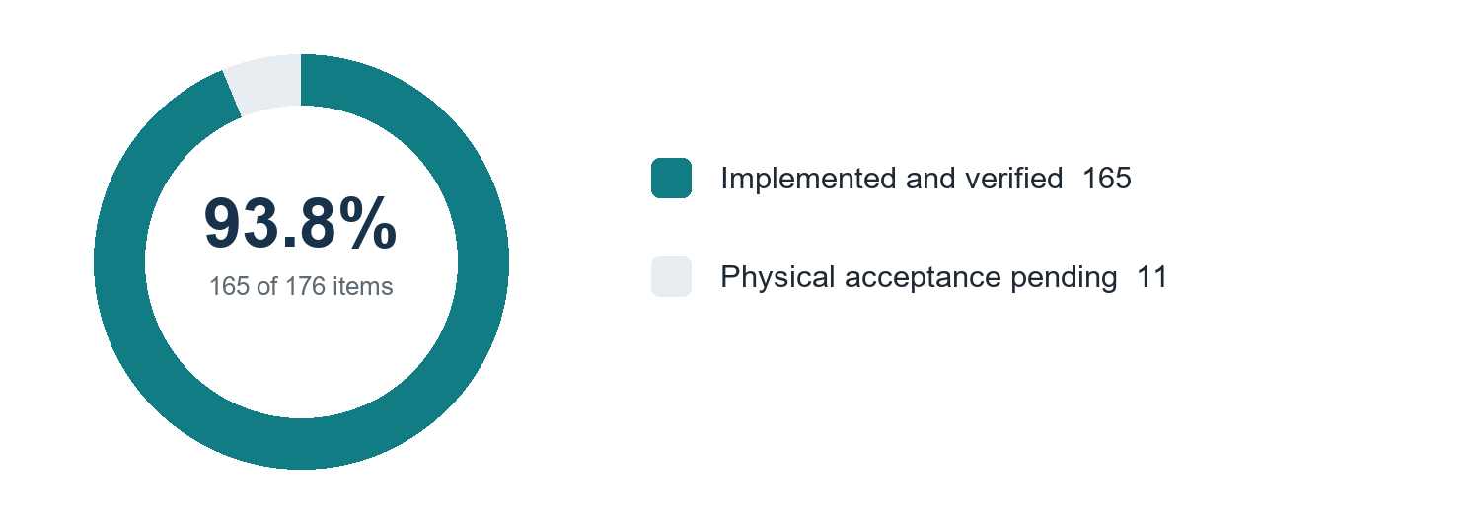
Figure 1. Roadmap completion at the current repository snapshot.

Project outcome
The delivered software connects batch evidence and authenticated live telemetry to a shared canonical event model and deterministic analysis pipeline. Investigators can review persisted findings through the connected interface, follow live updates, ask bounded evidence-grounded questions, and prepare reports and notification drafts subject to investigator approval.

What this report covers
- System scope and the path from source evidence to investigation results.
- Delivery status across the roadmap and the capabilities now available.
- Verification evidence recorded in the project documentation.
- The remaining physical demonstration checks and their acceptance boundary.

System Overview
Traceveil brings imported datasets and live device telemetry into one evidence workflow. Input is validated and normalized before analysis. The interface reads persisted, backend-authored results; the optional local language model can explain validated findings but does not create the underlying analytical evidence.
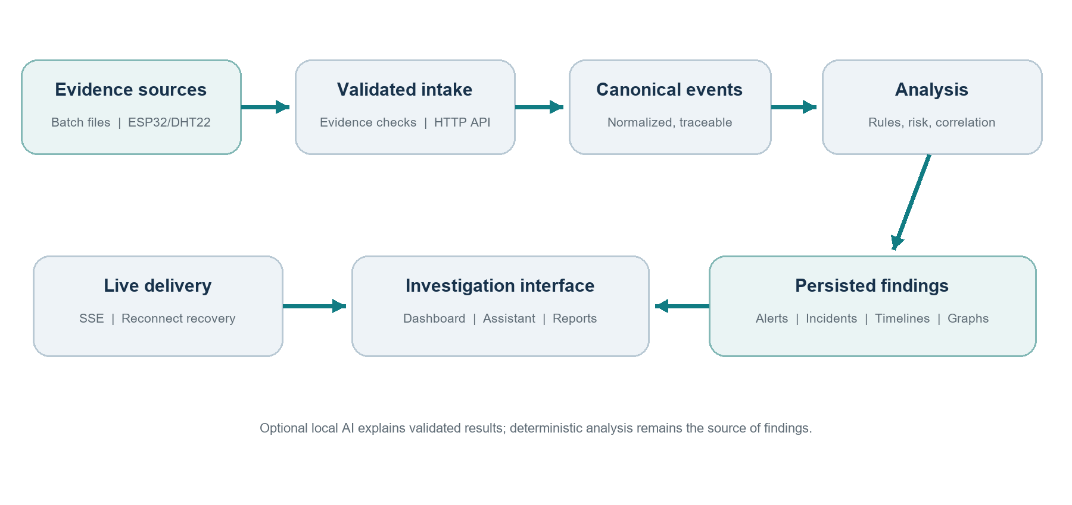
Figure 2. Traceveil evidence and investigation flow.

Core workflow
Evidence intake Batch files and authenticated live HTTP events enter through validation contracts that preserve source and device provenance.
Canonicalization Accepted records are mapped into a common event model with normalized timestamps, identities and source references.
Deterministic analysis Rules, behavioural baselines, bounded risk scoring and event correlation produce reproducible findings and investigation artifacts.
Investigation and response APIs and server-sent events deliver persisted events, alerts, incidents, timelines and visual data to the interface. Reporting and notification workflows retain investigator approval and audit history.

Current device reference
PR #30 adds an example one-sensor ESP32/DHT22 HTTP telemetry sketch, configurable example settings, and wiring/setup instructions under hardware/esp32/traceveil_dht22. The CI workflow compiles the sketch using the checked-in configuration. Physical sensor connectivity and end-to-end demonstration results remain unverified.

Delivery Status
Software delivery is complete through Steps 1–11 and Step 13. Step 12 is reserved for the physical live demonstration. The roadmap visual summarizes the status by step; the item-level checklist remains the controlling record for acceptance.

Figure 3. Roadmap stage status. Step 12 remains open pending physical acceptance.

Delivered capabilities
Area | Delivered scope
Evidence and data | Validated uploads, source provenance, canonical event normalization, curated dataset samples and checksums.
Analysis | Deterministic detection and correlation, explainable risk factors, bounded incidents, timelines, entity relationships and chart-ready results.
Live operation | Authenticated HTTP telemetry intake, device registration and heartbeat state, SSE delivery, replay and safe reconnect recovery.
Investigation interface | Case workspaces, historical analysis snapshots, paged timelines, evidence-linked visualizations and persisted investigation chat.
Governance and reporting | Deterministic incident summaries, report export, approval-gated notification drafts, and auditable delivery outcomes.

Evaluation data represented
The documented evaluation set includes HAI industrial telemetry, IoT-23 network flows, TON_IoT refrigerator readings, CASAS Milan smart-home events and controlled simulation samples. The repository catalog records sample checksums and describes represented devices and source types. Full dataset archives are not required for the curated demonstration samples.

Verification and Acceptance
The completion records document software regression and integration checks for the implemented workflows. These results support the software completion status; they are distinct from the pending physical hardware acceptance.
Evidence area | Recorded result
Backend | The Steps 7 and 11 completion run recorded 243 backend tests passing with a clean process exit.
Frontend | The same completion record reports 143 frontend tests passing.
Contracts and build | OpenAPI contract verification, TypeScript type-checking and the production build passed in that run.
Device firmware | PR #30 adds a CI compile check for the ESP32/DHT22 reference sketch and its example configuration.
Physical setup | No physical device demonstration is claimed by the current documentation snapshot.

Remaining Physical Acceptance
The following 11 checks remain open in the roadmap. They should be recorded as complete only after the laboratory setup is exercised and the resulting evidence is captured.
- Assemble the Arduino and IoT laboratory setup.
- Verify normal device telemetry.
- Verify live dashboard updates.
- Execute a controlled simulated suspicious scenario.
- Confirm the detection rule triggers.
- Confirm a live alert appears.
- Confirm the event is persisted as evidence.
- Confirm the incident timeline updates.
- Confirm device/entity relationships are visible.
- Confirm the captured incident can be investigated after the live event.
- Document the complete demonstration procedure.

Submission conclusion
The software platform is substantially complete and its connected workflows are documented as passing their recorded regression and integration gates. The project is ready to proceed to a controlled physical demonstration using the new ESP32/DHT22 reference firmware. Final completion of the roadmap depends on collecting evidence for the 11 physical acceptance checks above.

Project Records
The report status is aligned to main commit 40627d2, which merged PR #30 on 25 September 2026. The following repository records provide implementation detail and verification context:
- docs/roadmap.md — roadmap status and item-level completion checklist.
- docs/Completion_Report_2026-09-06.md — consolidated completion and verification record.
- docs/Contributions.md — repository contribution record (not reproduced in this report).
- docs/step-5-live-iot.md and docs/step-5-testing.md — live telemetry implementation and testing guidance.
- hardware/esp32/traceveil_dht22/README.md — ESP32/DHT22 wiring, configuration and setup instructions.
- .github/workflows/step5-integration.yml — CI integration workflow, including ESP32 sketch compilation.
Repository: Traceveil | Branch: main | Snapshot: 40627d2

