**Date: 10/10/2018**

Location: on the Wednesday class, Eaton Hall room 2

Members: Jielong Cong Jason Purinton Jacob Parnell

Description:

* Decide make the baseball board game on the webpage.
* Using Javascript and html.

(All together)

**Date: 10/10/2018**

Location: Eaton Hall fish bowl

Members: Jielong Cong Jacob Parnell

Description:

* Rough state diagram and list of task.

(Jielong & Jacob)

**Date: 10/11/2018**

Location: Eaton Hall fish bowl

Members: JasonPurinton Jacob Parnell

Description:

* Discussed individual tasks.
* Jacob on Game class
* Jason on Player classes

(Jason & Jacob)

**Date: 10/17/2018**

Location:  on the Wednesday class, Eaton Hall room 2

Members: Jielong Cong Jason Purinton Jacob Parnell

Description:

* Discussed how each class interact with each others.

(All together)

**Date: 10/17/2018**

Location:  Sphar library, room 1322.

Members: Jielong Cong Jason Purinton Jacob Parnell

Description:

* Working on the Team.js & all Player classes. (Jason)
* Working on Game.js. (Jacob)
* Working on main.js and html files (Jielong)

**Date: 10/19/2018**

Location:  on the Friday class, Eaton Hall room 2

Members: Jielong Cong Jason Purinton Jacob Parnell

Description:

* Do some documentation. (All together)

**Date: 10/19/2018**

Location:   Eaton Hall fish bowl

Members: Jielong Cong Jason Purinton Jacob Parnell

Description:

* Worked on prototype (Jielong, help from Jason & Jacob)
* Worked on diagrams (Jason & Jacob)

**List of Task:**

1, Player class: (Jason)

* Player attributes
* Pitcher, Position Player: Infielder, outfielder, catcher.

2, Team class: (Jason)

* Build Array to hold 9 players.
* Method of batter action: Do nothing(if you think the pitcher gives a “ball”), swing, bunt.

3, Game class: (Jacob)

* Determines the outcome each pitch.
* Keep track of inning, outs, balls, strikes, runner position, score of each team.
* Implement the Indicator of the original board game.

4, User interface: (Jielong)

* Main class, HTML
* Player interface: 3 views shows below.
* Draw the pixel image.
* Scoreboard on the side.
* Game log on the bottom.
* Multiplayer Interface (Jacob)
* Handle what gets displayed for both users and getting data from both

5, Database: (Jacob)

* Using Mongodb to store player information: team array, score they had.
* Waiting for make the game as multiplayer game.

6, Documentation:

* Team log (Jielong)
* Write up (Jason)
* Case diagram (Jason)
* State diagram, rough draft (Jielong & Jacob)
* Digital state diagram (Jason)
* Class flow diagram, rough draft (Jielong & Jacob)
* Digital class flow diagram. (Jason)
* Use Case Diagram (Jason, input from Jacob and Jielong)
* UML (All)
* Gantt Chart. (Jacob)

7, Team meeting origination and scheduling: (Jason)

* Reserve meeting rooms

User Interface:

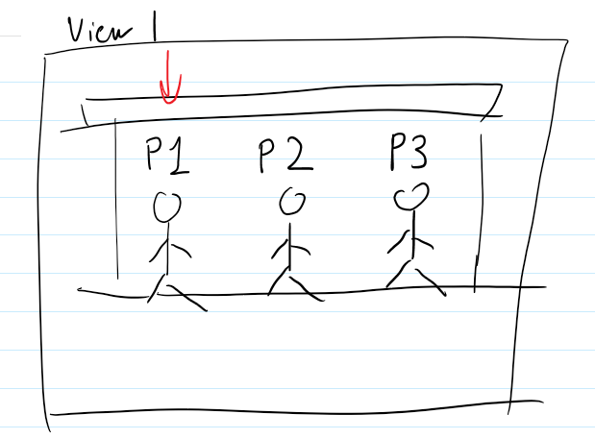Select team member

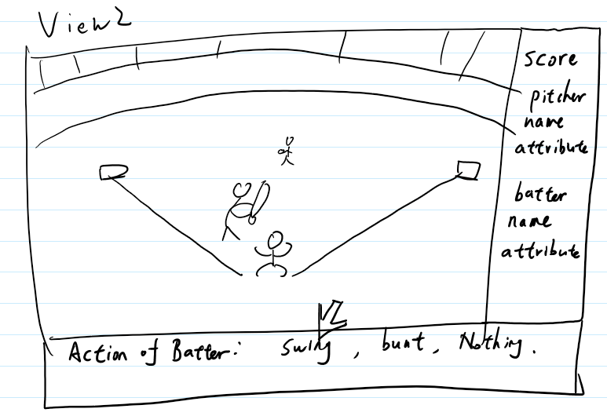During the pitch

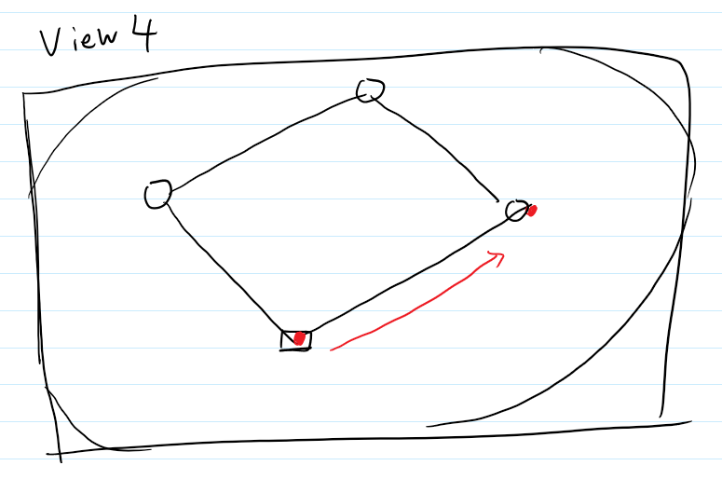The runner goes.

State Diagram

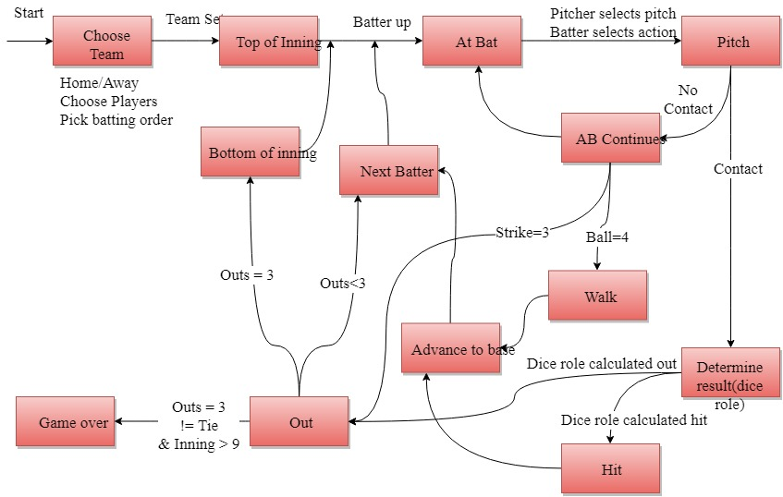

Class Diagram

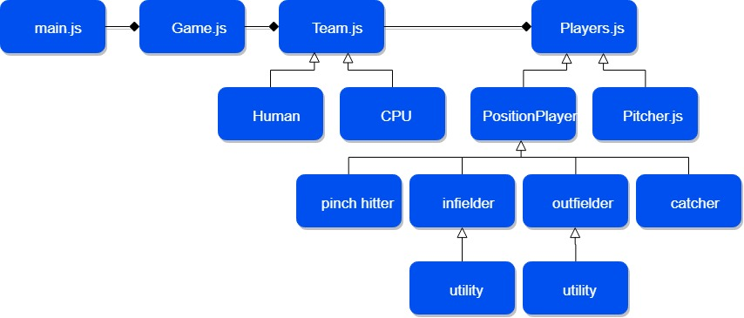

Use Case Diagram

