**Date: 10/10/2018**

Location: on the Wednesday class, Eaton Hall room 2

Members: Jielong Cong Jason Purinton Jacob Parnell

Description:

* Decide make the baseball board game on the webpage.
* Using Javascript and html.

(All together)

**Date: 10/10/2018**

Location: Eaton Hall fish bowl

Members: Jielong Cong Jacob Parnell

Description:

* Rough state diagram and list of task.

(Jielong & Jacob)

**Date: 10/11/2018**

Location: Eaton Hall fish bowl

Members: JasonPurinton Jacob Parnell

Description:

* Discussed individual tasks.
* Jacob on Game class
* Jason on Player classes

(Jason & Jacob)

**Date: 10/17/2018**

Location:  on the Wednesday class, Eaton Hall room 2

Members: Jielong Cong Jason Purinton Jacob Parnell

Description:

* Discussed how each class interact with each others.

(All together)

**Date: 10/17/2018**

Location:  Sphar library, room 1322.

Members: Jielong Cong Jason Purinton Jacob Parnell

Description:

* Working on the Team.js & all Player classes. (Jason)
* Working on Game.js. (Jacob)
* Working on main.js and html files (Jielong)

**Date: 10/19/2018**

Location:  In the Friday class, Eaton Hall room 2

Members: Jielong Cong Jason Purinton Jacob Parnell

Description:

* Do some documentation. (All together)

**Date: 10/19/2018**

Location:   Eaton Hall fish bowl

Members: Jielong Cong Jason Purinton Jacob Parnell

Description:

* Worked on prototype (Jielong, help from Jason & Jacob)
* Worked on diagrams (Jason & Jacob)

Project 4:

**Date: 10/24/2018**

Location:   Sphar library, room 1324.

Members: Jielong Cong Jason Purinton Jacob Parnell

Description:

* Determined new task list for everyone (All together)
* User Interface and advanced game logic (Jacob)
* Sound effect and advanced team class (Jason)
* Graphic and animation (Jielong)

Project 4:

**Date: 10/26/2018**

Location:   Eaton Hall fish bowl

Members: Jielong Cong Jacob Parnell

Description:

* Debugging and discussion of project. (Jielong & Jacob)

Project 4:

**Date: 10/29/2018**

Location:  on the Monday class, Eaton Hall room 2.

Members: Jason Purinton Jacob Parnell

Description:

* Debugging and discussion of project. (Jason & Jacob)

Project 4:

**Date: 10/31/2018**

Location:   Sphar library, room 1324.

Members: Jielong Cong Jason Purinton Jacob Parnell

Description:

* Debugging and discussion of project. (All together)

Project 4:

**Date: 11/2/2018**

Location:   In the Monday class, Eaton Hall room 2

Members: Jielong Cong Jason Purinton Jacob Parnell

Description:

* Debugging and discussion of project. (All together)

Project 4:

**Date: 11/7/2018**

Location:   In the Wednesday class, Eaton Hall room 2

Members: Jielong Cong Jason Purinton Jacob Parnell

Description:

* Debugging and discussion of project. (All together)

Project 4:

**Date: 11/9/2018**

Location:   Eaton Hall fish bowl

Members: Jielong Cong Jason Purinton Jacob Parnell

Description:

* Debugging and discussion of project. (All together)

Project 4:

**Date: 11/14/2018**

Location:   Eaton Hall fish bowl

Members: Jielong Cong Jason Purinton Jacob Parnell

Description:

* Debugging and discussion of project. (All together)

Project 4:

**Date: 11/16/2018**

Location:   In the Friday class, Eaton Hall room 2

Members: Jielong Cong Jason Purinton Jacob Parnell

Description:

* Implementing interface (Jacob, Jielong)

Project 4:

**Date: 11/19/2018**

Location:   Eaton Hall fish bowl

Members: Jielong Cong Jason Purinton Jacob Parnell

Description:

* Debugging issues and finishing plan. (All together)

Project 4:

**Date: 11/25/2018**

Location:   Group phone meeting

Members: Jielong Cong Jason Purinton Jacob Parnell

Description:

* Debug and help each other to place objects. (All together)

**List of Task:**

1 Player class: (Jason)

* Player attributes
* Pitcher, Position Player: Infielder, outfielder, catcher.

2 Team class: (Jason, Jacob)

* Build Array to hold 9 players.
* Method of batter action: Do nothing (if you think the pitcher gives a “ball”), swing, bunt.

3 Game class: (Jacob, Jielong, Jason)

* Determines the outcome each pitch.
* Keep track of inning, outs, balls, strikes, runner position, score of each team.
* Implement the Indicator of the original board game.
* Sound effects

4 Animation: (Jielong)

* Draw each frame of action by Aseprite.
* Build a new Animation files.
* Write JavaScript functions to draw animation on the screen.
* Arrange the animation order and trigger by the buttons.

5 User interfaces: (Jielong, Jacob)

* Main class, HTML
* Player interface: 3 views shows below.
* Draw the pixel image.
* Scoreboard on the side.
* Game log on the bottom.
* Multiplayer Interface
* Handle what gets displayed for both users and getting data from both

6 Sound effects: (Jason)

* Find copyright free baseball sounds
* Clip and mix sound effects
* Write sound functions throughout the program

7 Documentation:

* Team log (Jielong, Jason)
* Write up (Jason)
* Case diagram (Jason)
* State diagram, rough draft (Jielong & Jacob)
* Digital state diagram (Jason)
* Class flow diagram, rough draft (Jielong & Jacob)
* Digital class flow diagram. (Jason)
* Use Case Diagram (Jason, input from Jacob and Jielong)
* UML (All)
* Gantt Chart. (Jacob)
* Bug list (Jason, Jacob, Jielong)
* User Manual (Jacob)
* Deployment Plan
* Maintenance plan (Jielong)

8 Team meeting origination and scheduling: (Jason)

* Schedule and reserve meeting rooms

Example from project2

**Challenges:**

1. Finding copywrite free baseball sounds was a hug task. I had to use multiple smaller clips and mix them together in order to produce one large clip.

2. First time drawing picture. Didn’t make canvas frame animation before. It took plenty of time to find the examples and tutorials. Not very familiar with HTML and JavaScript.

3.

4.

**Retrospective on what the team would have done different.**

* Had a functioning display earlier to spend more time debugging.
* Had more animation category, and more different views for player.
* Had a better user interface.

State Diagram

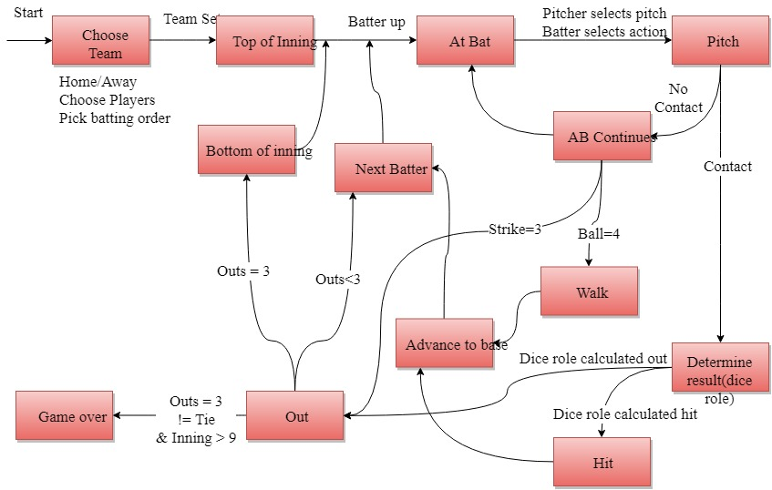

Class Diagram

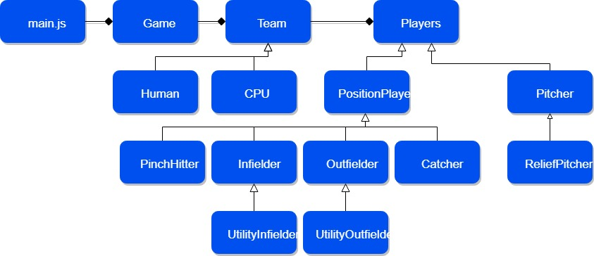

Use Case Diagram

