**Date: 10/10/2018**

Location: on the Wednesday class, Eaton Hall room 2

Members: Jielong Cong Jason Purinton Jacob Parnell

Description:

* Decide make the baseball board game on the webpage.
* Using Javascript and html.

(All together)

**Date: 10/10/2018**

Location: Eaton Hall fish bowl

Members: Jielong Cong Jacob Parnell

Description:

* Rough state diagram and list of task.

(Jielong & Jacob)

**Date: 10/11/2018**

Location: Eaton Hall fish bowl

Members: JasonPurinton Jacob Parnell

Description:

* Discussed individual tasks.
* Jacob on Game class
* Jason on Player classes

(Jason & Jacob)

**Date: 10/17/2018**

Location:  on the Wednesday class, Eaton Hall room 2

Members: Jielong Cong Jason Purinton Jacob Parnell

Description:

* Discussed how each class interact with each others.

(All together)

**Date: 10/17/2018**

Location:  Sphar library, room 1322.

Members: Jielong Cong Jason Purinton Jacob Parnell

Description:

* Working on the Team.js & all Player classes. (Jason)
* Working on Game.js. (Jacob)
* Working on main.js and html files (Jielong)

**Date: 10/19/2018**

Location:  In the Friday class, Eaton Hall room 2

Members: Jielong Cong Jason Purinton Jacob Parnell

Description:

* Do some documentation. (All together)

**Date: 10/19/2018**

Location:   Eaton Hall fish bowl

Members: Jielong Cong Jason Purinton Jacob Parnell

Description:

* Worked on prototype (Jielong, help from Jason & Jacob)
* Worked on diagrams (Jason & Jacob)

Project 4:

**Date: 10/24/2018**

Location:   Sphar library, room 1324.

Members: Jielong Cong Jason Purinton Jacob Parnell

Description:

* Determined new task list for everyone (All together)
* User Interface and advanced game logic (Jacob)
* Sound effect and advanced team class (Jason)
* Graphic and animation (Jielong)

Project 4:

**Date: 10/26/2018**

Location:   Eaton Hall fish bowl

Members: Jielong Cong Jacob Parnell

Description:

* Debugging and discussion of project. (Jielong & Jacob)

Project 4:

**Date: 10/29/2018**

Location:  on the Monday class, Eaton Hall room 2.

Members: Jason Purinton Jacob Parnell

Description:

* Debugging and discussion of project. (Jason & Jacob)

Project 4:

**Date: 10/31/2018**

Location:   Sphar library, room 1324.

Members: Jielong Cong Jason Purinton Jacob Parnell

Description:

* Debugging and discussion of project. (All together)

Project 4:

**Date: 11/2/2018**

Location:   In the Monday class, Eaton Hall room 2

Members: Jielong Cong Jason Purinton Jacob Parnell

Description:

* Debugging and discussion of project. (All together)

Project 4:

**Date: 11/7/2018**

Location:   In the Wednesday class, Eaton Hall room 2

Members: Jielong Cong Jason Purinton Jacob Parnell

Description:

* Debugging and discussion of project. (All together)

Project 4:

**Date: 11/9/2018**

Location:   Eaton Hall fish bowl

Members: Jielong Cong Jason Purinton Jacob Parnell

Description:

* Debugging and discussion of project. (All together)

Project 4:

**Date: 11/14/2018**

Location:   Eaton Hall fish bowl

Members: Jielong Cong Jason Purinton Jacob Parnell

Description:

* Debugging and discussion of project. (All together)

Project 4:

**Date: 11/16/2018**

Location:   In the Friday class, Eaton Hall room 2

Members: Jielong Cong Jason Purinton Jacob Parnell

Description:

* Implementing interface (Jacob, Jielong)

Project 4:

**Date: 11/19/2018**

Location:   Eaton Hall fish bowl

Members: Jielong Cong Jason Purinton Jacob Parnell

Description:

* Debugging issues and finishing plan. (All together)

Project 4:

**Date: 11/25/2018**

Location:   Group phone meeting

Members: Jielong Cong Jason Purinton Jacob Parnell

Description:

* Debug and help each other to place objects. (All together)

**List of Task:**

1 Player class: (Jason)

* Player attributes
* Pitcher, Position Player: Infielder, outfielder, catcher.

2 Team class: (Jason, Jacob)

* Build Array to hold 9 players.
* Method of batter action: Do nothing (if you think the pitcher gives a “ball”), swing, bunt.

3 Game class: (Jacob, Jielong, Jason)

* Determines the outcome each pitch.
* Keep track of inning, outs, balls, strikes, runner position, score of each team.
* Implement the Indicator of the original board game.
* Sound effects

4 Animation: (Jielong)

5 User interfaces: (Jielong, Jacob)

* Main class, HTML
* Player interface: 3 views shows below.
* Draw the pixel image.
* Scoreboard on the side.
* Game log on the bottom.
* Multiplayer Interface
* Handle what gets displayed for both users and getting data from both

6 Sound effects: (Jason)

* Find copyright free baseball sounds
* Clip and mix sound effects
* Write sound functions throughout the program

7 Documentation:

* Team log (Jielong, Jason)
* Write up (Jason)
* Case diagram (Jason)
* State diagram, rough draft (Jielong & Jacob)
* Digital state diagram (Jason)
* Class flow diagram, rough draft (Jielong & Jacob)
* Digital class flow diagram. (Jason)
* Use Case Diagram (Jason, input from Jacob and Jielong)
* UML (All)
* Gantt Chart. (Jacob)
* Bug list (Jason, Jacob, Jielong)
* User Manual (Jacob)
* Deployment Plan
* Maintenance plan (Jielong)

8 Team meeting origination and scheduling: (Jason)

* Schedule and reserve meeting rooms

Example from project2

**Challenges:**

1. Finding copywrite free baseball sounds was a hug task. I had to use multiple smaller clips and mix them together in order to produce one large clip.

2.

3.

4.

**Retrospective on what the team would have done different.**

Had a functioning display earlier to spend more time debugging.

State Diagram

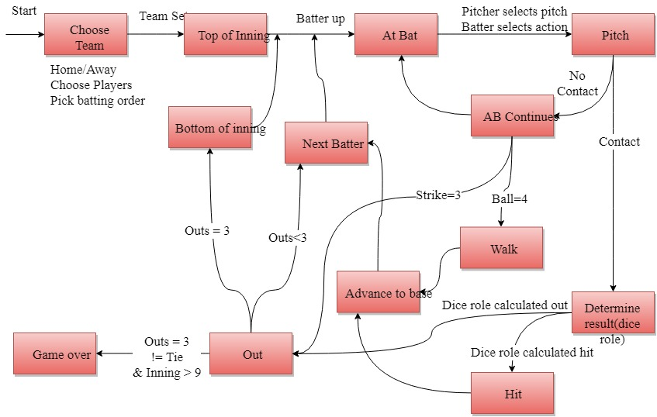

Class Diagram

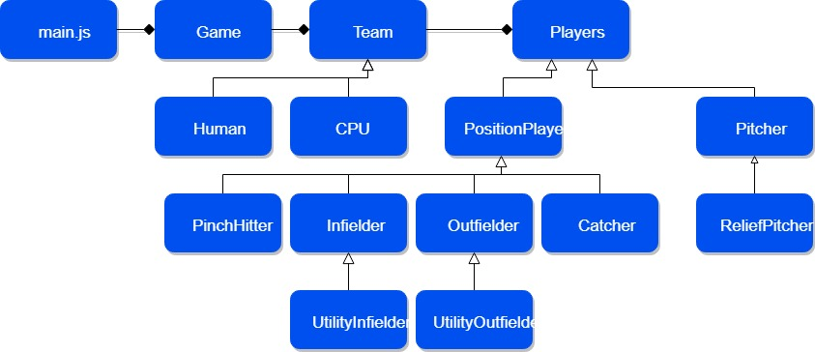

Use Case Diagram

