Web Architecture

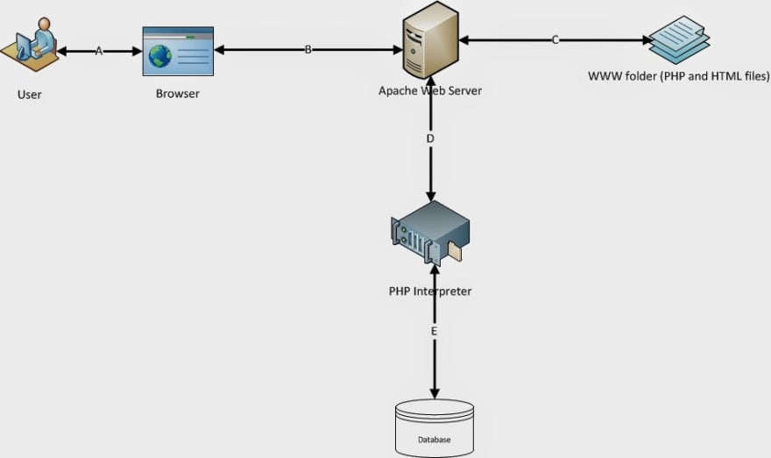

The numbers used below beside the Label names following 1 for Request flow and 2 for response flow.

* A1: First user accessed the website through browser. That means user types the URL of the website in browser and hit go.
* B1: The page request on browser will reach to the Web Server (Apache).
* C: Web server will collect that requested page (HTML or PHP or Image file etc) from its document root. (In our example it will be www folder in WAMP. You will see it in next one)
* B2: Now if it is a static element like HTML, CSS , image file or Java Script file then Apache will send it directly to browser.
* A2: And Browser will render it to user on screen
* D1: If it is a PHP file then Apache sends the content of the file to PHP Interpreter. PHP interpreter interprets the PHP code and executes it. if DB operation is required it performs the same (E)
* D2: PHP Interpreter generates output (if the PHP code is to generate any output) and sends to Apache
* B2: Apache sends that content to browser
* A2: Browser renders it to users' screen All static components like HTML, CSS files, Image Files, Java Scripts etc doesn't need interpreter. Our web browsers are built to render them and display on screen properly. That is why if user requests for these kind of components Apache collects them from Document root and sends back to Browser directly.