Climate Change

And How It Could Affect The World’s Economy

Jesse Dachyshyn

Contents

Introduction 2

Industrial Areas Affected By Climate Change 3

The Paris Agreement 4

Conclusion 5

Figure 1 Some cows 2

Table 1 The Paris Agreement 4

# Introduction

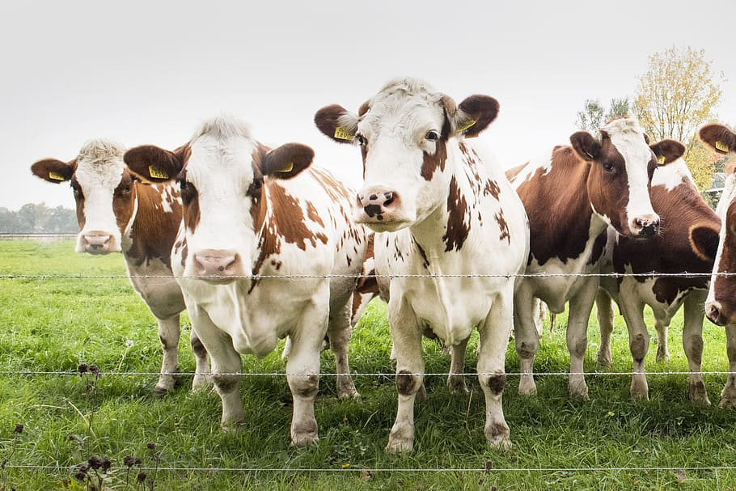

Figure 1 Some cows

Climate change is what happens when average weather patterns change over a long period of time. These can be brought about by the burning of fossil fuels, which increase the greenhouse gases in Earth’s atmosphere. This buildup of greenhouse gases increases the overall temperature of the Earth. Although there are other contributing factors of a more natural type, such as volcanic activity and ocean weather patterns such as El Nino, all of these factors work together to threaten the world’s economy. What areas of our economy on this planet will be affected by climate change?

*“Climate change is a long-term change in the average weather patterns that have come to define Earth’s local, regional and global climates. These changes have a broad range of observed effects that are synonymous with the term.”[1]*

# Industrial Areas Affected By Climate Change

There are several areas that could be affected by climate change if the overall temperature of the Earth continues its steady upward climb:

1. Tourism
2. Infrastructure
3. Human health and productivity
4. Agriculture

Tourism can be affected by warmer temperatures, which will result in an increase in melting snow and ice. This can be disastrous in regions where winter sports are big business, like the Adirondack Mountains.

*“Two billion dollars could be lost in winter recreation due to less snow and ice. For example, rapid warming in the Adirondack Mountains could decimate the winter activity sector, which makes up 30 percent of the local economy.”[2]*

Another problem caused by the excessive heat would be more algae in the water, which would have an adverse effect on fishing and other water sports.

Infrastructure is at risk from flooding due to a rise in sea level. This would include houses, docks, railway systems, airports and a host of other buildings. Military installations are also in danger of being flooded (especially if they are located near rivers). Extreme weather would mean more repairs for roads, runways, buildings and equipment.

Communications is another area that would suffer irreparable losses due to extreme weather. This would include 4,000 miles of fiber optic cable, data centers, traffic exchanges and termination points. And if the Internet infrastructure takes any damages, the repercussions for US businesses could be impossible to estimate.

Human health and productivity could be impacted in several areas, including deaths from extreme temperature-related issues. Extreme heat could bring up increased numbers of insects that could spread various foodborne and waterborne diseases (West Nile virus, Lyme disease, etc.). There would also be a loss in productivity because of the extreme heat.

*“As a result of climate change impacts, the Midwest is projected to lose up to 25 percent of its current corn and soybean yield by 2050.”[3]*

In agriculture, there is the possibility of loss of cattle and fields due to extreme rainfall and melting snow. Extreme heat could contribute to the loss of crops. There are also certain crops that don’t grow well above certain temperatures. These include rice, soybeans, corn, oats, wheat and cotton.

*“Many fields have washed away, and livestock have drowned; Nebraska alone lost $440 million worth of cattle, and as of March, Iowa had suffered $1.6 billion in losses.”[4]*

# The Paris Agreement

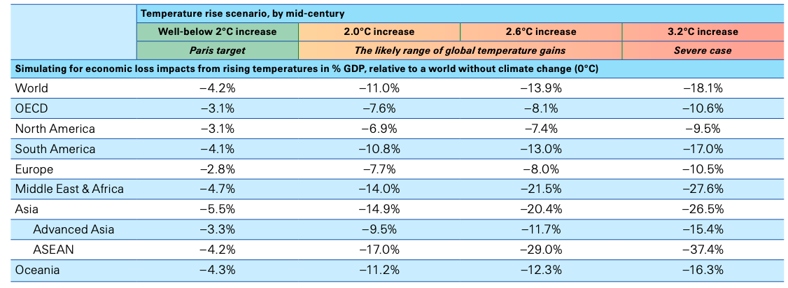

Table The Paris Agreement[5]

In 2015, the United Nations developed a treaty on climate change called the Paris Agreement. There were 196 parties that adopted this treaty on December 12, 2015. The treaty was ratified on November 4, 2016.

This agreement states that if the world temperature is kept below 2*C, the decrease in the world’s Gross Domestic Product (GDP) could be as little as 4%, but if there was an increase of 3.2%, then the loss could be as much as 18% (although there will be some variations in areas of the world with regard to both low decreases and higher decreases of the world’s GDP. In short, most areas of the world (like North America and Europe) that are more developed may see less of a decrease in the GDP than those areas that may be less developed (such as Africa and East Asia).

# Conclusion

It would seem mandatory that the world adopt changes that would prevent the burning of fossil fuels to prevent as much damage as possible to the world’s economy. Two common changes that society is embracing are electric cars (or maybe hybrid cars) and solar panels. Electric cars cut down the amount of gasoline burned in vehicles, and solar panels (or wind power) provide power and heat to homes by means other than burning wood or coal. When possible, people should ride a bike or walk instead of driving. Electric buses are becoming more common now for those that need to ride public transport. There are plenty of options for those that care about the future of the Earth’s economy.

1. <https://science.nasa.gov/climate-change/what-is-climate-change/>
2. <https://news.climate.columbia.edu/2019/06/20/climate-change-economy-impacts/>
3. <https://news.climate.columbia.edu/2019/06/20/climate-change-economy-impacts/>
4. <https://news.climate.columbia.edu/2019/06/20/climate-change-economy-impacts/>
5. <https://www.weforum.org/agenda/2021/06/impact-climate-change-global-gdp/>