Jesse’s Final Project Report

This report will focus on the following questions:

1. How much money is currently spent per year on space heating?
2. How much money could be saved per year if all 26 houses got new furnaces?
3. Which house currently uses the most energy?
4. Which house currently uses the least energy?
5. Which 5 houses would save the most money if they installed new furnaces?

Q: How much money is currently being spent per year on space heating?

A: The answer is $2.27 thousand dollars.

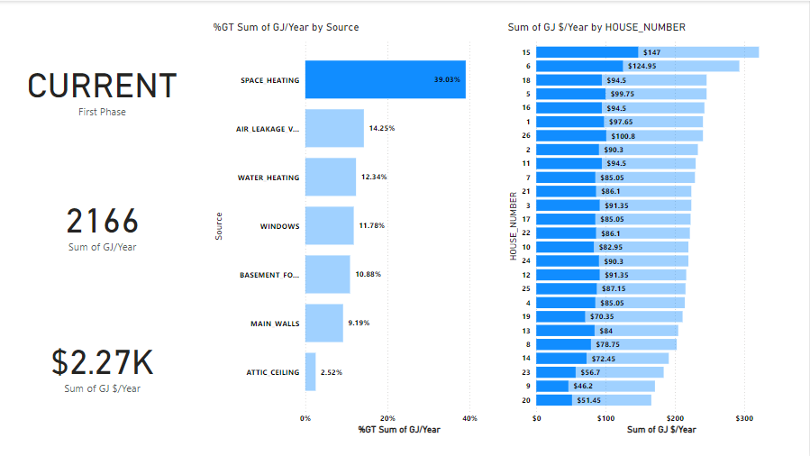

Q: How much money could be saved per year if all 26 houses got new furnaces?

A: The answer is $1.37 thousand dollars.

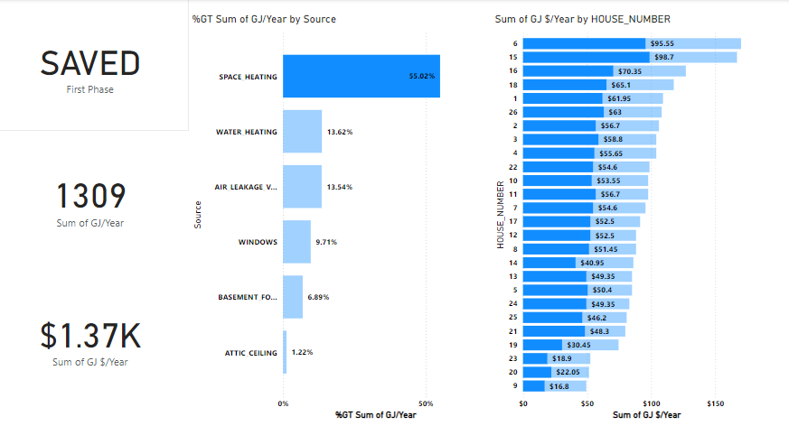Q: Which house currently uses the most energy?

A: The answer is house #15.



Q: Which house currently uses the least energy?

A: The answer is house #20.



Q: Which 5 houses would save the most money if they installed new furnaces?

A: The answer is houses #6, #15, #16, #18 and #1.

