Jennifer Manning

**Written Questions**

1. Indicate the best bound running time for your implementation of Dijkstra's algorithm. Note that this is

NOT likely to match that in the book, so be sure you figure it out, don't just tell me that Dijkstra's is so

and so.

The average running time is O(n^2); this is due to a while loop that will iterate through all of the vertices until it reaches the destination or goes through all of the vertices, and then a for loop that checks all adjacent vertices for each vertex.

The best case would be O(N), this would be that the destination is adjacent to the starting vertex, and the only vertices to iterate through would be the ones adjacent.

2. Give a simple example of a directed graph with negative edge weights for which Dijkstra's algorithm

produces incorrect results.

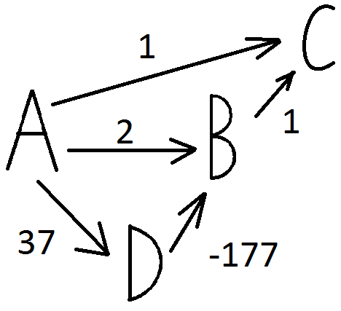

In the graph above, the shortest route from A to C would be -139; however, Dijkstra's algorithm will give a distance from A to C of 1.

3. Is the sequence [23, 17, 14, 6, 13, 10, 1, 5, 7 12] a max-heap?

No. 6 !> 7

23

17 14

6 13 10 1

5 7 12

4. What are the minimum and maximum number of elements in a heap of height h?

Minimum: ${ 2}^{h}$

Maximum: $2^{h+1}-1$