Finiteelementbasedmodellingofthestructuralresponseofweldedmaterialsincomplex
loadingconﬁgurations.PartII:Constitutivemodellingconsiderations
A.J.AwangDraupa,∗,B.I.Rodgersa,J.DRobsona,P.B.Prangnella,Q.M.Lia,M.J.Luntb
aTheUniversityofManchester,Manchester,M139PL,UK
bDSTL,Porton,SP40JQ,UK
Abstract
Thistwo-partarticlepresentstheresultsofnumericalpredictionandexperimentalstudieswhichaimtodeterminethestructural
responseoffrictionstirweldedaluminium2139-T8subjectedtocomplexloadingconﬁgurations,andinparticular,airblastloading.
Theaimofthisworkistodevelopanumericalmodellingmethodologytoallowdetailedpredictionofthelocalstrainevolution
acrosstheweldzoneasthishassigniﬁcantinﬂuenceinrelationtostructuralresponseandfailure.Inparticular,themethodallows
local material property gradients, which are due to variation in strengthening mechanism arising from microstructural damage
caused by thermal loading during the welding process, to be incorporated into a macro scale structural model. Part I details
themethodologyusedtoimplementlocalmaterialpropertygradientstogetherwithexperimentalevidencetoverifythepredicted
structural response in a range of loading conﬁgurations. Part II provides an insight into the assumptions made in Part I with
respecttohighstrainratematerialsmodellingacrosstheweldzoneandtheassociatedevidenceforthevariationinstrengthening
mechanismsinthealloy. Thecombinedworkpresentedhighlightstheimportanceofaccuratedescriptionofthevariationinlocal
materialproperties,particularlytheworkhardeningrate,indeterminingtheresponseofstructuresunderblastloading.
Keywords: Blastloading,Digitalimagecorrelation,Materialsmodelling,Finiteelementsimulation,Materialscharacterisation
1. Introduction
inducesigniﬁcanttransienttemperatureriseandplasticdefor-
mationthroughinteractionoftheweldingtoolwiththework-
piece[6,7]. WhilsttemperaturerisesinFSWremainsbelow
the melting point of aluminium, the combination of thermal
andmechanicalloadingcaninducediﬀusionalandrecrystalli-
sationprocessesinthework-piece[8,9,10].FSWisknownto
causephenomenasuchasprecipitatecoarsening;localdissolu-
tionofprecipitates;recoveryandrecrystallisation.Thisleadsto
theformationofmeso-scaleregionsacrosstheweldknownas
thenugget,theThermo-MechanicallyAﬀectedZone(TMAZ),
andtheHeatAﬀectedZone(HAZ).Thecombinedthermaland
plasticdeformationeﬀectsonthematerialmicrostructurealter
thelocalmaterialpropertiesinweldedstructures[8,9,10,6].
Asaresult,therearelargegradientsinmaterialandmechanical
propertiesacrossaweldzone[11].
InFiniteElementbasedmodelling,theuseofJohnson-Cook
constitutivemodelsiscommonplacewhensimulatingthenon-
linearresponsestructures[12,13]. However, sinceobtaining
parameters locally within a weld is diﬃcult [14], the typical
methodfordeﬁningtheconstitutivemodelparametersacross
theweldzoneistoassumethatthereisonlyvariationinyield
stressacrossaweld[12,13].Itisgenerallyacceptedthatthere
may be signiﬁcant variation in properties, such as the work
hardening rate, across a weld [15, 13, 16]. Thus, determin-
ingthenon-linearresponseofweldscanbediﬃcultandrequire
carefulcalibrationandinterpretation. InPartIofthisstudy,a
methodforimplementingmaterialpropertygradientsinmacro
scaleFEmodelstosimulatestructuralresponseofFSW2139-
T8wasdeveloped.Themethodwasshowntoprovideaccurate
Itiswidelyacceptedthatthemechanicalpropertiesofmet-
alsarelinkedtothematerialmicrostructureandthestrength-
eningmechanismsofthealloy. Foragehardenablealuminium
alloys,themechanismswhichcontributetothestrengthofthe
alloyinclude: precipitatehardening,solidsolutionstrengthen-
ing,workhardening,andgrainsizereﬁnement[1]. Uponage
hardening,ternaryAl-Cu-MgalloyswithlowCu:Mgratiosare
knowntoleadtotheformationoftheAl2CuMgbasedS’orS
phases[2]. Incomparison,Al-Cu-MgalloyswithhighCu:Mg
ratiosleadtotheformationofCuGPzonesandsubsequently
the Al2Cu θ0 phase; the addition of Ag promotes formation
of the Al2Cu based Ω phase [2, 3, 4]. The addition of trace
amounts of Ag in ternary alloys with Cu:Mg ratios of above
5.6,suchas2139-T8,enhancestheagehardeningresponseand
promotestheformationofAl2Cubasedprecipitatesaheadof
S’andSphases[2]. θformshabituallyonthe{100}α andΩ
formshabituallyonthe{111} [5]. Undertheappropriateheat
α
treatment,thehexagonalplate-likeΩphaseformsaheadofGP
zonesleadingtohighdensitiesofthestrengtheningphase[2].
IntheT8condition,thesizeanddistributionofΩphaseisop-
timisedtoreducedislocationmotion,hence2139isconsidered
tooﬀerpeakstrength.
Joining processes, such as Friction Stir Welding (FSW),
∗Correspondingauthor.Tel:+44(0)1613063578Ext.2261
Emailaddress:jefri.draup@postgrad.manchester.ac.uk(A.J.
AwangDraup)
PreprintsubmittedtoInternationalJournalofImpactEngineering
April16,2015

Z
t
tdt
t1*
quantitative prediction of strain evolution in structures under
complexloadingconﬁgurationsincludingblastloading. How-
ever,theconstitutivemodelparametersforelementsacrossthe
weldzoneweremerelystated.
Inthiscompanionpaper,theJohnson-Cookparametersfor
thediﬀerentregionsofaweldareestimatedbymeasuringthe
mechanicalpropertiesfromsimulatedweldmaterial(§2.1)which
isrepresentativeofageneralisedweldcondition.Thevariation
inparametersisrelatedtoobservationsofthemicrostructureus-
ingmethodsdescribedin§3.Togetherwiththeorypresentedby
Shercliﬀ[17,1],theJohnson-Cookparametersacrossgeneral
weldingconditioncanbedeﬁnedusingthemethoddescribed
in§4.3
=
(4)
t∗
eff
0
1
TheShercliﬀmodelcanbeused, therefore, topredicttheas-
weldedhardnessdistributioninaweld.Contributiontostrength-
eningfrompost-weldnaturalagingcanbeaccountedforbyem-
pirical measurement of the natural aging response (hardness)
[7]. Thus,ifoneassumesalinearrelationshipofyieldstress
withhardness(equation6),themodelcanbeusedtopredictthe
post-weldyieldstress. Indeed,severalstudieshaveshownthat
the model has bee successfully used to predict the post-weld
strengthdistributionacrossFSW2xxx,6xxx,and7xxxseries
aluminiumalloys[18,19]. Twoobservationscanbemadeof
theShercliﬀmodel,whichareusedinthisstudy:
1. Typically,theas-weldedstrengthproﬁleandthepostnat-
uralagingstrengthproﬁleshavecharacteristic“ﬂattrough
U-shape”and“W-shape”proﬁlesrespectively. Itcanbe
shown mathematically that the region of the weld en-
velopedbytheﬂattroughoftheU-shapeandtheregion
inbetweenthetwominimaoftheW-shapecoincidewith
thepositionsintheweldcrosssectionwherethesumof
equation4isequalto1.Hence,fromthehardnessproﬁle,
wecaninferthegeometricboundariesintheweldcross
sectionwherewecanassumethatlocally,thestrengthen-
ingprecipitateshaveundergonefulldissolutionaccord-
ingtoequation2.
2. BackgroundTheory
Inthisstudy,amodeldevelopedoriginallybyShercliﬀ[17,
1]andadaptedbyRobson[7]wasusedtogainanunderstanding
oftheeﬀectoftheweldingprocessonthepropertiesof2139-
T8.Themodelusedtointerpretmicrostructuralvariationacross
theweldandcanbeusedtohelpidentifyalogicalmethodfor
assigningconstitutivemodelparametersinweldcrosssections
(§4.3). Themodelwasalsousedtorecreate“simulatedweld
material”(§3.2)inordertomeasurethemechanicalproperties
acrosstheweld.
2. Whilst the Shercliﬀ model is designed to predict post-
weldhardnessfromknowledgeofthelocalweldthermal
cycle, it can be used in reverse to calculate equivalent
isothermalheattreatmentswhichcanbeusedtoheattreat
parent material to the equivalent hardness of any posi-
tion across the weld [18, 16]. In this way, it is possi-
bletogeneratemonolithicmaterialfrom2139-T8inthe
as-receivedconditionto“simulate”thelocalmicrostruc-
tureanywhereintheweldcrosssection. Thus,mechan-
icalpropertiesoflocalweldstructurecanbeestimated
throughmechanicaltestingofsimulatedweldmaterialas
discussedin§3.2.
2.1. ProcessModelling
Shercliﬀetal. [17,1]originallydevelopedamodeltopre-
dicttheas-weldedhardnessdistributionheattreatablealuminium
alloys. Themodelassumesthatchangestostrengthduringthe
thermalcyclefromweldingarerelatedtothevolumefraction
ofprecipitatesinthematerial,whichisfurtherassumedtohave
linearrelationshipwithhardness(equation1). Themodelas-
sumesthatanysofteningiscausedbydissolutionofstrengthen-
ingprecipitateswhichismodelledusinga2-dimensionaldiﬀu-
sionmodelofdissolution(equation2).Dissolutionbehaviouris
normalisedtoacalibratedreferencetemperaturebyexperimen-
talmeasurementofthetimerequiredtocausecompletesoften-
ing,andhencecompleteprecipitatedissolution,atthattemper-
ature.Thisnormalisationprocedureeliminatesanydependence
ofthediﬀusionmodelonprecipitategeometryandcanbeused
to estimate the time for complete dissolution to occur at any
temperature(equation3). Sincethemodelassumesisothermal
heattreatments,thetransienttemperatureproﬁlesduringweld-
ingareaccountedforbyusingequation4. DetailsoftheSher-
cliﬀmodel[17,1]andadaptationsbyRobson[7]canbefound
elsewhere,thereforeonlyabriefdescriptionisgivenhere.
2.2. ConstitutiveModelling
TheJohnson-Cookconstitutivemodelisapowerfultoolfor
modellingthenon-linearresponseofmaterialsasitcancapture
theeﬀectsofstrainrateandthermalsensitivityinadditiontothe
quasi-staticresponseofamaterial. Johnson-Cookconstitutive
modelsarefrequentlyusedtomodelthedynamicresponseof
materials and structures under transient loading [20, 21, 22].
Theirwidespreaduseislinkedtotheirabilitytocapturebulk
propertiesoverarangeofconditions.TheJohnson-Cookmodel
describestheﬂowstressusingtherelationshipusingequation
5:
HV−HVmin
Xp=
(1)
(2)
HV
max
−HV
min

¤˙p
T−T0
m
σ= A+B¤
n
p
1+Cln
1−
(5)

t
1
2
˙
T −T
¤
p0
m
0
Xp=1−
t∗
1
WhereAisthequasi-staticyieldstress,Bisthestrengthcoeﬃ-
cient,nistheworkhardeningrate,Cisthestrainratesensitiv-
ity,andmisthethermalsensitivity. AsdescribedbyJohnson
and Cook, these parameters are obtained empirically through
t1∗=tr1e

Qeff
R
1
T
−
1
Tr
(3)
2

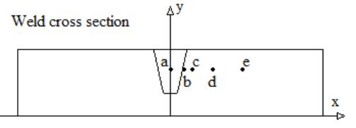
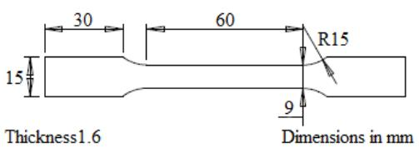
experimentswhichapproximatelyisolatequasi-staticresponse,
dynamicresponse,andthermalresponserespectively.
heat treated according to table 1. All samples, such as dog-
boneandcompressionspecimens,weremachinedpriortoheat
treatment,andquenchedinroomtemperaturewater. Thesam-
plesareheattreatedtobeequivalentasthepositionsindicated
inﬁgure1. However, representativenuggetmaterialwasob-
tainedbymachiningspecimensformechanicaltestingfromthe
nuggetregionofanactualweldusingtheconditionsdescribed
in§3.1
Unfortunately, extensiveexperimentalworkisrequiredin
ordertodevelopcompletesetofparametersforanyparticular
material [? ]. For material in the weld, due to the property
gradientsinducedbythetransientweldingprocess,theadded
complication of obtaining representative specimens makes it
diﬃculttomeasurelocalproperties[14]. Asaresult,itisof-
tenthecasethatparametersareinferredfromliteratureorare
assumedtoremainunchangedacrosstheweld. Instudiesby
McWilliams[13]andGrujicic[21],whichapplythe“lumped-
mass”methoddescribedinPartI,itisassumedthattheonly
parameterinequation5thatvariesacrosstheweldzoneistheA
parameter.Thissimpliﬁcationiscommonlymadedespitewide
comprehensiveevidenceofvarianceinproperties,particularly
theworkhardeningrate,acrossaweld.
Table1:Isothermalheattreatmentsappliedtoas-received2139-T8inorderto
simulatethemicrostructureacrossandactualweld.
EquivalentPosition
inWeld
VickersHardness Temperature(◦C) Time(Minutes)
BaseMetal
HAZOuter
HAZInner
Nugget
175
150
120
120
N/A
275
375
N/A
N/A
36
21
N/A
3. ExperimentalMethods
3.3. Quasi-StaticRoomTemperatureTensileTesting
3.1. WeldMicrostructure
The purpose of testing is to obtain a measure of the A,
B, and n parameters across all regions of the weld zone, as
deﬁned by equation 5. Dogbone specimens (ﬁgure 2) were
machinedfromas-received2139-T8rolledsheetwith1.6mm
gauge thickness. Samples were heat treated according to the
regimedescribedintable1andsubsequentlytestedinanIn-
BeadonplateFSWwascarriedouton2139-T8alloywhere
thework-piecedimensionsare150x300x38mm. Weldingwas
carriedoutwithaconventionaltoolwithtriﬂatpinsetata2◦
rakeangle. Thetooldimensionswere: 34mmshoulderdiam-
eter;2◦shoulderconcaveangle;18mmpinrootdiameter;20
mmpinheight;10mmpintipdiameter.Theweldsettingswere:
150mm·min−1traversespeed;500RPMrotationspeed;55kN
stron 5569 electromechanical load frame ﬁtted with a 50 kN
loadcell. Samplesweretestedinthestrainrateregime10−4
downforce. Theweldswerecarriedoutwiththetoolinforce
controlmode.Aregularlineproﬁleofhardnessmeasurements
intheweldcrosssectionwasmadeacrosstheweldcentreline;
hardnessindentationswerespacedevery1mmataposition10
mmfromthetopsurfaceoftheweld. Sampleswereprepared
forTEMstudies(§3.6)fromacrosssectioninthecentreofthe
weldandinpositions10mmfromthetopsurfaceoftheweld.
Samplesformicroscopy(§3.6and§3.7)weretakenfromthe
positionsindicatedinﬁgure1andarerepresentativeofthepar-
entmaterial(x=50mm);theouterregionoftheHAZ(x=50
mm); theinnerregionoftheHAZ(x = 50mm); theTMAZ
(x=50mm);andtheweldnugget(x=50mm).
s−1bysettingthecross-headdisplacementrateto2mm·min−1.
TestingwascarriedoutinaccordancewithBS6892-1:2009.
Figure2:Dimensionsoftensilespecimensusedfortensiletestingbothatroom
temperatureandhightemperatures.
3.4. Quasi-StaticHighTemperatureTensileTesting
Thepurposeoftestingistoobtainameasureofthempa-
rameteracrossallregionsoftheweldzone,asdeﬁnedbyequa-
tion5. Dogbonespecimens(ﬁgure2)weremachinedfromas-
received 2139-T8 rolled sheet with 1.6 mm gauge thickness.
Samples were heat treated according to the regime described
intable1andsubsequentlytestedinaGleeble3500thermal-
mechanical test system ﬁtted with a 100 kN load cell. Sam-
plesfromeachweldregionweretestedafteraninitialheating
Figure1: Locationsintheweldregionswheresamplesaresectionedandrep-
resentativeofa)thenuggetb)theTMAZc)theinnerHAZd)theouterHAZ
ande)theparentmaterial.
rampandsoaktime; testingwascarriedoutinthestrainrate
regime10−4s−1bysettingthecross-headdisplacementrateto2
3.2. SimulatedMicrostructure
mm·min−1.TestingwascarriedoutinaccordancewithBS6892-
InaccordancewiththeShercliﬀmethod[17,1]described
in §2.1, 2139-T8 material for each experimental method was
2:2011,withtheexceptionthatthesoaktimeduringtestingwas
lessthanthemandatory10minutes.Thiswasbecause2139-T8
3

alloyundergoessolidstatetransformationprocessesatthetest
temperaturesintable2,hence,soaktimewasminimisedtomit-
igatetheseeﬀects.
3.7. ScanningElectronMicroscopy
AnUltra-55FEG-SEMﬁttedwithanElectronBackScatter
Diﬀraction(EBSD)probewasusedtocarryoutmicro-texture,
andgrainsizeanalysisacrossFSW2139-T8. EBSDpatterns
wereproducedwiththemicroscopeoperating20kV;anaper-
turesettingof120µmHC;andaworkingdistanceof12mm.
Samplesfromthepositionsindicatedinﬁgure1wereprepared
Table2: Hightemperaturetestplanusedtotestsamplesfromsimulatedweld
regionsdeﬁnedin§3.2.
TestTemperature(◦C)
HeatRamp(◦Cs−1)
SoakTime(s)
100
200
300
400
foranalysisbysystematicgrindingandelectro-polishing.Anal-
ysiswascarriedoutusingOxfordHKLChannel-5software1.
20
5
20
5
20
5
20
5
4. ResultsandDiscussion
3.5. HighStrainRateRoomTemperatureCompressionTesting
4.1. MicrostructuralObservations
ThepurposeoftestingistoobtainameasureoftheCpa-
rameteracrossallregionsoftheweldzone,asdeﬁnedbyequa-
tion 5. Cylindrical specimens were machined from 38 mm
gauge as-received 2139-T8 and heat treated to simulate weld
materialasdescribedin§3.2.AKolskybarapparatus,setupas
describedGray,wasusedtotestsamplesacrossawiderange
ofstrainratesasdescribedbytable3. Allbarsweremachined
from20mmdiametermildsteelrods,wherethemeasuredspeed
ofsoundwasapproximately3300ms−1.Thestrikerbarwasma-
chinedtoalengthof250mm;theincidentbarto1000mm;and
thetransmitterto1500mm.
ItiswidelyknownthatFSWleadstothedevelopmentof
meso-scale features in metals: the nugget, TMAZ, and HAZ
[6].ThepurposeofthisstudyistoexaminehowtheFSWpro-
cessaﬀectsthelocalmicrostructurein2139-T8. Furthermore,
itisthepurposetodetermineifanyparticularmicrostructural
featuresmayrequireconsiderationwhenmodellingnon-linear
plasticbehaviour.
4.1.1. Precipitates
Figure3showsthelocaldistributionofΩphaseacrossthe
weldregion.Intheparentmaterial,thecontrolledagingprocess
leadstoformationofhexagonalplatelikeprecipitateswhichare
approximately50nmindiameterand2nmthick. Theprecip-
itatesareextremelyﬁnelydistributedwithperpendicularspac-
ingestimatedatapproximately10nm. Fromobservation,itis
clear that the dominant feature of the parent material on this
ﬁnescaleistheΩphaseanditisunsurprisingthatthestrength
of2139-T8isattributedtotheΩphase[23].
IntheouterregionsoftheHAZ,wherepeaktemperatures
arerelativelylow,theΩprecipitatesaremuchcoarserandap-
peartobeshorter,thicker,andmorewidelydistributedincom-
parison with the parent material. The precipitate dimensions
areapproximately30nminlength,3nminthickness,andthe
perpendicularspacingincreasestoapproximately30nm. The
thermalcyclehasalloweddiﬀusionalprocessestocauseover-
agingoftheprecipitates,therebyalteringtheprecipitatedimen-
sionsanddistribution. Nevertheless,ontheﬁnescaleofﬁgure
3, the Ω phase remains the dominant feature and is likely to
contributemostsigniﬁcantlytothelocalstrengthinthealloy.It
ispossiblethatsomeoftheΩphasehasdissolvedintosolution
therebyenhancingthecontributionfromsolidsolutionstrength-
ening. However,accordingtoShercliﬀ[1],ifprecipitatesare
over-agingfrompeakcondition,therelativecontributionfrom
solidsolutionstrengtheningremainslow.
Table3: Highstrainratetestplanusedtotestsamplesfromsimulatedweld
regionsdeﬁnedin§3.2.
Sample
Sample
StrikerVelocity EstimatedTest
(ms ) )
−1 StrainRate(s−1
Diameter(mm) Length(mm)
6.00
6.00
5.00
6.00
4.00
2.00
6.00
10.00
10.00
600
1500
3500
3.6. TransmissionElectronMicroscopy
Highresolutionimagingof2139-T8wascarriedoutusing
bothaPhilipsCM200andanFEITecnai30TransmissionElec-
tronMicroscope(TEM).TEManalysiswasrequiredtoobserve
theresponseofplate-likeΩstrengtheningphasetoFSWasΩ
is of the order 102 nm in diameter and 101 nm in thickness.
Sampleswerepreparedfromregionsinthecrosssectionofan
actualweld(seeﬁgure1§3.1),includingthenugget; TMAZ;
innerregionoftheHAZ;outerregionoftheHAZ;andthepar-
ent material. Samples from “simulated” weld material were
also prepared by heat treating 38 mm gauge 2139-T8 in the
as-receivedconditionasspeciﬁedintable1inordertocom-
pareactualmicrostructuretosimulatedmicrostructure. Sam-
pleswerepreparedﬁrstlybygrindingmaterialtoathicknessof
180µmandsubsequentlypunching3mmdiameterdiscs. The
Intheinnerregionoftheweldzone(innerHAZ,TMAZand
nugget),wheretemperaturesaremuchhigher,theΩphaseap-
pearstohavegonefullyintosolutionontheﬁnescaleofﬁgure
3.Intheseregions,itisconjecturedthatthelocalalloystrength
maybeattributed totheformationof GPzonesuponnatural
discswereelectropolishedinusinga30%byvolumenitricacid
andmethanolsolutionat−30◦C.Duringimaging,theelectron
beamwasalignedwiththe<211>zoneaxisinordertoview
thehexagonal,plate-likeΩprecipitatesedgeon,astheyform
habituallyalongthe{111}α.
1All sample preparation and microscopy were carried out externally by
Constellium(France),whilstdataanalysiswasperformedattheUniversityof
Manchester.
4

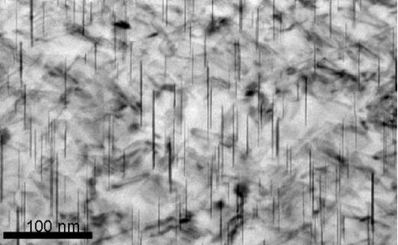
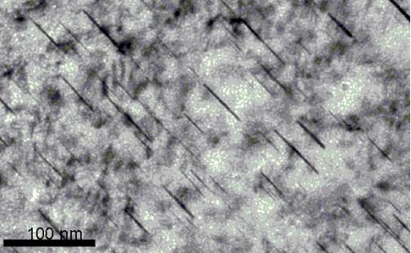
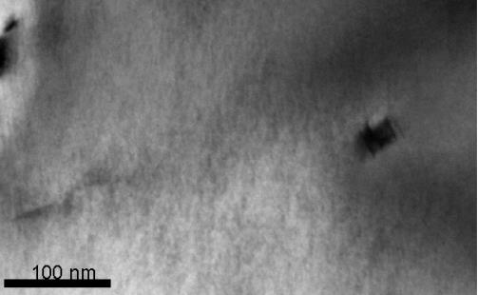
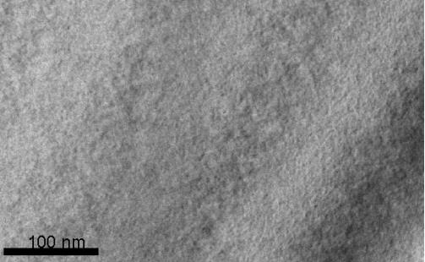
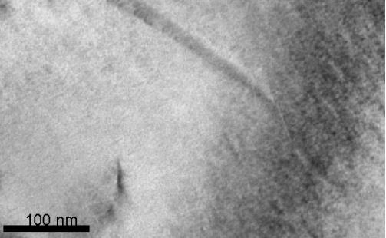
(a) BaseMetal
(b) HAZOuter
(c) HAZInner
(d) TMAZ
(e) Nugget
Figure3: TEMobservationof2139-T8withtheelectronbeamalignedwith< 211 >poleaxisinallimages. Allhexagonalplate-likeΩprecipitatesappearas
straightlines,astheyareviewededgeon.
aging, solid solution strengthening from dissolved Al2Cu, or
fromgrainreﬁnement.Itislikelythatthediﬀerentcontributors
toalloystrengthintheinnerregionsoftheweldarecompar-
ativelyassigniﬁcantaseachother. Thisisinlinewiththeory
on age hardening in aluminium alloys presented by Shercliﬀ
[1].Inaddition,sincetheregionhasundergoneanuncontrolled
transientthermalcyclefromtheweldingprocesstheΩphase
isunlikelyre-precipitateoutpostwelding; theagehardening
heattreatmentisﬁnelycontrolledtoinducetheformationofΩ
phase[2]. Onthislocalscale,itisclearthatΩphasedoesnot
contributesigniﬁcantlytostrengtheninginthealloyintheinner
regionsoftheweld.
In the TEM images of the parent material and the outer
HAZ,thereisadditionaldiﬀractioncontrastbeyondthatcaused
bythestrengtheningΩphase.Thismaybeduetothepresence
ofdislocationstructures,whichwouldhavebeengenerateddur-
5

ingthealloyprocessingroute,orduetoadditionalphasesinthe
material. IntheimagesoftheinnerHAZ,TMAZ,andnugget,
there is little in the way of diﬀraction contrast; this demon-
stratesanabsenceofdislocationstructuresinthematerial.The
absenceofdislocationstructuresintheinnerregionsoftheweld
islikelytobecausedbyrecoveryandrecrystallisationprocess
whichcauseannihilationofdislocations. Thereis, therefore,
likelytobeaneﬀectontheworkhardeningrateintheinner
regionsoftheweld.
texturesaredescribedasweakbecausethemeanuniformden-
sitypeaksarelessthan3timesrandominthepoleﬁgures.Fur-
thermore,thedistributionofintensitiesinthe{110}poleﬁgure
appearstoberandomlydistributed. IntheTMAZ,theheavily
distortedgrainsalsoexhibitweak{100}ﬁbre,weak{111}rolled
texture, andarandom{110}texture. However, thereexistsa
proportionofﬁneequiaxedgrainssampledwithintheTMAZ
which,whenanalysed,exhibitaweakcubetexture. Theﬁne
equiaxedgrainswithinthenuggetregionoftheweldexhibita
weakmisorientedcubetexture. Itwouldappearthattheweld-
ingprocessdoesnotinducesigniﬁcanttexturechangewiththe
exceptionofasubregionofgrainsintheTMAZandthegrains
ofthenugget. Itislikelythatthetexturechangeisattributable
to dynamic recrystallisation which is known to occur in the
nugget. Sincedynamicrecrystallisationisaresponsetother-
malinputandplasticdeformation,itisunsurprisingthatthere
isasubregionofrecrystallisedgrainsintheTMAZ.Fromthese
observationsitispossiblethattexturedevelopmentarisingdue
toFSWmayeﬀectthemeasuredmechanicalpropertiesofthe
nuggetregion. However,theeﬀectislikelytobesmalldueto
thelowintensitiesinthemeasuredpoleﬁgures.
4.1.2. Grains
TheHAZandparentmaterialappeartohavesimilargrain
structure.Equivalentgraindiameterisapproximatelyoftheor-
derof102µmandgrainshaveelongated,pancakelikestructure,
whichistypicalofrolledmaterial. TheTMAZregiondemon-
stratestwotypesofgrainstructure: theﬁrsthasgrainssimilar
in size to the parent material but subjected to large deforma-
tionwhilstthesecondhasmuchsmallerequiaxedgrains. The
equivalentgraindiameterreportedintable4isanaverageof
these two grain structures, hence, it is lower than that of the
parentmaterial. Thismaybebecausethelargeproportionof
ﬁnegrainsskewsthecalculationoftheaveragegraindiameter.
Inboththethickandmediumgauge(38and12.7mmre-
spectively),theas-receivedmaterialdemonstratesweak{100}
ﬁbre and weak {111} rolled texture; in all cases the peak in-
tensity is approximately 2.5. The {110} texture appears ran-
domlydistributedinthickandmediumgaugematerial.Incon-
trast,the{100}and{110}poleﬁguresofthethingaugematerial
showmoredistinctpoleintensitiescomparedwiththethickand
mediumgaugematerial.However,ingeneraltheintensitiesre-
mainrelativelyweak. Additionally,the{111}rolledtextureis
moredistinctcomparedwiththethickandmediumgaugemate-
rial.Itisnotunusualthattexturebecomesmoredistinctinthin
gaugematerialasdeformationduringrollingcausesalignment
ofthecrystalgrains. Itmustbenotedthatsinceonlymicro-
texture measurements have been made, it is possible that the
moredistinctpoleintensitiesisalocalisedeﬀect.Studiesofthe
macroscaletextureusingX-raydiﬀractiontechniquesmaybe
abletodetermineiftheretexturevariationisreallysigniﬁcant
withvariationingaugethicknessof2139-T8.Inthecontextof
thisstudy,itispossiblethatbyobtainingparametersforcon-
stitutivemodelling(equation5)separatelyfrom2139-T8mate-
rialindiﬀerentgaugethicknessmaybeinﬂuencedbytexture.
Thereislikelytobesomedegreeofanisotropyinthemeasured
propertiesofthematerial.Itisreasonablethatforthepurposes
ofmodelling, themostconservativeparametersbeusedfrom
measuringthepropertiesfromthediﬀerentmaterialdirections.
Overall,themicro-textureofthematerialinthingaugesisstill
relativelyweakcomparedtodiﬀerentalloys.
However,onaverage,theequivalentdiameteroftheTMAZap-
proachesthatoftheparentmaterialandHAZ(102µm). Inthe
nuggetregion,thegrainshaveaﬁneequiaxedstructure;grain
reﬁnementinthisregionisapproximatelyoneorderofmagni-
tude(101). Duetothelargeplasticdeformationandtransient
frictional heating due to interaction with the tool, it is likely
thatthisregionhasundergonedynamicrecrystallisation.Inline
withobservationsbySatoandPreuss,grainreﬁnementisonly
signiﬁcantinthenuggetregion.
Table4: Observedmicrostructuralcharacteristicsinthedistinctweldzonesof
FSW2139-T8.
Equivalent
diameter(µm)
WeldRegion
Observations
BaseMetal
HAZ
117
122
Rolledgrains
Rolledgrains
Deformed rolledgrains,
Regionsofdiﬀuserecrystallisation
Fine,equiaxedgrains
TMAZ
Nugget
90
24
4.1.3. Micro-Texture
Inthisstudy,materialparametersforJohnson-Cookconsti-
tutivemodelsareobtainedexperimentallyfrom2139-T8from
as-receivedmaterialinarangeofgaugethickness(1.6 ≤ t ≤
38mm).Sincealuminiumcanexhibitanisotropyduetotexture,
EBSDstudieswerecarriedouttodetermineiftexturedevelop-
mentwassigniﬁcantduetoeithertheweldingprocessorthe
reductionofmaterialgaugethicknessbyrolling. Thishelpsto
determineiftheeﬀectsoftexturedevelopmentinﬂuencesthe
experimentallyobtainedparametersoftheconstitutivemodels.
Fromﬁgure4,wecanseethatas-receivedmaterialexhibits
weak{100}ﬁbre(< 100 >paralleltothenormaldirection)in
boththeparentmaterialandHAZ.Inaddition,boththesere-
gionsoftheweldalsoexhibitweak{111}rolledtexture. The
4.2. MechanicalPropertiesinsimulatedFSW
Aftermeasuringthemechanicalresponseofsimulatedweld
material,theparametersforaJohnson-Cookmodelwereﬁtted
foreachregionoftheweld. Table5showsthedistributionof
propertiesacrosstheweldregionandﬁgure5showsthemea-
suredmechanicalresponseplottedalongsidetheJohnson-Cook
modelforthequasi-staticregime.
6

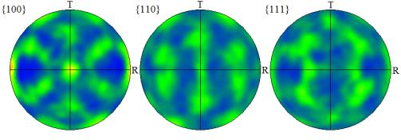
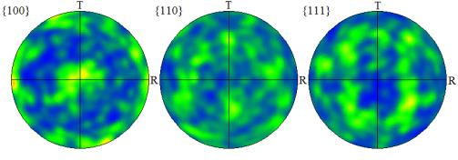
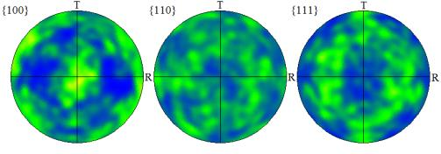
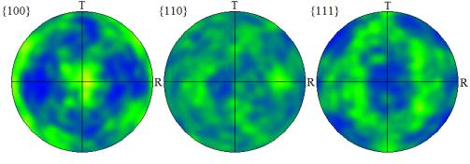
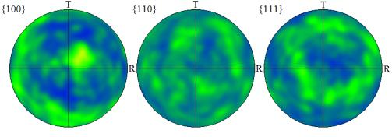
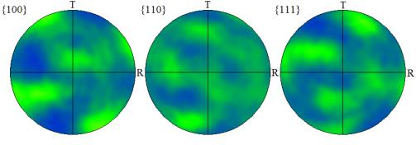
(a) BaseMetal(1.6mmgaugethickness)
(c) BaseMetal(38mmgaugethickness)
(e) TMAZ(38mmgaugethickness)
(b) BaseMetal(12.7mmgaugethickness)
(d) HAZ(38mmgaugethickness)
(f) Nugget(38mmgaugethickness)
Figure4:Upperhemispherepoleﬁgures(equalareaprojection)fromEBSDmicro-texturemeasurementsacrosstheweldzoneandoverarangeofgaugethickness.
WhereTistheshorttransversedirectionandRistherollingdirection; thenormaldirectionisorthogonaltothepage. Multiplesofuniformdensity(MUD)is
indicativeofthestatisticaldistributionofcrystalorientationswithinthesample.
ThevariationinyieldstressintheouterregionsoftheHAZ
appearstobeinlinewiththeliteratureasthereisaconstantlin-
earrelationshipwithhardness[13,21];thelinearcoeﬃcientis
measuredas2.5. Furthermore,thereisnosigniﬁcantvariation
inthemeasuredworkhardeningrateascomparedtotheparent
materialinthisouterregion;inbothconditionsitismeasured
at0.4. IntheinnerregionsoftheHAZ,thereappearstobea
slight variation inthe linear relationship betweenyield stress
andhardness;thelinearcoeﬃcientreducesto2.35. Addition-
ally,thereisameasuredincreaseinworkhardeningratewhich
isapproximately0.5inthisregion. Inthenuggetregionthere
isamoresigniﬁcantvariationinthelinearrelationshipofyield
stress with hardness; the linear coeﬃcient is measured to be
1.96. Furthermore,thereisalsoasigniﬁcantincreaseinwork
hardeningratewhichisapproximately0.65inthisregion.The
measureddatashowsthatthefollowingassumptionsforesti-
matingtheJohnson-Cookparametersacrossaweldusingthe
lumped-massmethodarenotstrictlytrue:
Boththeserelationshipsonlyappeartoholdtrueintheouter
regions of the weld but not in the inner regions of the weld.
Thereissomevariationinparametersacrosstheweldappears
toincrease,butbasedonthelimitednumberofdatapoints,no
particularrelationshipcanbedrawn.
Table5:Johnson-Cookparametersﬁttedtoexperimentallymeasuredmechani-
calpropertiesintheweld.
Regionofweld HardnessVickers
k
B(MPa)
n
C
m
BaseMetal
OuterHAZ
InnerHAZ
Nugget
175
150
120
120
2.5
2.5
2.35
1.96
250
250
400
650
0.4
0.4
0.5
0.02
0.02
0.03
0.04
1
1
1
1
0.65
Themeasuredstrainratesensitivityof2139-T8appearsto
correlatewithdatafromVuraletal. whoshowedthattheal-
loyremainsstrainrateinsensitiveuntilstrainratesoftheorder
103s−1[24].Furthermore,intheouterregionsoftheHAZthere
wasanegligiblevariationinstrainratesensitivityofthealloy.
Thisinsensitivityisthoughttobeduetothepropagationdy-
namics of dislocations due to the geometry and alignment of
1. Thelinearrelationshipbetweenyieldstressandhardness
isnotconstantacrosstheweld.
2. Theworkhardeningrateisnotconstantacrosstheweld.
7

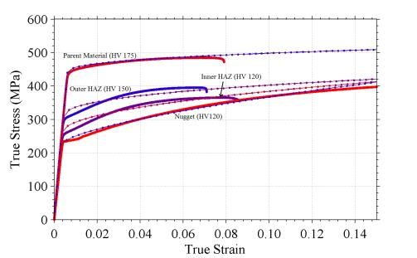
precipitatespacing.Thisislinkedtothelocalthermalcycleand
examinationofthehardnessdistributionacrosstheweldshows
thatthisisagradualprocess. Nevertheless, onalocalscale,
Ωphaseremainsﬁnelydistributedwithintheouterregionsof
theHAZandislikelytoremainthedominantcontributorsig-
niﬁcantlytostrengtheninginthealloy.Fromthemeasuredme-
chanical response of the parent material and the outer HAZ,
thereappearstobeaconstantlinearrelationshipbetweenyield
stressandhardness. Furthermore,theworkhardeningratere-
mainsrelativelyconstant.
IntheinnerregionsoftheHAZ,TMAZ,andthenugget,
temperaturesarehighenoughtocausefulldissolutionoftheΩ
phaseonalocalscale. Itislikely,therefore,thatcontributions
fromothersourcesofstrengtheningbecomecomparativelysig-
niﬁcant[1].Itisconjecturedherethatintheseinnerregionsof
theweld,solutestrengtheningandtheformationofGPzones
uponnaturalagingcontributetowardsthestrengthofthealloy
[2]. Furthermore, grain size analysis reveals that strengthen-
ingduetograinreﬁnementmaycontributetostrengtheningbut
is conﬁned to the nugget region of the weld. TEM observa-
tionsfurtherrevealthatthereisadecreaseindislocationdensity
fromtheparentmaterialtowardsthecentreoftheweld.Thisis
likelylinkedtorecoveryandrecrystallisationprocesseswhich
causeannihilationofdislocationsstructures. Furthermore,this
isindicativeofapossibleinﬂuenceontheworkhardeningrate
acrosstheweld. Indeed, themeasuredlinearrelationshipbe-
tweenyieldstressandhardnessdecreasesdistinctlyintheinner
HAZandagaininthenuggetregion.Themeasuredworkhard-
eningrateincreasesdistinctlyintheinnerHAZandagaininthe
nuggetregion.
Figure5: Exampleofmeasuredmechanicalpropertydataforsimulatedweld
material plotted alongside the Johnson-Cook prediction in the quasi-static
regime;theJohnson-Cookmodelsareplottedwithdotmarkers.
theΩphaseinthematrix. Dislocationsarethoughttogener-
ateattheedgeoftheprecipitateunderdeformationandprop-
agatealongthebroadfaceoftheΩphaseduetoitsalignment
withthenaturalslipplanesofaluminiumforcingdislocationsto
shearthroughtheprecipitates.Unlikeprecipitatesalignedwith
the< 100 >direction,theprecipitatesalignedwith< 111 >
willnotundergolocalised”buckling”ofprecipitates[25,5,26].
Hence,resistancetodislocationmotionisretainedinthepres-
enceoftheΩphase. IntheinnerregionsoftheHAZandthe
nugget,wheretheΩphaseisindissolutiononalocalscale,it
isunsurprisingthatthereisanincreaseinstrainratesensitivity.
Itislikelythatstrengtheningarisingfromotherstrengthening
phasesarecontributingtostrength.Sincetheyarealignedwith
directionsnotparallelto<111>itlikelythattheywillexhibit
”buckling”athighstrainratesandtherebybecomestrainrate
sensitive.Towardsthecentreoftheweldanystrengtheningpre-
cipitateswillbecoarserandmoresusceptibletothisbehaviour.
Thiscouldexplaintheincreaseinstrainratesensitivityacross
theweld.
Theobservationfromthelimitednumberofdatapointssug-
geststhatdistinctchangesinmechanicalpropertiesarelinked
to distinct changes in microstructure. These microstructural
changesareafunctionofboththethermalhistoryandplastic
deformation, which depends on the proximity to the welding
tool. Hence,wecandeﬁnepiece-wisecontinuousconstitutive
modelparametersacrosstheweldzoneusingequations6-11.
Incontrast,themeasuredthermalsensitivityreducesacross
theweld. Thisisexpectedsincealloystrengthisattributedto
the Ω phase. As the volume fraction of precipitates reduces
towardstheweldcentre,thereisareductioninyieldstrengthas
shownintable5. Therefore,theoverallsofteningeﬀectofand
sensitivitytotemperaturewillbereducingtowardsthecentreof
theweld.
A=k∗Hv
(6)
B=f1(T,t,~x)
n=f2(T,t,~x)
C=f3(T,t,~x)
m=f4(T,t,~x)
(7)
(8)
(9)
(10)
Where
4.3. Johnson-Cook constitutive parameter deﬁnition for alu-
minium2139-T8subjectedtoFSW
k=f5(T,t,~x)
(11)
Thepropertiesof2139-T8arewidelyreportedtobedomi-
natedbythepresenceofthestrengtheningΩphase[23]. TEM
observationoftheΩphaseshowthatthereisanextremelyﬁne
distributionofplatelikeprecipitatesorientedalongthe{111}α
[23,2]. TheFSWprocessinducessigniﬁcantthermalloading
allowingdiﬀusionalprocessestoalterthemicrostructureofthe
parentmaterial[17,1]. IntheouterregionsoftheHAZ,the
Ωphaseappearstobeover-agingasdemonstratedbycoarsen-
ingoftheprecipitatesandanincreaseinthedistributionofinter
and~xisthepositionwithintheweldedsamplerelativetothe
weldcentreline.
Ifweconsiderthequasi-staticpropertiesillustratedinﬁgure
6,andthehardnessvariationacrossFSW2139-T8,theapplica-
tionofequations6-11isrelativelysimple. Theﬁrstboundary
deﬁningthestepchangesinmeasuredpropertiesisthelocation
wheredissolutionofprecipitatesisassumedtooccur;thisde-
ﬁnesthestartoftheinnerHAZandcoincideswiththelocation
oftheminimaofthe“W-shaped”post-weldhardnessproﬁle,as
8

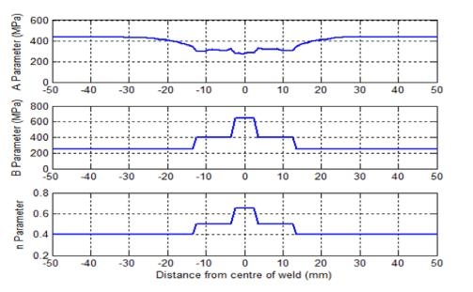
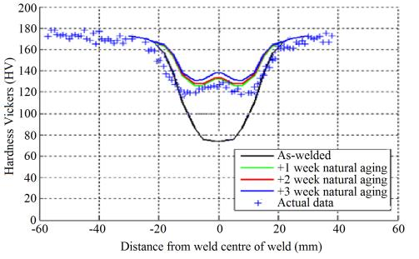
deformationduetorollingduringthemanufacturingprocess.
Examinationofthepoleﬁguresinﬁgure4showsthatthede-
gree of texturing is relatively low as pole intensities are less
than3. Nonetheless,itislikelythatanisotropyduetothetex-
tureinthingaugematerialsinﬂuencesthemeasuredmechanical
properties.Aconservativeapproachwouldbetousedirectional
parameterstodetermineanupperandlowerboundofconstitu-
tivebehaviour.
5. Conclusions
Inadditiontopredictingthehardnessdistributionforany
weldingparametersandtooldimensions,theShercliﬀmethod
canbeusedtoheattreat2139-T8tosimulateanyregionwithin
theweld. Thismethodwasusedtogeneratemechanicalprop-
ertiesfortheregionslocaltotheweld.Dataforarepresentative
nugget region were obtained from nugget material extracted
fromarealweld. TEMandEBSDstudieswerecarriedouton
actualFSW2139-T8inordertocapturelocalmicrostructural
variationacrosstheweld.Basedonthesestudiesthefollowing
observationsweremade:
Figure6: ProposedvariationoftheJohnson-Cookparametersacrossaweld
crosssection.
1. FSWinducessigniﬁcantvariationtothelocalmicrostruc-
tureinaluminium2139-T8. Intheouterregionsofthe
HAZ,precipitatesundergopartialdissolutionandcoars-
eningbutthestrengtheningΩphaseremainsthegreatest
contributortoalloystrengthening. Intheseregionsthe
measuredworkhardeningrateandthelinearrelationship
ofyieldstresswithhardnessisclosetotheparentma-
terial. Thedissolutionofprecipitatesinthisregionisa
gradualprocesswhichisdependentonthelocalthermal
historyfromtheweld.
Figure7: ProposedvariationoftheJohnson-Cookparametersacrossaweld
crosssection.
2. In the inner regions of the HAZ and TMAZ, tempera-
turesarehighenoughtocausefulldissolutionofΩphase.
Hence,othercontributionstoalloystrengthinﬂuencethe
measuredmaterialproperties,suchassolutestregnthen-
ingandtheformationofGPzonesuponnaturalaging.
Intheseregions,theworkhardeningrateincreasesdis-
tinctlycomparedwiththeparentmaterialandouterHAZ.
Furthermore,thereisadistinctdecreaseinthelinearre-
lationship of yield stress with hardness compared with
theparentmaterialandouterHAZ.Thepositioninthe
weldwhereprecipitatesundergofulldissolutioncanbe
predictedusingtheShercliﬀmethodandcorrespondsto
theminimaofthetypical“W-shape”hardnessproﬁleof
theweld.
describedin§2.1. TheendoftheinnerHAZisdeﬁnedbythe
geometryoftheweldingtoolpin;thenuggetregionisbounded
bythedimensionsofthetool. Hence, amethodfordeﬁning
Johson-Cookparametersacrosstheweldisasfollows:
1. Heattreatmaterialtosimulatedistinctregionswithinthe
weld(InnerHAZ,OuterHAZ,andTMAZ)andgenerate
representativenuggetmaterialfromanactualweld.
2. Measurethemechanicalresponseofsimulatedmaterial
inthequasi-static,highstrainrate,andhightemperature
regimes.
3. FitJohnson-Cookparameterstomeasureddataforeach
regionoftheweld.
3. In the nugget region, the combination of plastic defor-
mationandtransienttemperatureriseduetointeraction
with the weld tool has led to dynamic recrystallisation
ofthealuminiummatrixinadditiontocausingfulllocal
dissolutionoftheΩphase.Inthisregionoftheweld,the
contributiontoalloystrengtheningwhichaﬀectsmaterial
propertiesisduetosolutestrengthening,theformationof
GPzonesuponnaturalagingandgrainreﬁnement.Inthis
region,themeasuredworkhardeningratedemonstratesa
distinctincreasecomparedwiththeotherregionsofthe
4. Specifyboundariesfordeﬁningmaterialpropertieswith
piece-wisecontinuousfunctions(equations6-11)across
theweldzonebasedonthelocationofprecipitatedisso-
lutionandpositionrelativetothetoolgeometry.
4.3.1. Limitations
TheJohnson-CookparametersfortheweldregionsofFSW
2139-T8wereobtainedmaterialinarangeofgaugethickness’.
Micro-textureanalysisrevealsthatthingaugematerialhasmore
distincttexturethanthickgaugematerialasaconsequenceof
9

weld.Furthermore,thereisadistinctdecreaseinthelin-
ear relationship of yield stress with hardness. The po-
sitionintheweldthatcanbeclassiﬁedasweldnugget
isencapsulatedapproximatelybythedimensionsofthe
weldingtoolpin.
4. Theseobservationindicatethatthetypicalassumptionsin
the“lumped-mass”approachforconstitutivemodelling
doesnotcapturesigniﬁcantpropertyvariationinwelded
material.Hence,wesuggestpiece-wisecontinuousfunc-
tionsbasedonmeasurementsofrepresentativeweldma-
terialtocapturedistinctchangesinpropertiesacrossthe
weld.
[6] R. Mishra, Z. Ma, Friction stir welding and processing, Materi-
als Science and Engineering: R: Reports 50 (1-2) (2005) 1–78.
doi:10.1016/j.mser.2005.07.001.
URL
http://linkinghub.elsevier.com/retrieve/pii/
S0927796X05000768
[7] J.D.Robson,a.Sullivan,Processmodelforstrengthofagehardenable
aluminiumalloywelds,MaterialsScienceandTechnology22(2)(2006)
146–152.doi:10.1179/174328406X81603.
URL
http://openurl.ingenta.com/content/xref?genre=
article\&issn=0267-0836\&volume=22\&issue=2\&spage=146
[8] Y.S.Sato, H.Kokawa, M.Enomoto, S.Jogan, MicrostructuralEvolu-
tionof6063AluminumduringFriction-StirWelding,Metallurgicaland
MaterialsTransactionsA30(September)(1999)2429–2437.
[9] Y.S.Sato,H.Kokawa,M.Enomoto,S.Jogan,PrecipitationSequencein
FrictionStirWeldof6063AluminumduringAging, Metallurgicaland
MaterialsTransactionsZ30(December)(1999)3125–3130.
Based on these observations, the Johnson-Cook parame-
terscanbedeﬁnedforanyweldingconditionsfromthemea-
suredpropertiesof“simulated”weldmaterial, observationof
the hardness distribution of the weld, and the dimensions of
the welding tool. It must be noted that micro-texture analy-
sisrevealsthatanisotropyinmaterialpropertiesduetotexture
developmentislikelytoinﬂuencethepropertiesofthingauge
material.Therefore,simplydeﬁningJohnson-Cookparameters
basedonourobservationsislikelytobesubjecttosomede-
greeoferror.Conservativeparametersshouldbeusedtodeﬁne
upperandlowerboundsofmaterialresponse.
[10] Y.S.Sato,H.Kokawa,DistributionofTensilePropertyandMicrostruc-
tureinFrictionStirWeldof6063Aluminum,MetallurgicalandMaterials
TransactionsA32(December).
[11] M.W.Mahoney,C.G.Rhodes,J.G.Flintoﬀ,R.A.Spurling,W.H.Bin-
gel,PropertiesofFriction-Stir-Welded7075T651Aluminum,Metallur-
gicalandMaterialsTransactionsA29(July).
[12] M. Grujicic, G. Arakere, a. Hariharan, B. Pandurangan, Two-Level
Weld-MaterialHomogenizationforEﬃcientComputationalAnalysisof
Welded Structure Blast-Survivability, Journal of Materials Engineering
andPerformancedoi:10.1007/s11665-011-9876-5.
URL
http://www.springerlink.com/index/10.1007/
s11665-011-9876-5
[13] B. a. McWilliams, J. H. Yu, C.-F. Yen, Numerical simulation and
experimentalcharacterizationoffrictionstirweldingonthickaluminum
alloy AA2139-T8 plates, Materials Science and Engineering: A 585
(2013)243–252.doi:10.1016/j.msea.2013.07.073.
Acknowledgements
URL
http://linkinghub.elsevier.com/retrieve/pii/
TheauthorsacknowledgethefundinggrantedfromEPSRC
viatheAdvancedMetallicSystemsCDT(EP/L016273/1)atthe
Universities of Manchester and Sheﬃeld and LATEST2 pro-
gram(EP/G022402/1).Further,theauthorsacknowledgeDSTL
fortheircontributiontowardsdevelopmentoftheFEmethod;
Constellium for the provision and manufacture of materials;
andBlastechfortechnicalsupportduringblasttesting.Thanks
alsotoDavidStrongandBillStorreyfortheircontributionto-
wardsexperimentaltesting;andSamuelTammas-Williams,Tom´as
Brownsmith, and Richard Watson for their assistance in pro-
ducingthispaper. Pleasecontactthecorrespondingauthorfor
accesstotheoriginaldatausedinthisarticle.
S0921509313008435
[14] C.Genevois,a.Deschamps,P.Vacher,Comparativestudyonlocaland
globalmechanicalpropertiesof2024T351,2024T6and5251Ofriction
stir welds, Materials Science and Engineering: A 415 (1-2) (2006)
162–170.doi:10.1016/j.msea.2005.09.032.
URL
http://linkinghub.elsevier.com/retrieve/pii/
S0921509305010695
[15] M. Grujicic, B. Pandurangan, a. Arakere, C.-F. Yen, B. a. Cheeseman,
FrictionStirWeldFailureMechanismsinAluminum-ArmorStructures
UnderBallisticImpactLoadingConditions, JournalofMaterialsEngi-
neeringandPerformance22(1)(2012)30–40. doi:10.1007/s11665-012-
0239-7.
URLhttp://link.springer.com/10.1007/s11665-012-0239-7
[16] a.Sullivan,C.Derry,J.Robson,I.Horsfall,P.Prangnell,Microstructure
simulationandballisticbehaviourofweldzonesinfrictionstirweldsin
highstrengthaluminium7xxxplate,MaterialsScienceandEngineering:
A528(9)(2011)3409–3422.doi:10.1016/j.msea.2011.01.019.
References
URL
http://linkinghub.elsevier.com/retrieve/pii/
S092150931100027X
[1] H.R.Shercliﬀ,M.F.Ashby,aprocessmodelforagehardeningofalu-
minium alloys–i. the model, Acta Metallurgica 38 (10) (1990) 1789–
1802.
[2] D. Bakavos, P. Prangnell, B. Bes, F. Eberl, The eﬀect of silver on
microstructuralevolutionintwo2xxxseriesAl-alloyswithahighCu:Mg
ratioduringageingtoaT8temper,MaterialsScienceandEngineering:
A491(1-2)(2008)214–223.doi:10.1016/j.msea.2008.03.014.
[17] H. Shercliﬀ, M. F. Ashby, a process model for age hardening of alu-
minium alloys 2 applications of the model, Acta Metallurgica 38 (10)
(1990)1803–1812.
[18] H. R. Shercliﬀ, M. J. Russell, A. Taylor, T. L. Dickerson, Microstruc-
turalmodellinginfrictionstirweldingof2000seriesaluminiumalloys,
Mecanique&Industries35(2005)25–35.doi:10.1051/meca.
[19] J. D. Robson, N. Kamp, a. Sullivan, H. R. Shercliﬀ, Modelling Pre-
cipitate Evolution during Friction Stir Welding of Aerospace Alu-
minium Alloys, Materials Science Forum 519-521 (2006) 1101–1106.
doi:10.4028/www.scientiﬁc.net/MSF.519-521.1101.
URLhttp://www.scientific.net/MSF.519-521.1101
[20] M. Grujicic, G. Arakere, W. C. Bell, I. Haque, Computational investi-
gationoftheeﬀectofup-armouringonthereductioninoccupantinjury
orfatalityinaprototypicalhigh-mobilitymulti-purposewheeledvehicle
subjected to mine blast, Proceedings of the Institution of Mechanical
Engineers, Part D: Journal of Automobile Engineering 223 (7) (2009)
903–920.doi:10.1243/09544070JAUTO1170.
URL
http://linkinghub.elsevier.com/retrieve/pii/
S0921509308002931
[3] B.C.Muddle,I.J.Polmear,THEPRECIPITATEOmegaPHASEINAl-
Cu-Mg-AgALLOYS,ActaMetallurgica37(3)(1989)777–789.
[4] J.F.Nie, B.C.Muddle, Ontheformoftheage-hardeningresponsein
highstrengthaluminiumalloys, MaterialsScienceandEngineering: A
321(2001)448–451.
[5] K. Elkhodary, W. Lee, L. Sun, D. Brenner, M. Zikry, Deformation
mechanisms of an Ω precipitate in a high-strength aluminum alloy
subjected to high strain rates, Journal of Materials Research 26 (04)
(2011)487–497.doi:10.1557/jmr.2010.29.
URL
http://journals.pepublishing.com/openurl.asp?
genre=article\&id=doi:10.1243/09544070JAUTO1170
URL
http://www.journals.cambridge.org/abstract\
_S0884291410000294
10

[21] M. Grujicic, G. Arakere, a. Hariharan, B. Pandurangan, Two-Level
Weld-MaterialHomogenizationforEﬃcientComputationalAnalysisof
Welded Structure Blast-Survivability, Journal of Materials Engineering
and Performance 21 (June) (2011) 786–796. doi:10.1007/s11665-011-
9876-5.
URLhttp://link.springer.com/10.1007/s11665-011-9876-5
[22] S. Dey, T. Bø rvik, O. Hopperstad, M. Langseth, On the inﬂuence
of constitutive relation in projectile impact of steel plates, Inter-
national Journal of Impact Engineering 34 (3) (2007) 464–486.
doi:10.1016/j.ijimpeng.2005.10.003.
URL
http://linkinghub.elsevier.com/retrieve/pii/
S0734743X0500134X
[23] A. Cho, B. Bes, Damage Tolerance Capability of an Al-Cu-Mg-
Ag Alloy (2139), Materials Science Forum 519-521 (2006) 603–608.
doi:10.4028/www.scientiﬁc.net/MSF.519-521.603.
URLhttp://www.scientific.net/MSF.519-521.603
[24] M.Vural, J.Caro, Experimentalanalysisandconstitutivemodelingfor
thenewlydeveloped2139-T8alloy,MaterialsScienceandEngineering:
A520(1-2)(2009)56–65.doi:10.1016/j.msea.2009.05.026.
URL
http://linkinghub.elsevier.com/retrieve/pii/
S0921509309005991
[25] K.Elkhodary,W.Lee,B.Cheeseman,L.Sun,D.Brenner,M.Zikry,The
EﬀectsofPrecipitatesandMn-bearingParticlesontheHighStrain-Rate
CompressionofHighStrengthAluminum,MaterialsResearch1225(c)
(2010)0–4.
[26] D.T.Casem,D.P.Dandekar,M.Elert,M.D.Furnish,W.W.Anderson,
W.G.Proud, W.T.Butler, ResponseofAluminum2139-T8ToShock
Loading,Shock973(1)(2009)973–976.doi:10.1063/1.3295308.
URL
http://link.aip.org/link/APCPCS/v1195/i1/p973/s1\
&Agg=doi
11

