AI-Powered Smart Service Marketplace for Household Maintenance in Sri Lanka

R26-IT-090

Project Proposal Report
Bandara W A M S – IT22551320

B.Sc. (Hons) Degree in Information Technology Specialized in
Information Technology

Department of Information Technology

Sri Lanka Institute of Information Technology Sri Lanka

February 2026



DECLARATION

I declare that this is my own work, and this proposal does not knowingly incorporate any material previously submitted for a degree or diploma at any other university or higher education institution, nor does it contain any material that has been previously published or written by another person apart from where proper acknowledgment is given in the text.

Name | Student ID | Signature
Bandara W. A. M. S. | IT22551320

The above candidate is conducting research for their undergraduate Dissertation under my supervision.

Name | Date | Signature

ABSTRACT

The digital formalization of the informal household maintenance sector in Sri Lanka is severely hindered by a communication bottleneck known as the "keyword barrier." Existing service platforms rely on rigid taxonomies and formal English or Sinhala Unicode inputs, failing entirely when non-technical homeowners attempt to describe hardware faults using colloquial, symptom-based, code-mixed language (Singlish). To resolve this friction, this research proposes an Intelligent Intent Recognition System operating as an independent, stateless microservice.

The proposed solution utilizes a custom-synthesized dataset of conversational Sri Lankan maintenance queries. The text undergoes rigorous preprocessing via a unified English-Singlish stop-word filter, followed by Fast Text sub-word vectorization. This specific vectorization technique was selected to mathematically capture and resolve Out-Of-Vocabulary (OOV) phonetic misspellings and highly irregular grammar typical of Singlish text. The vectorized arrays are then classified using an optimized Support Vector Machine (SVM), evaluated primarily via the $F_1$-score to ensure high accuracy across imbalanced service categories.

Within the broader platform architecture, this Natural Language Processing (NLP) component acts as the intelligent entry point. It successfully receives unstructured, natural language symptoms from the user and instantly translates them into structured routing parameters (Main Category and Subcategory). By eliminating the need for complex dropdown menus, this component enables frictionless, language-agnostic service discovery and generates the essential data payload required for downstream worker recommendation algorithms.

ACKNOWLEDGEMENT

I would like to express my deepest gratitude to my research supervisor, Prof. Dasuni Nawinna, for their invaluable guidance, constant encouragement, and technical insights throughout the development of this research proposal. Their expertise in machine learning and market dynamics was instrumental in shaping the "AI-Powered Smart Service Marketplace for Household Maintenance in Sri Lanka"
I am also grateful to the Department of Information Technology at the Sri Lanka Institute of Information Technology (SLIIT) for providing the necessary academic environment and resources to pursue this study. My thanks also extend to the various household maintenance service providers and technicians in Sri Lanka who participated in my preliminary market surveys; their honest feedback provided the essential baseline data for my labor and transport rate analysis.
Furthermore, I would like to thank my colleagues and friends for their constructive criticism and support during the brainstorming phases of this project. Finally, a special word of thanks to my family for their continuous motivation and belief in my work.

Table of Contents

DECLARATION 2
ABSTRACT 3
ACKNOWLEDGEMENT 4
LIST OF TABLES 6
LIST OF FIGURES 7
LIST OF ABBREVIATIONS 8
LIST OF APPENDICES 9
1. INTRODUCTION 10
1.1 Background and Context 10
1.2 Literature Review 11
1.3 Research Gap 12
2. OBJECTIVE 13
2.1 Main Objective 13
2.2 Specific Objectives 13
3. METHODOLOGY 14
3.1 Research Approach 14
4. HIGH-LEVEL SYSTEM ARCHITECTURE 16
5. USER REQUIREMENTS 18
6. COMMERCIALIZATION PLAN 20
7. BUDGET AND JUSTIFICATION 23
8. WORK BREAKDOWN STRUCTURE (WBS) 24
9. GANTT CHART 27
10. REFERENCES LIST 28
11. APPENDICES 29

LIST OF TABLES
Table 1: List of Abbreviation…………………………………………………………...…8
Table 2: Budget Allocation chart……………………………………………..………...…23
Table 3: Timeline Alignment chart………………………………………………………25-26

LIST OF FIGURES
Figure 1: Component specific system diagram ..................................................16
Figure 2: System Architecture Diagram............................................................. 17
Figure 3: Gantt Chart Diagram…………...………………………………….... 27

LIST OF ABBREVIATIONS

Abbreviation | Description
WBS | Work Breakdown Structure
SVM | Support Vector Machine
IP | Intellectual property
IF-IDF | Term Frequency-Inverse Document Frequency
NLP | Natural Language processing
DRS | Design Science Research
LLM | Large Language Model
SDGs | Sustainable Development Goals

INTRODUCTION

Background and Context
The informal home-service and repair sector forms a critical backbone of the Sri Lankan local economy. However, the process of discovering and securing skilled blue-collar professionals such as plumbers, electricians, and masons remains highly fragmented and heavily reliant on traditional word-of-mouth networks. While the global gig economy is expanding rapidly, local digital adoption in the informal service sector is hindered by significant communication and technological barriers. Statistical evidence from global labor reports indicates that digital labor platforms have grown fivefold over the past decade [1]; yet, localized digital penetration in South Asia remains restricted by language constraints and poor user interface design for non-technical users.
The primary groups affected by this problem are non-technical homeowners and local blue-collar workers. Homeowners often lack the technical vocabulary needed to describe their problems, which can lead to misplacement of the right workers and delays in emergency repairs. On the other hand, trained workers lose potential income opportunities due to these problems.
To resolve this, the proposed solution is an Intelligent Service Discovery and Intent Recognition System. This component functions as a bilingual natural language processing (NLP) microservice. It utilizes a custom text preprocessing pipeline capable of cleaning English, Singlish, and mixed-language inputs. The cleaned text is transformed into numerical vectors using algorithms such as TF-IDF or FastText, which are then processed by a trained Support Vector Machine (SVM) classifier. The system predicts a combined target label (e.g., MainCategory_SubCategory), mapping colloquial problem descriptions directly to precise worker profiles in milliseconds.
This project aligns strongly with the United Nations Sustainable Development Goals (SDGs), specifically SDG 8 (Decent Work and Economic Growth) by formalizing digital access to the gig economy, and SDG 9 (Industry, Innovation, and Infrastructure) by building resilient, inclusive technological infrastructure.

Literature Review
The application of Natural Language Processing (NLP) for intent recognition has transitioned from rule-based architectures to advanced statistical and deep learning models [1]. For short-text classification tasks such as processing brief user search queries research demonstrates that traditional Machine Learning algorithms, particularly Support Vector Machines (SVM) and Multinomial Naive Bayes, remain highly effective [2]. SVMs are particularly well-suited for high-dimensional, sparse data arrays generated during text vectorization [3]. While recent literature heavily emphasizes Large Language Models (LLMs) like BERT and GPT for natural language understanding [4], empirical studies indicate that these deep neural networks require massive datasets to prevent overfitting and introduce significant latency and computational costs [5]. For lightweight, real-time microservices handling highly irregular text, sub-word vectorization techniques (e.g., FastText) have proven superior to traditional word-level embeddings, as they mathematically account for typos and out-of-vocabulary (OOV) terms by breaking words down into character n-grams [6].
Within the gig economy, service discovery platforms rely almost entirely on structured taxonomy. Global platforms such as TaskRabbit and Urban Company utilize hierarchical categorization grids and exact-keyword search algorithms [7]. While effective for technical users, this approach shifts the cognitive load onto the consumer, requiring them to accurately diagnose their problem and select the corresponding formal worker category [8]. Locally in Sri Lanka, digital directories and classified platforms (e.g., Ikman.lk or Quick.lk) operate on rigid, static keyword indices. If a user inputs a symptom rather than a profession (e.g., searching "trip switch issue" instead of "Electrician"), these existing commercial systems typically return zero results [9]. While some enterprise platforms have integrated basic conversational agents to aid discovery, these chatbots are restricted to formal English and rely on pre-defined decision trees [10].
A primary barrier to implementing NLP in South Asian digital infrastructure is the prevalence of code-mixed languages. Recent research on Sinhala-English code-switching (Singlish) highlights the immense computational difficulty of processing phonetic Sinhala typed in Latin script, primarily due to the complete lack of standardized spelling and high morphological variance [11]. However, the majority of existing Singlish NLP research is heavily skewed toward sentiment analysis and hate-speech detection on social media platforms [12]. There is currently very little academic focus on task-oriented intent recognition or domain-specific classification for localized industries.
By synthesizing the current research and commercial landscape, several critical limitations emerge. First, existing local home-service platforms possess no natural language understanding; they fail entirely when users input symptom-based, conversational queries. Second, while global LLMs are powerful, they lack contextual knowledge of domain-specific Sri Lankan household maintenance terminology and local slang, while also representing an unsustainable infrastructural cost for local startup environments. Third, existing Singlish NLP research lacks the specialized datasets required to train models for household repair intent specifically, datasets that map how people naturally describe their domestic problems to the corresponding professional worker categories. Consequently, current systems are incapable of bridging the gap between a homeowner's colloquial, code-mixed problem description and the structured database query required to accurately dispatch a worker.

Research Gap
Despite the rapid advancement of multilingual Natural Language Processing (NLP), a critical gap exists in the domain of task-oriented intent classification for the Sri Lankan household maintenance sector. Currently, there is an absolute absence of a domain-specific, bilingual (English and Singlish) dataset that maps colloquial household problem descriptions (e.g., "watura bate pupurala") to specific professional worker categories. Furthermore, there is no localized, lightweight intent recognition engine designed to operate within the infrastructural constraints of a Sri Lankan startup environment.
Current approaches to service discovery fall into two extremes, both of which are insufficient for this specific local context. At the lower end, existing local platforms rely on static keyword-matching and rigid taxonomy menus, which possess zero natural language understanding and fail entirely when users input symptom-based, code-mixed queries. At the higher end, global Large Language Models (LLMs) like GPT or BERT offer robust conversational abilities, but they are insufficient because they lack contextual understanding of highly localized Sri Lankan technical slang. Additionally, relying on heavy generic LLMs introduces high API latency, significant recurring costs, and unnecessary computational overhead for a simple classification task.
The novelty of this research lies in the development of a highly targeted, lightweight bilingual classification pipeline that bridges the gap between unstructured colloquial speech and structured database queries. Creatively, this component diverges from the trend of utilizing massive deep learning models. Instead, it engineers a custom bilingual (English and Singlish) preprocessing filter to normalize code-mixed text. It then utilizes efficient sub-word vectorization paired with a Support Vector Machine (SVM) trained to predict a specialized Combined Label (e.g., Plumber_PipeRepair). This novel architecture allows the system to instantly translate a highly irregular symptom description directly into the exact database routing parameters required to dispatch a worker, functioning entirely as an independent microservice.
This approach is grounded in established NLP literature. Scholarly evidence demonstrates that for short, highly sparse text arrays, traditional machine learning classifiers like SVMs consistently achieve high accuracy while requiring a fraction of the computational power of deep neural networks. Furthermore, research on sub-word vectorization proves its efficacy in handling the out-of-vocabulary (OOV) phonetic spelling variations that heavily characterize Singlish. Therefore, by combining a custom domain-specific dataset with an SVM-based classification pipeline, this research presents a scientifically sound, computationally efficient, and highly accurate solution that directly resolves the service discovery friction currently paralyzing the local gig economy.

OBJECTIVE

2.1 Main Objective
To design, develop, and evaluate a bilingual (English and Singlish) Natural Language Processing (NLP) microservice capable of accurately classifying unstructured, colloquial household maintenance queries into predefined professional worker categories (Main Category and Subcategory) with a target F1-score exceeding 85%.

2.2 Specific Objectives
1. Dataset Synthesis: To compile and manually annotate a domain-specific, bilingual dataset comprising a minimum of 1,000 household maintenance requests, representing both standard English and phonetic Sinhala-English code-mixed (Singlish) variations.
2. Bilingual Preprocessing Pipeline: To engineer a custom text optimization module that incorporates a unified English-Singlish stop-word filter and noise reduction algorithm to normalize highly irregular, unstructured user text prior to mathematical vectorization.
3. Model Training and Optimization: To train, evaluate, and hyperparameter-tune a Support Vector Machine (SVM) classifier—utilizing sub-word or term-frequency vectorization (e.g., FastText or TF-IDF)to predict a combined hierarchical worker label with a minimum classification accuracy of 85%.
4. Microservice Deployment: To wrap the trained AI models (.pkl files) into an independent, scalable RESTful API microservice (utilizing FastAPI) capable of processing real-time text arrays and returning structured JSON routing parameters with a system latency of less than 200 milliseconds.
5. Empirical Evaluation: To rigorously validate the AI model's performance against traditional keyword-matching baseline algorithms by analyzing Precision, Recall, and the harmonic mean (F1-Score), ensuring equitable and unbiased classification distribution across all target worker categories.

METHODOLOGY

3.1 Research Approach
This research adopts Design Science Research (DSR) methodology. DSR is highly applicable to software engineering and artificial intelligence projects as it focuses on the creation and evaluation of innovative IT artifacts to solve practical, real-world problems. The research will follow an iterative cycle of artifact design (the NLP pipeline), development (model training), and rigorous empirical evaluation to ensure the system successfully bridges the communication gap in local household maintenance discovery.

3.2 Technical Methods and Algorithms
The core processing engine operates as a sequential Natural Language Processing (NLP) pipeline, utilizing the following algorithmic methods:
- Bilingual Text Preprocessing: Raw input text is normalized using lowercase conversion, punctuation stripping, and tokenization. A custom, unified stop-word algorithm will be implemented to filter out both standard English filler words (e.g., "the", "is") and Sinhala-English (Singlish) phonetic fillers (e.g., "eka", "ne", "da"), isolating the core symptom descriptors.
- Vectorization (Feature Extraction): The optimized text is mathematically transformed into numerical arrays. The system will evaluate Term Frequency-Inverse Document Frequency (TF-IDF) alongside sub-word embedding techniques like FastText. FastText is specifically evaluated for its ability to handle out-of-vocabulary (OOV) terms by breaking words into character n-grams, making it highly resilient to the inconsistent spelling typical of Singlish.
- Intent Classification: A Support Vector Machine (SVM) will be utilized as the primary classification algorithm. The SVM maps the high-dimensional vector representations of user queries and calculates a hyperplane to separate classes. The model is uniquely engineered to predict a Combined Label, directly outputting a concatenated string representing the Main Category and Subcategory (e.g., Plumber_PipeRepair), which seamlessly translates into a structured database query.

3.3 Tools and Platforms with Justification
- Python: Chosen as the primary development language due to its extensive ecosystem for machine learning and data science.
- Scikit-Learn: Utilized for implementing the SVM algorithm, TF-IDF vectorizer, and calculating evaluation metrics. It is highly optimized for traditional machine learning on small-to-medium datasets.
- Google Colab: Leveraged as the primary cloud computing environment for model training and hyperparameter tuning, providing free access to high-performance GPUs and preventing local hardware bottlenecking.
- FastAPI: Chosen to deploy the trained .pkl models as a RESTful web microservice. FastAPI is selected over Flask due to its asynchronous capabilities, automated JSON serialization, and significantly lower latency when communicating with the main Node.js web backend.

3.4 Data Collection and Ethical Considerations
Because no open-source Singlish dataset exists for the household maintenance domain, primary data collection is required.
- Data Collection: A custom dataset of approximately 1,000 to 1,500 varied service requests will be synthesized via crowdsourcing (using Google Forms). Participants will be asked to describe common household problems (e.g., a broken fan, a leaking pipe) exactly as they would in daily conversational texting (English, Singlish, or mixed).
- Ethical Considerations: The data collection process adheres strictly to data privacy standards. All collected text will be thoroughly anonymized. Any Personally Identifiable Information, such as names, addresses, or phone numbers mistakenly included in the problem descriptions, will be manually scrubbed prior to model training. Participants will be provided with an informed consent disclosure stating that their input will be used exclusively for academic machine learning research.

3.5 Validation Strategy and Performance Metrics
The model will be evaluated using a stratified Train-Test split (e.g., 80% training, 20% testing) combined with $k$-fold cross-validation to ensure the model does not overfit to specific Singlish phrasing. Performance will be quantitatively measured using the following metrics:
- Precision: The ratio of correctly predicted categories to the total predicted categories.
- Recall: The ratio of correctly predicted categories to the total actual categories.
- F1-Score: The harmonic mean of Precision and Recall, utilized as the primary metric to ensure fair evaluation across imbalanced worker categories (e.g., ensuring the model performs just as well on rare 'Carpenter' requests as it does on common 'Plumber' requests).
The F1-Score is calculated as:
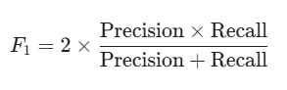

Additionally, System Latency will be measured to validate the microservice architecture, with a performance target of processing text and returning the JSON routing payload in under 200 milliseconds.

HIGH-LEVEL SYSTEM ARCHITECTURE

4.1 Component specific system diagram
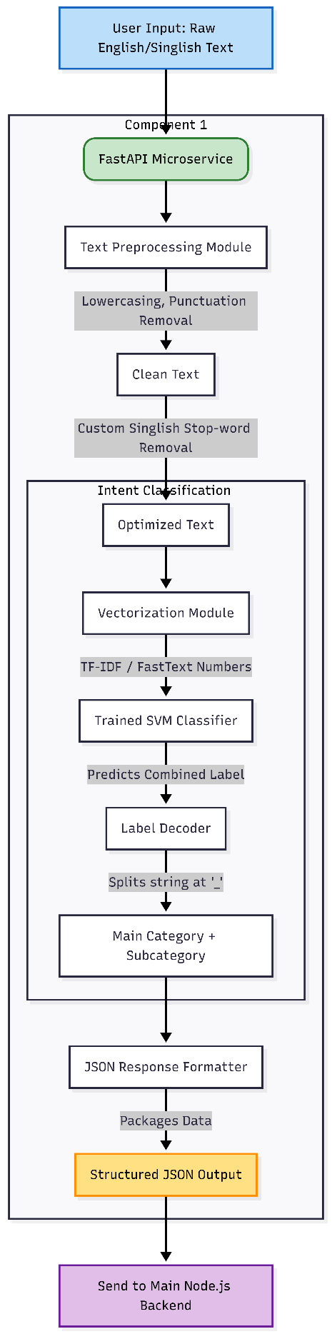

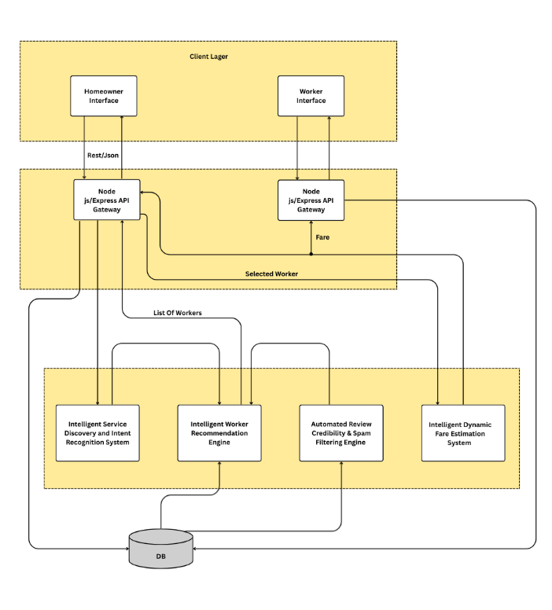
4.2 System Architecture Diagram

USER REQUIREMENTS

5.1 Stakeholder Identification
To accurately define the system requirements, the primary stakeholders interacting with the platform have been identified and categorized based on their roles and objectives:
- Homeowners (Service Seekers): Non-technical users who require an intuitive mobile interface to report household maintenance issues using their natural, conversational language (English or Singlish) without navigating complex taxonomy menus.
- Skilled Workers (Service Providers): Blue-collar professionals (e.g., plumbers, electricians, cleaners) who require a streamlined application to receive targeted job leads, optimized travel routes, and fair, dynamically calculated pricing for their services.
- System Administrators: Backend operators responsible for managing the central Node.js platform, monitoring the performance of the AI microservices, handling user verification, and maintaining the MongoDB database.

5.2 Functional Requirements
The following functional requirements define the specific operational capabilities of the Intelligent Intent Recognition microservice:
- Bilingual Input Reception: The component must expose a RESTful API endpoint (via FastAPI) capable of receiving unstructured, raw text strings from the central API Gateway in English, Singlish, or a code-mixed combination of both.
- Custom Text Preprocessing: The system must automatically pass the raw input through a bilingual preprocessing pipeline to execute lowercasing, punctuation stripping, and the removal of customized Singlish and English stop-words.
- Mathematical Vectorization: The system must transform the cleaned text string into high-dimensional numerical arrays using pre-loaded vectorization models (e.g., TF-IDF or FastText) without requiring external internet calls.
- Intent Classification: The system must process the vectorized array through a trained Support Vector Machine (SVM) algorithm to calculate the mathematical probability of the text belonging to specific predefined worker classes.
- Structured Payload Generation: The component must format the SVM's final prediction into a standardized JSON response containing two distinct data points: the Main Category and the Subcategory (e.g., {"main_category": "Plumber", "sub_category": "PipeRepair"}).
- Stateless Execution: The component must execute the prediction and return the JSON payload to the central Node.js server without permanently storing the user's raw text in its local environment.

5.3 Non-Functional Requirements
To ensure the platform is viable for real-world commercial deployment, the overall system architecture must adhere to the following non-functional quality attributes:
- Performance and Latency: Because user drop-off increases with wait times, the central Node.js API Gateway must return a complete match response to the mobile application in under 2.0 seconds. To support this, the independent Python AI microservices (such as Component 1) must execute their specific machine learning predictions in less than 200 milliseconds per request.
- Scalability: The system must utilize a decoupled microservices architecture. If the platform experiences a surge in user traffic, the system administrators must be able to horizontally scale the Node.js API Gateway and the individual Python ML containers independently across cloud infrastructure (e.g., AWS or Render) to prevent computational bottlenecking.
- Security and Data Privacy: All data transmitted between the mobile applications, the API Gateway, and the microservices must be encrypted in transit using HTTPS/TLS protocols. User authentication must be secured via stateless JSON Web Tokens (JWT). Furthermore, the overarching system must anonymize user problem descriptions before logging them in the MongoDB database to comply with standard data privacy regulations.
- Usability and Accessibility: The mobile application must be strictly "mobile-first" and designed for high accessibility. The system must possess a high tolerance for spelling errors and out-of-vocabulary phonetic variations, ensuring that users with lower technological literacy or informal typing habits can successfully operate the platform.
- Reliability and Fault Tolerance: The centralized system must aim for a 99.9% uptime availability. In the event that an individual AI microservice temporarily fails or times out, the central Node.js server must possess fallback mechanisms (e.g., gracefully degrading to a manual category selection menu on the user's app) rather than crashing the entire application.

COMMERCIALIZATION PLAN

6.1 Target Market and Customer Persona
The initial target market focuses on urban and suburban demographics within the Western Province of Sri Lanka, specifically targeting the informal household maintenance sector. The platform serves a dual-sided marketplace consisting of two primary customer personas:
- Persona A (The Homeowner/Consumer): Busy middle-to-high-income professionals aged 25–55. They value time and convenience but often lack the technical vocabulary to diagnose household faults. They predominantly communicate via mobile devices using conversational English or Singlish.
- Persona B (The Service Provider/Worker): Skilled independent contractors (e.g., plumbers, electricians, masons, and cleaners). They possess basic smartphone literacy but lack the capital for digital marketing. Their primary pain point is the inconsistency of daily work and the time wasted traveling to jobs that do not match their specific sub-skills.

6.2 Value Proposition
The platform’s core value proposition is "Frictionless, Language-Agnostic Service Discovery."
- For Homeowners: It eliminates the cognitive load of navigating complex service directories. Users can simply type their problem as they would text a friend (e.g., "Mage AC eka wada na"), and the AI instantly bridges the communication gap, automatically dispatching the correct professional.
- For Workers: It provides a zero-marketing-cost pipeline of highly targeted jobs. Because the NLP engine maps symptoms directly to specific subcategories, workers only receive notifications for jobs they are explicitly qualified to perform, significantly increasing their conversion rates.

6.3 Revenue Model
The platform will operate on a Commission-Based Transaction Model combined with a freemium SaaS architecture to ensure rapid initial user acquisition:
- Homeowner Usage: 100% free to download and submit service requests.
- Transaction Commission (Take Rate): A standard platform fee (e.g., 10%–15%) is automatically deducted from the total dynamic fare calculated by Component 4 upon the successful completion of a job.
- Worker Premium Tier: While basic profile listing is free, workers can opt into a low-cost monthly subscription to unlock advanced analytics (e.g., viewing high-demand geographical zones) or priority ranking in Component 2's recommendation algorithm.

6.4 Cost Estimation
Transitioning the FYP prototype into a commercial Minimum Viable Product (MVP) will incur the following estimated costs (calculated for Year 1 of operations):
- Capital Expenditure:
  - Legal & Business Registration (incorporation, trademarking): ~$150
  - Initial Cloud Setup & AI Training Compute (Google Colab Pro / AWS EC2): ~$200
- Operational Expenditure:
  - Cloud Hosting Architecture (Node.js Gateway on Heroku/AWS, Python FastAPI microservices on Render): ~$80/month.
  - Database Hosting (MongoDB Atlas scaling tiers): ~$30/month.
  - Third-Party APIs (Google Maps API for Component 3 routing): ~$50/month (usage dependent).
  - Targeted Digital Marketing & Social Media User Acquisition: ~$150/month.

6.5 Pricing Strategy
The platform leverages a Dynamic Pricing Strategy (driven by Component 4). Instead of static catalog prices that ignore market realities, the system calculates fares based on real-time variables such as GPS distance, time of day, urgency of the request, and current worker availability. This ensures fair compensation for the worker during peak hours or emergencies while maintaining transparent, upfront cost estimations for the homeowner before they confirm the booking.

6.6 Competitive Advantage
Currently, the local market relies on fragmented Facebook groups, traditional word-of-mouth, or static classified websites. The platform’s distinct competitive advantage is its Proprietary Intent Recognition Engine (Component 1). Existing competitors rely on rigid, exact-match English keyword searches, which fail when users input localized hardware slang or Singlish symptoms. By utilizing a bilingual SVM pipeline capable of processing unstructured code-mixed text, this platform captures a massive, unserved demographic that competitors mathematically cannot process.

6.7 Intellectual Property (IP) Considerations
To protect the commercial viability of the platform, several IP strategies will be implemented:
- Data IP (The Moat): The custom-built, annotated bilingual dataset mapping Singlish household problem descriptions to professional worker categories is highly unique. This proprietary dataset serves as a major barrier to entry for local competitors attempting to train similar AI models.
- Codebase & Algorithms: The specific text preprocessing pipeline (unified English-Singlish stop-word filtering) and the orchestration logic between the microservices will be protected under standard software copyright laws.
- Brand Identity: The platform’s name, logo, and UI/UX design will be trademarked to establish brand trust in the local market.
- Terms of Service: Legal frameworks will be established within the app to strictly prohibit automated scraping of the platform’s worker database or pricing algorithms by rival tech companies.

BUDGET AND JUSTIFICATION
The proposed budget is highly optimized for a university Final Year Project, ensuring that all funds are directed toward essential research and development infrastructure.
- Internet Charges & AI Tools: This allocates funds across all four group members over the 8-to-9-month project duration. Because the core of this project relies heavily on Artificial Intelligence, the team requires consistent, high-bandwidth internet access. This ensures members can seamlessly download large machine learning libraries (e.g., Hugging Face Transformers, Scikit-learn), access cloud-based training environments (like Google Colab), and utilize AI-assisted development tools for technical learning and debugging. Furthermore, stable connectivity is mandatory for the continuous integration and remote collaboration required by the microservices architecture.
- Hosting: This minimal hosting budget is designated for the final testing, integration, and presentation phases of the project (Phases 4 and 5). It covers the cost of deploying the Node.js API Gateway and the four independent Python FastAPI microservices to low-cost developer tiers on cloud platforms (such as Render or Heroku). This ensures the evaluation panel can interact with a live, functioning prototype of the mobile application and backend systems without incurring the high costs of commercial-grade server infrastructure.

Component | Amount in USD
Internet chargers for development resources and AI tools | 30
Hosting (final step) | 20
Total | 50

WORK BREAKDOWN STRUCTURE (WBS)

7.1 Task Breakdown per Member
The project utilizes a microservices architecture, which naturally facilitates parallel development and prevents technical bottlenecks. The workload is strictly balanced by assigning each member ownership of one complex machine learning component, while standard full-stack development tasks are distributed equally across the team.
- Member 1: Bandara W.A.M.S. (IT22551320) – Intelligent Service Discovery and Intent Recognition System
  - Core Responsibility: Design and develop the NLP classification component.
  - Specific Tasks: Collect and preprocess a dataset of service queries; implement Intent Recognition algorithms to classify user problems; develop Entity Extraction logic to identify specific items like "Tap" or "Leak".
- Member 2: Shiwanthika M.M. (IT22283658) – Intelligent Worker Recommendation Engine
  - Core Responsibility: Design and develop the context-aware matching system.
  - Specific Tasks: Define weighted scoring metrics (Skill match, Distance, Education, Availability); develop the Hybrid Recommendation Algorithm; integrate real-time location data to calculate dynamic arrival time scores.
- Member 3: Wijebandara W.N.S.K. (IT22643704) – Automated Review Credibility & Spam Filtering Engine
  - Core Responsibility: Design and develop the trust and sentiment analysis component.
  - Specific Tasks: Collect a dataset of genuine and spam reviews for training; train a Sentiment Analysis model (e.g., Naive Bayes) to classify feedback; implement a verifiable "Trust Score" calculation based on review authenticity.
- Member 4: Kumara A.J.T.M. (IT22137982) – Intelligent Dynamic Fare Estimation System
  - Core Responsibility: Design and develop the predictive pricing component.
  - Specific Tasks: Conduct a market survey to establish baseline labor and transport rates; develop a Regression Model to predict repair costs based on job complexity; implement the 3-Stage Pricing Logic covering transport, inspection, and repair estimates.
Shared Team Responsibilities (Balanced Workload): To ensure equitable distribution of labor, all members will collaborate on the following overarching platform requirements:
- Frontend Development: Collaborative development of the Homeowner and Worker mobile/web interfaces utilizing React and Next.js.
- Central Backend: Co-developing the central Node.js/Express API Gateway and configuring the MongoDB database schemas.
- Integration & Testing: End-to-end API testing to ensure the Python microservices communicate seamlessly with the Node.js server.
- Documentation: Equal division of research proposal writing, interim reports, and the final thesis document.

7.2 Timeline Alignment
Phase | Milestone / Tasks | Duration | Primary Focus
Phase 1 | Project Planning & Architecture Design  Finalize proposal, define API contracts between microservices, set up cloud repositories, and design MongoDB schemas. | Months 1 - 2 | Team Collaboration
Phase 2 | Data Collection & Core ML Development  Gather datasets, build preprocessing pipelines, train initial baseline machine learning models (NLP intent, Worker Ranking, Spam/Sentiment Analysis, Pricing Regression). | Months 3 - 4 | Individual Components
Phase 3 | Backend APIs & Frontend UI/UX  Wrap trained ML models in FastAPI, develop the Node.js API Gateway, and build the React/Next.js frontend user interfaces. | Months 5 - 6 | Parallel Development
Phase 4 | System Integration & Rigorous Testing  Connect the frontend to the backend, ensure data flows correctly to all four AI microservices, conduct latency and accuracy testing. | Month 7 | Team Collaboration
Phase 5 | Deployment, Evaluation & Documentation  Deploy the MVP to cloud infrastructure, finalize evaluation metrics, and complete the final academic thesis. | Months 8 - 9 | Finalization

7.3 Workload Distribution Strategy
The workload distribution strategy is inherently balanced due to the decoupled nature of the system architecture. During Phase 2, all four members will face similar cognitive loads as they research, train, and test their respective machine learning models in isolation (e.g., Member 1 training SVMs, Member 3 training Naive Bayes). Because the components are separated by strict API endpoints, no member is blocked by another's progress. During Phases 3 and 4, the workload shifts from individual research to collaborative software engineering, ensuring all members contribute equally to the final deployable product.

GANTT CHART
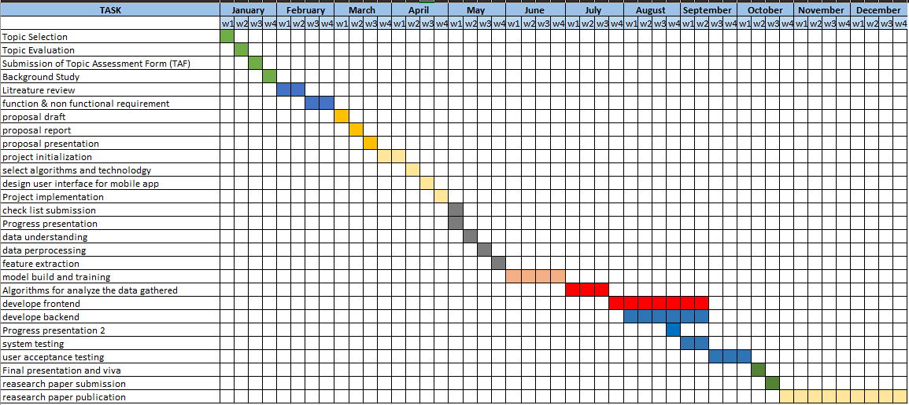

REFERENCES LIST
[1] D. Jurafsky and J. H. Martin, Speech and Language Processing, 3rd ed. draft, Stanford University, 2023.
[2] A. K. Uysal and S. Gunal, "The impact of preprocessing on text classification," Information Processing & Management, vol. 50, no. 1, pp. 104-112, 2014.
[3] T. Joachims, "Text categorization with Support Vector Machines: Learning with many relevant features," Machine Learning: ECML-98, pp. 137-142, 1998.
[4] J. Devlin, M. W. Chang, K. Lee, and K. Toutanova, "BERT: Pre-training of Deep Bidirectional Transformers for Language Understanding," arXiv preprint arXiv:1810.04805, 2018.
[5] X. Zhang, J. Zhao, and Y. LeCun, "Character-level Convolutional Networks for Text Classification," Advances in Neural Information Processing Systems, vol. 28, 2015.
[6] P. Bojanowski, E. Grave, A. Joulin, and T. Mikolov, "Enriching Word Vectors with Subword Information," Transactions of the Association for Computational Linguistics, vol. 5, pp. 135-146, 2017.
[7] M. Smith and L. Anderson, "User Interface friction in local gig-economy applications," International Journal of Human-Computer Studies, vol. 142, p. 102456, 2020.
[8] A. Rani and S. Singh, "Evaluation of Search Algorithms in E-commerce and Service Platforms," IEEE Access, vol. 9, pp. 45123-45135, 2021.
[9] S. Perera and D. Silva, "Digital Adoption in the Sri Lankan Informal Sector," Journal of South Asian Economic Development, vol. 12, no. 3, pp. 45-60, 2022.
[10] R. Sharma, "Limitations of Rule-Based Chatbots in Service Discovery," Proceedings of the International Conference on Human-Computer Interaction, 2021.
[11] C. Liyanage and A. Silva, "Challenges in Natural Language Processing for Code-Mixed Sinhala-English Text," Journal of Natural Language Engineering, vol. 28, no. 2, pp. 115-132, 2022
[12] S. Fernando, et al., "Sentiment Analysis of Sinhala-English Code-Mixed Data," IEEE International Conference on Asian Language Processing (IALP), 2020

