Design Document

Overview
The Jungle Game implementation follows the Model-View-Controller (MVC) architectural pattern to ensure clear separation of concerns, maintainability, and testability. The system is designed as a command-line application that manages game state, enforces rules, and provides file-based persistence for game records and save states.
The core design principles include:
- Object-oriented design with clear class hierarchies
- Separation of game logic (model) from user interface (view) and input handling (controller)
- Immutable game state transitions for reliable undo functionality
- Extensible architecture supporting different piece types and board configurations
- Robust error handling and input validation

1. Game Architecture Diagram
The Jungle Game follows the Model-View-Controller (MVC) architectural pattern, which provides clear separation of concerns and enables maintainable, testable code.
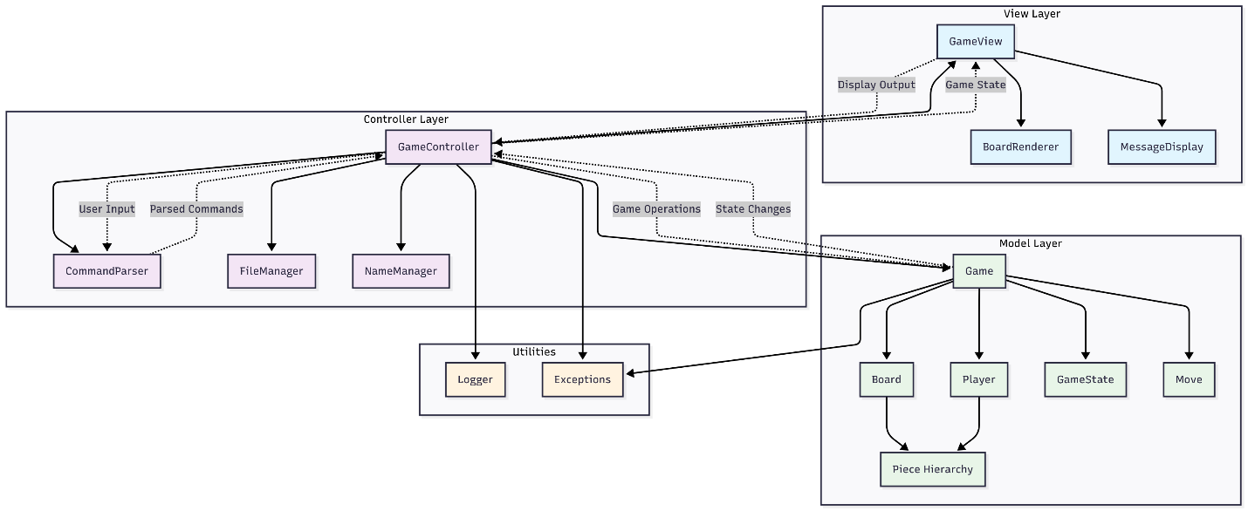
A copy of the diagram with higher definition is provided in the root folder
Why MVC was chosen:
- Separation of Concerns: Game logic, user interface, and input handling are cleanly separated
- Testability: The model can be unit tested independently of the UI
- Maintainability: Changes to game rules don't affect the UI, and UI changes don't affect game logic
- Extensibility: New features can be added to specific layers without affecting others
Component Instantiation:
Model: Contains all game logic, rules, and state management
- Game class: Central game state and rule enforcement
- Board class: Board representation and piece management
- Piece hierarchy: Animal pieces with specific behaviors
- Player class: Player information and piece ownership
- GameState class: Immutable snapshots for undo functionality
View: Handles all output and display formatting
- GameView class: Formats and displays game state
- BoardRenderer class: Renders the board with pieces and terrain
- MessageDisplay class: Handles user messages and prompts
Controller: Manages user input and coordinates between model and view
- GameController class: Main game loop and command processing
- CommandParser class: Parses and validates user input
- FileManager class: Handles save/load and record operations

2. Structure and Relationships Among Main Code Components
This diagram shows the detailed class structure and relationships within the Jungle Game system:
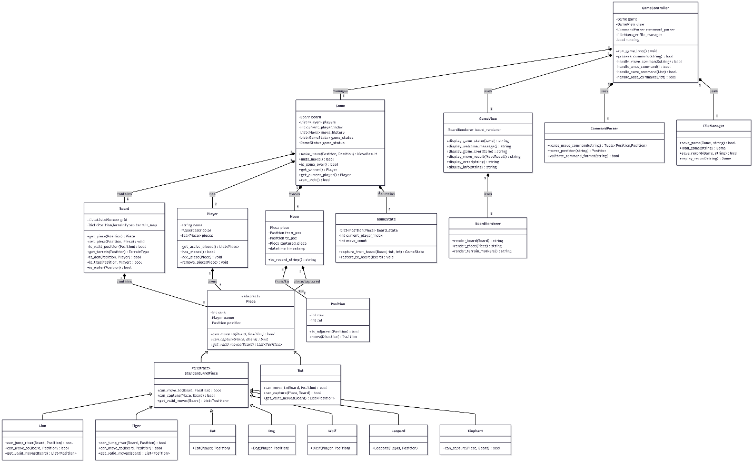
A copy of the diagram with higher definition is provided in the root folder

Key Relationships Explained:
Composition Relationships (strong ownership):
- Game contains Board, Players, Moves, and GameStates
- Board contains Pieces at specific positions
- Player owns multiple Pieces
- GameController manages the Game and uses View components
Inheritance Relationships:
- All animal pieces inherit from Piece abstract base class
- Most land animals inherit from StandardLandPiece for common behavior
- Rat, Lion, and Tiger have special behaviors requiring direct Piece inheritance
Dependency Relationships:
- Controllers depend on Models for game logic
- Views depend on Models for display data
- All components use supporting classes like Position and Move

3. User Turn Sequence Diagram
This diagram illustrates the complete flow of events during a user's turn, from input to game state update:
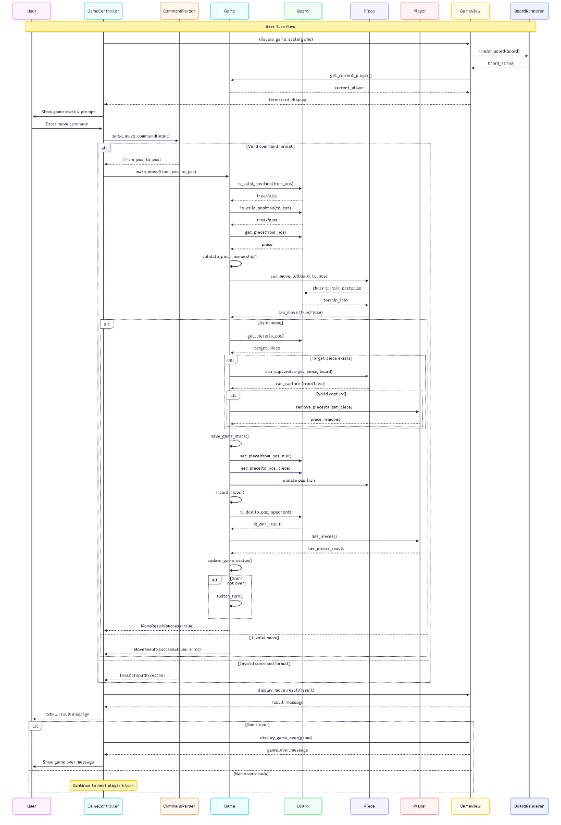
A copy of the diagram with higher definition is provided in the root folder
Key Phases Explained:
1. Display Phase:
- Controller requests current game state from View
- View renders board using BoardRenderer
- Current player information is displayed
- User sees complete game state and input prompt
2. Input Processing Phase:
- User enters move command
- CommandParser validates and parses input format
- Invalid format results in immediate error feedback
3. Move Validation Phase:
- Game validates position bounds using Board
- Game checks piece ownership and existence
- Piece validates move legality using Board terrain information
- Complex validation includes terrain restrictions and piece-specific rules
4. Move Execution Phase:
- Game saves current state for undo functionality
- Capture logic executed if target piece exists
- Board state updated with new piece positions
- Move recorded in game history
5. Game State Update Phase:
- Victory conditions checked (den reached, all pieces captured)
- Game status updated if victory achieved
- Turn switched to next player if game continues
6. Feedback Phase:
- Move result displayed to user
- Game over message shown if applicable
- System ready for next turn or game end actions
This sequence ensures complete validation, proper state management, and comprehensive user feedback throughout each turn.
Components and Interfaces
Model Package Components
Core Game Classes
class Game:
"""Central game state manager and rule enforcer"""
- board: Board
- players: List[Player]
- current_player_index: int
- move_history: List[Move]
- game_states: List[GameState] # For undo functionality
- game_status: GameStatus

+ make_move(from_pos: Position, to_pos: Position) -> MoveResult
+ undo_move() -> bool
+ is_game_over() -> bool
+ get_winner() -> Optional[Player]
+ get_current_player() -> Player
+ can_undo() -> bool

class Board:
"""7x9 game board with terrain and piece management"""
- grid: List[List[Optional[Piece]]]
- terrain_map: Dict[Position, TerrainType]

+ get_piece(pos: Position) -> Optional[Piece]
+ set_piece(pos: Position, piece: Optional[Piece]) -> None
+ is_valid_position(pos: Position) -> bool
+ get_terrain(pos: Position) -> TerrainType
+ is_den(pos: Position, player: Player) -> bool
+ is_trap(pos: Position, player: Player) -> bool
+ is_water(pos: Position) -> bool

class Player:
"""Player information and piece ownership"""
- name: str
- color: PlayerColor
- pieces: Set[Piece]

+ get_active_pieces() -> List[Piece]
+ has_pieces() -> bool
+ remove_piece(piece: Piece) -> None
Piece Hierarchy
class Piece(ABC):
"""Abstract base class for all game pieces"""
- rank: int
- owner: Player
- position: Position

+ can_move_to(board: Board, target: Position) -> bool
+ can_capture(target_piece: Piece, board: Board) -> bool
+ get_valid_moves(board: Board) -> List[Position]

class Rat(Piece):
"""Rank 1 - Can move in water, special capture rules"""
+ can_move_to(board: Board, target: Position) -> bool
+ can_capture(target_piece: Piece, board: Board) -> bool

class Cat(Piece):
"""Rank 2 - Standard land animal"""

class Dog(Piece):
"""Rank 3 - Standard land animal"""

class Wolf(Piece):
"""Rank 4 - Standard land animal"""

class Leopard(Piece):
"""Rank 5 - Standard land animal"""

class Tiger(Piece):
"""Rank 6 - Can jump over rivers"""
+ can_jump_river(board: Board, target: Position) -> bool

class Lion(Piece):
"""Rank 7 - Can jump over rivers"""
+ can_jump_river(board: Board, target: Position) -> bool

class Elephant(Piece):
"""Rank 8 - Cannot be captured by rat"""
+ can_capture(target_piece: Piece, board: Board) -> bool
Supporting Classes
class Position:
"""Immutable position representation"""
- row: int
- col: int

+ is_adjacent(other: Position) -> bool
+ get_direction(other: Position) -> Direction
+ __eq__, __hash__, __str__

class Move:
"""Immutable move record"""
- piece: Piece
- from_pos: Position
- to_pos: Position
- captured_piece: Optional[Piece]
- timestamp: datetime

class GameState:
"""Immutable game state snapshot for undo"""
- board_state: Dict[Position, Optional[Piece]]
- current_player_index: int
- move_count: int

+ restore_to_game(game: Game) -> None

class GameStatus(Enum):
ONGOING = "ongoing"
PLAYER_ONE_WINS = "player_one_wins"
PLAYER_TWO_WINS = "player_two_wins"
DRAW = "draw"
View Package Components
class GameView:
"""Main view coordinator"""
- board_renderer: BoardRenderer
- message_display: MessageDisplay

+ display_game_state(game: Game) -> None
+ display_welcome_message() -> None
+ display_game_over(winner: Optional[Player]) -> None

class BoardRenderer:
"""Handles board visualization"""
+ render_board(board: Board) -> str
+ render_piece(piece: Optional[Piece]) -> str
+ render_terrain_markers() -> str

class MessageDisplay:
"""Handles user messages and prompts"""
+ show_error(message: str) -> None
+ show_info(message: str) -> None
+ prompt_for_input(prompt: str) -> str
Controller Package Components
class GameController:
"""Main game controller and command processor"""
- game: Game
- view: GameView
- command_parser: CommandParser
- file_manager: FileManager

+ run_game_loop() -> None
+ process_command(command: str) -> bool
+ handle_move_command(args: List[str]) -> None
+ handle_save_command(filename: str) -> None
+ handle_load_command(filename: str) -> None

class CommandParser:
"""Parses and validates user input"""
+ parse_move_command(input_str: str) -> Tuple[Position, Position]
+ parse_position(pos_str: str) -> Position
+ validate_command_format(command: str) -> bool

class FileManager:
"""Handles file operations for save/load and records"""
+ save_game(game: Game, filename: str) -> bool
+ load_game(filename: str) -> Optional[Game]
+ save_record(game: Game, filename: str) -> bool
+ load_record(filename: str) -> Optional[List[Move]]
Data Models
Core Data Structures
# Enumerations
class TerrainType(Enum):
LAND = "land"
WATER = "water"
DEN = "den"
TRAP = "trap"

class PlayerColor(Enum):
RED = "red"
BLUE = "blue"

class Direction(Enum):
NORTH = (-1, 0)
SOUTH = (1, 0)
EAST = (0, 1)
WEST = (0, -1)

# Data Transfer Objects
@dataclass
class MoveResult:
success: bool
message: str
captured_piece: Optional[Piece] = None

@dataclass
class GameConfig:
board_width: int = 7
board_height: int = 9
max_undo_moves: int = 3
player_names: List[str] = field(default_factory=lambda: ["Player 1", "Player 2"])
File Format Specifications
Save File Format (.jungle):
{
"version": "1.0",
"players": [
{"name": "Player 1", "color": "red"},
{"name": "Player 2", "color": "blue"}
],
"current_player": 0,
"board_state": {
"0,0": {"piece": "elephant", "owner": "red"},
"0,6": {"piece": "elephant", "owner": "blue"}
},
"move_history": [
{
"piece": "rat",
"from": "2,0",
"to": "3,0",
"captured": null,
"timestamp": "2024-01-01T10:00:00"
}
],
"game_status": "ongoing"
}
Record File Format (.record):
JUNGLE_GAME_RECORD_V1.0
Players: Player 1 (Red), Player 2 (Blue)
Start Time: 2024-01-01 10:00:00
Move 1: Player 1 - Rat from (2,0) to (3,0)
Move 2: Player 2 - Cat from (2,6) to (3,6)
...
Game Result: Player 1 Wins - Reached opponent's den
End Time: 2024-01-01 10:15:30

Error Handling
Exception Hierarchy
class JungleGameException(Exception):
"""Base exception for all game-related errors"""

class InvalidMoveException(JungleGameException):
"""Raised when a move violates game rules"""

class InvalidPositionException(JungleGameException):
"""Raised when position is outside board bounds"""

class GameOverException(JungleGameException):
"""Raised when attempting to play after game ends"""

class FileOperationException(JungleGameException):
"""Raised when file save/load operations fail"""
Error Handling Strategy
- Input Validation: All user inputs are validated before processing
- Graceful Degradation: Invalid commands show helpful error messages
- State Consistency: Game state remains consistent even after errors
- File Operation Safety: Backup existing files before overwriting
- Recovery Mechanisms: Undo functionality helps recover from mistakes

Testing Strategy
Unit Testing Approach
Model Testing (Primary Focus):
- Piece Movement Tests: Validate each piece type's movement rules
- Capture Logic Tests: Test all capture scenarios including special cases
- Board State Tests: Verify board initialization and state management
- Game Flow Tests: Test turn management and game ending conditions
- Undo Functionality Tests: Validate state restoration accuracy
- File Operations Tests: Test save/load and record functionality
Test Categories:
- Rule Enforcement Tests
  - Valid/invalid moves for each piece type
  - Capture rules including rank-based and special cases
  - Water movement restrictions
  - River jumping mechanics
  - Trap and den interactions
- Game State Management Tests
  - Turn switching
  - Victory condition detection
  - Undo/redo functionality
  - Game state serialization
- Edge Case Tests
  - Boundary position handling
  - Multiple piece interactions
  - Complex capture scenarios
  - File corruption handling
Testing Framework: Python's built-in unittest framework Coverage Target: 90%+ line coverage for the model package Test Data: Predefined board states and move sequences for consistent testing
Integration Testing
- Controller-Model Integration: Test command processing and game state updates
- File System Integration: Test save/load operations with actual files
- View-Model Integration: Test display formatting with various game states
Test Automation
- All tests executable via python -m unittest discover
- Continuous integration setup for automated test execution
- Coverage reporting using coverage.py tool
- Test data fixtures for consistent test scenarios

