**Housing Prices in Lisbon**

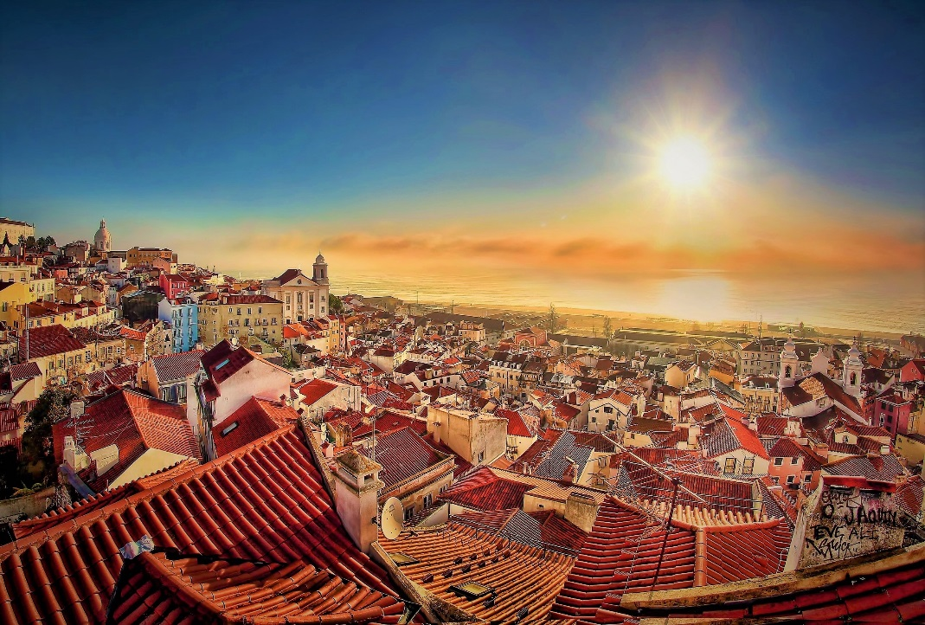Realized by João Santos

**Description of the problem & Background**

Lisbon is the stunning capital city of Portugal and is one of the most charismatic and vibrant cities of Europe. It is a city that effortlessly blends traditional heritage, with striking modernism and progressive thinking. As a holiday destination, Lisbon offers a rich and varied history, a buzzing nightlife and is blessed with a glorious year-round climate. Data shows over 4,5 Million tourists visit Lisbon, per year, being Lisbon one of the most desired places to visit. The district is divided into 16 municipals in total, and each of them have different aspects that makes them unique. As a resident of this city, I decided to use Lisbon as my project. With this project, investors, young people looking for houses, can find the most affordable regions to live on, as well some information regarding venues.

If we think of the city residents, they may want to choose the regions where real estate values are lower, too. At the same time, they may want to choose the district according to the social place’s density. However, it is difficult to obtain information that will guide investors in this direction, nowadays. When we consider all these problems, we can create a map and information chart where the real estate index is placed on Lisbon and each municipal is clustered according to the venue density.

**Data Description**

In this project, I will get the data from two sources: Second-level Administrative Divisions of Portugal from Spatial Data Repository of NYU and Price per square meter in Portugal municipals. From the first one, the .json file has coordinates of the all city of Portugal. I will clean the data and reduced it to city of Lisbon where I will use it to create choropleth map of the prices per square meter in the district of Lisbon. The second is a dataset that contains the price per square meter in all municipalities in Portugal. Also, I will use Foursquare API to get the most common venues of given Borough of Lisbon, alongside Google Map, ‘Search Nearby’ option to get the center coordinates of each Borough.