Loan Calculator React App - Technical Assessment

Candidate: Jagadeesh Roy

Submission Date: May 06, 2025

# 1. Features Implemented

- EMI calculation using financial formula  
- Amortization schedule with monthly breakdown  
- Currency conversion using ExchangeRate API  
- Pagination for exchange rates  
- Dark/Light theme toggle  
- Responsive mobile navigation (collapsible drawer)  
- Error and 404 pages

# 2. Technologies Used

- React with Hooks and Context API  
- Material UI for styling and components  
- Axios for API fetching  
- ExchangeRate API for currency conversion

# 3. Deployment

Deployed using Vercel (link to be added in GitHub README).

# 4. How to Run Locally

1. Clone the repo: git clone https://github.com/yourusername/loan-calculator.git  
2. Navigate to the project folder.  
3. Run `npm install` to install dependencies.  
4. Run `npm start` to start the development server.

# 5. Screenshots

Included screenshots of the application pages (EMI form, amortization table, currency conversion table, 404 page, dark/light mode toggle }

dark/light mode toggle

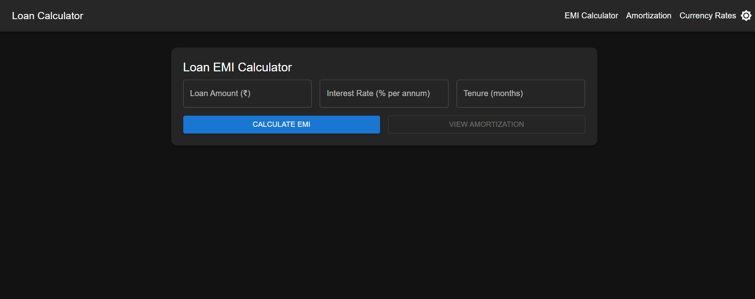

Thank you!

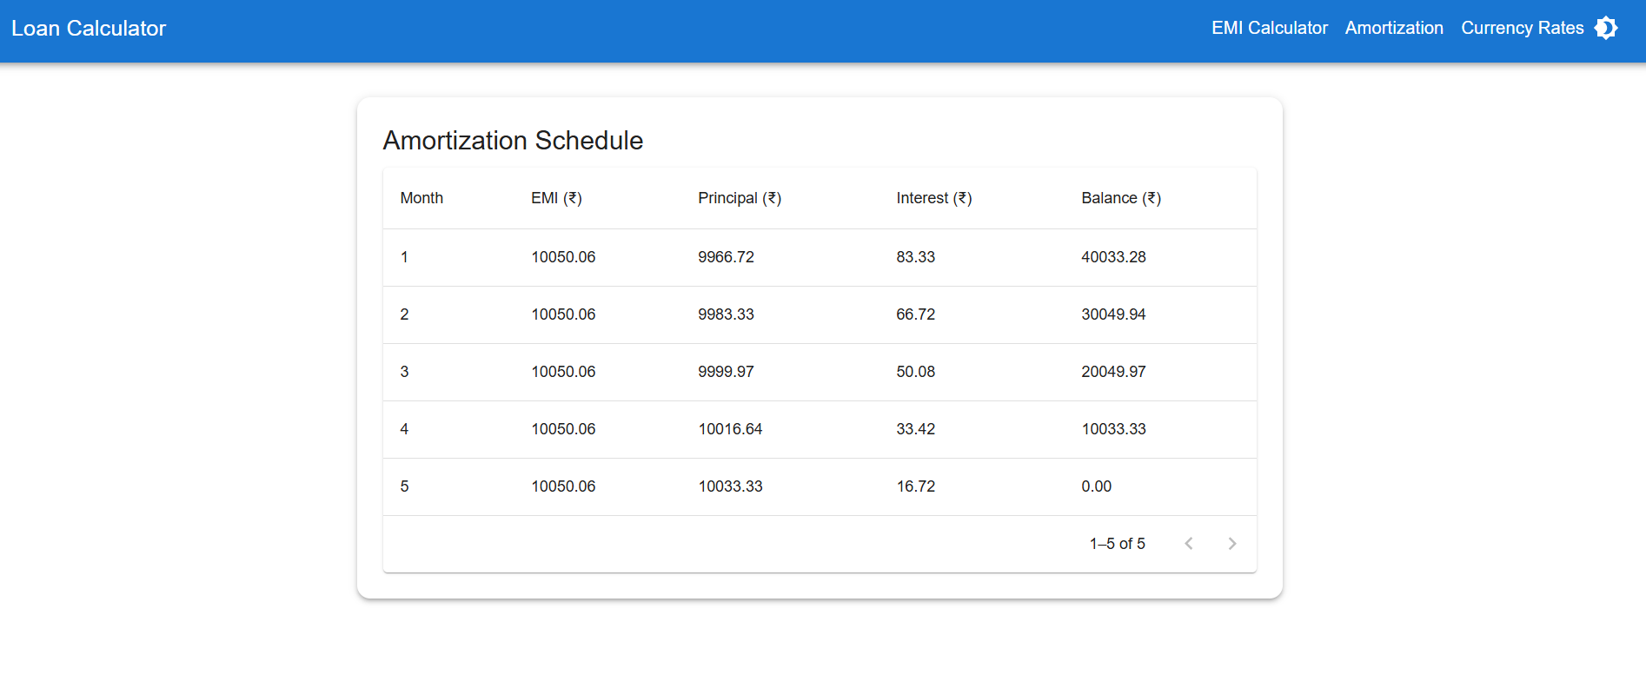

# 📸 Screenshots

Below are the screenshots of the completed Loan Calculator App:

1. EMI Calculator Form

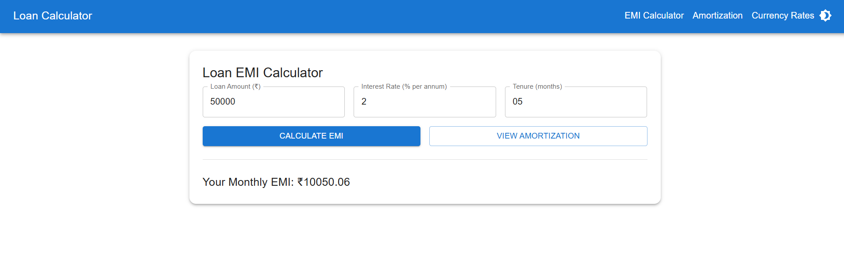

1. Amortization Schedule Table



3. Currency Conversion Table with Pagination 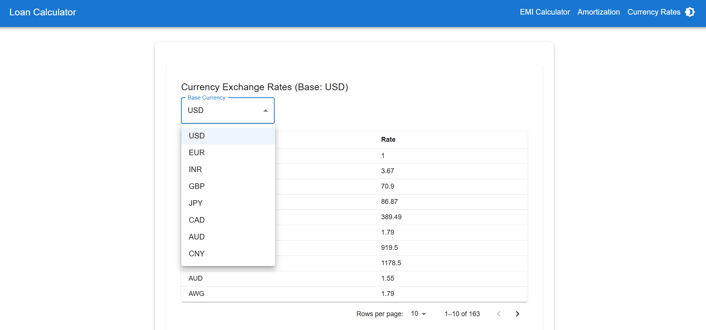

4.Dark/Light Mode Toggle



5. 404 Not Found Page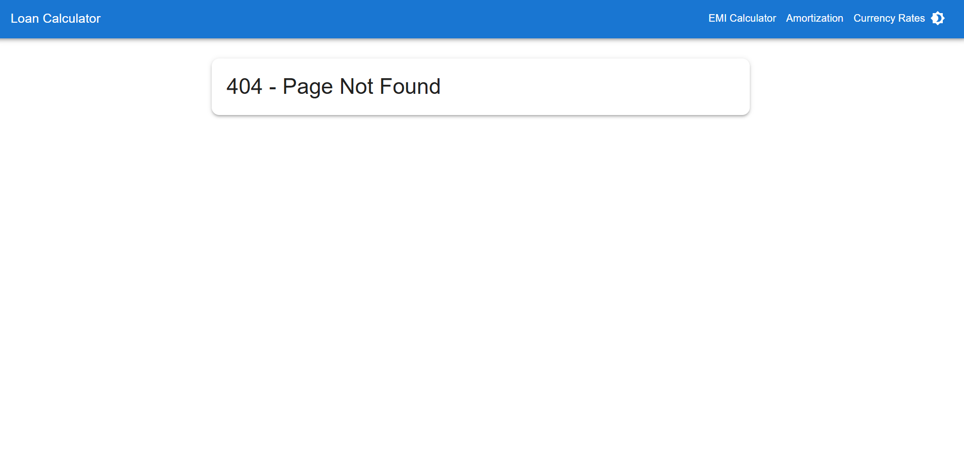

6. Responsive Drawer Navigation (Mobile View) 