Groovy Grove

IDEA:
Groovy Grove is a local co-op forest ranger-sim, where two players are tied together and must work to preserve a forest. Players work on tasks such as planting saplings, collecting trash and repairing nesting boxes while avoiding possible hazards that could separate the two by breaking the rope that connects them.
-Target audience: ages 7 and above, anyone interested in a funky co-op adventure in the woods.

GOALS:
-Complete a certain number of different tasks
-Avoid hazards and keep the rope connecting the two players intact.
Win conditions:
-Players have completed the main objective(s)
-Players interact with a car on Area 4 (more below)
Loss conditions:
-The rope breaks

MECHANICS & CONTROLS:
-Controller & Keyboard support
-Bird-view movement (WASD/arrows, D-pad/joystick)
-Interaction input (E, Space, X, A (on Xbox controller))
-Minigame input (Q, E, D-Pad/LB&RB)
-Players tied together with a rope that can break
-Co-op minigames (or minigames that require both players)
-Simple inventory system (one item per player at a time)

TWO-PLAYER INTERACTION MODEL:
-All the tasks in the game require both players but are also individual. Each task requires a pair of items; each player holds one and is assigned an individual task based on the item.

Tasks:
-Repair a nesting box: One player gets a ladder and the other a hammer, the one with a ladder must hold it as the other climbs them up and repairs the nesting box.
-Replant trees: One player gets a garden spade and the other a bag of saplings, upon reaching a replanting spot, one player must make the spot suitable for the sapling using their spade, then the other simply plants the sapling.
-Collect trash: One player gets a pair of picking pliers and the other a garbage bag, the players must clear a certain area by picking up trash with the pliers and putting it into the trash bag.

LEVEL DESIGN:
-Planting spots, trash clearing areas and nesting boxes across the map
-Hazards across the map (thorny bushes, sharp rocks, trees)
-Players must avoid obstacles and navigate the forest as a team, or they WILL get entangled.

ART STYLE:
-The game has a top-down pixel-art style, inspired by indie titles like “Stardew Valley” and “The Escapists 2”.
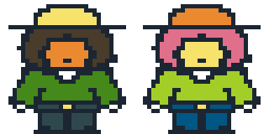
Figure 1, Concept of player characters
-The art for the game will be made by us; we use a colour palette called “ARNE 16”: https://lospec.com/palette-list/arne-16.
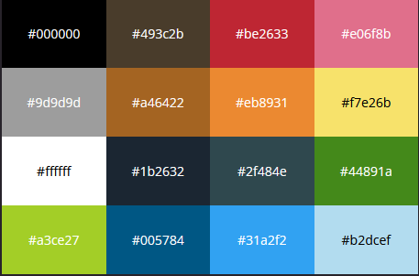
Figure 2, Colour palette
-The game will have sounds for walking, task progression (depending on the task) and task completion. Ambient, looping background music will also be added.

GAMEPLAY LOOP:
-Gameplay will use a linear model, where new areas unlock only when the current one is completed.
-The map will always be 100% open, players spawn in the centre of the map.
Players spawn >> Players obtain the required tools for the first area >> Players navigate the map (while avoiding hazards) to get to the specific tasks depending on the current area >> Players complete tasks and unlock the next set of items and progress to the next area.
-Tasks per area:
Area 1 (left): River, collect trash
Area 2 (up): Logging square, replant trees
Area 3 (right): The woods, repair nesting boxes
Area 4 (down): The exit, players need to get here to complete the game but can’t leave until each required task is completed.
-Sub-areas (bonus points, doesn’t require tools):
Ditch (In between areas 1 and 2, removing lupines (invasive species))
Pathway (In area 3, clear blockage)
Struggling sapling (across the map, protect new growth)

SCOPE:
-At minimum, the game must contain working mechanics for the rope, hazards. controls and minigames.
-Player inventory limited to one item to make coding easier and faster, simple minigames (quick-time event, appears as a part of a task, planting trees, for example) for the same reason.
-Simple and readable art style, we don’t want to waste too much time on art.
-Sub-areas are optional, yet we aim to deliver them in time.

