
УДК 001.92 Scientific article DOI: DOI:10.18287/2223-9537-2025-15-1-ХХХ-ХХХ
Operational Limits of Ontological Innovation in LLMs: Evidence from Controlled Sensory-Modality Generation
© 2026, J.O. Matarmaa¹
¹ Institute of Radio Electronics and Information Technologies, Ural Federal University, Yekaterinburg, Russia
Abstract
Contemporary large language models generate text that can appear conceptually novel, raising the question of whether outputs reflect genuine ontological innovation—the introduction of concepts that cannot be expressed as recombinations or transformations of training-derived primitives—or sophisticated recombination within a fixed representational manifold. We address this question through a controlled empirical study using an eight-modality multi-modal sensory ontology as the experimental universe. Seven state-of-the-art language models (N = 168 proposals, 24 runs each) were prompted to propose a ninth sensory modality genuinely beyond the defined eight. Outputs were evaluated through four convergent methods: literature traceability with calibrated threshold (τ = 0.40), structural decomposition, embedding-space convex-hull analysis, and continuous novelty scoring. Results show a strict novelty rate of p̂_{novel} = 0.000 (95% CI: [0.000, 0.000]), a traceability rate of p̂_{traceable} = 0.982, and 100% convex-hull membership under Sentence-BERT embeddings reduced to three principal components. Structural decomposition identified three failure modes: range extension (20.2%), hybrid combination (44.6%), and functional recombination (17.9%). Cross-model effects were moderate (η² = 0.305) yet all models remained within the same low-novelty regime, supporting a constrained-manifold rather than a model-deficit explanation. We interpret these findings through the No New Basis Theorem: gradient-descent learning over fixed vocabularies can- not expand representational dimensionality beyond training data. These results support the view that current neural architectures are bounded within training- derived conceptual closures, with implications for operationalizing and evaluating ontological creativity.
Keywords: ontological innovation, computational creativity, large language models, conceptual spaces, traceability analysis, representational constraints.
Citation: Matarmaa J.O. Operational Limits of Ontological Innovation in LLM: Evidence from Controlled Sensory-Modality Generation. Ontology of designing. 2026. Т.15, №1(55). С.ХХХ-ХХХ. DOI: DOI:10.18287/2223-9537-2025-15-1-ХХХ-ХХХ.
Funding: No funding was received to assist with the preparation of this manuscript.
Authors’ contributions: The author was solely responsible for the conception, writing, and revision of this manuscript.
Competing Interests: The authors declare no competing interests.
Ethics Approval: Not applicable.
Introduction
The capacity to generate fundamentally new concepts—not merely recombinations of existing ones—has long been considered a hallmark of human intelligence and a defining test of genuine creativity. As large language models (LLMs) achieve impressive performance on a broadening range of generative tasks, a pressing question has emerged: do these systems exhibit ontological innovation, generating ideas that lie outside the conceptual closure of their training environment, or do they operate as extremely capable recombiners constrained to a fixed representational manifold?
This question has both philosophical and practical stakes. Philosophically, it bears on the computational theory of mind, the nature of creativity, and whether algorithmic systems can in principle exceed the representational resources with which they were trained. Practically, it determines what roles LLMs can occupy in scientific discovery, design, and other domains where genuinely new concepts—not just novel arrangements of existing ones—are required [1].
The challenge is that outputs from modern LLMs frequently appear novel. Proposals that introduce unfamiliar terminology, combine concepts across disciplinary boundaries, or describe mechanisms not explicitly present in any single training document can pass casual inspection as genuinely creative [2, 3]. Evaluating whether such outputs constitute true conceptual innovation requires a controlled experimental setup and rigorous multi-method analysis rather than surface-level assessment.
In this paper we report a focused empirical study designed to provide exactly this kind of evaluation. We use a multi-modal sensory ontology—a well-defined, eight-modality conceptual space representing biological and extended machine sensing—as the experimental universe. This setup provides precise control: we know exactly which concepts exist in the training context, enabling systematic investigation of whether AI-generated proposals lie outside the defined space. Seven contemporary LLMs were prompted to propose a ninth sensory modality, genuinely beyond any of the eight. We evaluate their proposals through four convergent methods that progressively sharpen the diagnostic picture.
Our main contributions are:
- A controlled experimental paradigm for operationalizing ontological innovation, grounded in a well-defined multi-modal sensory ontology that functions as an explicit training universe.
- Multi-method evaluation combining literature traceability with calibrated thresholds, structural decomposition, embedding-space convex-hull analysis, and continuous novelty scoring, providing convergent evidence without reliance on subjective expert judgment.
- Systematic empirical evidence that seven state-of-the-art LLMs produce zero strictly novel proposals across 168 evaluated outputs, with near-saturated traceability to known conceptual material.
- Formal grounding through the No New Basis Theorem, relating observed empirical constraints to architectural properties of gradient-descent-trained neural networks.
The paper is organized as follows. Section 1 reviews related work on computational creativity and representational limits. Section 2 describes the dataset, task, models, and evaluation procedures. Section 3 presents the results across all evaluation methods. Section 4 interprets the findings and discusses limitations.
- Background and Related Work
  - Boden's Creativity Taxonomy
The dominant framework for analyzing machine creativity is Margaret Boden's tripartite taxonomy [4], which distinguishes outputs based on their relationship to the conceptual space from which they arise. Combinational creativity produces novel combinations of familiar ideas—poetic metaphors, analogies, conceptual blends. Exploratory creativity systematically searches well-defined conceptual spaces to find previously unvisited regions. Transformational creativity, the most radical category, modifies the conceptual space itself by relaxing or changing its defining constraints.
Research on AI systems has demonstrated substantial competence at combinational and exploratory creativity [5, 6]. Systems such as Copycat, JAPE, and AARON can generate outputs that human evaluators judge as genuinely surprising and apt within their respective domains. Robust transformational creativity, however, remains rare: most documented examples involve superficial parameter modifications rather than fundamental reconceptualization [4].
Wiggins [2] introduced a formal framework for evaluating creativity claims and identified a "framing" problem: systems appear to transform their conceptual space while actually operating within an implicitly broader space defined by human designers. This critique applies with particular force to contemporary LLMs, whose training corpora implicitly define a vast but still finite conceptual universe.
  - Ontological Creativity
We argue that a fourth category, which we term ontological creativity, is needed to capture the most radical form of conceptual innovation. Transformational creativity modifies operators $Ω$ or relations $E$ within a conceptual space $C=\left(V,E,Φ,Ω\right)$; ontological creativity introduces new primitive concepts $v′∈V′$ where $V′⊄V$ and critically $V′$ cannot be expressed as $Ω\left(V\right)$ for any existing operators.
This distinction maps onto Ryle's philosophical notion of category mistakes [7]: ontological creativity involves recognising that existing categories are insufficient and proposing new ones that cannot be defined by recombining or transforming current primitives. Einstein's reconceptualisation of absolute simultaneity as a category error, leading to a revised ontology of relativistic spacetime, exemplifies this form of creativity. Generating a genuinely new sensory modality would be analogous: not an extension or hybridization of existing ones, but a proposal for a sensing type with a physical basis and information content that cannot be expressed as a composition of the existing eight.
  - Formal Representational Constraints
The computational theory of mind [8, 9] and its critics [10–12] have long debated whether algorithmic systems face principled limits on what they can represent and understand. Recent work in mechanistic interpretability provides empirical traction on this question by revealing that generation in transformer-based LLMs proceeds through retrieval and interpolation among training examples rather than through any inference mechanism that could introduce entirely new primitives [13, 14].
The transformer architecture [15] encodes all knowledge implicitly in weights learned from distributional co-occurrence, which grounds the output space in the training vocabulary of concepts. Gärdenfors's conceptual-spaces formalism [16] provides complementary geometric intuition: a learned concept lives as a region in a quality space, and generating a new concept outside all existing regions requires an external basis vector not present in the training data.
We formalize the core constraint as the No New Basis Theorem: for any neural architecture $A$operating over representation space $ℝ^{d}$ with generative process G: $ℝ^{d}→ℝ^{d}$ learned from training data $D=x₁,...,xₙ$, all generated outputs $x′=G\left(z\right)$ lie within $M′$, a continuous deformation of $M=span\left(x₁,...,xₙ\right)$ satisfying $dim\left(M′\right)≤dim\left(M\right)$. Ontological novelty would require expanding the basis of $M$, which no internal generative mechanism can achieve without architectural or data augmentation.
This theorem explains why even highly capable models that produce surprising combinations remain formally constrained to the conceptual universe their training data defines. Our empirical study provides a controlled test of whether this theoretical constraint manifests behaviourally.
  - Evaluation Challenges in Computational Creativity
A persistent methodological challenge in computational creativity research is evaluation [2, 3]. Human expert judgments are subjective, difficult to reproduce, and sensitive to framing. Recent studies show that LLMs can achieve human-level performance on divergent-thinking tasks such as the Alternative Uses Test [17], but scoring quality depends strongly on the evaluation metric [18]. Recent 2024–2026 work further confirms metric sensitivity and proposes newer creativity-evaluation protocols for LLMs, including human-comparative, temperature-sensitivity, and model-guided creativity-judging paradigms [19–25]. Our multi-method approach—traceability search, structural decomposition, embedding-space geometry, and continuous scoring—provides convergent automated evidence that can be replicated and extended. Calibrated traceability thresholds replace arbitrary cut-offs with empirically justified operating points.
- Materials and Methods
  - The Multi-modal Sensory Ontology
The experimental universe consists of eight sensory modalities, each defined by a physical basis, an information channel, and a functional role in an agent's interaction with its environment (Table 1). Modalities span biological human senses and extended machine-sensing capabilities.

Table 1 — Eight-modality sensory ontology used as the experimental universe. Each modality is defined by its physical basis, representational dimensionality, and functional role.
Modality | Physical basis | Functional role | Dim.
Visual | EM spectrum 300–1000 nm (5 nm steps) | Scene and object recognition | 140
Auditory | Pressure waves 1 Hz–100 kHz (128-bin FFT) | Sound source localisation | 128
Tactile | Mechanical vibrations 5–800 Hz | Surface texture and pressure | 32
Olfactory | Chemical categories (10 classes) | Substance identification | 10
Gustatory | Taste dimensions (sweet/sour/salty/bitter/umami) | Ingestion guidance | 5
Proprioceptive | 20 joint angles + 10 muscle tensions | Body-state estimation | 30
Vestibular | 3-axis acceleration + 3-axis angular velocity | Balance and motion | 6
Interoceptive | HR, respiration, skin conductance, temperature, hunger, thirst, fatigue, pain | Homeostatic regulation | 8

The full dataset contains 5,000 training, 1,000 validation, and 1,000 test examples, each representing a 60-second episode at 1 Hz sampling (21,540 data points per example) drawn from seven everyday scenarios (walking, running, sitting, eating, drinking, listening, viewing). An explicit machine-readable ontology layer documents the physical basis, information content, and functional role of each modality, enabling automated evaluation.
  - Task Definition and Prompt Contract
Each model was asked to propose a ninth sensory modality that is genuinely new and not reducible to combinations, extensions, or transformations of the existing eight. Proposals were required to specify: (1) the physical phenomenon to be sensed, (2) the information channel and encoding, and (3) the functional difference from existing modalities. The complete ontology table (Table 1) was provided in structured tabular format alongside a natural-language description of each modality.
Prompts were designed to be task-neutral—they did not suggest what kinds of answers would or would not qualify as novel, to avoid anchoring models toward specific response types. Twenty-four independent runs were collected from each of seven models, yielding $N=7×24=168$ proposals in total.
  - Models and Implementation
Seven state-of-the-art models were evaluated: GPT-5.2 [26], Claude-3.7-Sonnet, Gemini-3.1-Pro-Preview [27], LLaMA-3.3-70B-Instruct [28], DeepSeek-v3.2 [29, 30], Mistral-Large [31], and Perplexity Sonar Pro, accessed via the OpenRouter, Perplexity, and Mistral APIs. All runs used temperature $T=0.7$; the Perplexity API does not support temperature adjustment and was operated at provider defaults. System prompts were crafted to neutrally present the task without introducing bias toward particular answer types.
  - Evaluation Protocol
Literature traceability: Each proposal was matched against a curated scholarly corpus of 125 documents covering sensory biology, robotics sensing, and computational neuroscience, using cosine similarity over Sentence-BERT embeddings [32]. A proposal is classified as traceable if its best-match similarity exceeds threshold $τ$.
Threshold selection followed an explicit calibration step. Three candidate operating points ($τ∈0.30,0.40,0.50$) were compared on the full response–corpus similarity distribution. At $τ=0.30$, every proposal was traceable (mean 23.7 matching documents per proposal), providing no discrimination. At $τ=0.50$, only 64.9% of proposals were traceable (mean 1.24 matching documents), indicating over-pruning. The intermediate value $τ=0.40$ was retained as the best-justified operating point: 98.2% traceability with a mean of 7.36 above-threshold matches per proposal, preserving discriminability while avoiding either degenerate extreme.
Structural decomposition: Each proposal was analysed for whether its key claims can be expressed using only the eight training primitives through: (i) range extension (preserving the sensing type while shifting its physical parameter range), (ii) hybrid combination (combining features from two or more existing modalities), or (iii) functional recombination (repurposing an existing sensing mechanism for a different functional role). Proposals not fitting any category were labelled structurally novel.
Embedding-space convex-hull analysis: Sentence-BERT embeddings were computed for each proposal and for the eight training-modality descriptions. Principal component analysis reduced both sets to three components; convex-hull membership was computed in 3D using half-space equations with numerical tolerance. A proposal classified as outside the hull would occupy a semantically isolated region suggesting basis expansion beyond the training ontology.
Continuous novelty scoring: A continuous novelty score $s∈\left[0,1\right]$ was computed for each proposal by combining structural novelty sub-scores: (i) absence from structural decomposition categories, (ii) inverse of maximum cosine similarity to training modalities, and (iii) geometric distance from the convex-hull boundary. Proposals with $s≥0.5$ were classified as strictly novel under this operational threshold.
- Results
  - Primary Outcomes
The aggregate strict novelty rate was ${\hat{p}}_{novel}=0.000$ $\left(95\text{\%}CI:\left[0.000,0.000\right];N=168\right)$. No proposal satisfied the strict novelty criterion $s≥0.5$. The mean continuous novelty score was ${\hat{µ}}_{continuous}=0.059$ $\left(SD=0.031\right)$, indicating weak novelty signal without threshold-level novelty events across any model or run.
Under the calibrated traceability threshold $τ=0.40$, the traceability rate was ${\hat{p}}_{traceable}=0.982$ (95% CI: [0.962, 1.000]); 165 of 168 proposals had a best-match cosine similarity above threshold, with a mean best-match score of 0.528 across all proposals. Of the 165 traceable proposals, all 165 were matched to sources from the strong-evidence tier of the corpus. Figure 1 presents the dominant classification split: traceable/non-novel outputs are overwhelmingly prevalent across all models.

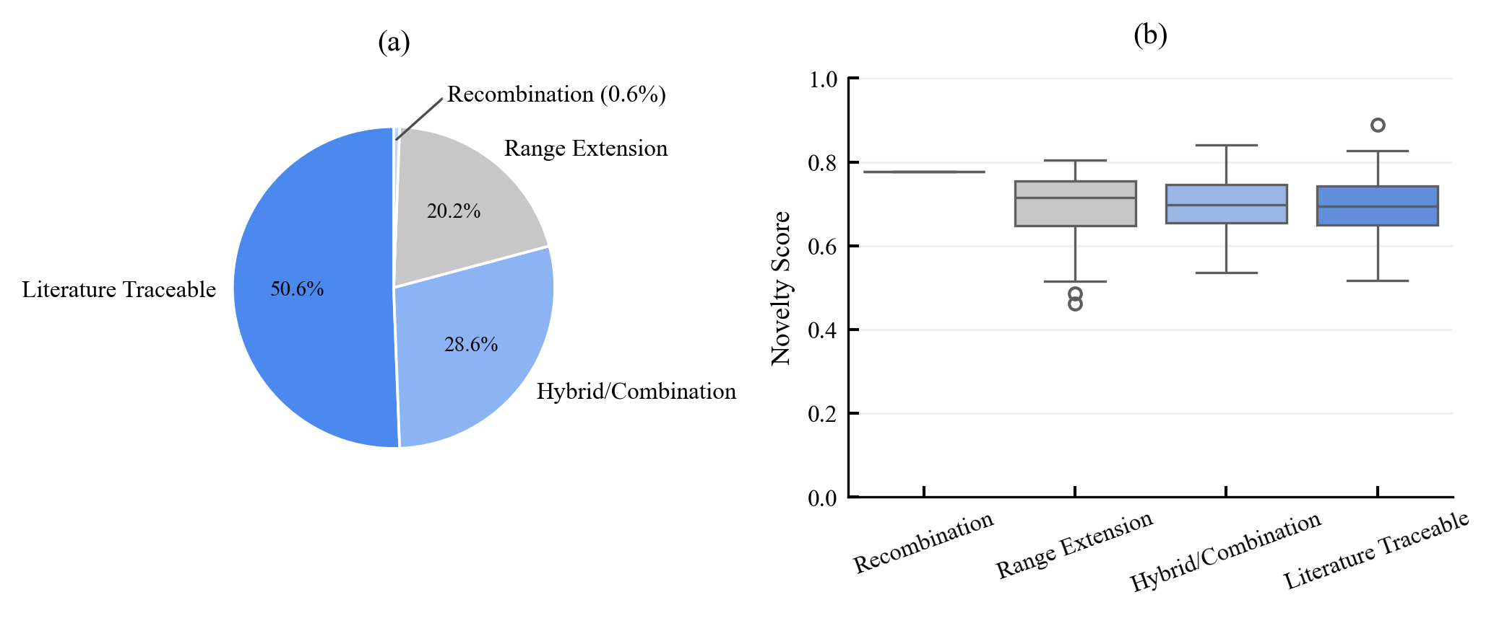
Figure 1 – Classification summary (N= 168 proposals, seven models). (a) Distribution of classification outcomes; the distribution is dominated by traceable categories consistent with low operational ontological novelty under calibrated thresholds. (b) Novelty score distributions by classification category shown as box plots.
  - Structural Decomposition
Of the 168 proposals, 88 (52.4%) were structurally decomposable into training-ontology primitives. Three failure modes account for the decomposable proposals:
- Range extension (34 cases, 20.2%): proposals that extend the physical parameter range of an existing modality (e.g., far-infrared thermal sensing as an extension of visual EM-band coverage, or infrasound-extended auditory detection).
- Hybrid combination (75 cases, 44.6%): proposals combining features from two or more existing modalities (e.g., combined tactile-proprioceptive "haptic flow" sensing, or olfactory-gustatory integration).
- Functional recombination (30 cases, 17.9%): proposals repurposing an existing sensing mechanism for a different functional role (e.g., using interoceptive signals for external-environment monitoring rather than homeostatic regulation).
The remaining 80 proposals (47.6%) were not fully decomposable through the three named categories but nonetheless fell within the traceability threshold, indicating semantic proximity to known concepts even without a simple structural decomposition path. Figure 2 shows novelty-frontier band assignments by model, confirming that the low-novelty/high-traceability pattern holds architecture-wide rather than being driven by a single underperforming model. Figure 3 further illustrates that most proposals fail multiple frontier criteria simultaneously, supporting a coupled-constraint interpretation.
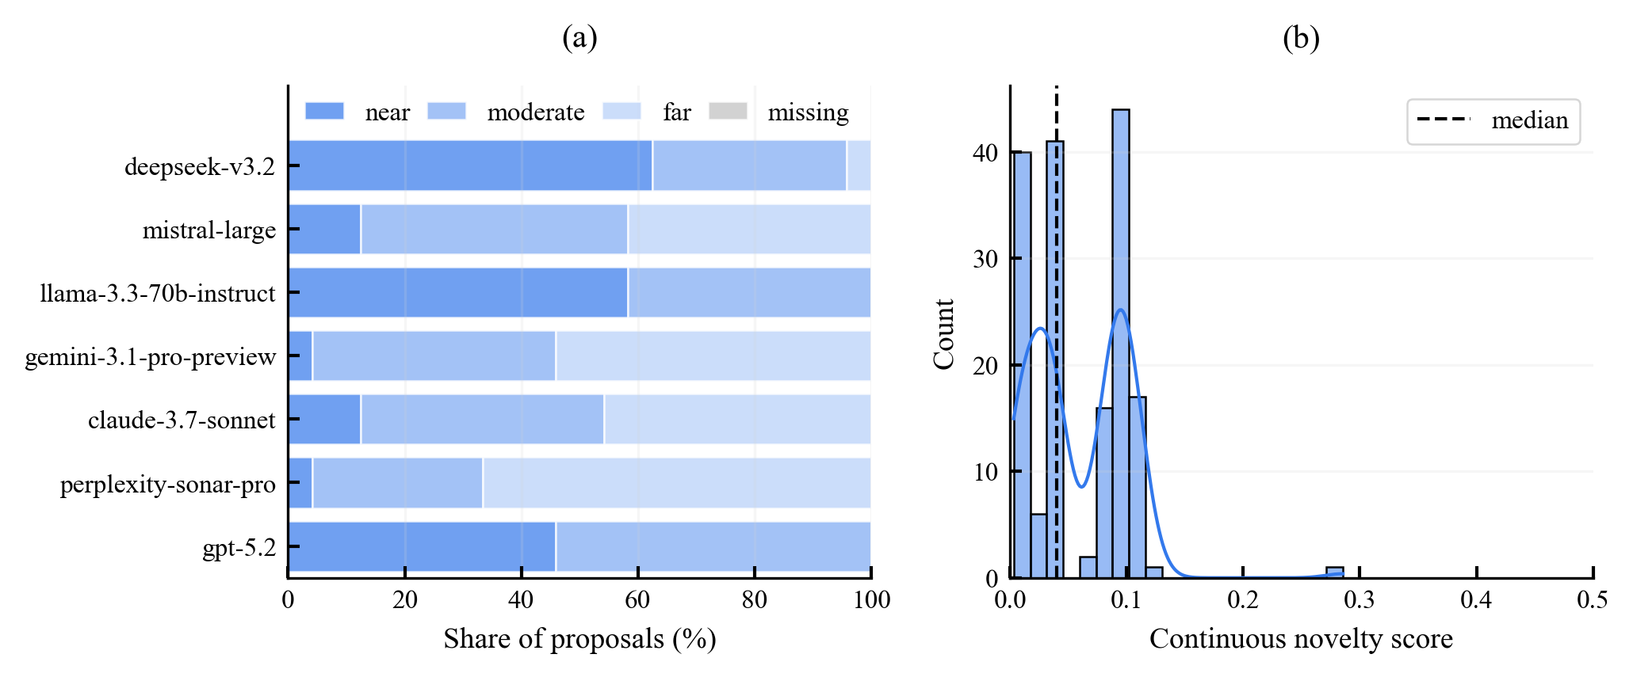
Figure 2 – Novelty-frontier band assignments and score distribution. (a) Band assignment by model: responses are concentrated in low-novelty and frontier-proximal bands across all seven architectures, indicating architecture-independent constraint patterns rather than isolated model failures. (b) Overall continuous novelty score distribution with KDE overlay; dashed line marks the median.

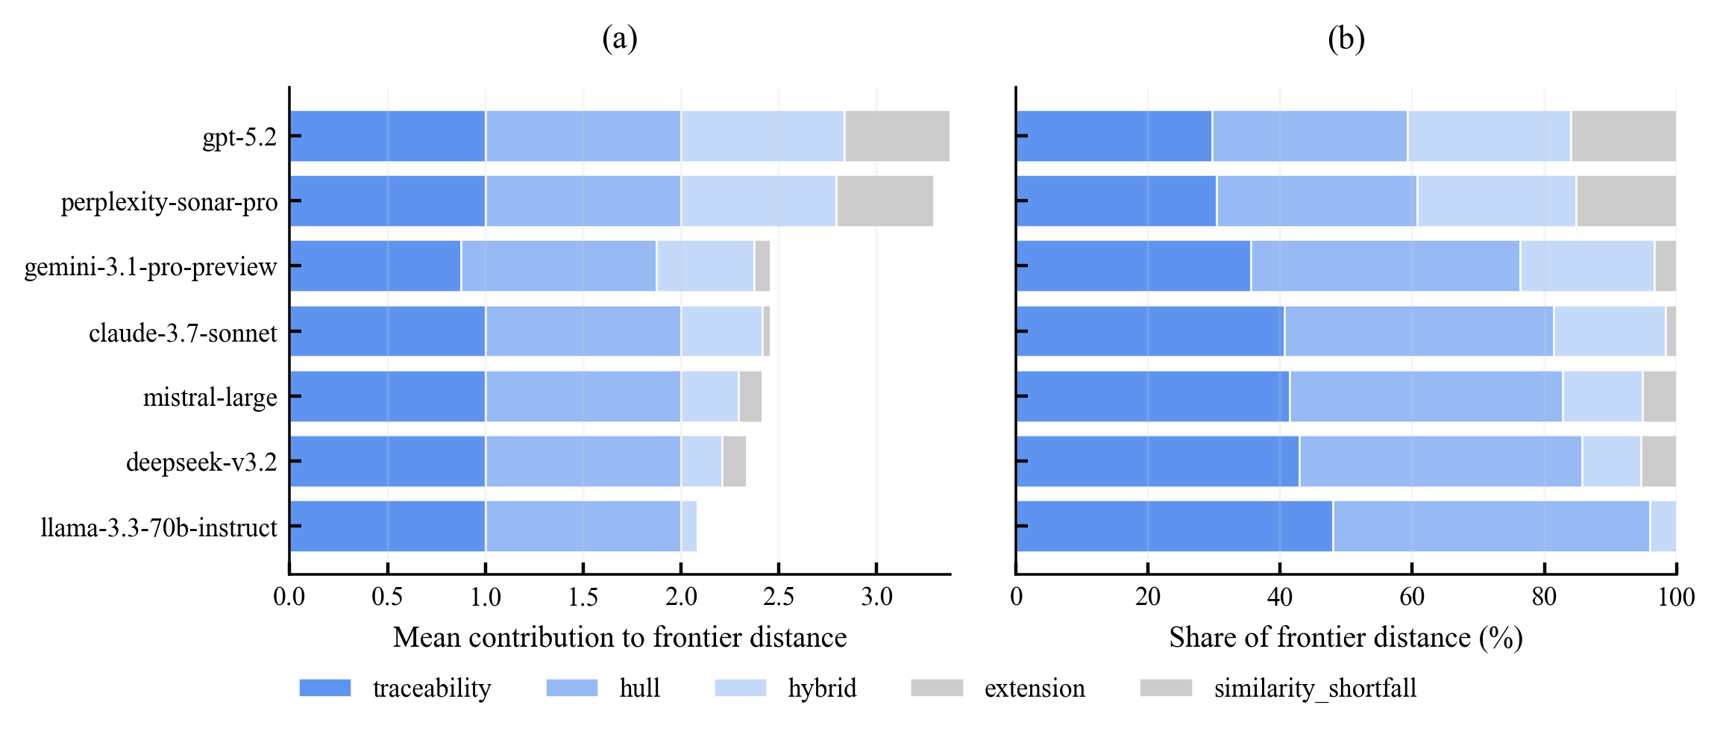
Figure 3 – Novelty-frontier criterion decomposition by model. (a) Absolute mean contribution of each criterion to overall frontier distance. (b) Relative share (%) of frontier distance per criterion. Both panels confirm that most responses violate multiple criteria simultaneously, supporting a coupled-constraint interpretation of low ontological novelty.
  - Embedding-Space Geometry
All 168 proposals (100%) were classified as inside the 3D Novelty-frontier band assignments and score distribution. (a) Band assignment by model: responses are concentrated in low-novelty and frontier-proximal bands across all seven architectures, indicating architecture-independent constraint patterns rather than isolated model failures. (b) Overall continuous novelty score distribution with KDE overlay; dashed line marks the median convex hull of training-modality embeddings. Proposal markers cluster in the interior region of the training manifold; no proposal occupies a semantically isolated region that would suggest basis expansion beyond the training ontology. The mean cosine similarity between each proposal and its closest training modality was $\bar{d}=0.305$ $\left(SD=0.078\right)$, indicating substantial semantic overlap with training concepts.
Figure 4 presents the embedding-space analysis with proposals visualized in the first two principal components and the 3D hull boundary shown as a visual aid. Figure 5 provides the aggregated cosine-similarity heatmap of proposed modalities against the eight training modalities, reaching the same conclusion from a complementary metric: every proposal records elevated similarity to one or more training modalities, with no proposal showing uniformly low similarity across all eight.

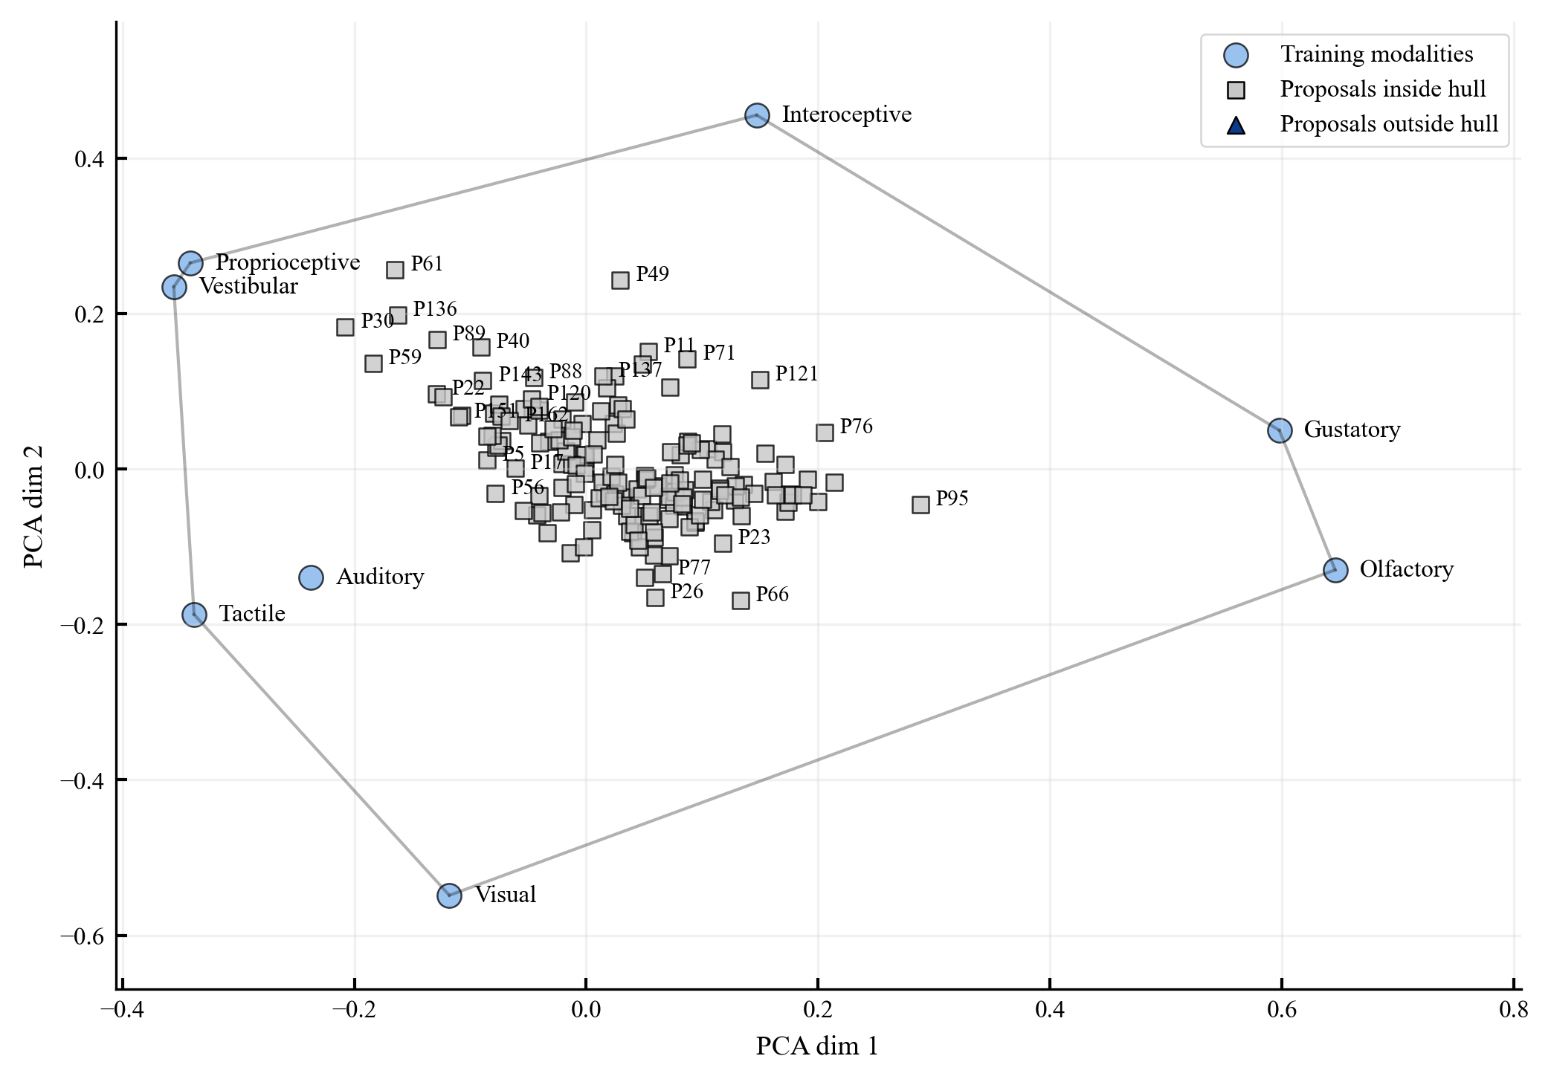
Figure 4 – Embedding-space analysis for proposals and training modalities. Convex-hull membership is computed in PCA-reduced 3D space; the 2D boundary shown is illustrative only. All 168 proposal markers cluster near the interior of the training manifold—none escape to a semantically isolated region.

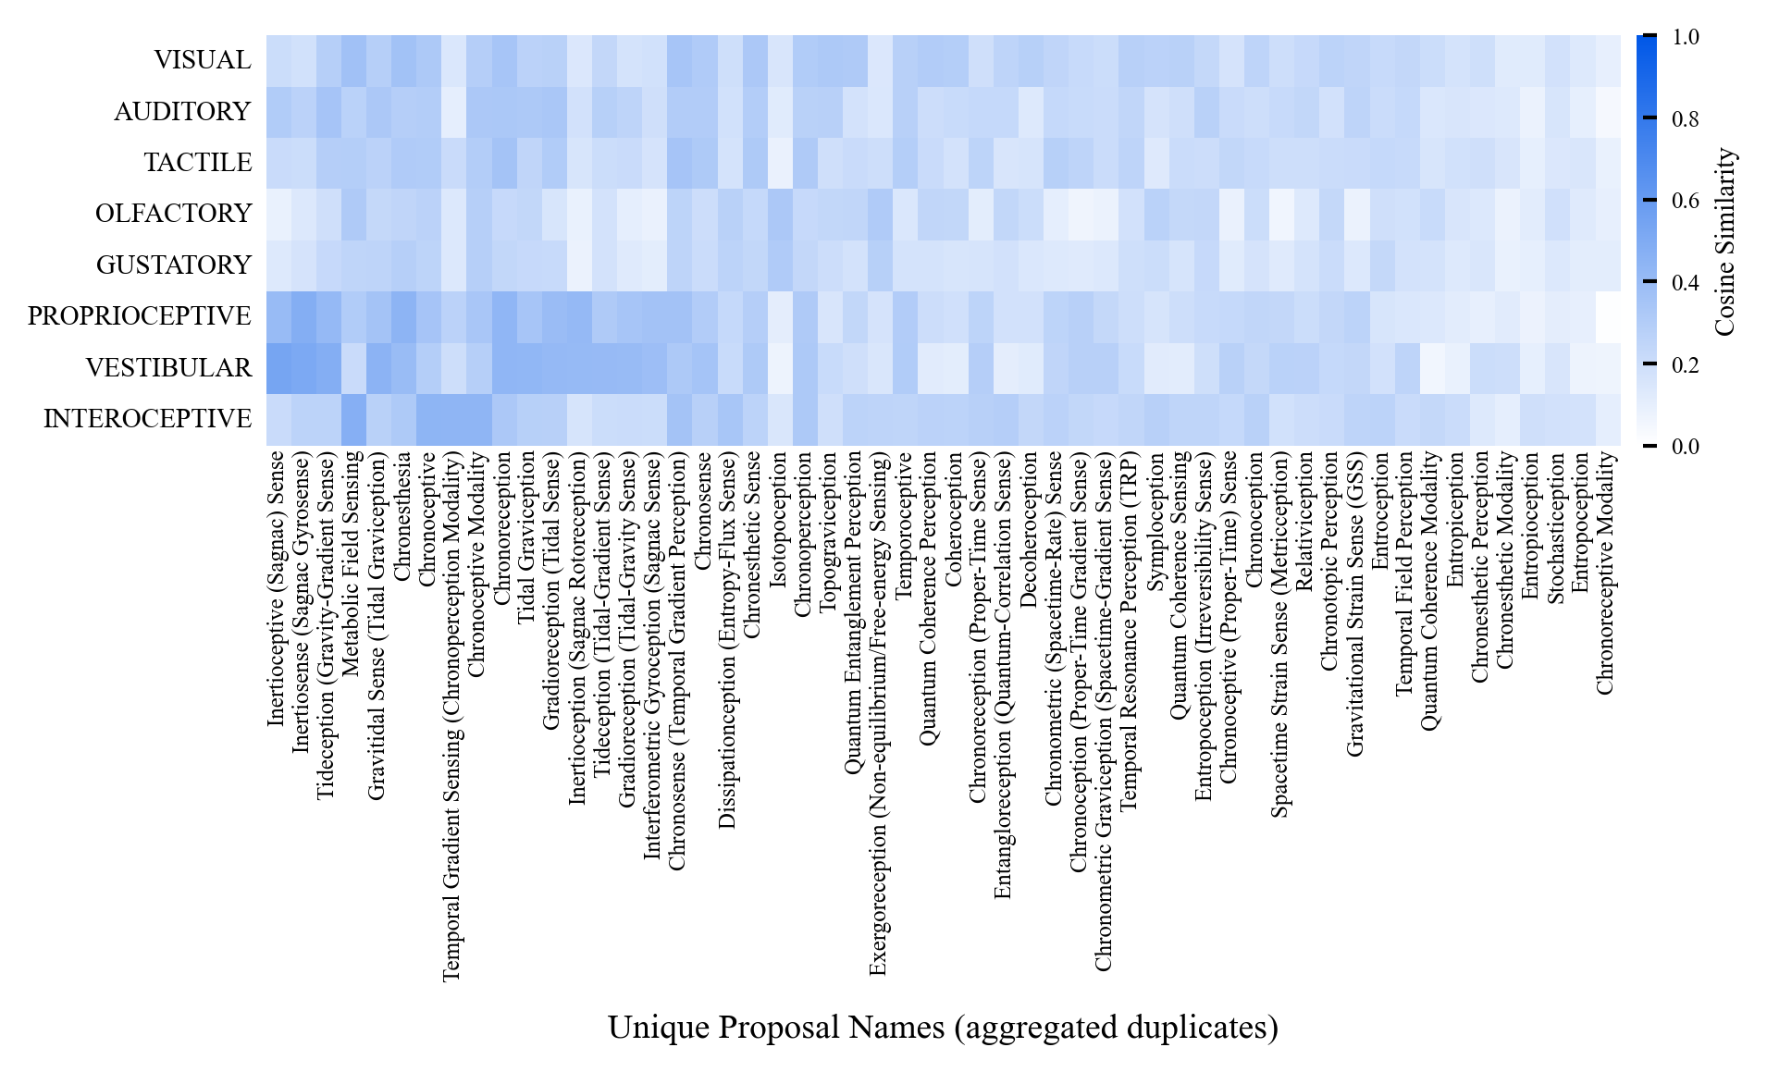
Figure 5 – Aggregated cosine similarity of proposed modalities to the eight training modalities. Concentration of similarity values confirms the traceability finding: no proposal is simultaneously dissimilar from all eight training types.
  - Cross-Model Comparison
The model effect on the primary novelty metric was moderate: one-way ANOVA yielded $η²=0.305$, indicating non-trivial between-model variance in raw scores. Nonetheless, all seven models remained within the same low-novelty/high-traceability regime; no model produced proposals classified as strictly novel, and no model achieved a mean continuous novelty score exceeding $µ=0.12$.
Figure 6 shows that between-model variation takes the form of different preferences among known canonical families rather than emergence of structurally new families: some models more frequently produced range-extension proposals while others favoured hybrid combinations, but neither pattern represents departure from the training-derived manifold. Figure 7 presents continuous novelty score distributions per model as a ridgeline plot. Distributional overlap is high across all seven models, and peaks consistently remain in low-to-moderate ranges, indicating that model-specific differences in architecture and scale do not qualitatively alter the constraint pattern.
  - Summary of Results
The four evaluation methods converge on a coherent picture: across 168 proposals from seven state-of-the-art LLMs, zero proposals satisfy the strict novelty criterion, 98.2% are traceable to the training corpus under the calibrated threshold, and every proposal lies inside the training-derived convex hull in embedding space. The structural decomposition reveals that the proposals explore recognisable combinatorial and extension patterns rather than introducing new ontological primitives. Cross-model effects influence degree of constraint rather than its qualitative nature.

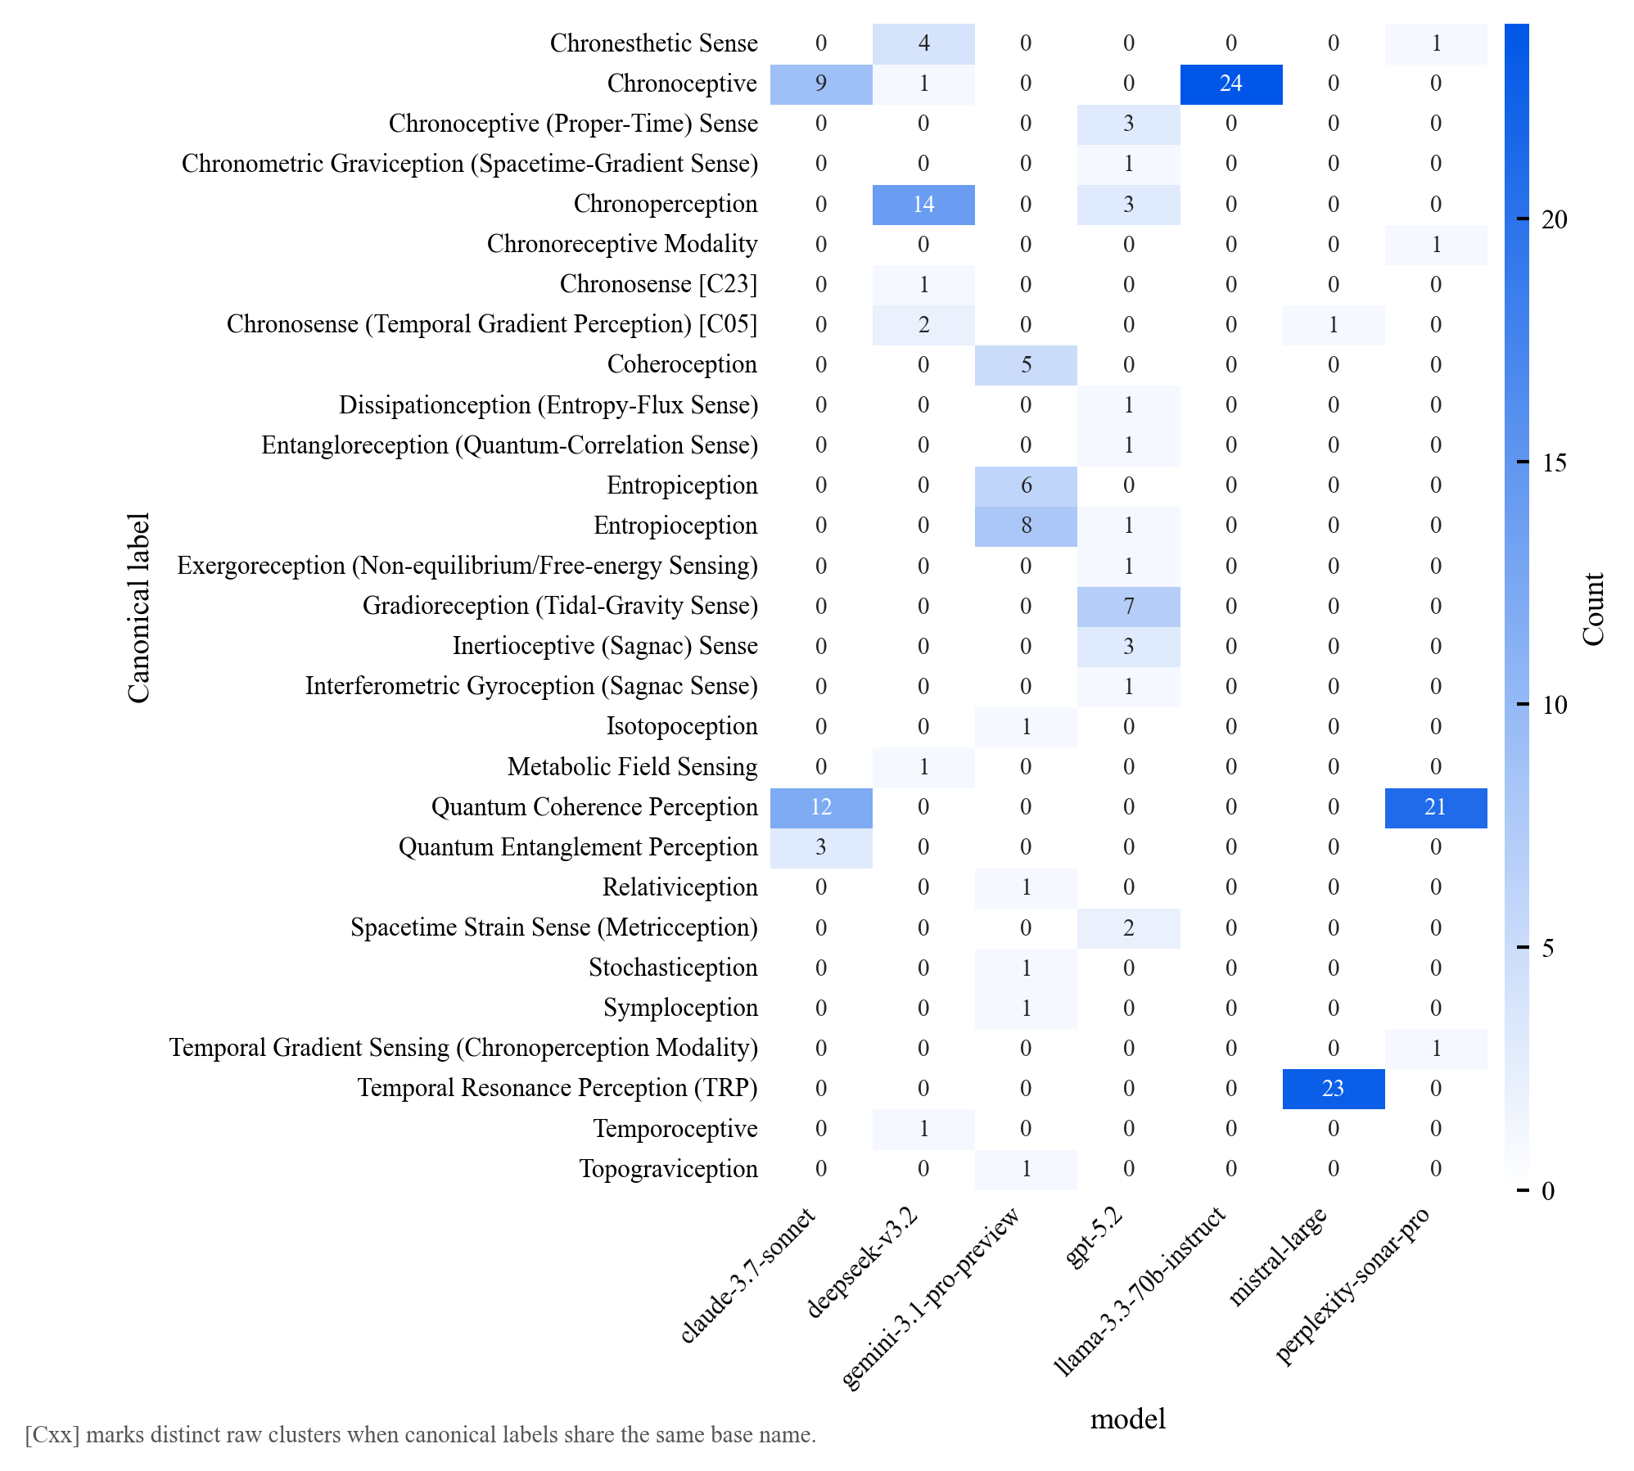
Figure 6 – Canonical proposal clusters by model. Between-model variation manifests primarily as preference differences among existing canonical families (range extension, hybrid combination, functional recombination) rather than as emergence of qualitatively new ontological families.

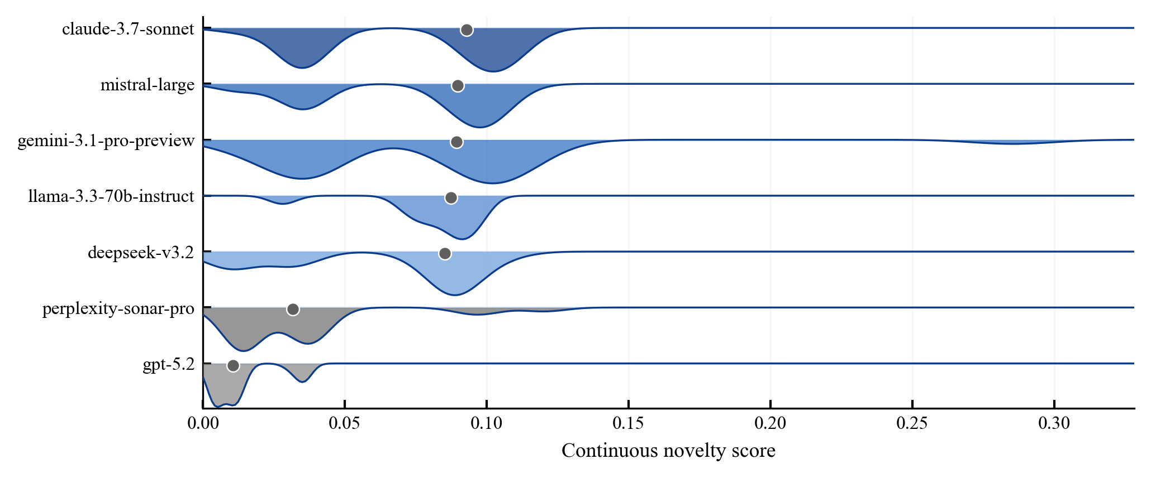
Figure 7 – Continuous novelty score by model (ridgeline plot). High distributional overlap and consistently low-to-moderate peaks indicate that model scale and architecture do not qualitatively alter the constrained-manifold pattern.
- Discussion
  - Constrained Manifold Interpretation
The consistent null result across models, evaluation methods, and threshold sensitivity checks supports a constrained-manifold interpretation: LLMs generate outputs within a representational manifold shaped by training data, and this manifold does not expand during inference regardless of prompt framing, model scale, or generation temperature. This interpretation aligns with the No New Basis Theorem stated in Section 2. The theorem establishes that generative processes learned via gradient descent on continuous loss functions cannot increase the intrinsic dimensionality of the output manifold beyond the span of training data. Our empirical results are consistent with this prediction: even the continuous novelty scores, designed to reward partial innovation, show no threshold-level events and a mean value close to zero.
Gödel's incompleteness results [9] and Turing's halting-problem proof [8] provide deeper formal context. If recognising the inadequacy of one's own conceptual framework requires a form of self-reference analogous to constructing a Gödel sentence, then this capacity may be unavailable to computational systems operating within fixed formal specifications. Our empirical evidence is consistent with this theoretical prediction, though it does not constitute a formal proof that such incapacity is necessary rather than contingent.
  - Relationship to the Creativity Taxonomy
Within Boden's taxonomy [4], the structural decomposition results place nearly all proposals firmly in the combinational and exploratory categories: proposals are either novel combinations of existing primitives (hybrid combinations) or new regions of existing modality spaces (range extensions). A small fraction involve functional recombination, which could be viewed as approaching transformational creativity, but the transformations remain within the ontological type system defined by the training modalities rather than introducing new types.
The absence of any proposal in the ontological creativity category supports Wiggins's [2] observation that apparent transformational creativity in AI systems frequently reflects an implicitly broader framing space defined by human designers. In our setup the framing space is made explicit through the eight-modality ontology, enabling a precise test: proposals must introduce a sensing type genuinely outside this space. None do.
  - Alternative Explanations
Several alternative explanations deserve consideration:
Scale. All seven models span a wide range of scales, from the 70B-parameter LLaMA-3.3-70B to large-scale commercial systems such as GPT-5.2 and Claude-3.7-Sonnet. The $η²=0.305$ model effect indicates that scale influences raw novelty scores, but no model achieves strict novelty. This suggests the constraint is not a contingent result of insufficient scale within the tested range.
Prompt sensitivity. The present study used a fixed prompt design with temperature ablation limited to $T=0.7$. We cannot rule out that alternative prompt formulations might yield marginally higher novelty scores, though they would need to change not just lexical generation patterns but the geometric structure of the output manifold. Future work should include systematic prompt-paraphrase grids to test robustness.
Evaluation sensitivity. Conservative thresholds mean we may underestimate AI creativity by classifying some proposals as traceable that an expert would consider novel. However, the embedding-space analysis is threshold-free, and 100% hull membership provides threshold-independent evidence of constrained generation.
Recombination as the norm. One counterargument holds that human ontological creativity may also, on careful analysis, involve recombination of prior concepts in ways we fail to recognise due to incomplete historical knowledge of our own cognitive processes. We cannot definitively rule this out, but the structural patterns here—range extension, hybrid combination, functional recombination—are qualitatively different from the kind of reconceptualisation exemplified by the introduction of non-Euclidean geometry or special relativity, even granting that such innovations drew on prior materials.
  - Implications
The results have direct implications for deploying LLMs in discovery-oriented tasks. Within Kuhnian normal science [1]—systematic exploration of hypothesis space within an established paradigm—LLMs offer substantial value through exhaustive combinatorial coverage and perfect recall. The success of AlphaFold in predicting protein structures [33] illustrates how AI can achieve transformative impact within a well-defined problem space, yet that system still required the conceptual primitives of physical chemistry and evolutionary co-evolutionary constraints that were established by prior human science.
For paradigm-shifting innovation, however, the constrained-manifold pattern suggests that the required conceptual moves—recognising framework inadequacy, proposing new primitives, evaluating whether new frameworks are coherent—are not achievable by current architectures without external conceptual input.
Faggin's framework [34] provides one theoretical lens: if genuine ontological creativity requires phenomenological access to the semantic realm—awareness of what concepts mean rather than merely how they co-occur—then classical computational systems operating on distributional statistics may face a principled barrier. Whether this reflects the absence of consciousness in current LLMs or some more specific architectural deficiency remains an open empirical question, one that the operationalisation introduced here can in principle be applied to test.
  - Limitations
Several methodological limitations constrain the conclusions.
- Single domain. The study uses one conceptual domain (sensory modalities). Findings may not generalise to conceptual domains with different structural properties, such as mathematical objects, physical theories, or social organisational forms.
- Automated evaluation. All evaluation methods are automated. Conservative thresholds mean we likely underestimate AI creativity, but the methods cannot capture all nuances an expert might perceive. Future work should include expert validation of a subset of proposals to calibrate and improve automated methods.
- Prompt robustness. Full prompt-paraphrase grids were not included in the canonical experimental block. Conclusions should be read as structural tendencies under the present protocol, not as invariances proven over every prompting regime.
- Temperature range. Temperature ablations were not systematically applied; runs were conducted at T = 0.7. Extending to broader temperature ranges and verifying that the null result persists would strengthen confidence.
- Generative architecture coverage. All tested models are transformer-based autoregressive LLMs. The No New Basis Theorem applies to a wider class of gradient-descent learners, but empirical coverage of non-autoregressive or hybrid architectures is absent.
- Interpretation of the No New Basis Theorem. The theorem provides formal motivation for the constrained-manifold interpretation but rests on assumptions (fixed vocabulary, continuous gradient-based learning) that may not hold for future architectures incorporating discrete search, external memory, or online learning components.
- Conclusion
This study provides controlled empirical evidence that seven state-of-the-art large language models, evaluated across 168 proposals using four convergent methods, produce zero strictly novel ontological outputs when prompted to extend a well-defined sensory ontology. The strict novelty rate of ${\hat{p}}_{novel}$ = 0.000, combined with 98.2% traceability to the training corpus and 100% convex-hull membership in embedding space, supports a constrained-manifold interpretation: current neural architectures operate within representational closures defined by their training data and cannot expand this space during inference.
These findings align with the No New Basis Theorem and broader theoretical arguments from Gödel, Turing, and Ryle suggesting principled limits on what fixed-specification computational systems can conceptually generate. The moderate cross-model effect ($η²=0.305$) confirms that the constraint is architecture-wide rather than a deficit of any particular model or scale. Within Boden's taxonomy, LLM outputs occupy the combinational and exploratory categories; the ontological creativity category—introducing genuinely new primitive concepts—remains unoccupied.
Practically, these results suggest that LLMs are powerful tools for normal science but are unlikely to drive paradigm-shifting conceptual innovation autonomously. Operationalising and evaluating ontological creativity remains an open challenge; the experimental paradigm introduced here—grounded in an explicit training universe with automated multi-method evaluation—provides a replicable foundation for future work across conceptual domains beyond sensory modalities
Data and Code Availability
Data, prompts, model responses, and analysis code are publicly available at https://github.com/JABE22/PhD/Research/ontological-innovation. The repository includes the following artefacts:
- results/test1ontologicalinnovation/ — processed results and summary tables
- airesponses/test1ontologicalinnovation/ — raw model outputs
- 2-test1-ontological-innovation.ipynb — canonical analysis notebook
- data/ontology.json — machine-readable eight-modality ontology definition
- setups/thresholds.py — all threshold values used in evaluation
List of figures and tables
Figure 1 — Classification summary
Figure 2 — Novelty-frontier band assignments and score distribution
Figure 3 — Novelty-frontier criterion decomposition by model
Figure 4 — Embedding-space analysis (PCA-reduced 3D)
Figure 5 — Aggregated cosine similarity heatmap
Figure 6 — Canonical proposal clusters by model
References
- Kuhn TS. The Structure of Scientific Revolutions. Chicago: University of Chicago Press; 1962. 212 p.
- Wiggins GA. A preliminary framework for description, analysis and comparison of creative systems. Knowledge-Based Systems. 2006; 19(7): 449–458.
- Colton S, Wiggins GA. Computational creativity: The final frontier? In: Proceedings of the 20th European Conference on Artificial Intelligence. Amsterdam: IOS Press; 2012: 21–26.
- Boden MA. The Creative Mind: Myths and Mechanisms. 2nd ed. London: Routledge; 2004. 344 p.
- Hofstadter DR, Fluid Analogies Research Group. Fluid Concepts and Creative Analogies: Computer Models of the Fundamental Mechanisms of Thought. New York: Basic Books; 1995. 528 p.
- Cope D. Experiments in Musical Intelligence. Madison, WI: A-R Editions; 1996. 542 p.
- Ryle G. The Concept of Mind. London: Hutchinson; 1949. 334 p.
- Turing AM. On computable numbers, with an application to the Entscheidungsproblem. Proceedings of the London Mathematical Society. 1936; s2-42(1): 230–265.
- Gödel K. Über formal unentscheidbare Sätze der Principia Mathematica und verwandter Systeme I [In German]. Monatshefte für Mathematik und Physik. 1931; 38: 173–198.
- Searle JR. Minds, brains, and programs. Behavioral and Brain Sciences. 1980; 3(3): 417–424.
- Penrose R. The Emperor's New Mind: Concerning Computers, Minds and the Laws of Physics. London: Vintage; 1990. 480 p.
- Dreyfus HL. What Computers Can't Do: A Critique of Artificial Reason. New York: Harper & Row; 1972. 259 p.
- Brown TB, Mann B, Ryder N, Subbiah M, Kaplan J, et al. Language models are few-shot learners. Advances in Neural Information Processing Systems. 2020; 33: 1877–1901.
- Elhage N, Nanda N, Olsson C, Henighan T, Joseph N, et al. A mathematical framework for transformer circuits. Transformer Circuits Thread. 2021. Available at: https://transformer-circuits.pub/2021/framework/index.html
- Vaswani A, Shazeer N, Parmar N, Uszkoreit J, Jones L, et al. Attention is all you need. Advances in Neural Information Processing Systems. 2017; 30. arXiv:1706.03762.
- Gärdenfors P. Conceptual Spaces: The Geometry of Thought. Cambridge, MA: MIT Press; 2000. 307 p.
- Stevenson C, Smal I, Baas M, Grasman R, Maas H. Putting GPT-3's creativity to the test. Scientific Reports. 2022; 12: 14472. DOI: 10.1038/s41598-022-18979-y.
- Organisciak P, Dumas D. Beyond semantic distance: Automated scoring of divergent thinking greatly improves with large language models. Thinking Skills and Creativity. 2023; 49: 101356. DOI: 10.1016/j.tsc.2023.101356.
- Zhao Y, Zhang R, Li W, Huang D, Guo J, Peng S. Assessing and understanding creativity in large language models. arXiv preprint. 2024. arXiv:2401.12491.
- Wang H, Zou J, Mozer M, Goyal A, Lamb A, Zhang L. Can AI be as creative as humans? arXiv preprint. 2024. arXiv:2401.01623.
- Peeperkorn M, Kouwenhoven T, Brown D, Jordanous A. Is temperature the creativity parameter of large language models? arXiv preprint. 2024. arXiv:2405.00492.
- Bellemare-Pepin A, Lespinasse F, Thölke P, Harel Y, Mathewson K, Olson JA. Divergent creativity in humans and large language models. arXiv preprint. 2024. arXiv:2405.13012.
- Ismayilzada M, Stevenson C, Plas L. Evaluating creative short story generation in humans and large language models. arXiv preprint. 2024. arXiv:2411.02316.
- Nakajima K, Zuiderveld J, Pezzelle S. Beyond divergent creativity: A human-based evaluation of creativity in large language models. arXiv preprint. 2026. arXiv:2601.20546.
- Olson ML, Ratzlaff N, Hinck M, Tseng S, Lal V. Steering large language models to evaluate and amplify creativity. arXiv preprint. 2024. arXiv:2412.06060.
- OpenAI, Achiam J, Adler S, et al. GPT-4 technical report. arXiv preprint. 2023. arXiv:2303.08774.
- Gemini Team, Georgiev P, Lei VI, Burnell R, et al. Gemini 1.5: Unlocking multimodal understanding across millions of tokens of context. arXiv preprint. 2024. arXiv:2403.05530.
- Grattafiori A, Dubey A, Jauhri A, et al. The LLaMA 3 herd of models. arXiv preprint. 2024. arXiv:2407.21783.
- DeepSeek-AI, Liu A, Feng B, et al. DeepSeek-V3 technical report. arXiv preprint. 2024. arXiv:2412.19437.
- DeepSeek-AI, Guo D, Yang D, et al. DeepSeek-R1: Incentivizing reasoning capability in LLMs via reinforcement learning. arXiv preprint. 2025. arXiv:2501.12948.
- Jiang AQ, Sablayrolles A, Roux A, et al. Mixtral of experts. arXiv preprint. 2024. arXiv:2401.04088.
- Reimers N, Gurevych I. Sentence-BERT: Sentence embeddings using Siamese BERT-networks. In: Proceedings of the 2019 Conference on Empirical Methods in Natural Language Processing. Stroudsburg, PA: ACL; 2019: 3982–3992.
- Jumper J, Evans R, Pritzel A, Green T, Figurnov M, et al. Highly accurate protein structure prediction with AlphaFold. Nature. 2021; 596: 583–589. DOI: 10.1038/s41586-021-03819-2.
- Faggin F. Irreducible: Consciousness, Life, Computers, and Human Nature. Washington: John Hunt Publishing; 2024. 352 p.
About the Author

Jarno Olavi Matarmaa (b. 1989) graduated from the University of Tampere, Institute of Information and Communication Technology, in 2020, B.Sc. in Computer Science. Completed M.Sc. in Data Science at Ural Federal University, Institute of Radio Electronics and Information Technologies, in 2023. Since 2023, PhD candidate and Assistant Professor at Ural Federal University. He is a teacher of Machine Learning Methods and Time Series Analysis. His research focuses on artificially intelligent systems, natural language processing, philosophy of mind, and interdisciplinary approaches to AI. Broader scientific interests include consciousness studies, philosophy of information, and quantum information theory. ORCID: 0009-0009-1024-7211; Author ID (Scopus): 58489682500; Researcher ID (WoS): KRP-1088-2024. iarnoolavi.matarmaa@urfu.ru 🖂
________________________________________________________________________________________________________________________
Received May 10, 2026. Revised May 24, 2026. Accepted June 10, 2025.
________________________________________________________________________________________________________________________

